CALL FOR PAPERS

CALL FOR PAPERS
9th National
&
3rd International Conference
on
“Refrigeration & Air Conditioning”
NCRAC 2026
13-16th December 2026
Theme: Smart & Sustainable HVAC Systems for Viksit Bharat 2047

organized by

Indian Institute of Technology Tirupati
&
Supported by


important dates

Short abstracts (250 words) : 28th Feb 2026
Abstract acceptance : 15th March 2026
Full paper submission : 30th June 2026
Revised paper submission : 30th September 2026
Conference dates : 13-16th December 2026

REGISTRATION FEE

The registration fee per delegate is ₹12,000, while the fee for an accompanying person is ₹5,000. For students from academic institutions and research laboratories, the registration fee is ₹7,500, with an accompanying person fee of ₹3,500. The registration fee for industry participants is ₹15,000. For overseas delegates, the registration fee is USD 400, and for overseas student authors, it is USD 250. Detailed information regarding the registration will be communicated soon.

SPONSORSHIP AND ADVERTISEMENT

In NCRAC 2026, sponsors will have the opportunity to conduct product presentations, exhibit their products, and display posters and catalogues, as well as distribute promotional brochures. The printed conference proceedings will include plenary, keynote, and invited papers, along with abstracts of contributed papers and paid advertisements. Detailed information regarding sponsorship and advertising opportunities will be provided in the second announcement.

VENUE AND ACCOMMODATION
Conference will be in offline mode only. The venue is IIT Tirupati campus.

Publication
Selected papers will be considered for publication in reputed SCI and Scopus indexed Journals.

ADDRESS FOR CORRESPONDENCE
Organizing Secretary, NCRAC 2026
Department of Mechanical Engineering
Indian Institute of Technology Tirupati
Tirupati – 517619, Andhra Pradesh, India
Email: ncrac2026@iittp.ac.in

ABSTRACTS and papers
Academicians, industry professionals, and consultants are invited to present their work at NCRAC 2026. Authors are required to submit an abstract of no more than 250 words via email to ncrac2026@iittp.ac.in. Upon acceptance of the abstract, contributors will be invited to submit a full-length paper, with detailed formatting and submission guidelines to be communicated subsequently. All submissions will be subject to a rigorous peer-review process conducted by a panel of experts from both academia and industry. Dedicated presentation sessions will be organized, including sessions highlighting industry-focused contributions such as field experience, case studies, and emerging trends in the HVAC&R sector.
topics
The conference will cover all significant areas of Refrigeration and Air conditioning, including:
- Energy efficiency & cold/heat recovery
- Novel/alternate ecofriendly RAC systems
- Natural/new refrigerants & mixtures
- Refrigerated cold chain, transport & cold stores
- Sorption heating and cooling systems
- District heating and cooling
- Desiccant and evaporative cooling
- Polygeneration
- Heat pump
- Indoor air quality and Industrial ventilation,
- HVAC systems for Healthcare Applications
- Clean Room for semiconductor / Solar PV/ Automobile / Pharma sectors
- Green buildings
- Building management systems
- Modern innovations in HVAC systems
- Low temperature applications
- Application of IoT in RAC
- AI/ML models for refrigeration systems
- Role of CFD in HVAC design
- Refrigeration cycles
- Thermal comfort and comfort standards
- Thermal energy storage
- Materials and HMT in HVAC
- Cooling as Service
- Thermal management in Datacenter / e-applications

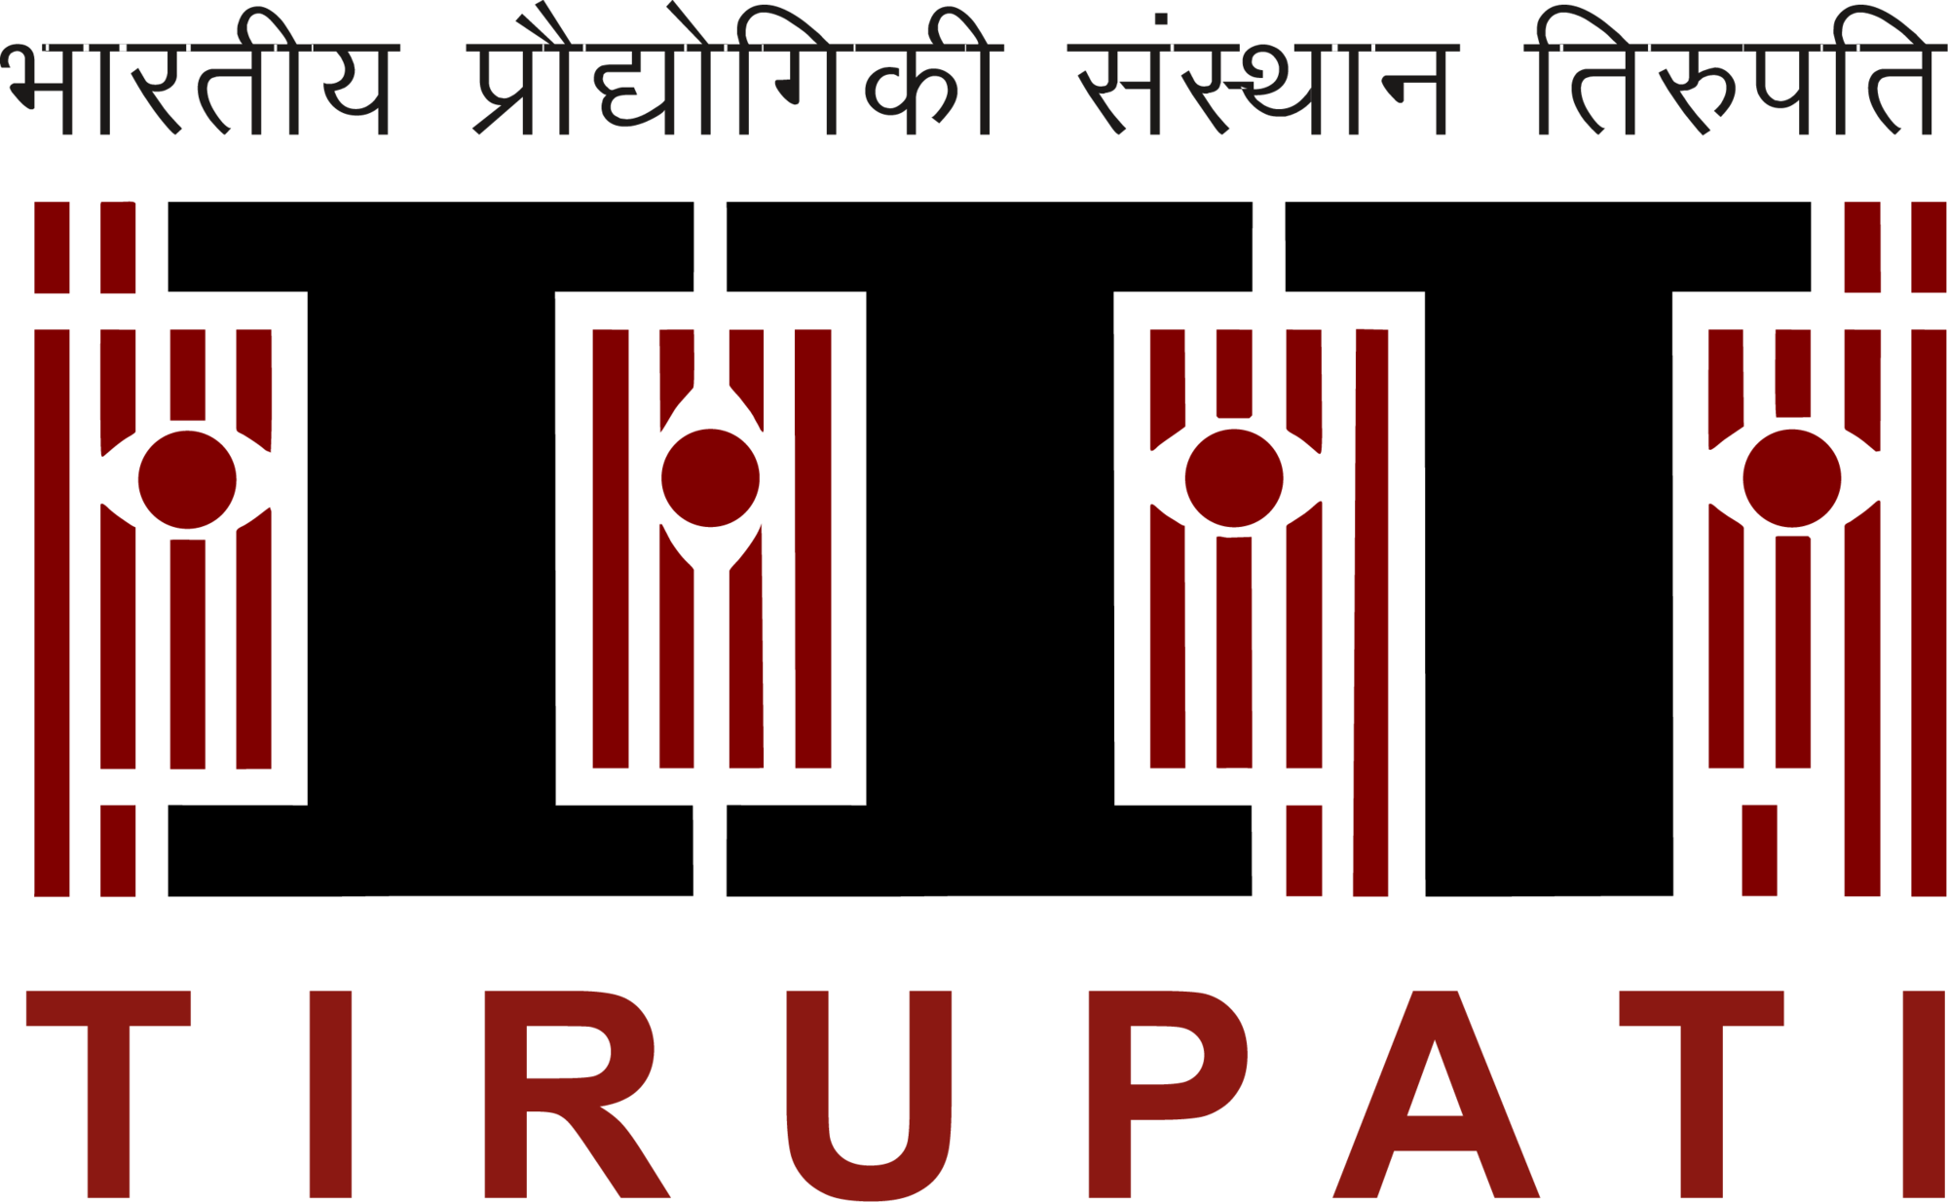
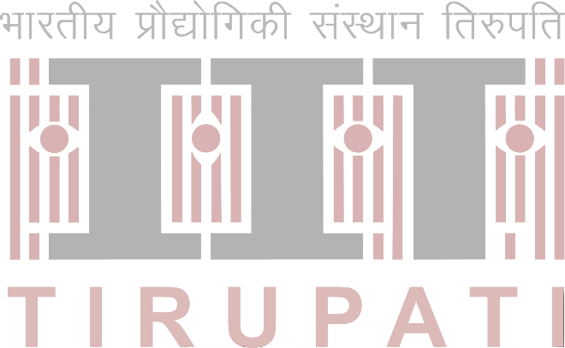
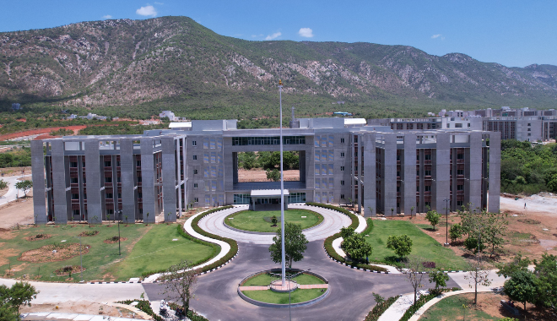
COMMITTEES
Patron
Prof. K. N. Satyanarayana, Director, IIT Tirupati

Chairman
Prof. S. Srinivasa Murthy, IISc Bangalore
Prof. P. Muthukumar, Mechanical Engg., IIT Tirupati

Co-Chairmen
Prof. E. Anil Kumar, Mechanical Engg., IIT Tirupati
Prof. R. Saravanan, President Elect, ISHRAE / Anna Univeristy
Prof. M. Ram Gopal, IIT Kharagpur
Prof. Bidyut Baran Saha, WPI-I2CNER, Kyushu University, Japan

Organizing Committee
Dr. N. Gnanasekaran, Mechanical Engg., IIT Tirupati
Dr. Vignesh T.G., Mechanical Engg., IIT Tirupati
Dr. Mohd Furquan, Mechanical Engg., IIT Tirupati

Advisory Committee
Prof. S. Srinivasa Murthy, ICER, IISc Bangalore
Prof. D. Y. Goswami, University of South Florida, USA
Prof Alberto Coronas, URV - Rovira i Virgili, Spain
Prof. Pradip Dutta, Mechanical Engg., IISc Bangalore
Prof. Pramod Kumar, Chairperson, ISER, IISc Bangalore
Prof. Jyotirmay Mathur, Mechanical Engg., MNIT Jaipur
Dr. Yashkumar Shukla, Head CARBSE, CEPT University, Ahmedabad
Mr. I Hariprasad, President Elect, ASHRAE Chennai Chapter
Mr. Krishnasamy R., President Elect, ISHRAE Chennai Chapter
Prof. M. V. Rane, Mechanical Engg., IIT Bombay
Dr. Sukumar Devotta, Former Director NEERI
Prof. M.S. Dasgupta, Mechanical Engg., BITS Pilani
Prof. Armin Hafner, Energy and Process Engineering, NTNU, Norway

Technical Committee
Dr. Advaith, Mechanical Engg., IIT Madras
Dr. B. Satya Sekhar, Mechanical Engg., IIT Jammu
Dr. Gurubalan A, Energy Science & Engg., IIT Bombay
Dr. B. Kiran Naik, Mechanical Engg., NIT Rourkela
Prof. Jahar Sarkar, Mechanical Engg., IIT-BHU
Dr. Aakash C Rai, Mechanical Engg., IIT Kanpur
Dr. S. Sahoo, Mechanical Engg., IIT (ISM) Dhanbad
Dr. Vinod Kumar sharma, Mechanical Engg., NIT Calicut
Dr. G Praveen kumar, Mechanical Engg., VIT Vellore
Dr. Harikrishnan S., Mechanical Engineering, CUSAT Kochi
Dr. Rakesh Sharma, Mechanical & Industrial Engg., MIT, Manipal
Dr Sarun Kumar K, Energy and Process Engg., NTNU, Norway
OBJECTIVES
The aspirations and living standards of humankind continue to rise alongside rapid technological progress, while challenges such as environmental degradation, global warming, and climate change demand urgent attention. Meeting human comfort and industrial needs in an environmentally sustainable manner places Refrigeration and Air Conditioning (RAC) at the forefront of technological innovation. Beyond human comfort, RAC systems are essential to sectors including food preservation, healthcare, space exploration, and digital infrastructure, and currently account for nearly 20% of global electricity consumption. Although international efforts such as the Montreal Protocol have successfully addressed ozone depletion, the goals of the Kyoto Protocol and Paris Agreement—particularly reducing greenhouse gas emissions and limiting global temperature rise to within 2°C—remain ongoing challenges. Addressing these issues requires the development of eco-friendly refrigerants, innovative system architectures, integration with renewable energy, and life-cycle–based sustainability approaches. This conference aims to bring together researchers, academicians, industry professionals, and policymakers to discuss these challenges, showcase emerging technologies, and chart a path toward a low-carbon, energy-efficient, and sustainable future for refrigeration and air conditioning.
ABOUT NCRAC
The National Conference on Refrigeration and Air Conditioning (NCRAC) was initiated at IIT Madras in 2009 and subsequently held as a biennial event in 2011 and 2013. The 4th NCRAC was hosted by Rajalakshmi College of Engineering, Chennai in 2015, followed by the 5th NCRAC at NITK Surathkal in 2018. The 6th NCRAC returned to IIT Madras, while the 7th NCRAC in 2022, organized by IIT Guwahati in association with IIT Tirupati, marked the first international edition of the conference. The most recent edition, NCRAC 2024, was hosted by IIT Madras. Building on this legacy, NCRAC 2026 aims to provide an international platform for the discussion and dissemination of cutting-edge research in refrigeration and air conditioning to the global community.

about iit TIRUPATI

IIT Tirupati, established in 2015, began functioning in the academic year 2015–16 with the support of its mentoring institute, IIT Madras. By 2018, its academic programs had expanded to nine departments spanning engineering, sciences, and humanities, offering B.Tech, M.Tech, M.Sc, M.S.(R), and PhD programmes. Its curricula emphasize a strong foundation in theory complemented by practice-oriented laboratories, fostering innovation, creativity, teamwork, communication skills, ethics, and societal engagement. The permanent campus, spread over 548 acres, is under development, with several buildings operational since 2018. IIT Tirupati is also developing an 18-acre research park on its campus, set to be one of the largest in India upon completion. This facility aims to foster innovation, entrepreneurship, and industry-academia collaborations in areas like smart infrastructure, energy, and AI. Located in Tirupati, the institute benefits from an airport and excellent connectivity to Chennai and Bengaluru.

ABOUT MECHANICAL ENGINEERING DEPARTMENT

The Department of Mechanical Engineering at IIT Tirupati, established in 2015, is a dynamic and rapidly growing academic unit offering programmes at multiple levels, including B.Tech, M.Tech (with specializations in Design & Manufacturing and Thermal Engineering and Energy Systems), as well as MS (R) and phd programmes. Recently, M.Tech programmes in Computational Mechanics and Executive M.Tech in Manufacturing have been approved. The faculty are actively engaged in diverse research areas such as renewable and wind energy, thermal energy storage, hydrogen production and storage, compact heat exchangers, advanced manufacturing, advanced materials, CFD, fluid–structure interaction, multiphase flows, robotics, aerial and underwater drones, precision agriculture, and food processing, and theoretical and applied mechanics. The department is supported by well-equipped instructional and research laboratories, a central workshop, and state-of-the-art facilities, and is recognized for its interdisciplinary collaborations, industry-aligned curriculum, and strong emphasis on applied research.

