this is available at localhost:9870 ->utilities ->browse file system

we create a user dir in the distributed file system.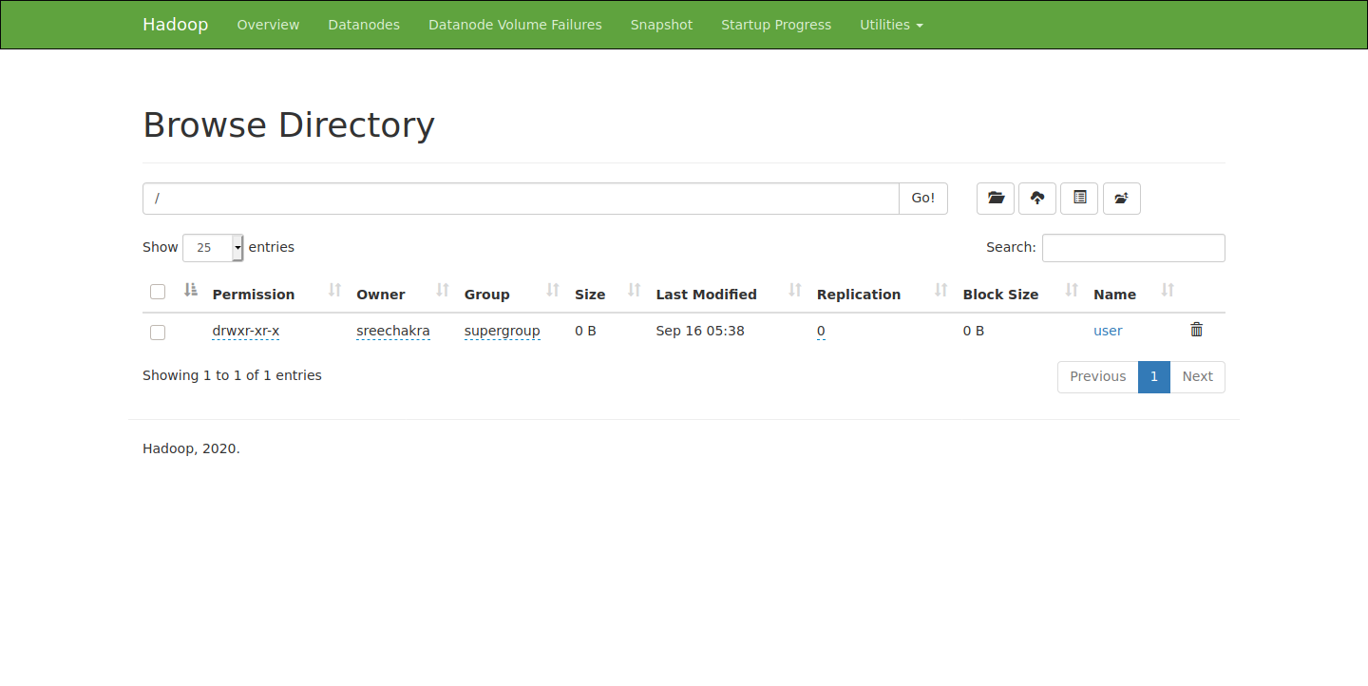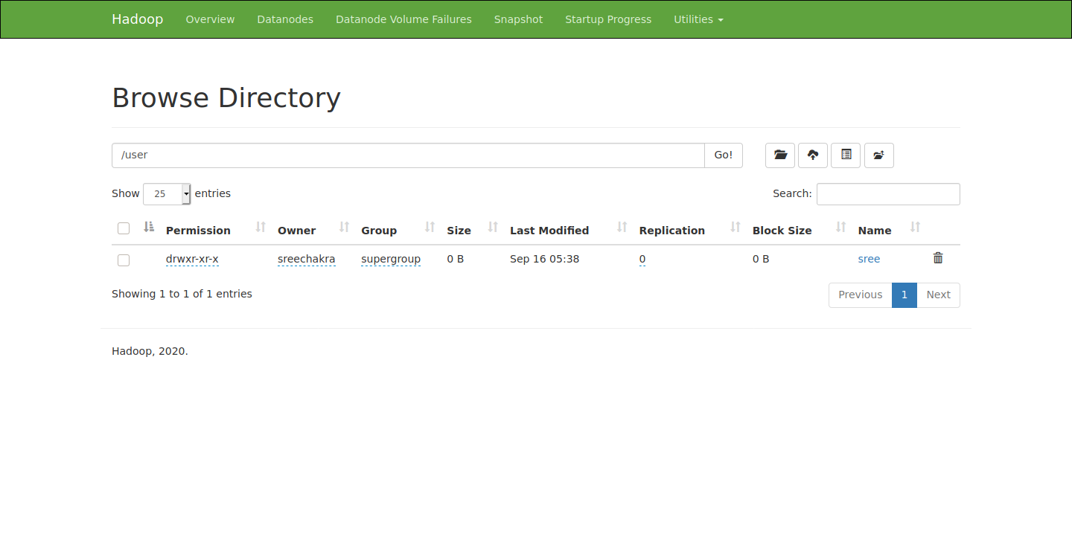

this is the sub directory sree ,which is the username, of user filesystem.

i put the input and output directories in sree for the input files and output files respectively.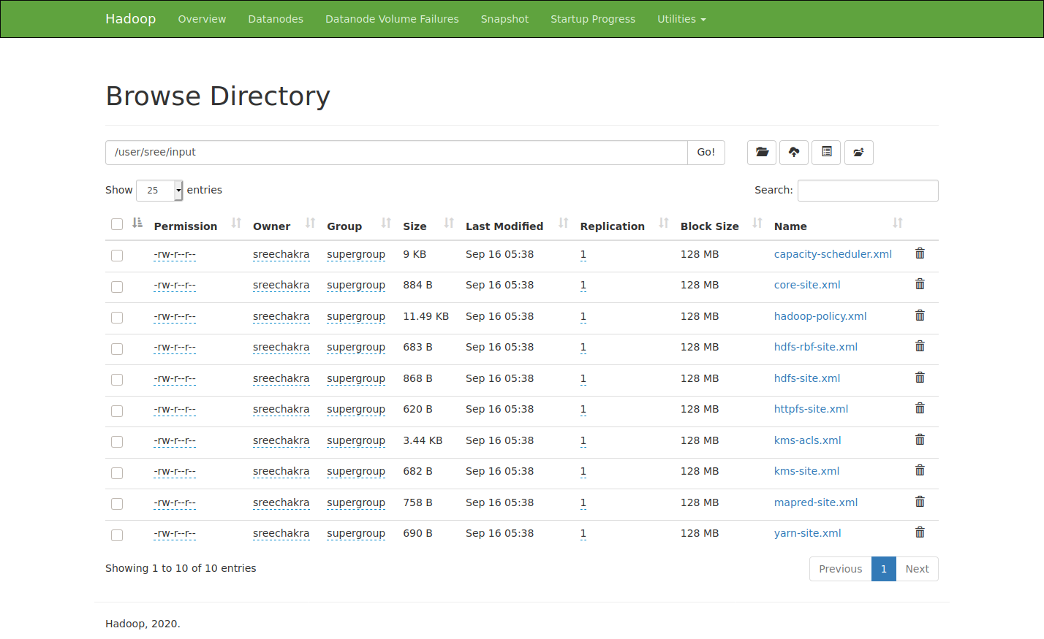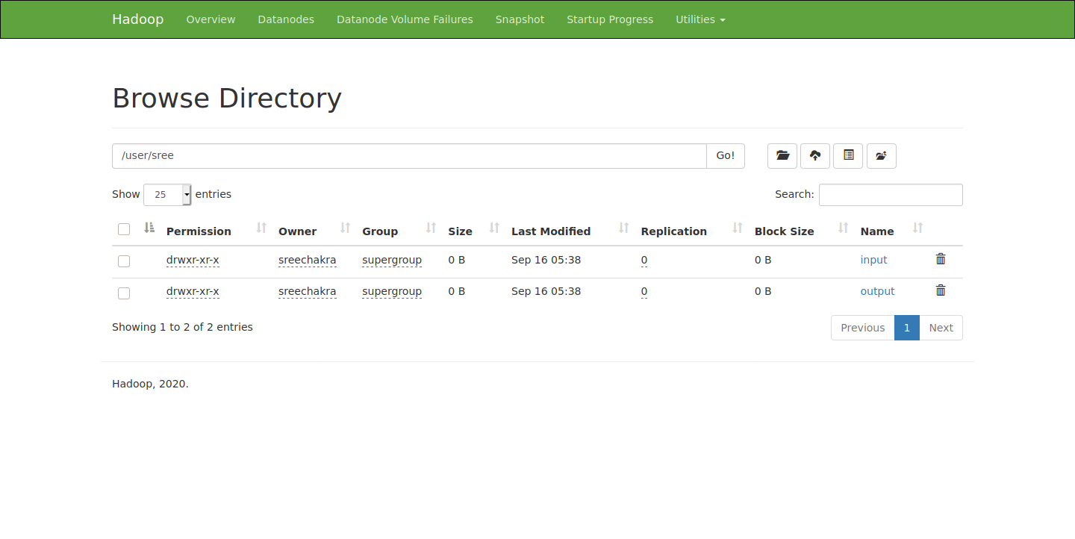

i copied the \*.xml files in etc/haddop to input to use as input for word count example using -put option.

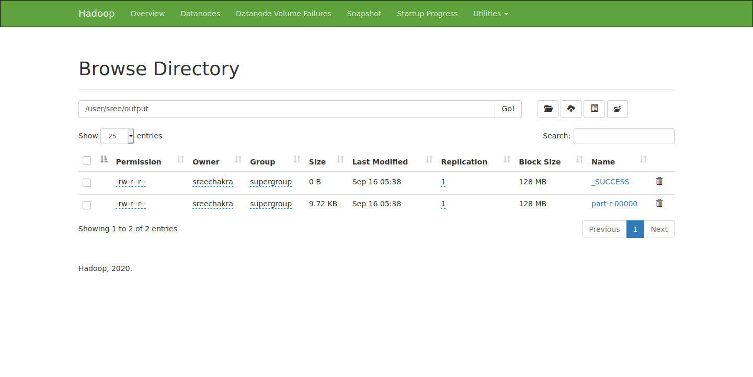

i output the result to the output directory in sree.

part-r-00000 contains the results of the word count operation which can be downloaded and is available as result.txt in this folder.