this is available at localhost:9870 ->utilities ->browse file system

we create a user dir in the distributed file system.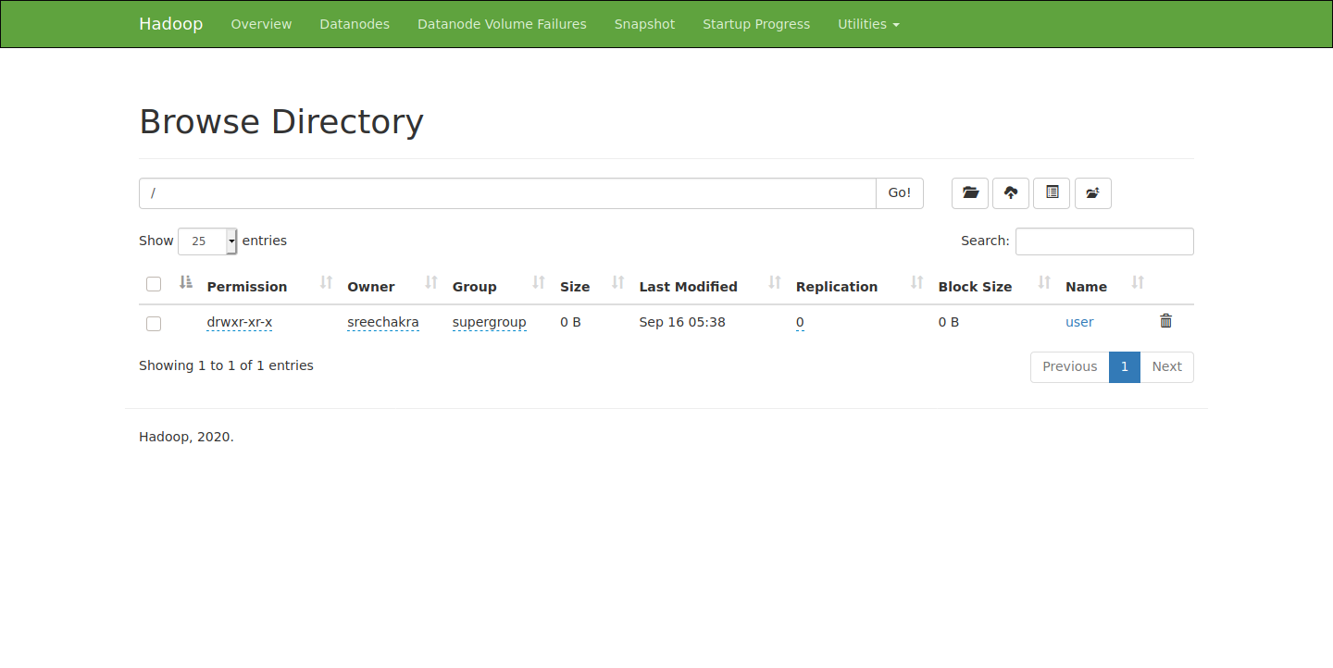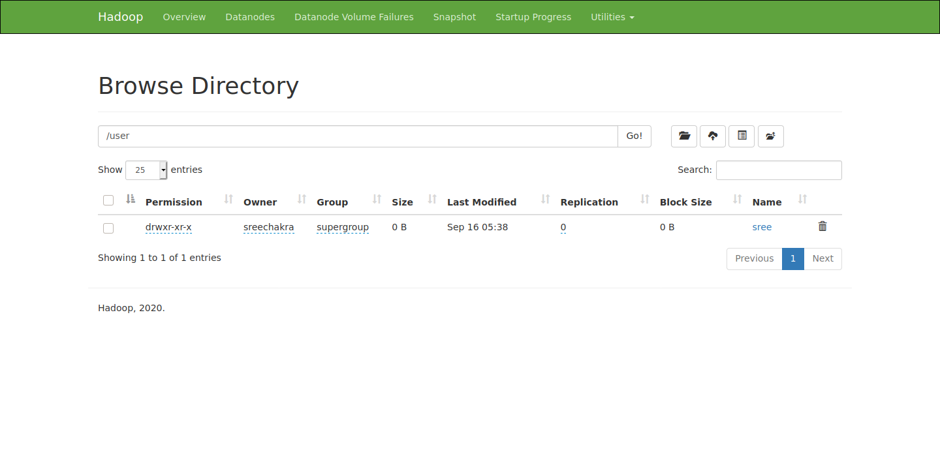

this is the sub directory sree ,which is the username, of user filesystem.

i put the input and output directories in sree for the input files and output files respectively.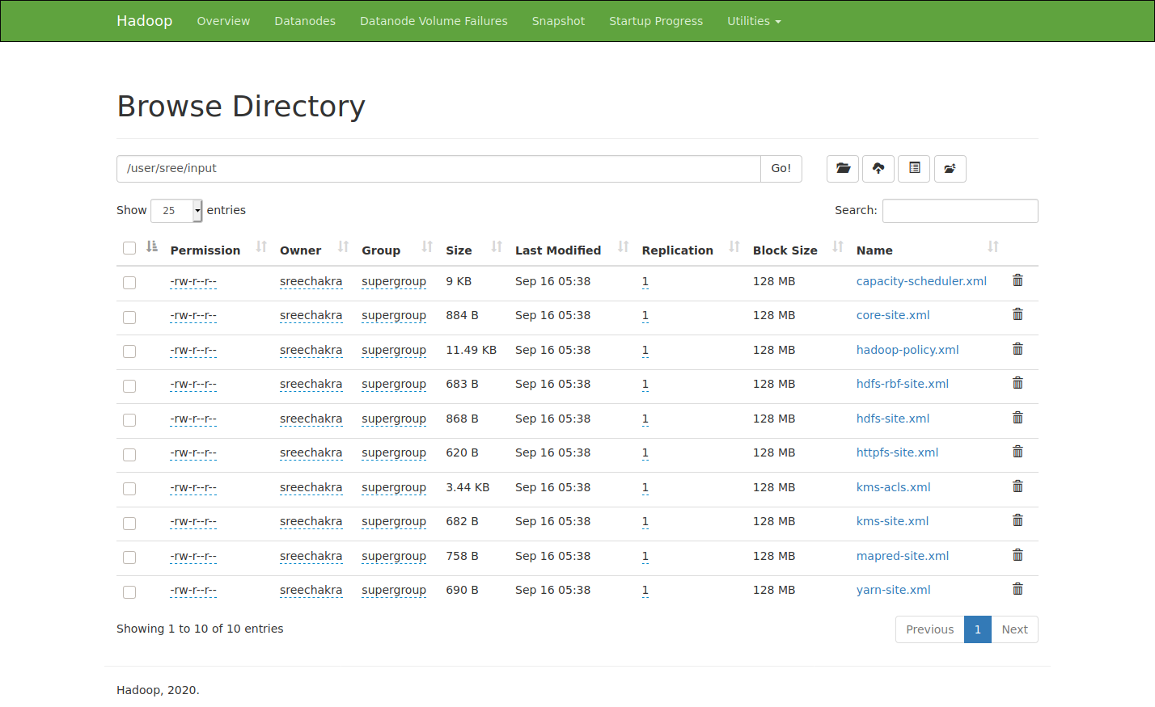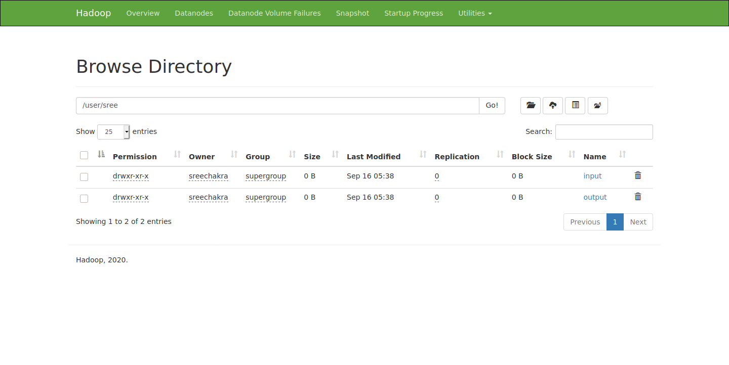

i copied the \*.xml files in etc/haddop to input to use as input for word count example.

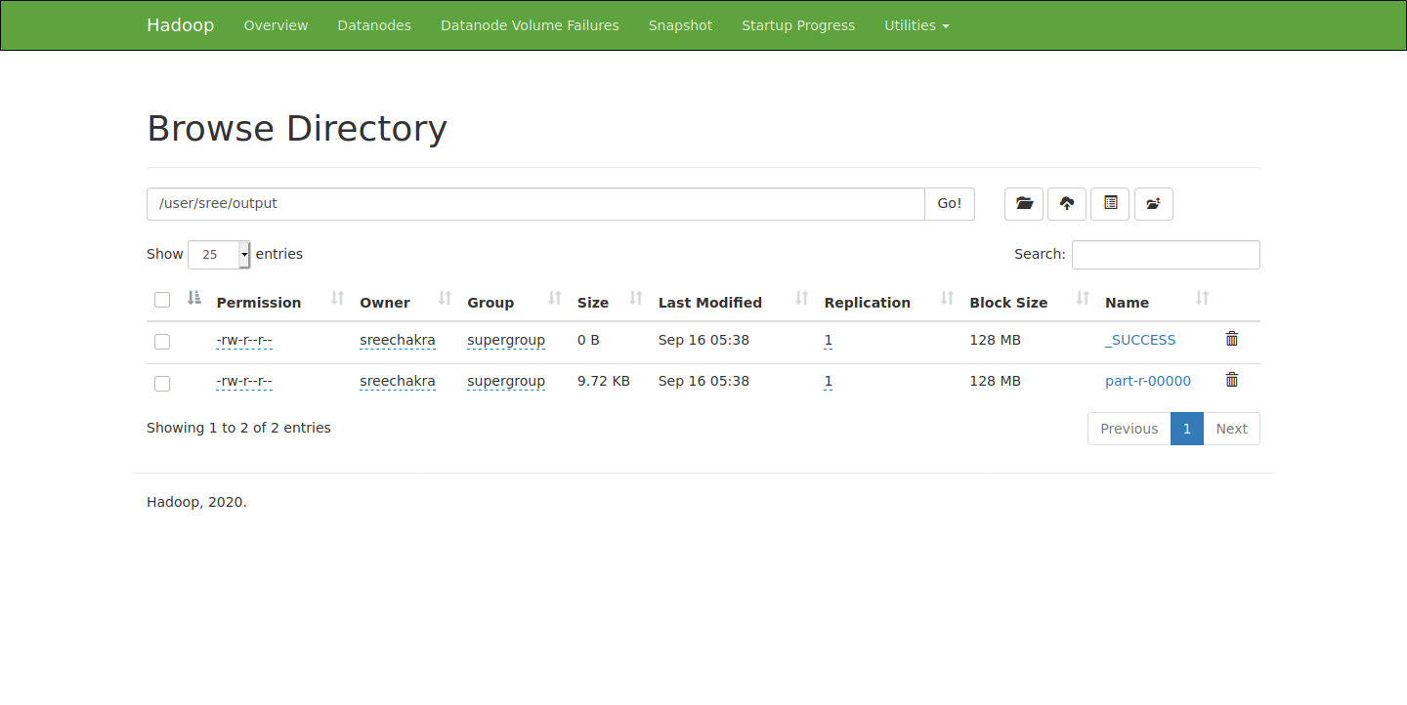

i output the result to the output directory in sree directory.