Battery Health Assessment
and Dynamic Allocation
Siemens Energy · IMECE India 2026
Brain Bolt Engineers Sprint
Prepared 04 August 2026 · github.com/sreecharan-desu/siemens-battery-allocation
battery-allocation v1.2.1

Executive Summary
This document presents a production-grade system for classifying battery health, scoring pack suitability, and allocating batteries to light EV swap requests at a station with 200 packs and 50 concurrent vehicle demands. The proposed Priority-Suitability allocator matches the Highest-SoC-First baseline on vehicles served (36/50) while improving high/critical priority coverage (+3.85 pp), average state-of-health (+9.88%), and suitability scores — with zero unsafe allocations and zero constraint violations.

Platform Overview
- Classifies 200 batteries into Safe, Degraded, or Unsafe/Quarantine (14 quarantined)
- Scores each pack 0–100 on five health parameters (SOH, SOC, resistance, imbalance, temperature)
- Allocates batteries by vehicle priority (Critical → High → Normal) and suitability
- Compares against Highest-SoC-First baseline on every run
- Exports CSV tables, JSON metrics, and five analytical charts
- CLI, REST API, Docker, and CI pipeline with 58 automated tests

Key Results
Metric | Proposed | Baseline | Delta
Vehicles served | 36 | 36 | 0
High/Critical served % | 73.08 | 69.23 | +3.85
Avg SoH allocated | 90.37 | 80.49 | +9.88
Avg suitability score | 84.54 | 76.8 | +7.74
Unsafe allocations | 0 | 0 | 0

Results & Visualizations
The following figures were generated from the competition datasets (200 battery packs, 50 vehicle requests) using battery-allocation run. All charts are reproducible from the submitted code and input CSV files.

1. Battery Classification Distribution
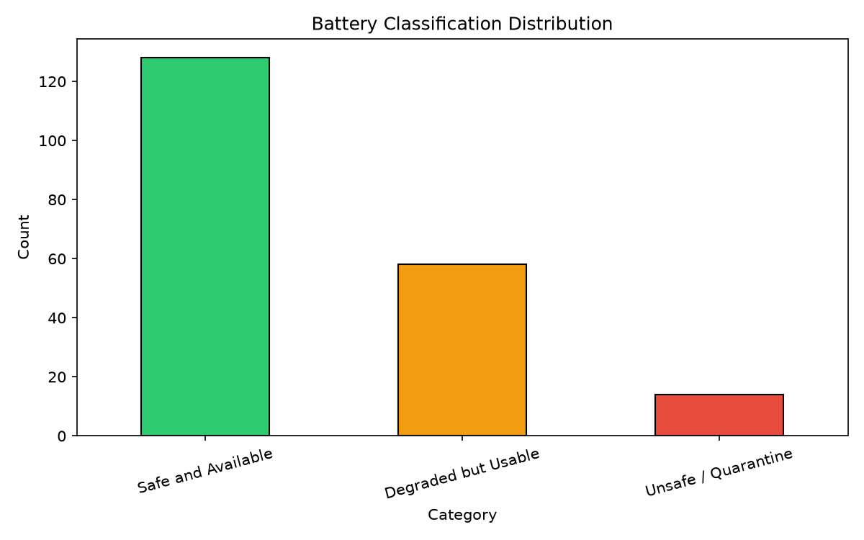
Figure 1: Distribution of 200 battery packs across Safe, Degraded, and Unsafe/Quarantine categories.

Key Observations
- 128 batteries (64%) classified as Safe and Available for allocation
- 58 batteries (29%) classified as Degraded but Usable under constraints
- 14 batteries (7%) flagged Unsafe/Quarantine and excluded from all allocations
- Classification uses configurable thresholds in config/thresholds.yaml
- Station status REVIEW/QUARANTINE triggers immediate unsafe classification

2. Suitability Score Distribution
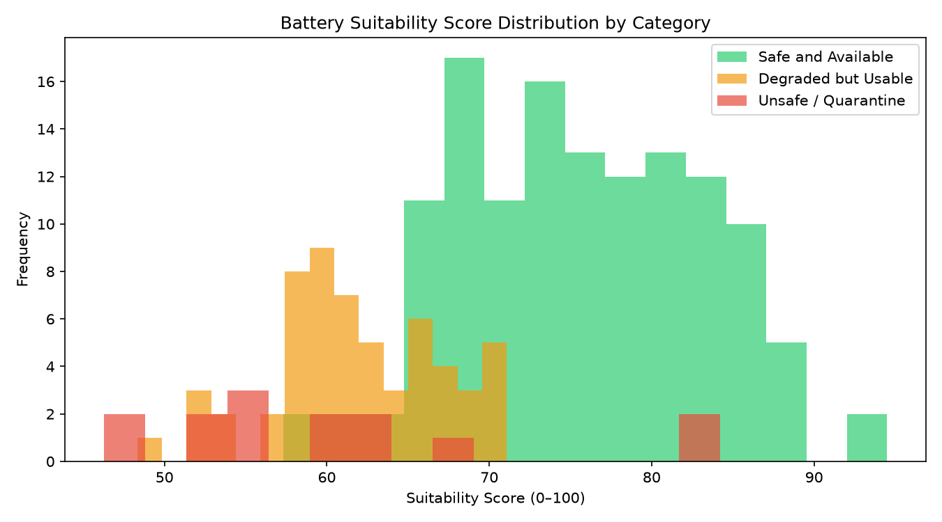
Figure 2: Histogram of suitability scores (0–100) grouped by battery category.

Key Observations
- Safe packs cluster at higher suitability scores (avg ~75.6)
- Degraded packs show wider spread (avg ~61.8) reflecting mixed health signals
- Unsafe/quarantined packs still scored for audit but never allocated
- Score weights: SOH 30%, SOC 25%, resistance 20%, imbalance 15%, temperature 10%

3. Allocation by Priority (Proposed Method)
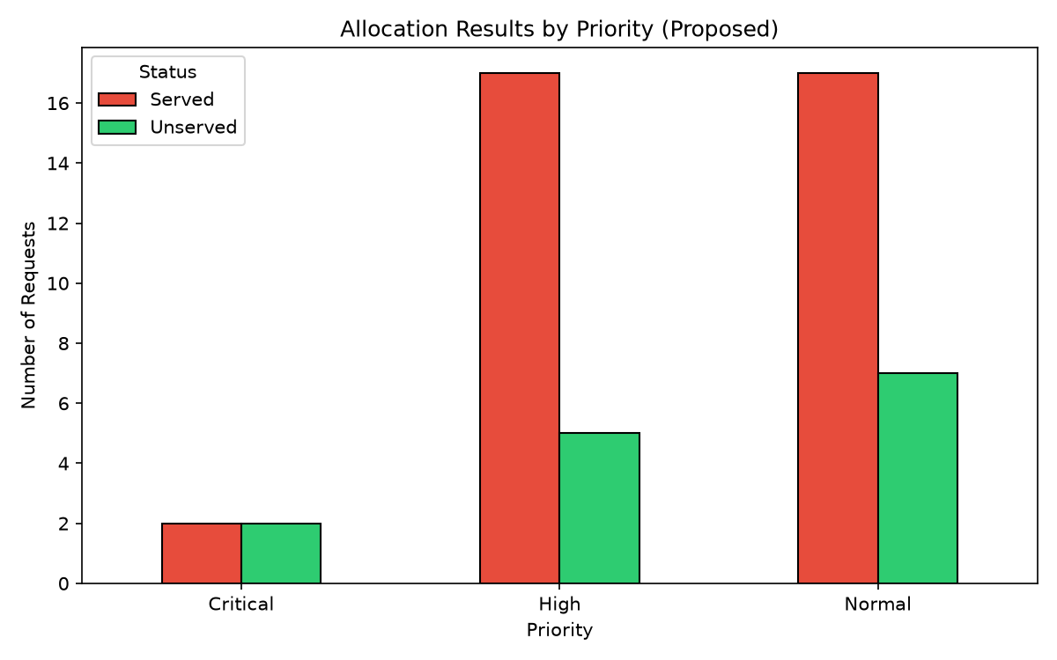
Figure 3: Vehicles served vs unserved broken down by Critical, High, and Normal priority.

Key Observations
- Critical: 2 of 4 served (50.0%) — limited by eligible pack availability
- High: 17 of 22 served (77.3%) — strongest coverage among priority tiers
- Normal: 17 of 24 served (70.8%)
- Priority ordering ensures Critical and High requests are processed first

4. Method Comparison — Proposed vs Baseline
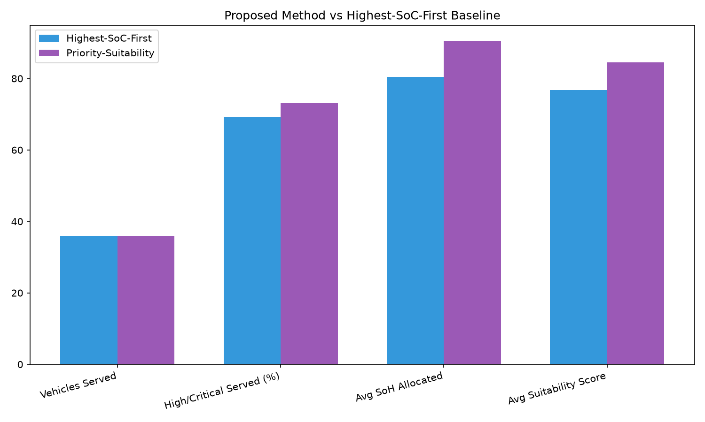
Figure 4: Side-by-side comparison of Priority-Suitability vs Highest-SoC-First metrics.

Key Observations
- Both methods serve 36 of 50 vehicles — same throughput
- Proposed method improves High/Critical served rate by 3.85 percentage points
- Average SoH of allocated packs rises from 80.5% to 90.4% (+9.88 pp)
- Average suitability score rises from 76.8 to 84.5 (+7.74 points)
- All 36 served vehicles receive different battery assignments under proposed method

5. Quarantine Battery Identification
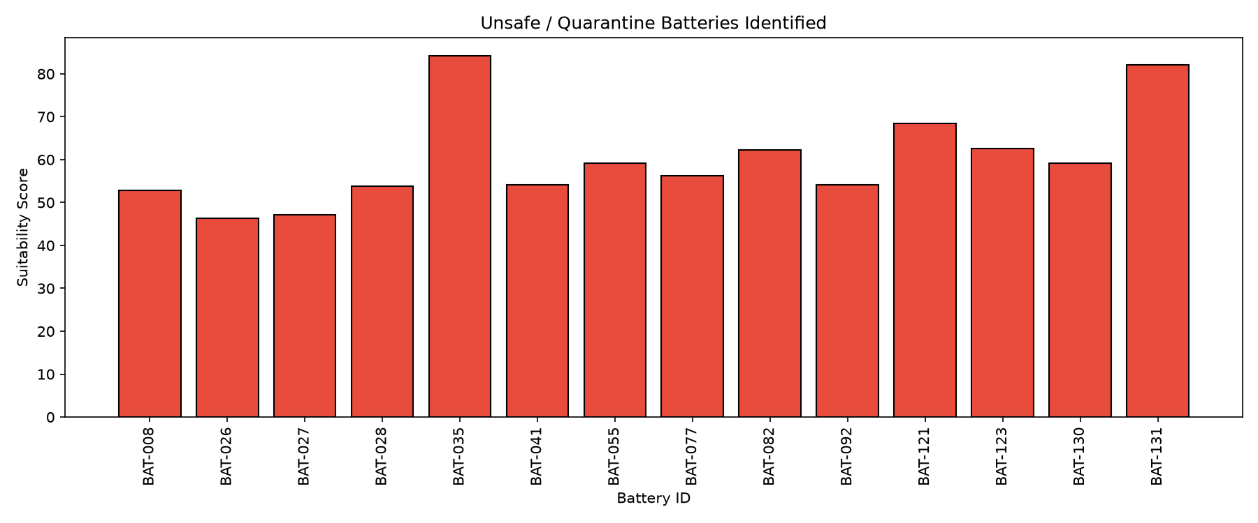
Figure 5: Visualization of 14 unsafe/quarantined batteries excluded from allocation.

Key Observations
- Each quarantined pack identified by battery_id with triggering health parameters
- Full detail exported to outputs/quarantine_report.csv
- Zero unsafe batteries appear in proposed or baseline allocation outputs
- Constraint verifier runs automatically after every pipeline execution

System Capability Matrix
Capabilities delivered in the submission against typical competition and pilot-deployment requirements.
Capability | Status | Notes
Battery health classification (3 categories) | Yes | Delivered
Suitability scoring 0–100 | Yes | Delivered
Priority-aware allocation | Yes | Delivered
Highest-SoC-First baseline comparison | Yes | Delivered
Constraint verification (no unsafe, no duplicates, SOC min) | Yes | Delivered
CSV + Excel data ingestion | Yes | Delivered
Dynamic file discovery (no hardcoded paths) | Yes | Delivered
Interactive CLI | Yes | Delivered
REST API (FastAPI) | Yes | Delivered
Docker container | Yes | Delivered
CI pipeline (lint, type-check, tests) | Yes | Delivered
Onsite twist handler | Yes | Delivered
Configurable thresholds (YAML) | Yes | Delivered
Automated visualizations (5 charts) | Yes | Delivered
Cross-platform setup (macOS/Linux/Windows) | Yes | Delivered

Method Summary

Classification Rules
- Unsafe/Quarantine: station REVIEW/QUARANTINE, or SOH/temp/resistance/imbalance beyond unsafe thresholds
- Degraded but Usable: not unsafe, but exceeds degraded thresholds on SOH, resistance, imbalance, or cycles
- Safe and Available: all parameters within safe limits

Proposed Allocation (Priority-Suitability)
- Sort requests by priority (Critical → High → Normal), then arrival time
- For each request, filter eligible batteries: not unsafe, SOC ≥ minimum, energy ≥ trip requirement
- Score candidates: suitability + energy margin + category bonus + SOC balance
- Assign highest-scoring unused battery

Architecture
Layered Python package: CLI and REST API → Pipeline Runner → Classification / Scoring / Allocation / Twist Handler → Data Loader → YAML config. Deployment modes: batch CLI, API server, Docker container.

Quality Gates
- 58 automated tests, ≥80% code coverage
- Ruff lint and Mypy strict mode in CI
- Pipeline smoke test on Python 3.11 and 3.12
- All constraint checks pass on competition datasets

Recommendations

Competition Presentation
- Lead with safety: 0 unsafe allocations, 14 batteries correctly quarantined
- Highlight method comparison chart — same serve count, better health outcomes
- Demonstrate live CLI: battery-allocation run --sample
- Show twist handler for onsite scenario adaptation

Pilot Deployment
- Deploy API via Docker at station edge; integrate with BMS telemetry feed
- Tune thresholds.yaml on local fleet data before production cutover
- Use upload workflow for operator-submitted CSV/Excel exports from station systems
- Enable JSON logging for centralized monitoring

Future Enhancements
- Real-time streaming allocation as requests arrive (event-driven API)
- ML-based SOH prediction layered on rule-based safety guardrails
- Operator dashboard for quarantine review and manual override audit trail
- Multi-station fleet balancing across swap network

— End of Document —
Internal / competition submission reference. Proprietary — Siemens Energy / IMECE India 2026.

