ITA - Build II  
NITK chat bot

short line

M.Sri Charan Reddy(16CO228)

M. kunal(16CO227)

M.Chakradhar(16CO226)

November 12, 2018

# 1. Basic Information

<Write brief information about change in functional requirements OR introduction of new functional requirements, and Non-functional requirements >

In the previous build we have implemented the following functioning requirements

1. **Academic calendar**:

Student can ask for the academic calendar for a particular year and semester the Bot directs the student to the calendar.

1. **Warden Info**

Student can ask for warden info based on the block number .Bot replies back with the name and contact number of warden.

In this build II we have implemented the following functional requirements

1. **Faculty search**

Student can ask for details of staff in the NITK based on the post of the professor and department.

1. **Library check**
   1. **based on book**

Student can ask for the location of book based on the contents in the book or by the book name itself . Bot replies back with whether the book is available and if it is available then it replies back with the floor number and shelf number of the book and the author of the book.

* 1. **Based on Author**

Student can also ask the bot for the location of the book based on the author of the book.

1. **Timings of places in NITK**

Student can ask for the opening and closing time of the places in NITK by asking the bot to tell the timings of the particular place.

1. **NITK canteen**
   1. **check the menu**

Student can ask the bot for the menu of the NITK canteen, then the bot directs him to the menu page where user can see the menu.

* 1. **Order for food in menu**

Student can see the items on the menu and order for them Bot replies back with order amount and the order id.

* 1. **check the order**

Student can also enquire about the order he gave by his order id,Bot replies back with the items and the Bill amount.

1. **CGPA calculator**

Student can ask for bot for calculating his cgpa bot ask the student to enter his details like course and grades then the bot replies back with his cgpa.

1. **Hospital Management** 
   1. **Medicine availability**

Student can ask the bot for availability of medicine by specifying its name then the bot replies back with the answer whether the medicine is available or not.

* 1. **Details of Medicine**

Student can ask bot for the details of the medicine then the bot replies back with the answer specifying how many times he should eat it per day and how much it costs.

* 1. **Medicine based on symptom**

Student can ask bot for the medicine by telling his symptom then the bot replies back with the medicine he need to take.

* 1. **Doctors List**

Student can ask for a list of doctors in location by specifying the location and specialty of the doctor.

6.5 **Patient Register**

Student can register for the Hospital so that he can book an appointment in the hospital.

6.6 **Book an Appointment**

Student can book an appointment in the hospital by specifying what specilasist doctor he want, his details , date,time, place, cause for appointment.Bot books an appointment by taking his details.

# 2. Pending ,New,Implemented Functional Requirements

|  |  |  |  |  |
| --- | --- | --- | --- | --- |
| Intent | Type | Sample Utterances | Entities | Actions |
| Academic_calendar | Completed | Show academic calendar for 2018 odd sem  2015 even sem | {Semester}  {academic_calendar-year} | Look the Academic_calendar and direct to a web page containing the academic calendar of that year and sem the user wanted. |
| Faculty.search | pending | I want all the professors with PhD qualification in CS dept. | {Professors}  {Department} | Look up the Faculty and display the names of all professors with qualification phd and department CSE. |
| HostelWardens_Info | Completed | can you tell me phone number of warden of Mega tower 1 | {Block} | Look up the warden relation and display the phone number of the warden of block mega tower 1 |
| Campus.Timings | Pending | What are the timings of Health Care centre | {place} | Look up the Campus_timings relation and display the block timings of the Block name Health care center. |
| menu.search | Pending | Can you tell the items available in 7th NC | {NC_name} | Look up the food relation and direct to web page containing menu of 7th Block |
| Food.Order | Pending | I want one Biryani from 7Th NC | {NC_name}  {Item}  {Quantity} | Place order in the NC_Order relation with Quantity 1,Item Biryani, NC_name 7Th block |
| Food.check | pendiing | Can you tell me the order details of orderid 21 | {orderid} | Look up the order and items table and display the items and biil amount for that order |
| Library.search | Pending | Where are the Ansi C books available in the library | {Book} | Look up the Library relation and display the shelf, floor and availability of the book Ansi C |
| CGPA calcultor | pending | Calcule my cgpa | {cgpa} | Bot ask the student no of coursesa and thepointers in them and shows the cgpa to the student |
| Doctors.list | Pending | List out the dentists present in the Mangalore | {Specialist}  {place} | Look up the Doctors relation and display the .dentists present in the mangalore |
| Medicine.availability | New | Is the paracetomol available | {medicine name} | Look up the medicine relation and display the availabilty for the medicine name paracetomol |
| Medicine.info | New | Details of dolo | {medicine name} | Look up the relation table display the description and cost of the medicine Dolo |
| symptoms | New | I have fever | {symptom} | Look up the symptom relation search for medicine for the symptom by the foreignkey in it |
| Hospital.location | New | List out doctors in mangalore  of speciality dentist | {location}  {speciality} | Look up the doctor and availability relations and find the name and availability time of the doctor |
| Patient Register | New | Add a new patient | {patient} | Bot asks to insert name age sex of patient then the user is inserted into the list of patients |
| Appointment.doctor | New | Book an appointment | {appointment} | Bot asks the patient  To enter the various details of him and takes an appointment |

# 4. Screenshots of Functional Requirements Implemented in this Build

## 4.1. Search for calendar

Student can ask for the academic calendar for a particular year and semester the Bot directs the student to the calendar in new page shown below.

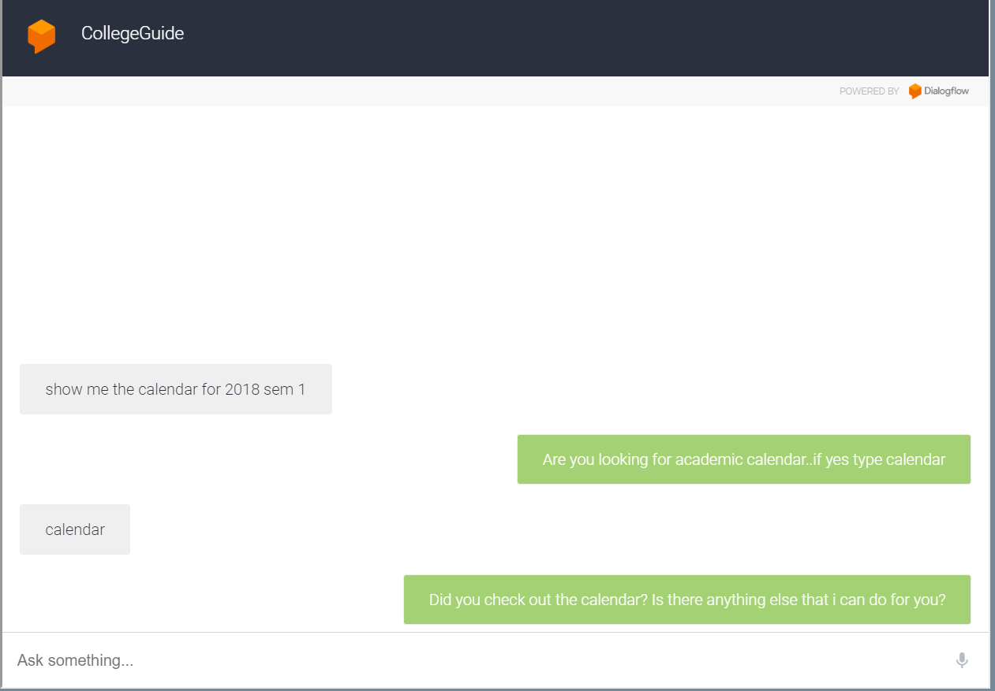

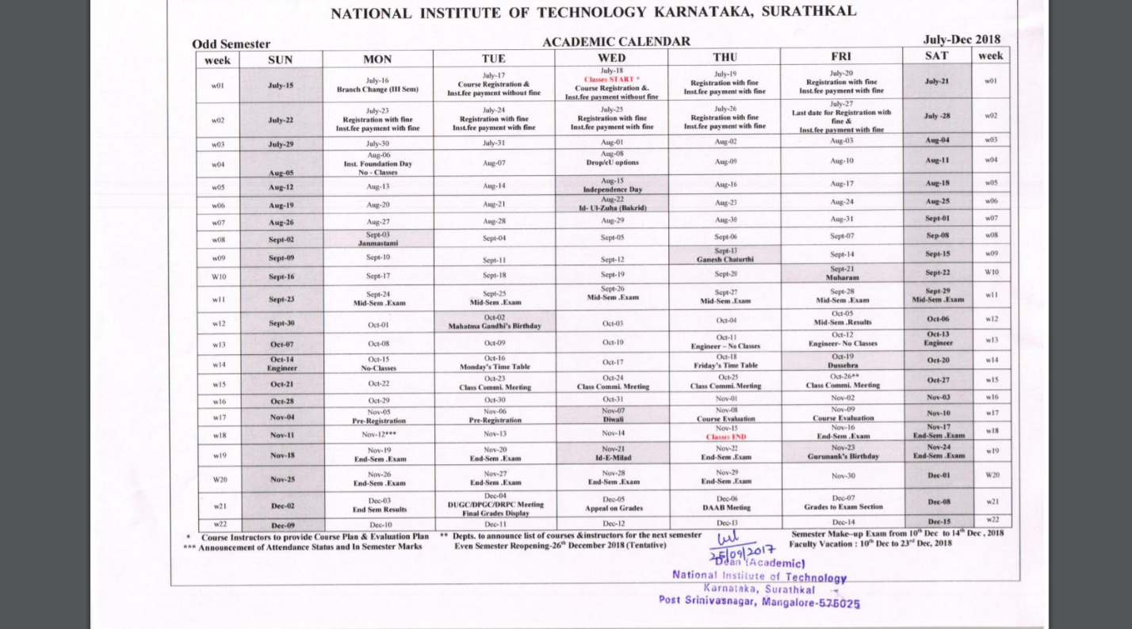

## 4.2. Ask for Warden

Student can ask for warden info based on the block number .Bot replies back with the name and contact number of warden 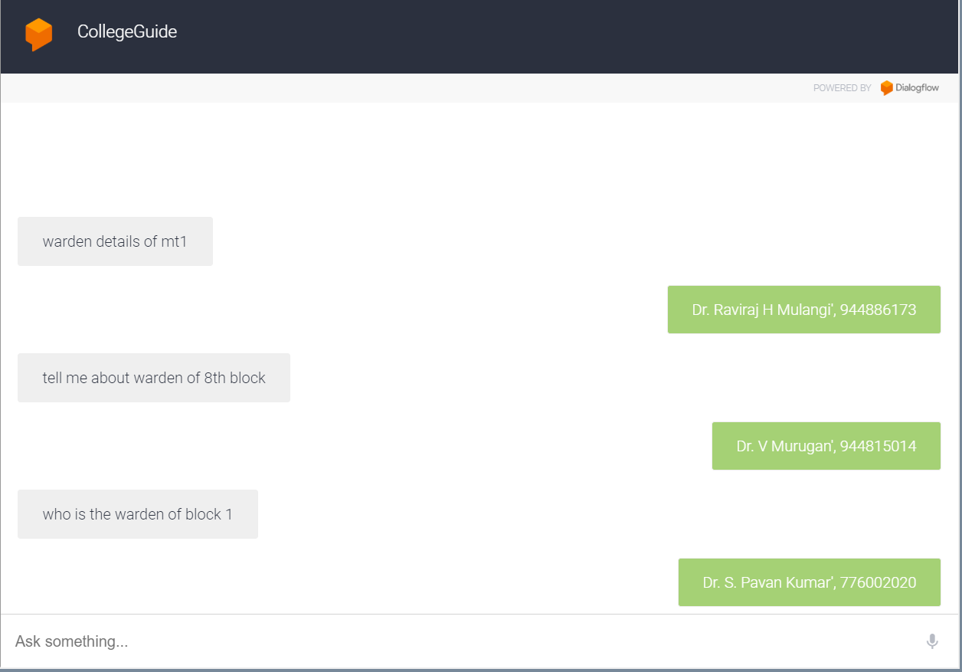

## 4.3. Faculty of all departments in NITK

Student can ask for details of staff in the NITK based on the post of the professor and department.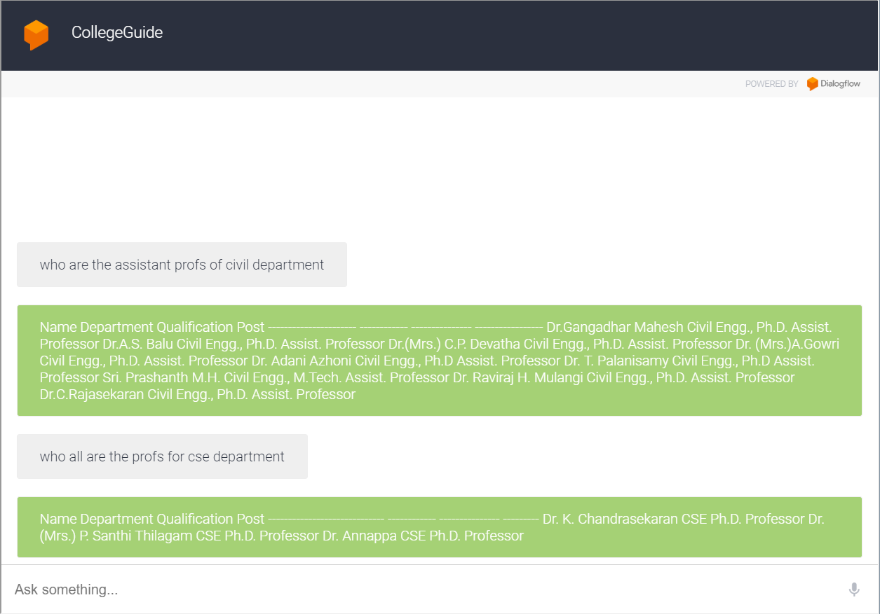

## 4.4. Library Book search

Student can ask for the location of book based on the contents in the book or by the book name itself . Bot replies back with whether the book is available and if it is available then it replies back with the floor number and shelf number of the book and the author of the book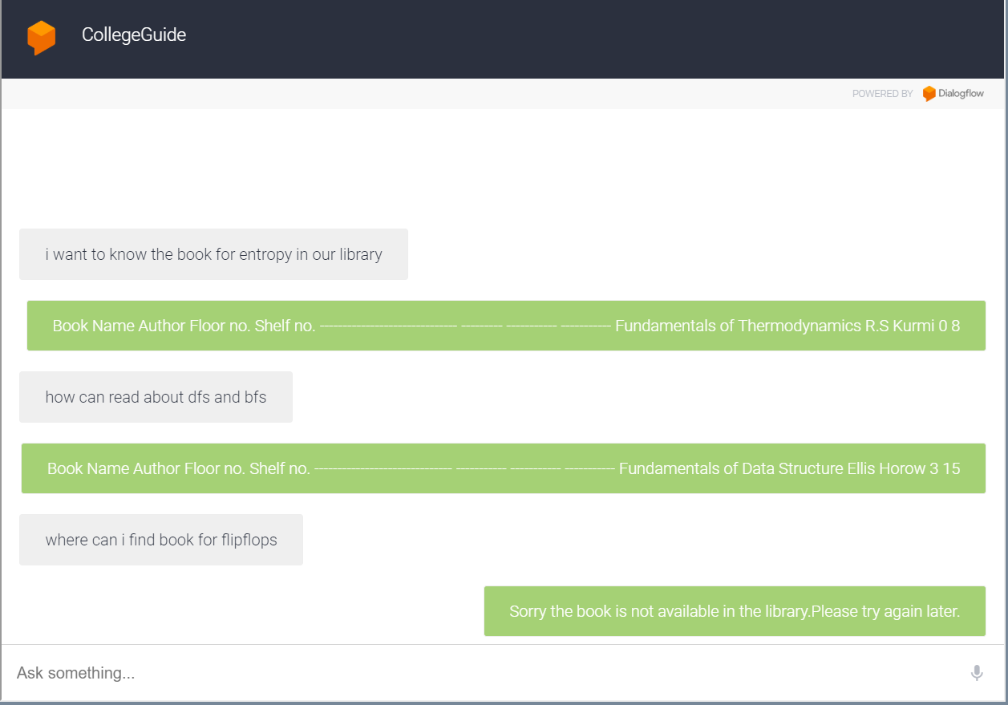

## 4.5. Library Author search

Student can also ask the bot for the location of the book based on the author of the book.

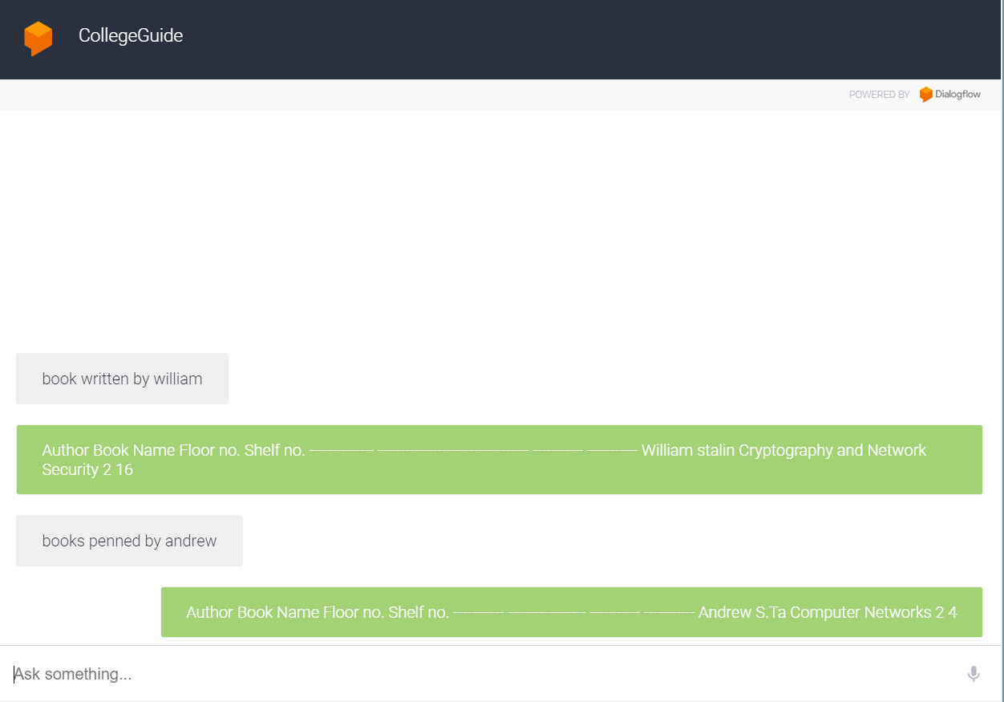

## 4.6. Timings in NITK

Student can ask for the opening and closing time of the places in NITK by asking the bot to tell the timings of the particular place.

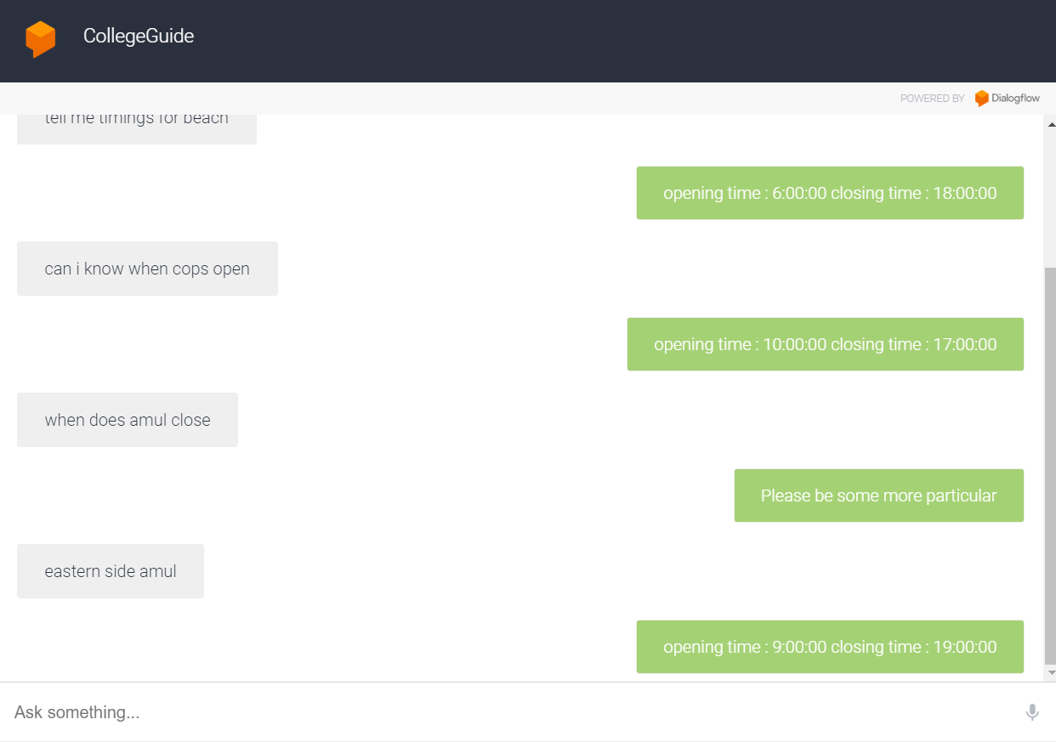

## 4.7 Menu for canteen

Student can ask the bot for the menu of the NITK canteen, then the bot directs him to the menu page where user can see the menu.

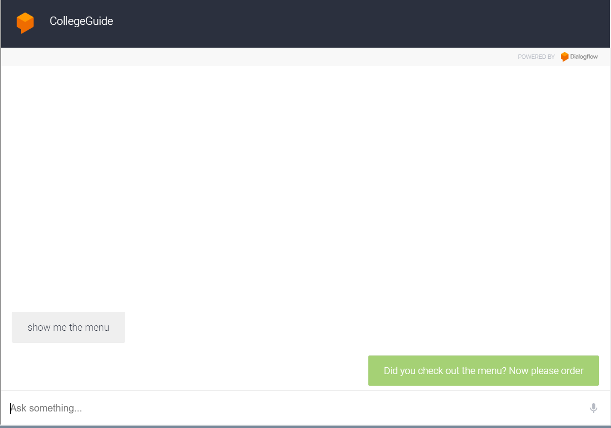

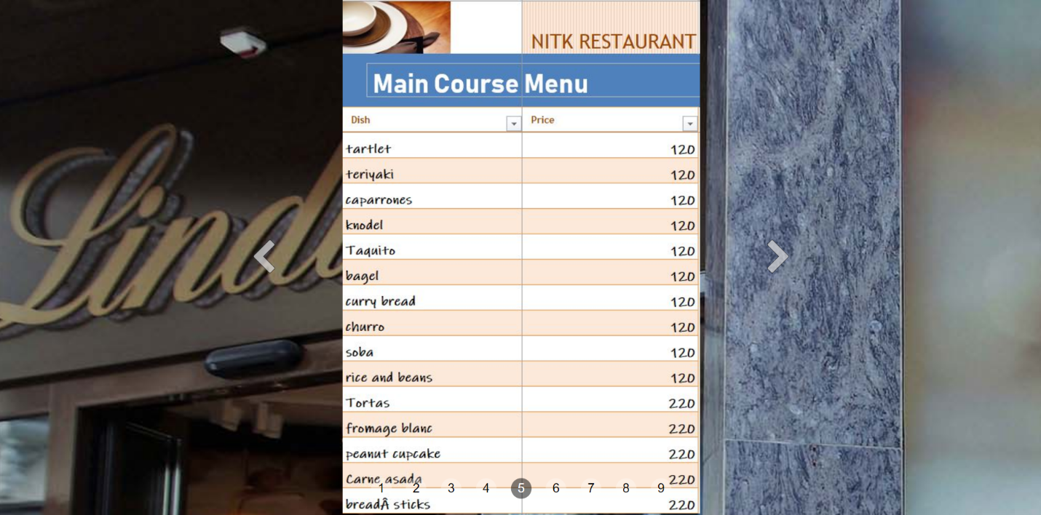

## 4.8 Order item from Menu

Student can see the items on the menu and order for them Bot replies back with order amount and the order id.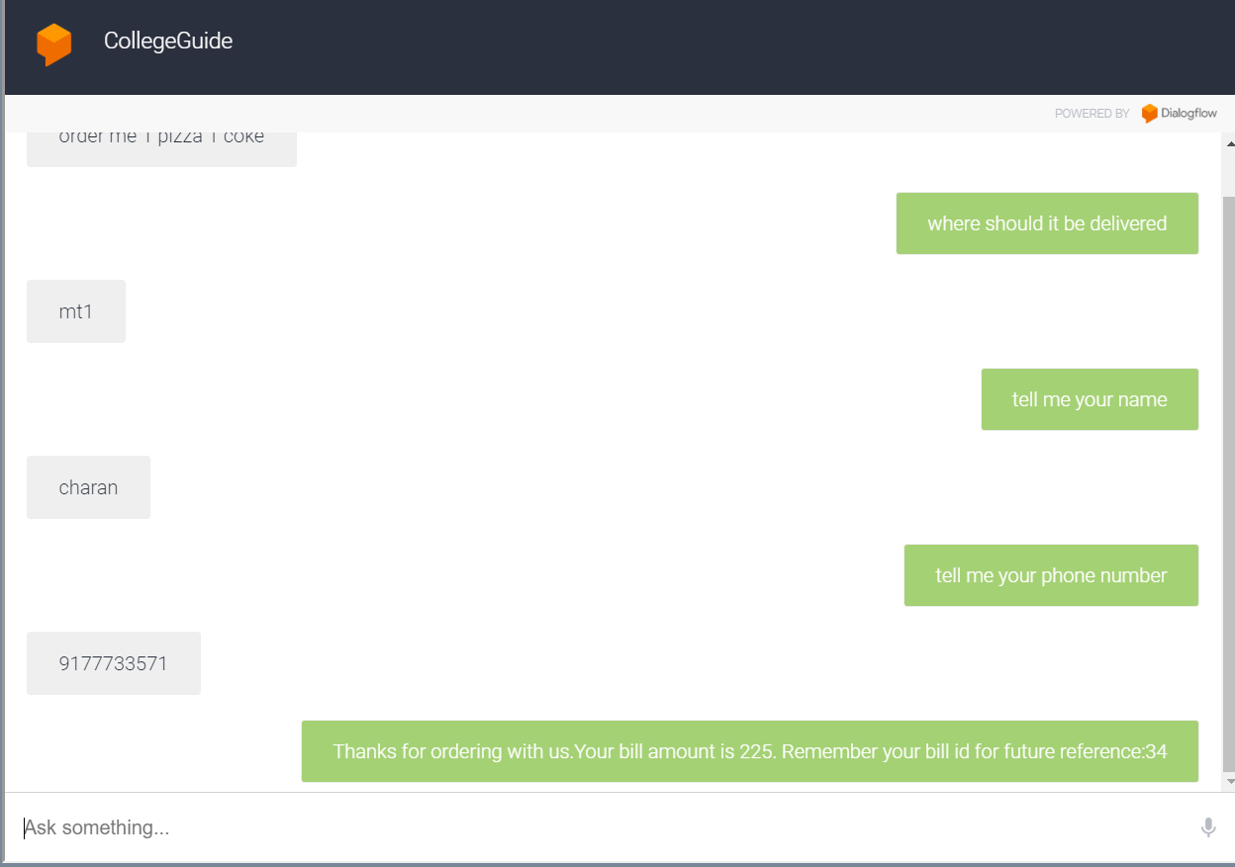

## 4.8 Check Order

Student can also enquire about the order he gave by his order id,Bot replies back with the items and the Bill amount.

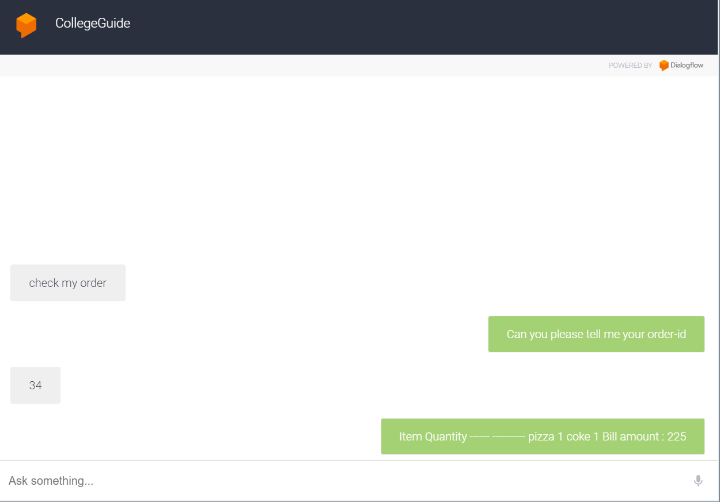

## 4.9 CGPA calculator

Student can ask for bot for calculating his cgpa bot ask the student to enter his details like course and grades then the bot replies back with his cgpa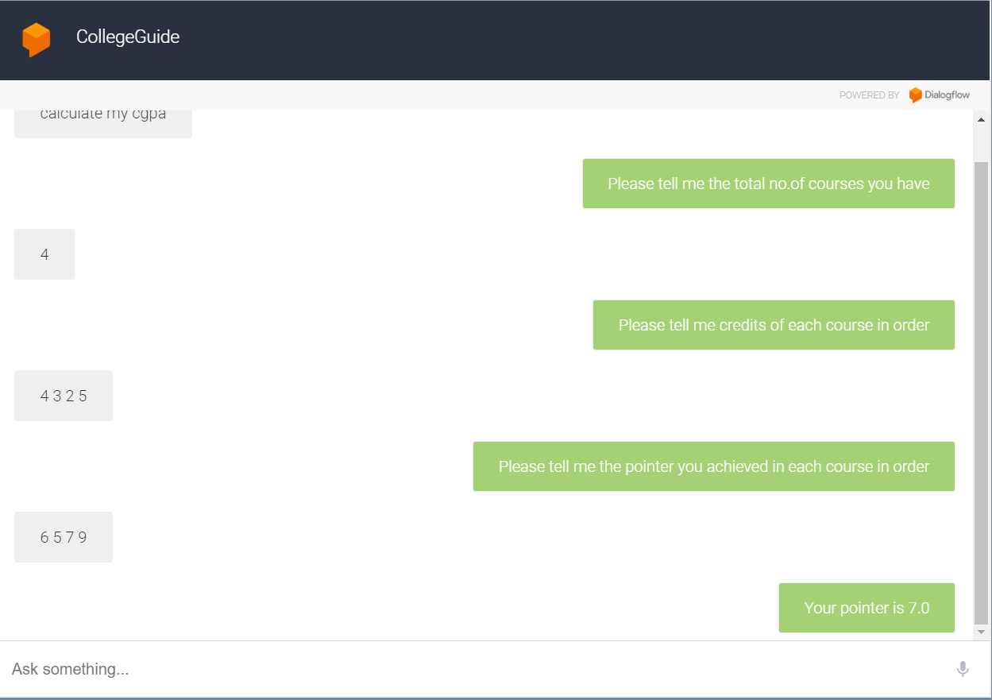

## 4.10 check for medicine availability

Student can ask the bot for availability of medicine by specifying its name then the bot replies back with the answer whether the medicine is available or not.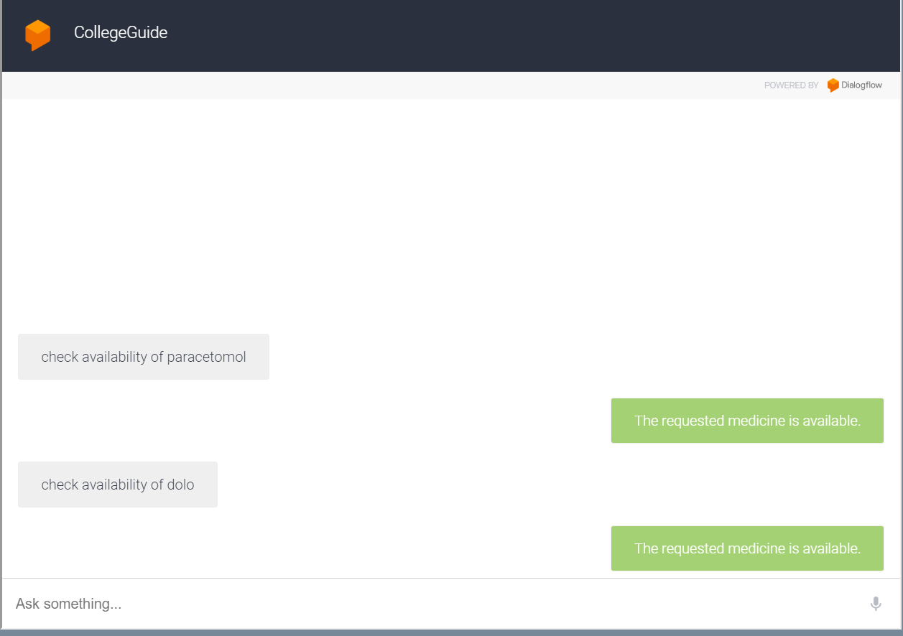

## 4.10 check the details of the medicine

Student can ask bot for the details of the medicine then the bot replies back with the answer specifying how many times he should eat it per day and how much it costs.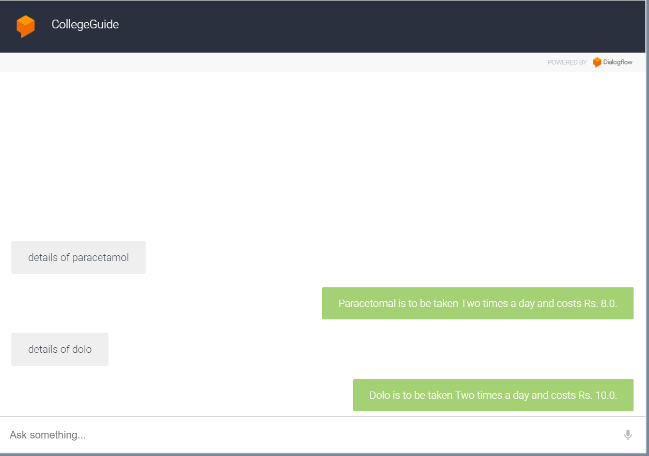

## 4.11 Medicine for your symptom

Student can ask bot for the medicine by telling his symptom then the bot replies back with the medicine he need to take.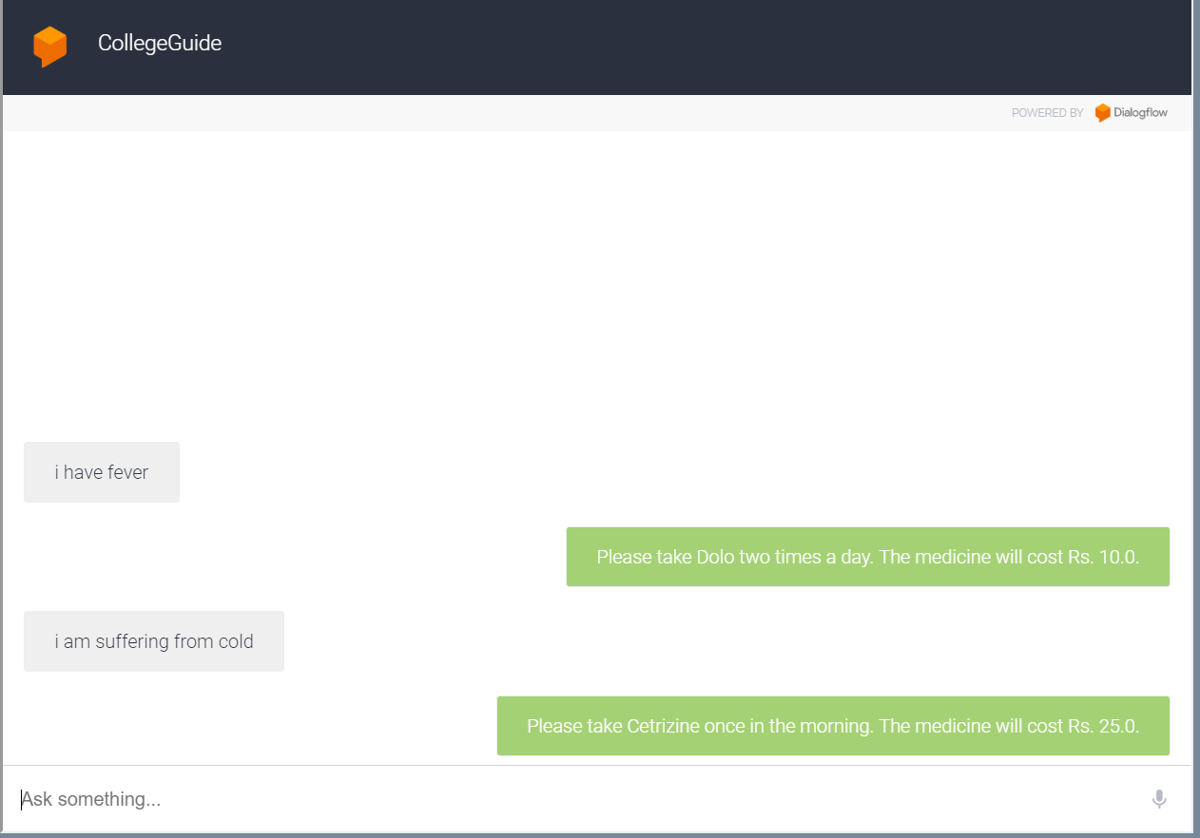

## 4.11 Location of hospital

Student can ask for a list of doctors in location by specifying the location and specialty of the doctor.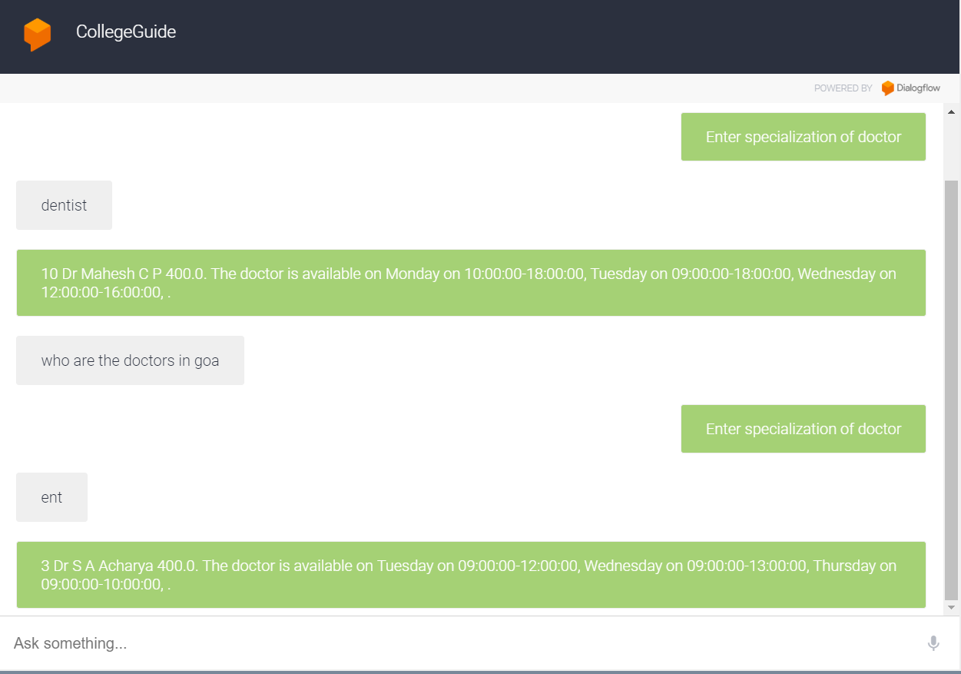

## 4.12 patient register

Student can register for the Hospital so that he can book an appointment in the hospital.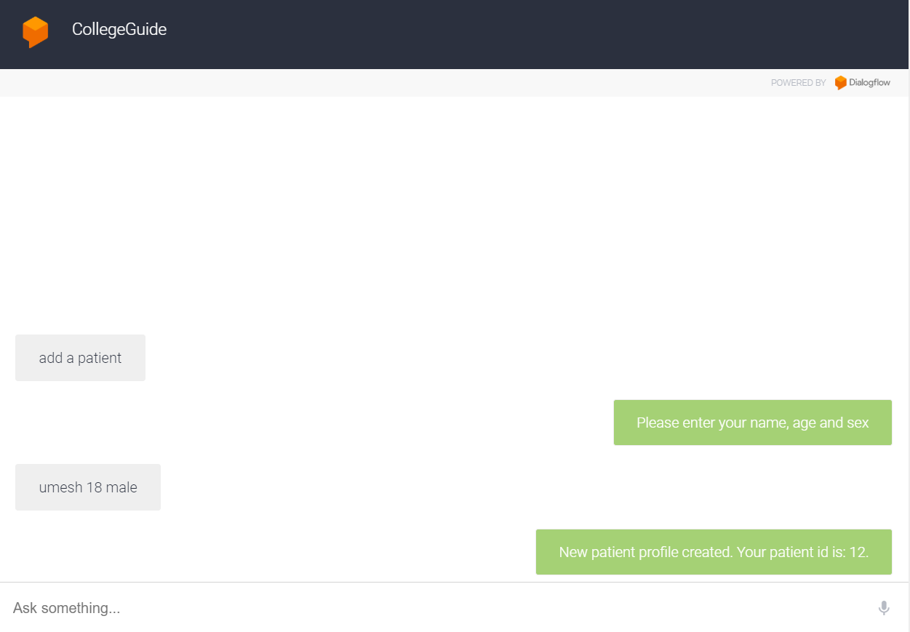

## 4.13 Appointment for a doctor

Student can book an appointment in the hospital by specifying what specialist doctor he want, his details , date, time, place, cause for appointment.Bot books an appointment by taking his details.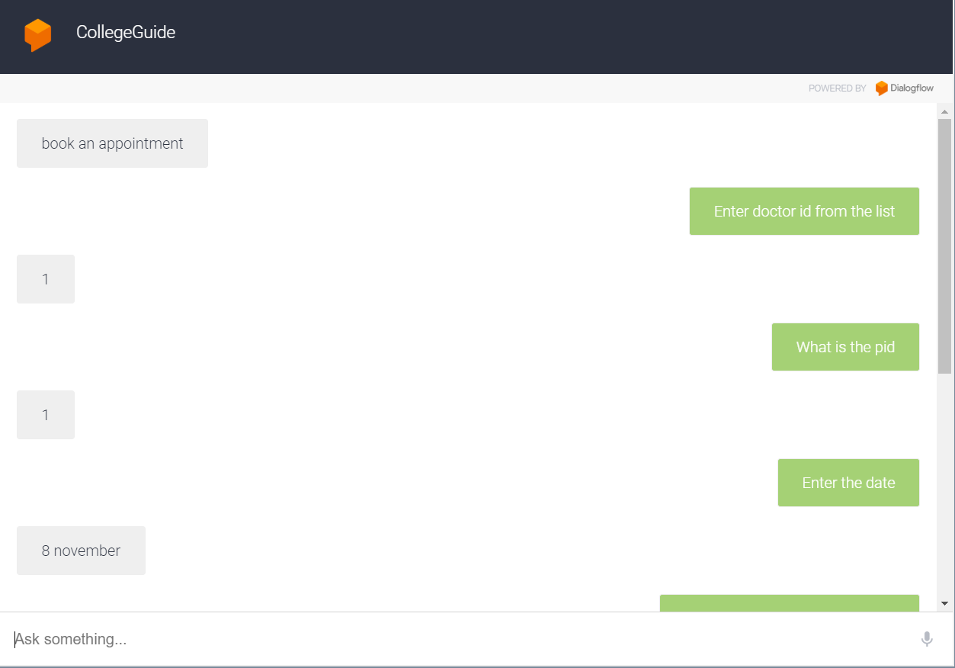

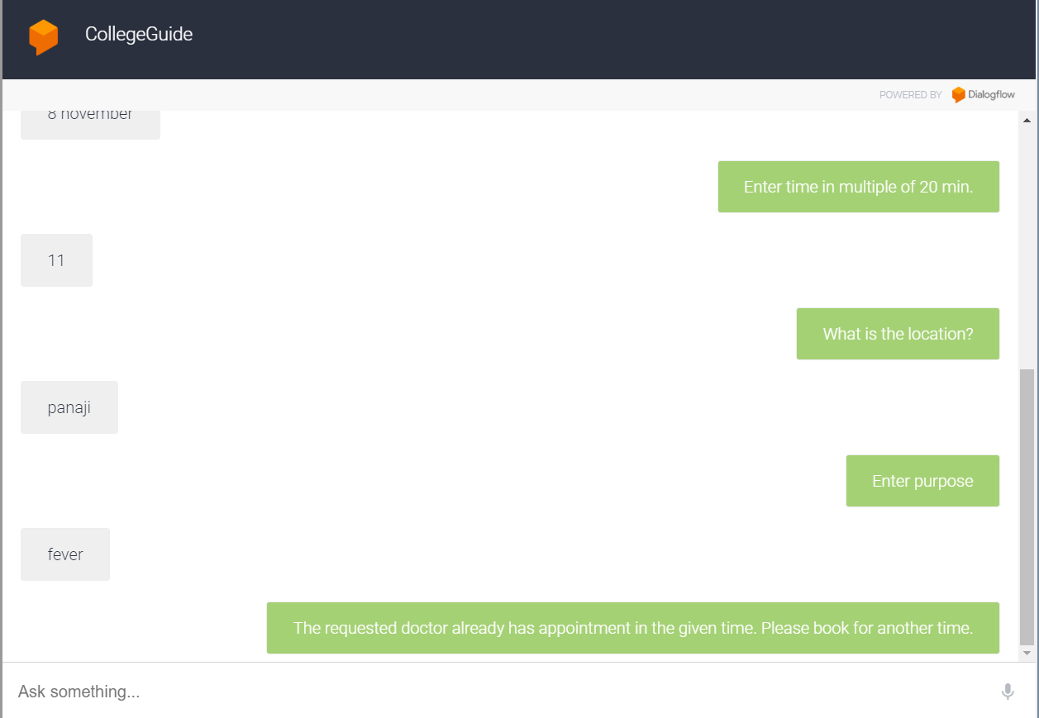

# 5. Non-functional Requirements Considered

# Nonfunctional Requirements

## 5.1 API

Modularity- The system will be designed in such a way that the algorithms for the different will be separate and can be easily modified.

Security- The connection between the Web API and the programs will use HTTPS, for security.

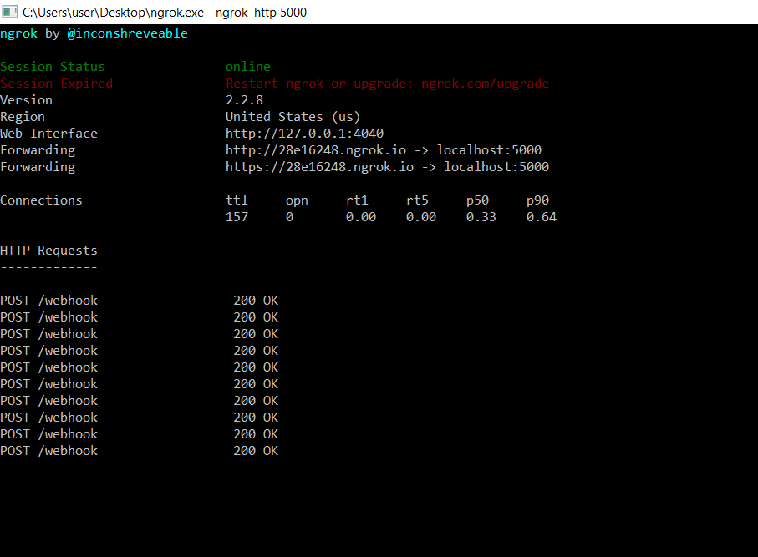

## 5.2 Web Application

Ease of Use-A new user is likely to make mistakes after 5 minutes of use as the application is easy to understand and use.

# 7. Summary of Test Plan

* Write information about functional/non-functional requirements to be tested AND not to be tested
* Write information about type of testing to be performed
* Write information about automated testing tools (if you are planning to use)
* Write any other information related to your testing phase and outcome of testing

# 8. Summary

short dash

This report is a build 2 for our project which has implementations of new and pending fuctional requirements. The implementation screenshots are also put up above. The main objectives of the project were to develop an algorithm that will be used to identify answers related to user submitted questions. To develop a database were all the related data will be stored and to develop a web interface. The web interface is for students in the particular college. A background research took place, which included an overview of the conversation procedure and any relevant chat bots available. A database was developed, which stores information about questions, answers, keywords, logs and feedback messages. A usable system was designed, developed and deployed to the web server.