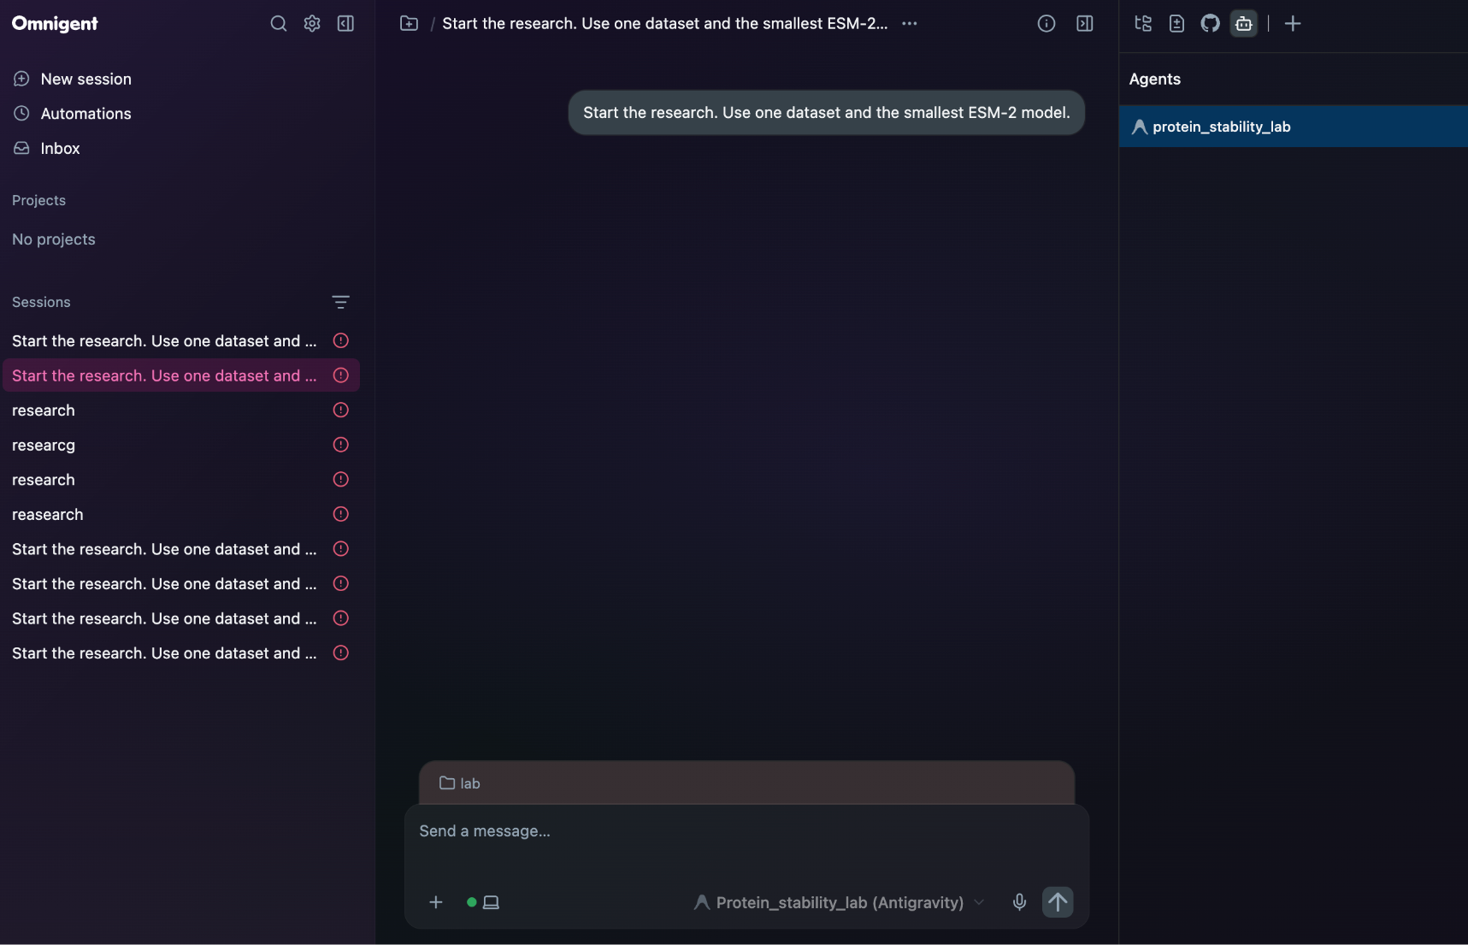
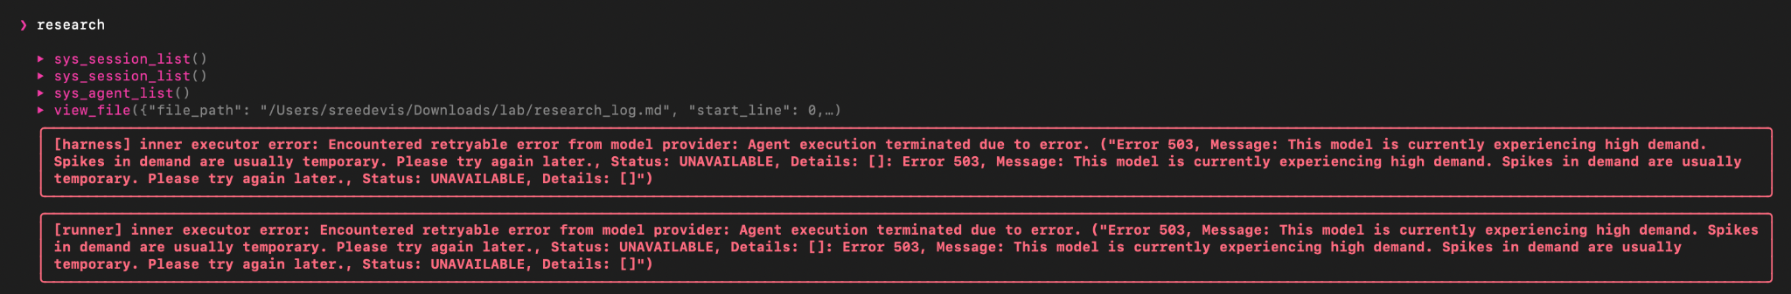

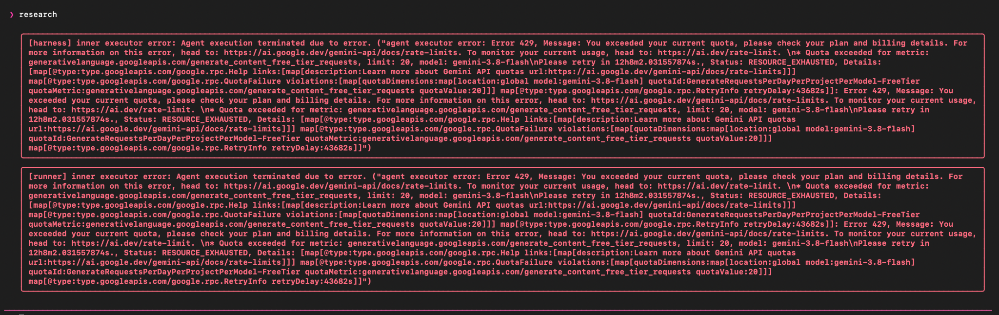
We built and launched a five-agent scientific lab on Omnigent to test how well a compact, zero-shot ESM-2 model predicts mutation stability effects (ΔΔG). The workflow loaded and the agents began running. A complete experiment was not finished in the hackathon window, because the Gemini API key we used reached its free-tier daily quota. No Spearman correlation was computed in this run, so we report no accuracy or speed-up figures.
What we demonstrated
- The Omnigent director and five specialist agents (literature, hypothesis, planner, runner, analysis) load from a single specification file (Figure 1).
- The agents started working: the lab searched the web for literature on zero-shot protein language models and ΔΔG, and wrote to a shared research log. (Add the screenshot of the search_web and view_file calls if you have it.)
- We found and worked around a safety restriction that blocked the runner agent's shell. We replaced it with two restricted tools, run_python and pip_install, so code runs only through them.
What blocked the experiment (Figure 2)
- The Gemini API returned a quota error (HTTP 429): the free tier allowed 20 requests per day for the model, and a multi-agent run uses that quickly.
- Earlier attempts also hit temporary 503 "high demand" errors from the provider.
What this means. The orchestration and agent design are in place, but the central scientific claim is still untested. The planned experiment compares ESM-2 pseudo-log-likelihood scores against BLOSUM62 and random baselines on one stability benchmark, reporting Spearman ρ with a bootstrap confidence interval.
Next step. Re-run the lab with a billed API key or another model provider, complete the two budgeted experiments, and fill in the results table and the measured speed-up.

