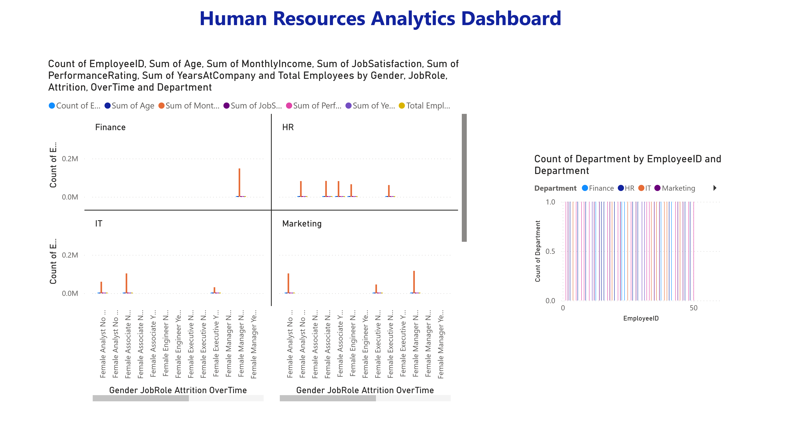
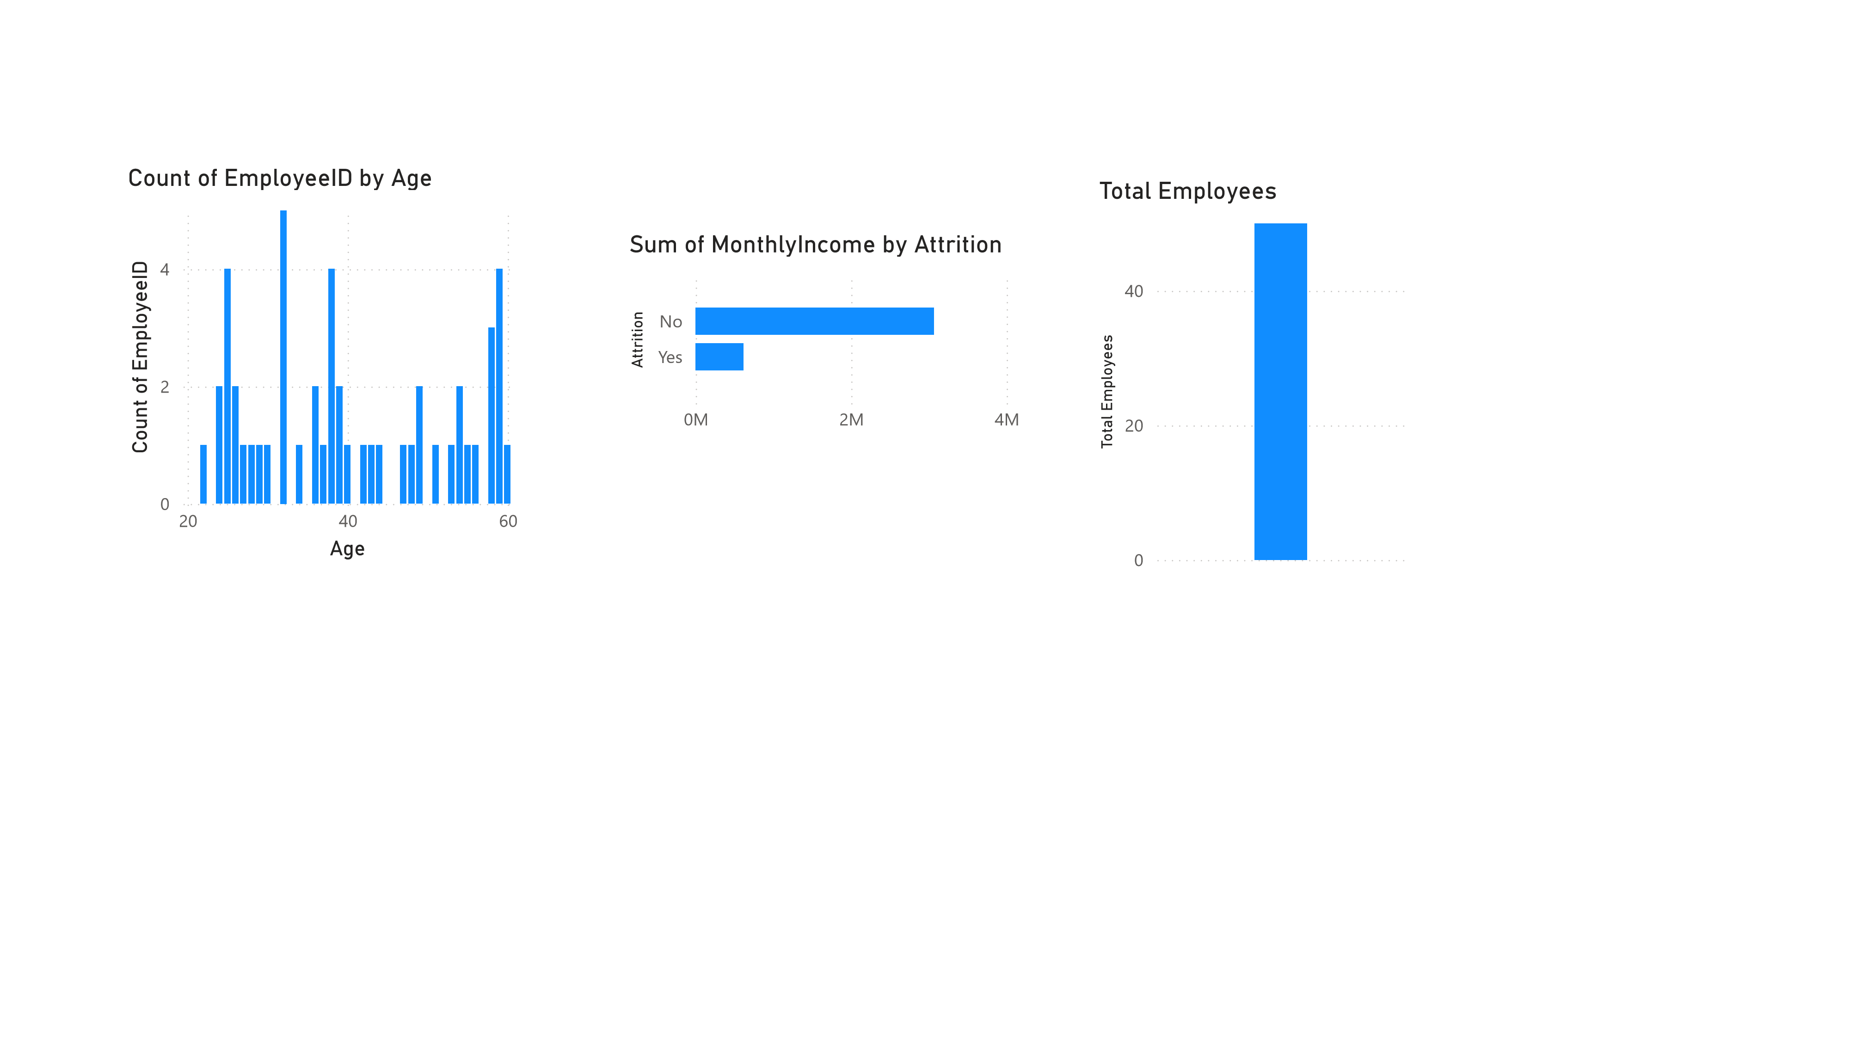
 | Power BI Desktop
Average of Monthly Income by Department  K  0  K  50  Department  A  v  erage of Monthl  yI…  Sales  HR  Operati…  IT  Marketing  Finance | Average of Performance Rating by  Department  0  2  4  Department  Sales  Finance  Marketing  IT  HR  Operations  Average of Performance Rating

