Power BI Desktop
Total Student
Count of Student ID
100
Student Distribution by Class
(26%)
(23%)
)
(19%
19
)
(1
…
13
(13%
)
26
23
19
Class
B
9
B
10
10
A
9
A
8
A
Educational Performance & Resource Allocation

Dashboard
Power BI Desktop
Average Marks
Average of Marks
65.44
Average of Marks by Class
0
50
Average of Marks
Class
10
B
10
A
9
B
9
A
8
A
72.96
65.32
64.65
62.95
57.54
Average Attendance
Average of Attendance %
80.92
Attendance Percentage
60
80
100
Student Name
A
v
erage of A
ttendan…
K
eerthi 65
Meena 54
Rahul 56
Ravi 43
Aarav 80
Sai 10
Average of Attendance…

 | Power BI Desktop
Total Grades  Count of Grade  100 | Count of Student ID by Grade  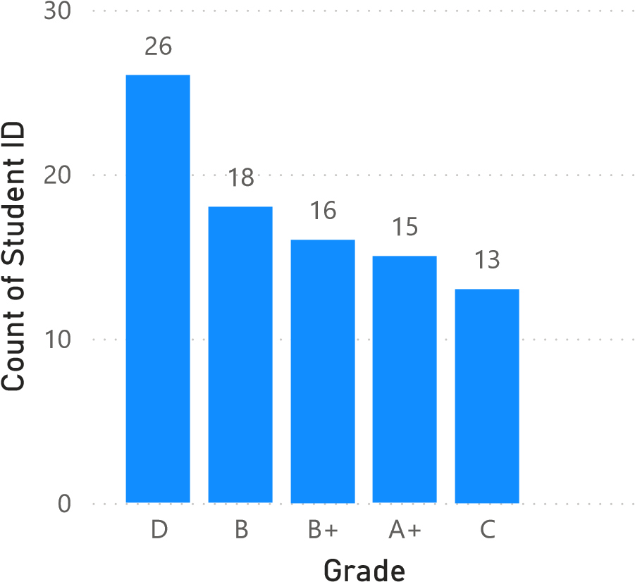 | 12  A
