Robot Framework – Automation Test Scripts for Pet Store Web App
I have developed 3 automation test scripts by using Robot Framework. Created “PetStore-Assignment-RobotTests-SreedharGuntala.robot” file for these tests.

For viewing this code, PetStore-Assignment-RobotTests-SreedharGuntala.robot file can be opened by using ‘TextPad’. If TextPad is not available in the machine, the same code is available in the text file “PetStore-Assignment-RobotTests-SreedharGuntala-RobotCode.txt” in the same folder for reviewing the Robot code.

Developed Robot Automation tests are as follows.

Test 1: Automation test for the user story US0003 – Adding a new pet
Test 2: Automation test for the user story US0004 – Modifying existing pet
Test 3: Automation test for the user story US0001 – Viewing current date

Basic test execution results from the command window.

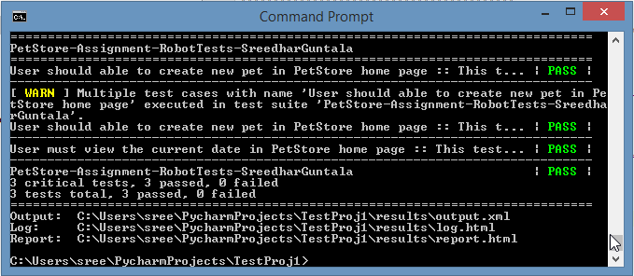

After executing these tests, Test Results will be created with the test report and log details. Test Results of these tests are sending as a separate folder “PetStoreWebAppRobotTestResults”. This folder contains, “log.html”, “output.xml”, “report.html”.
report.html page will be displayed as below screenshot. 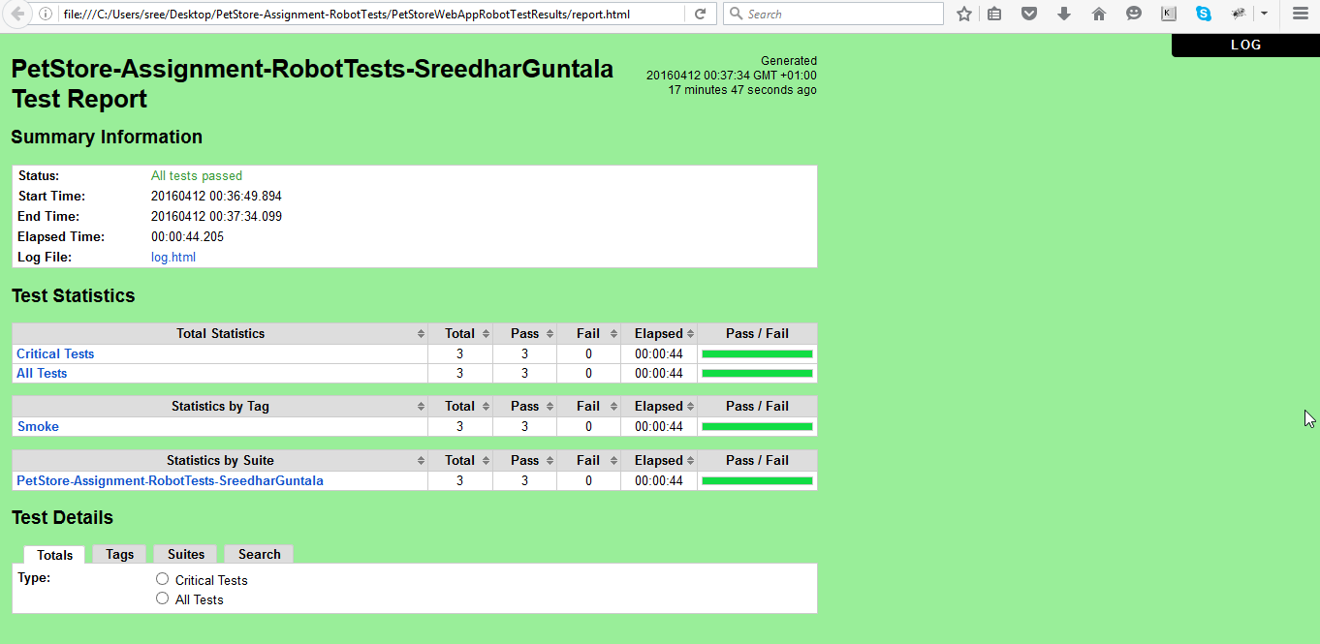
“report.html” can be viewed by opening this file from “PetStoreWebAppRobotTestResults” folder location.

“log.html” will be displayed as below screenshot and can be viewed by opening from “PetStoreWebAppRobotTestResults” folder location.

