Automation Test execution instructions for ‘Web Automation Exercise’ by automating the given scenarios for dummy web site http://automationpractice.com.

Credentials used:
Username: SeleniumTesting@gmail.com
Password: Selenium123

IDE used: IntelliJ Idea

Steps to download the developed automation test project from GitHub website.

- Navigate to my GitHub repository where the project was uploaded. Navigate to the following GitHub URL.

https://github.com/sreedhar-spark/SreedharAutomationPracticeTest

- Click on “BDDCucumberAutomationPracticeTest.zip” file.

- Click on ‘Download’ option as shown below screen
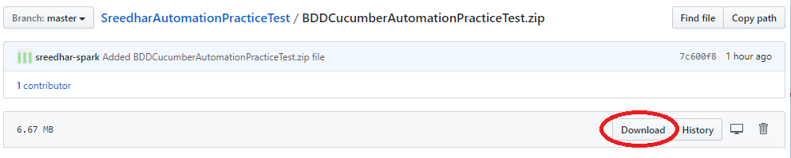

- Copy the downloaded “BDDCucumberAutomationPracticeTest.zip” file to local machine into destination folder where the file need to be copied. In this case, I have created folder “RBS Test’ in C drive

Example: C:\RBSTest\ BDDCucumberAutomationPracticeTest.zip”.

- Extract the “BDDCucumberAutomationPracticeTest.zip” file. Extracted folder “BDDCucumberAutomationPracticeTest“ will be created as below screen.
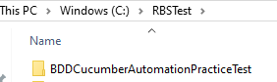

- Navigate to the above extracted folder “BDDCucumberAutomationPracticeTest” by double clicking on “BDDCucumberAutomationPracticeTest” folder name as screen below.

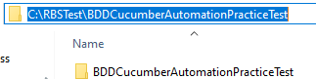

Copy the above path: C:\RBSTest\BDDCucumberAutomationPracticeTest

- Open the IntelliJ IDE. Click on ‘File -> ‘Open’ option.
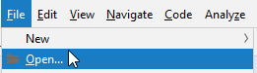

‘Open File for Project’ window will be displayed. Provide the copied path (as in step 6 and highlighted in blue colour) in the ‘Open File for Project’ window as shown in screen below.

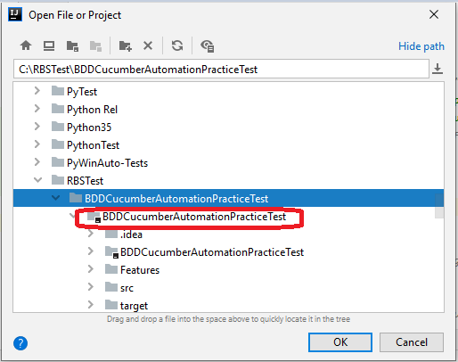

Now, choose the Folder ‘BDDCucumerAutomationPracticeTest’ which is highlighted in red colour (which is parent folder of ‘.idea’ folder).

‘Open Project’ window will be displayed as screen below.
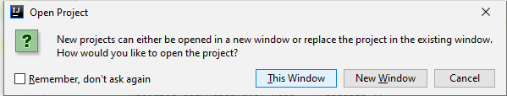

Click on ‘New Window’ button as screen below.
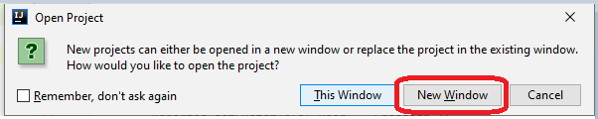

- Chosen project ‘BDDCucumberAutomationPracticeTest’ will be opened in IntelliJ Idea IDE, similar to the below screen,
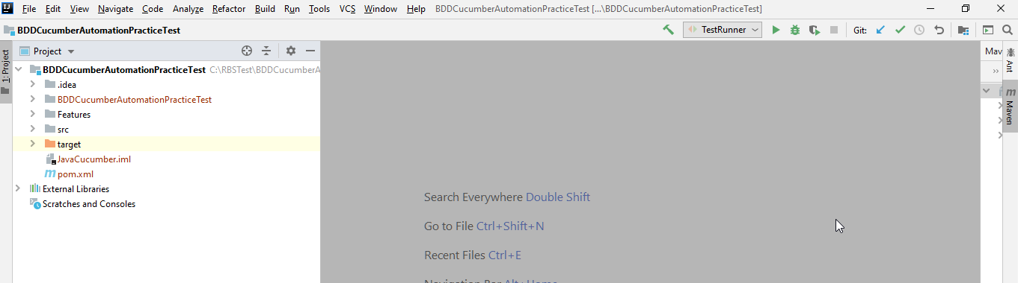

- Navigate to the folder ‘Features’ for features as screen below.

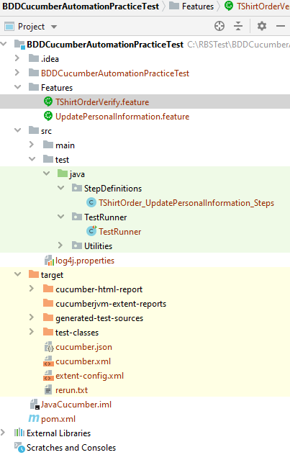

BDD Feature files created:
- TShirtOrderVerify.feature
- UpdatePersonalInformation.feature

StepDefinitions created:
- TShirtOrder_UpdatePersonalInformationSteps.java

TestRunner file created:
- TestRunner.java

Chromedriver.exe included in ‘Utilities’ folder to run the automation tests in Chrome browser.

pom.xml created to manage all dependencies (Cucumber JVM, Selenium, Java, Junit and other required dependencies) as part of Maven project.

Scenario 1:

TShirtOrderVerify.feature file is developed for the Scenario 1 (Order TShirt and Verify in Order history).

I have created two (2) scenarios for testing this functionality.

Scenario 1: Order T-Shirt and Verify in order history (With passing parameters)
Secnario 2: Order T-Shirt and Verify in order history

Scenario 1: Order T-Shirt and Verify in order history (With passing parameters)

This scenario is with passing parameters which is more generic. For example, this test can be executed for any different user account email address and password details by passing the desired user email address and password details.

As per test requirement, I have covered all steps to perform the T Shirt order and verify the order reference in order history.

Scenario 2: Order T-Shirt and Verify in order history

This scenario is without passing parameters and it is not generic. This scenario can be executed only with only one user account details (in this case user name as SeleniumTesting@gmail.com and password as Selenium123) which is hard coded in the step definition file. This test is not suitable for other user accounts except SeleniumTesting@gmail.com account.

Scenario 2:

UpdatePersonalInformation.feature file is developed for Scenario 2 - Update Personal Information (First Name) in My Account.

I have created one (1) scenario for testing this functionality.

Scenario 1: Update First Name details in My Account Personal Information (With passing parameters)

This scenario is with passing parameters which is more generic. For example, this test can be executed for any different user account and can update the first name with required data as we wish. This test is not limited to only for single update for first name data and it it not hard coded with single name value. This test can be executed with ‘n’ number of times by changing the required first name details which is more dynamic.

Also this scenario included in verifying the updated first name is displayed in account personal information in the top right corner of the page as shown below screen.



Automation Test Execution:

To run the automation tests, we need to use ‘Test Runner’ class. Navigate to ‘TestRunner’ class as shown below screen. Right click on ‘Test Runner’ and choose “ Run ‘Test Runner’ ” option as shown below screen.

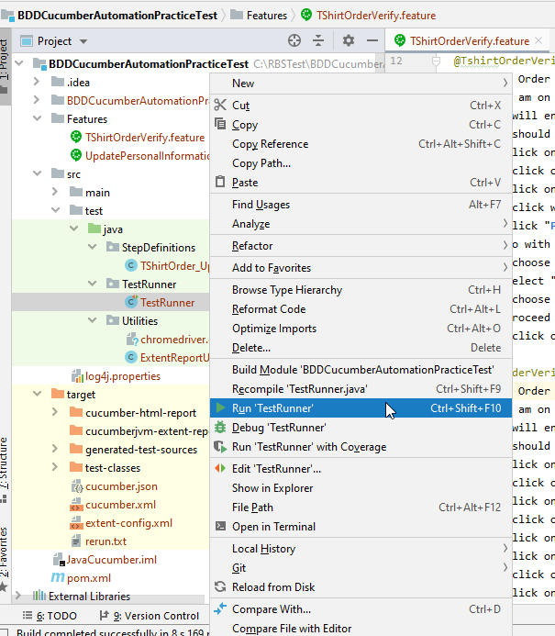

Now, Automation Test execution starts. IDE bottom window shown as similar to the follwing screen.

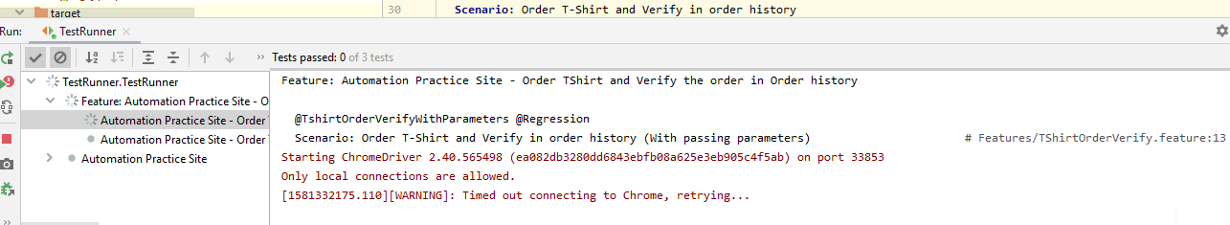

After test execution completed, the IDE (Test Runner window) shows similar to the screen below.

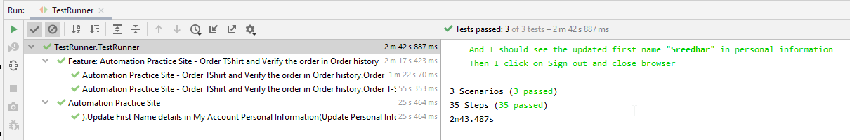

Automation Test Execution Report:

As part of automation test execution, basic cucumber HTML report will be generated.

To view the generated html report, navigate to cucumber-html-report folder as shown screen below.

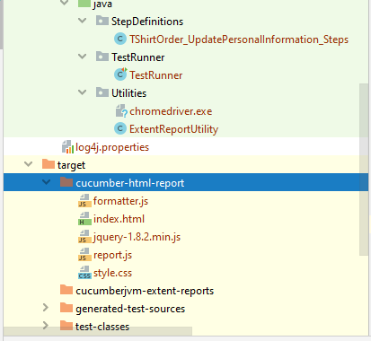

“index.html” is the generated report html file. This file can be viewed in browser. Right click on ‘index.html’ and choose ‘Open Browser’ and Select ‘Chrome’ browser to view the report in browser.
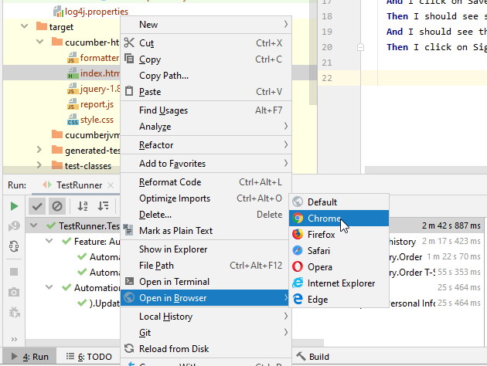

‘index.html’ report will be shown as below screen.

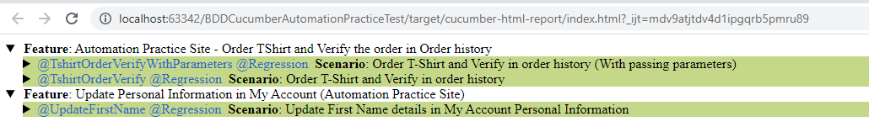

Expand the report by clicking on traingle symbol. Expanded report will be shown as below screen.

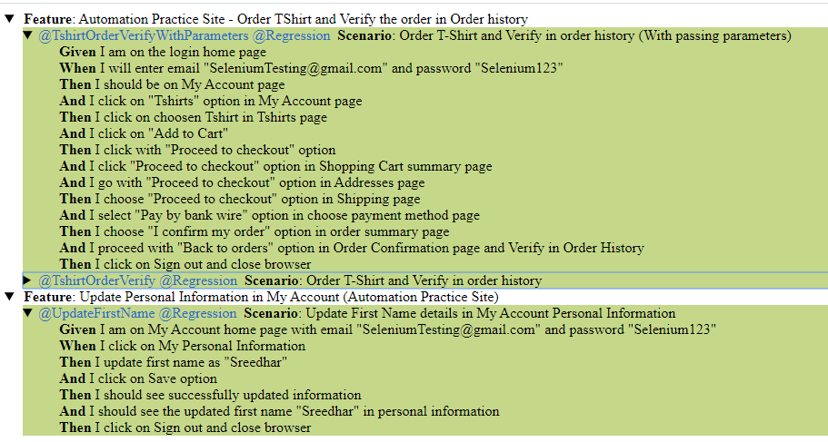

Candidate Requirements

a. Build a test project that includes automation of the 2 scenarios above.
[Maven test project created to automate the 2 scenarios as mentioned]

b. Solution to be coded in Java and driven using a BDD tool (see potential solution components below)
[Automation tests are developed by using Java, BDD, Cucumber, Gherkin syntax]

c. Share code in a public GitHub repository for review. Include execution instructions.
[GitHub repository details are shared as below.
https://github.com/sreedhar-spark/SreedharAutomationPracticeTest
Download BDDCucumberAutomationPracticeTest.zip file. Proceed the steps from Step 2 onwards as mentioned in page 1.
]

d. Share further improvements that could be considered to develop the framework (Optional).

Further improvements that could be considered as follows:

- POM (Page Object Model) pattern will be implemented as part of developing the framework. Usage of POM pattern will be efficient by reducing the repeated code, effectively reuse the code, good maintenance of test framework, separate the UI code with selenium test code. No need to change entire code, when there is any change of UI element Id/Xpath etc attributes. Just change the UI Page Object class, which reflects the entire test suite.
- Efficient report generation need to be implemented. Extent report would be fine. I have tried to generate the extent report by providing the necessary details. But, not able to resolve the issue which causes for extent report generation.
- Logging mechanism could be implemented. I have included Log4J as part of automation tests. But it is not generating the logs into log file due to the technical error as below.
log4j:WARN Please initialize the log4j system properly.
- Cross browser testing could be implemented by executing the tests in different browsers, with different operating systems, parallel test execution by using Selenium Grid.
- Data driven testing could be implemented for the scenarios where the large data set is required by using external data files including .csv, .txt files.
- Screenshot capture could be implemented for error scenarios as part of developing automation framework.
- Automation Test suite could be executed as part of Continuous Integration/Continuous Delivery (CI/CD) implementation.

Note: If there is any issue with the automation test execution, I am happy and ready to clarify the things. Please let me know, if you have any issues in executing the automation tests even after following the above test execution instructions.

