Assignment 1,2,6

Topic 1: User and Group Management

Assignment 1: • Create user “trholiam” using IAM.

• Rename user name to trholiamnew”

**Created User : trholsr850840iam**

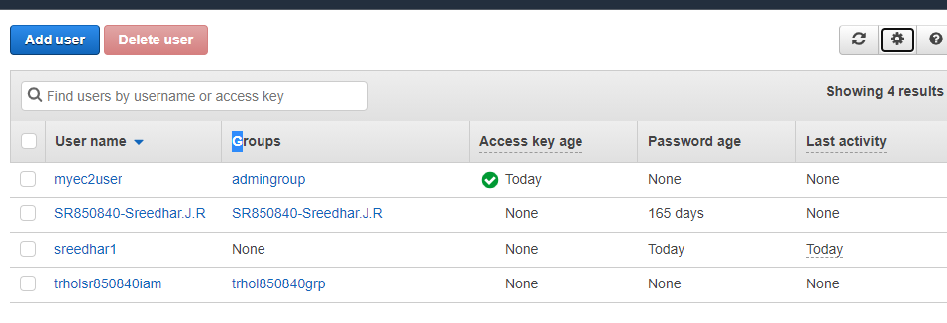

**Renaming User:**



**Post renaming:**

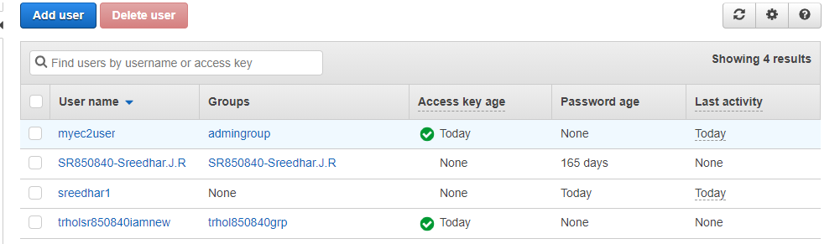

Assignment 2:

• Create IAM group “trholgrp” using IAM.

• Add users to this groups and assign permissions

**Created Group : trhol850840grp**

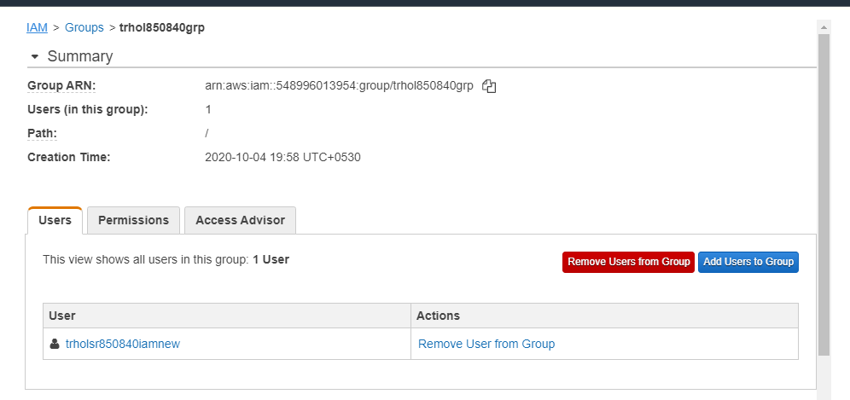

**Adding User in to trholsr850840iam**

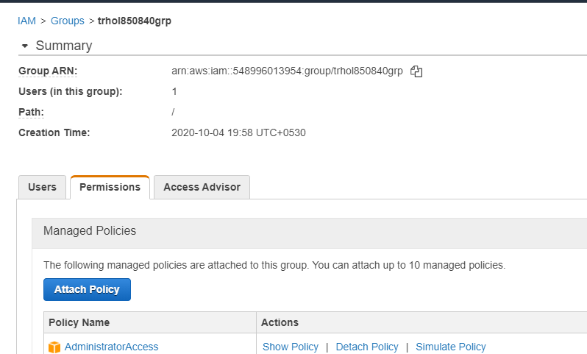

Assignment 3:

• Create IAM role “trholrole”

• Using this Newly create IAM role to login to EC2 VM CLI without using Key pairs

**Created role :trholsr850840role**

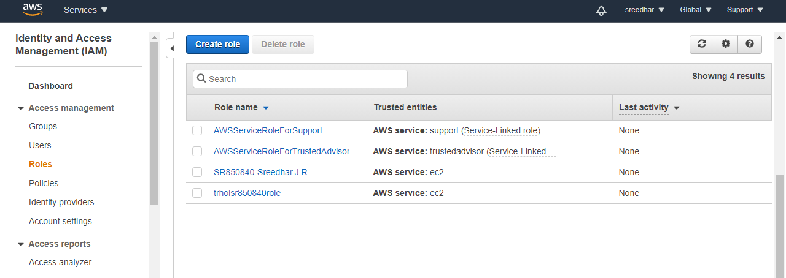

**Assigned role to Instance directly :**

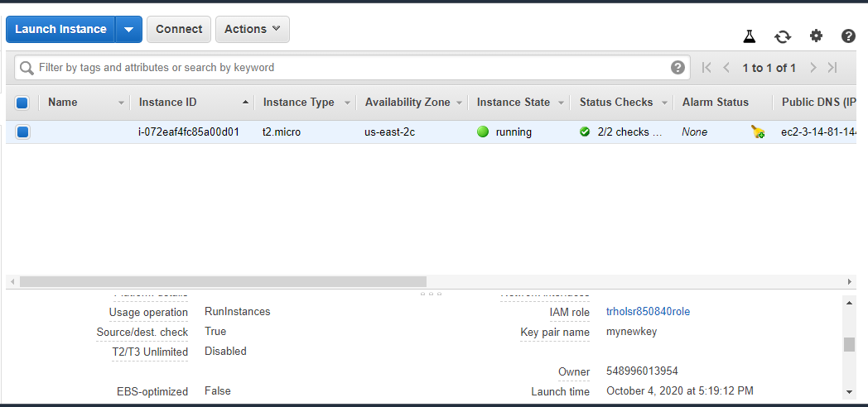

**Logged in without key pairs**

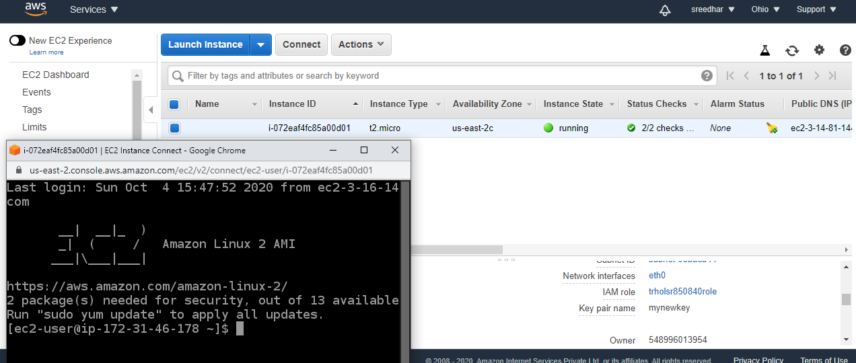

Topic 2: Compute Assignment

1: • Create EBS-Backed Linux AMI from the instance directly or from the EBS snapshot

**Created VM : (mybasevm)**

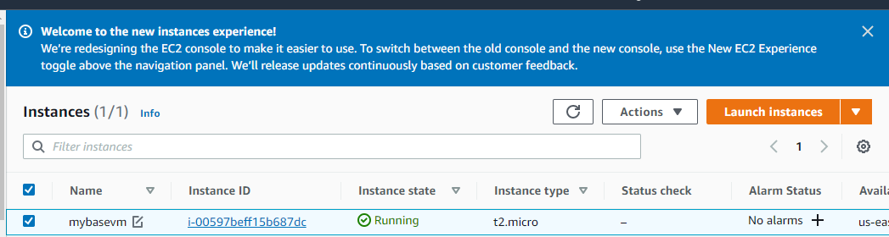

**Volume:**



**Created Snapshot:**

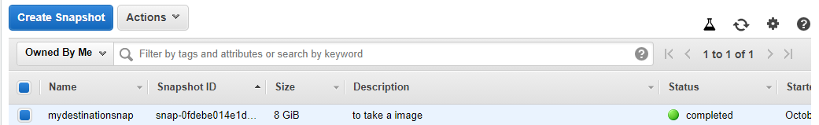

**Created Image:**

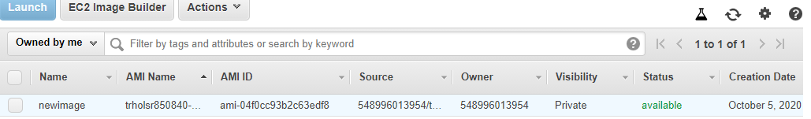

**Launched VM from Image:**

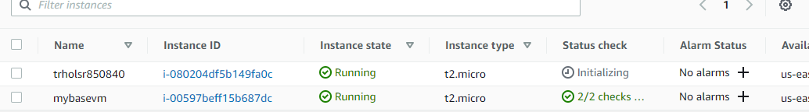

Assignment 2:

• Create Instance Store-Backed Linux AMI

**Choosing Instance Storage Backed Linux Ami in Community AMI**

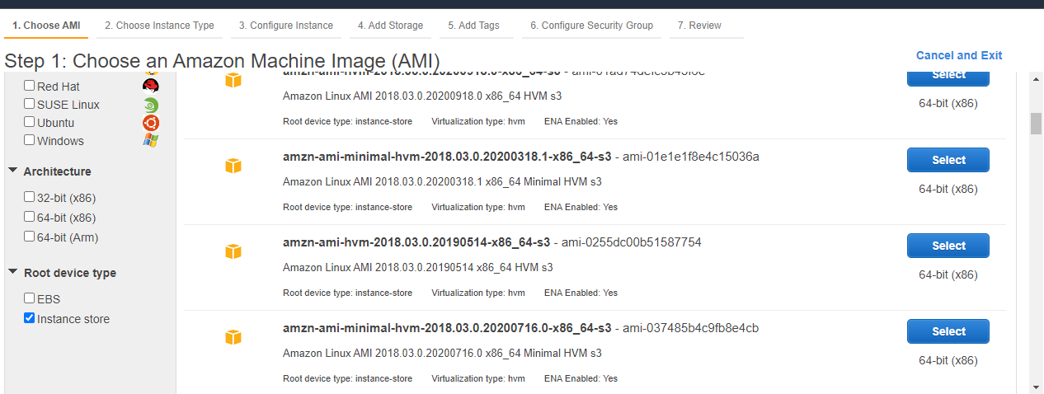

Adding Storage:

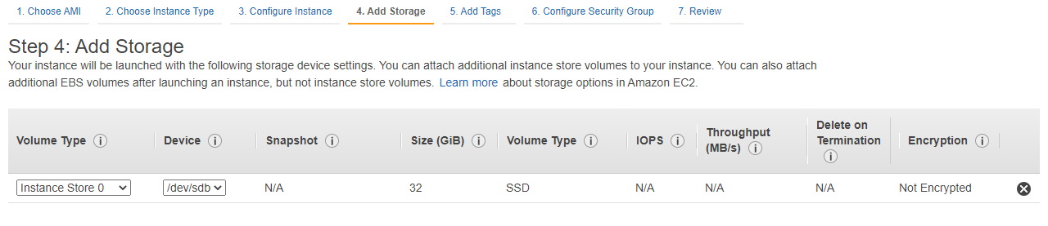

Status:

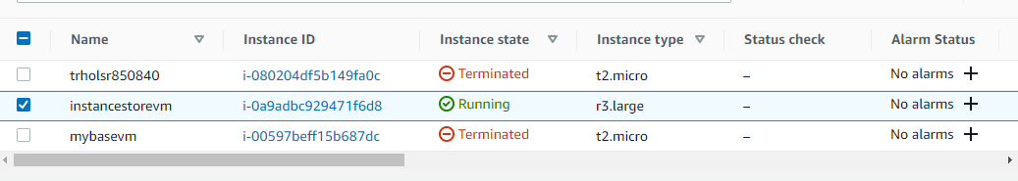

Assignment 3:

• Copy Amazon EBS-backed AMIs or instance store-backed AMIs and spin instance using copied AMI.

Using same image for copy AMI.

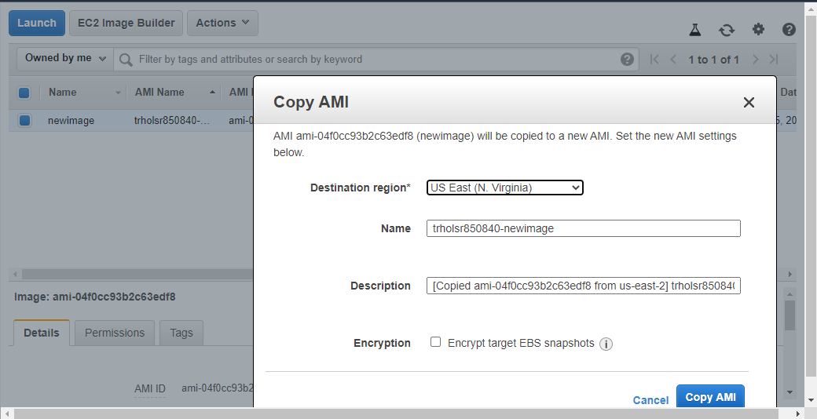

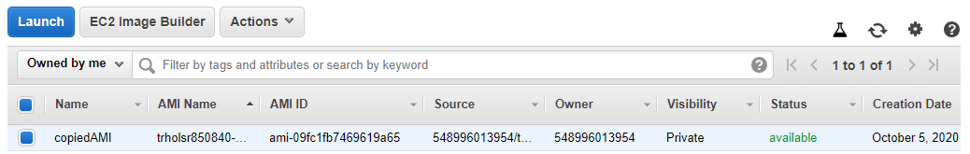

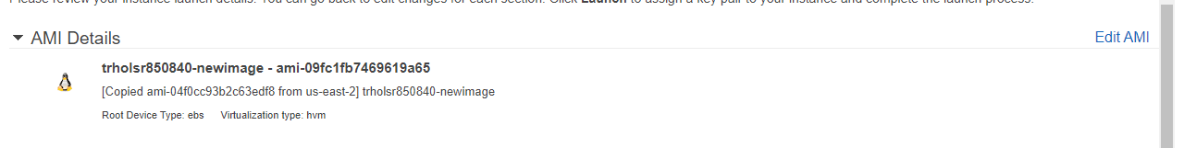

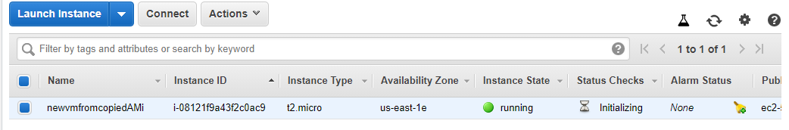

Assignment 4:

• Spin up EBS Optimised instance VM with tag “trholebsopt”

**Choosing EBS-optimized Storage in Instance type:**

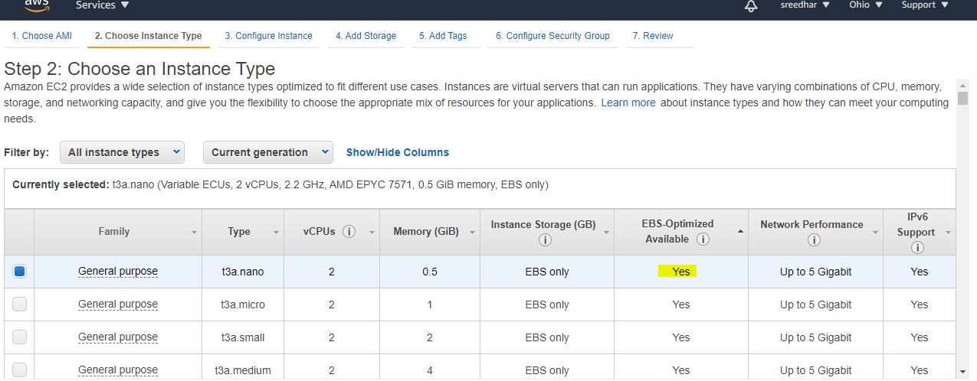

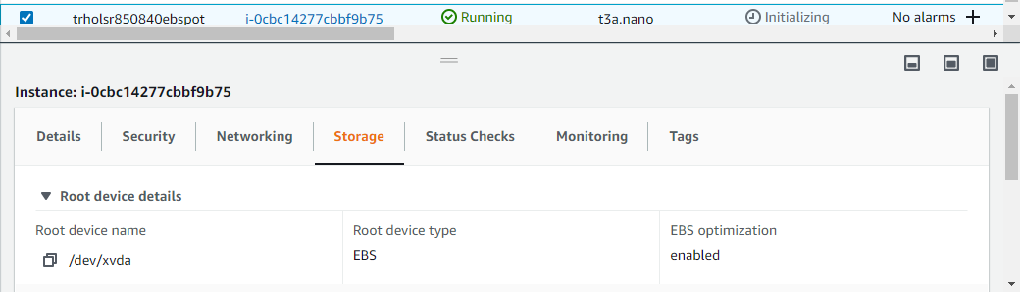

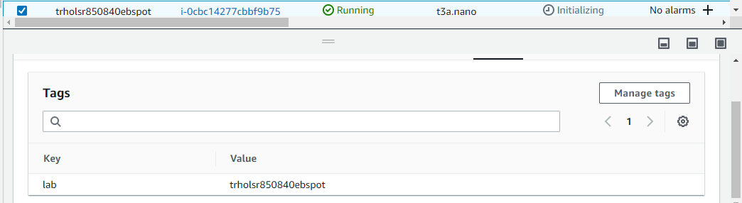

**Topic 6: Database**

Assignment 1:

• Create RDS database using “t2.micro” instance class DB size as 20 Gib and tag “trholrds”

