Assignment 3,4,5

Topic 3: Networking

• Create VPC with tag “trholvpc”

• Create two subnets (one public and private) within this VPC “trholvpc” (Subnet Tag “trhol(Emp AD ID>subnet1 and2) with appropriate security group, Internet gateway and NACL

**Created VPC: trholsr850840vpc**

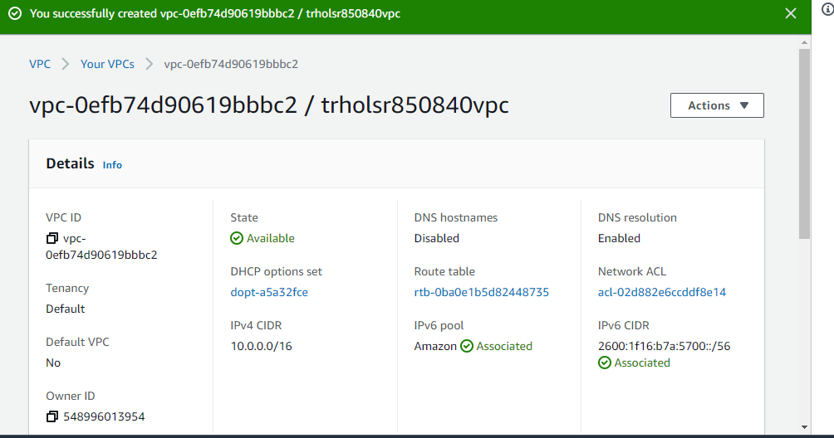

**Created Subnets:**

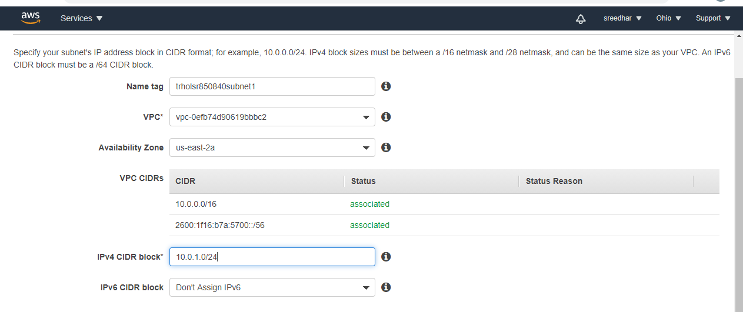

Created Public Subnet1 and Private Subnet 2 with Below names:

Trholsr850840subnet1

Trholsr850840subnet2

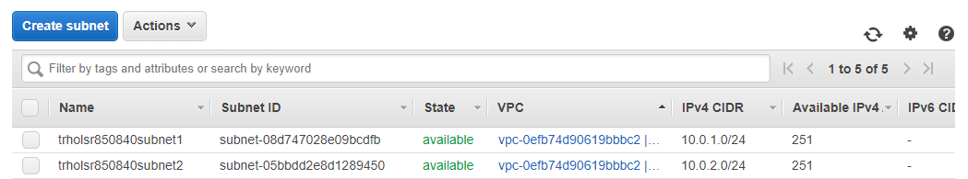

**Made one Subnet Public:**

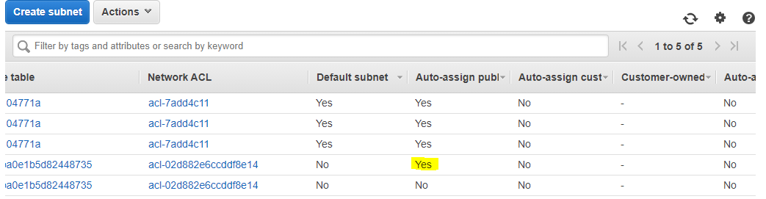

**Created Internet Gateway**

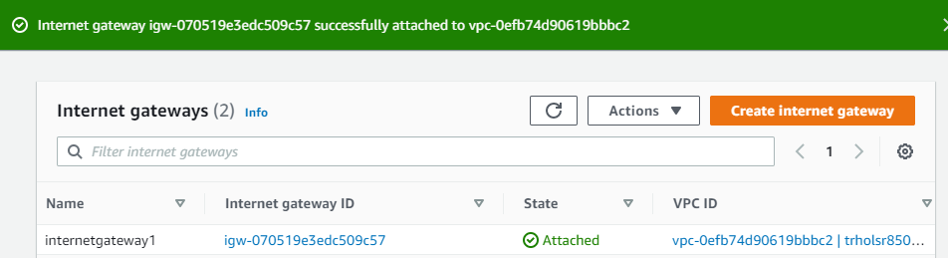

**Created New route Table (for Public subnet)**

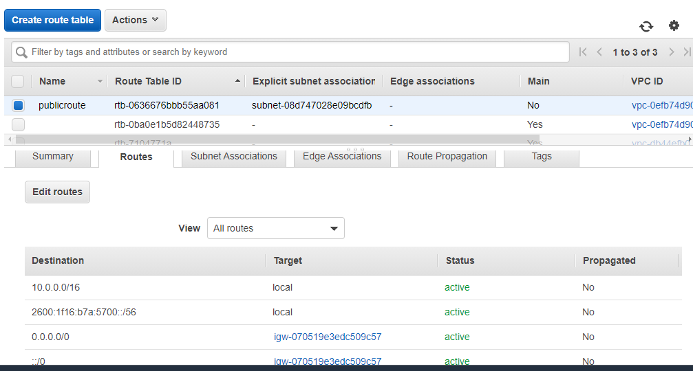

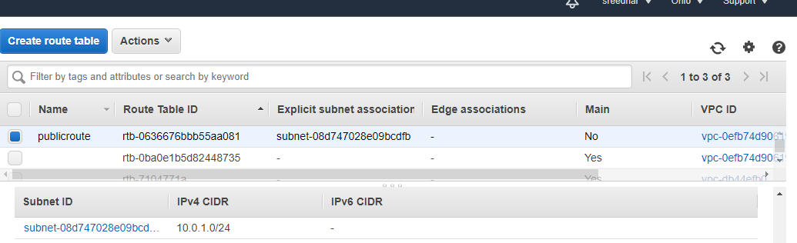

**Security Groups:**

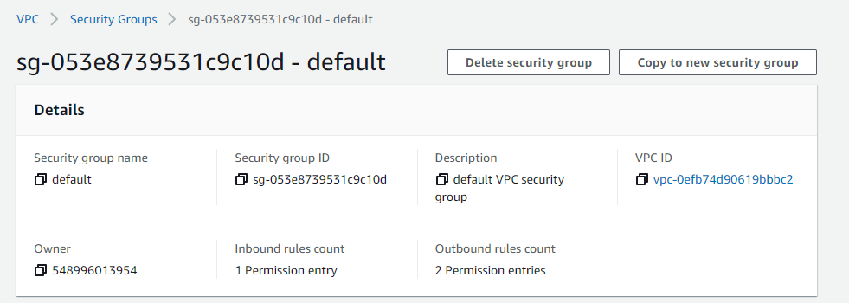

**NACLS:**

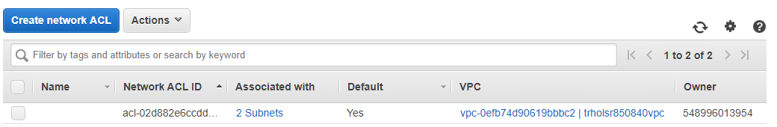

Assignment 2:

• Create VPC with tag “trholvpc”

• Create ENI with tag “trholeni” and attach it to the instance “trholvm”

**Created VPC: trholsr850840vpc**

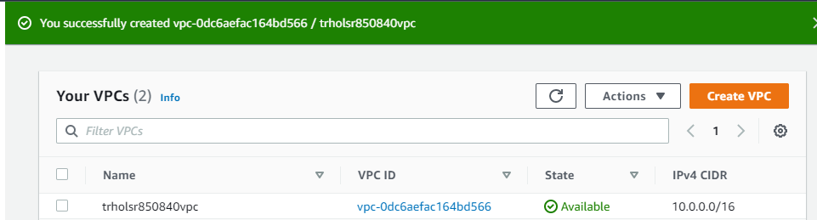

**Created New Interface :trholsr850840eni**

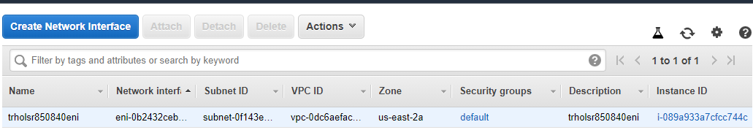

**Attaching to Instance**

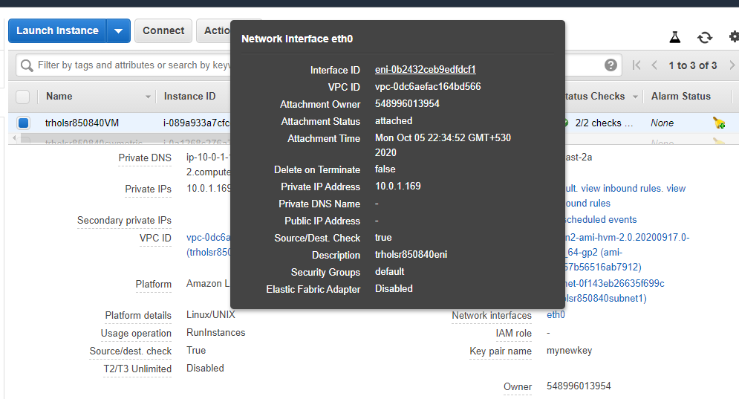

**Topic 4: Storage**

Assignment 1: • Create S3 Bucket with name “trhols3” with versioning • Create file name “trholawsl1” • Upload the object onto S3 • View the Object and its proprieties • Delete the Object • Restore the object trholawsl1 from versioned objects. • Delete the bucket

**Created the Bucket trholsr850840s3 and uploaded file trholawsl1.txt and enable versioning**

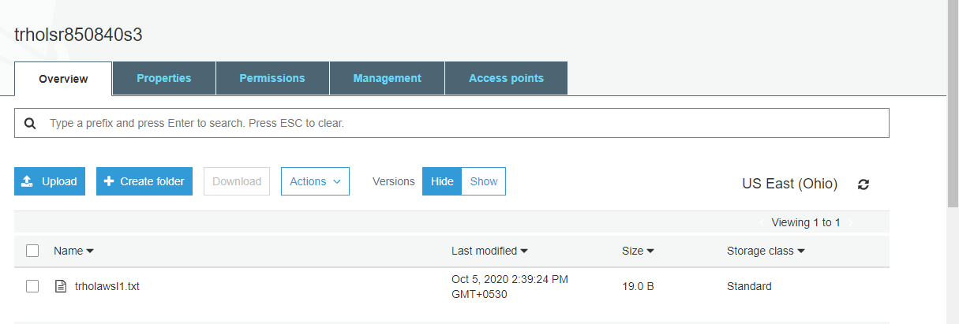

**View File content:**

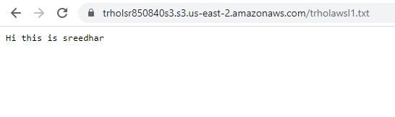

**Delete the Object:**

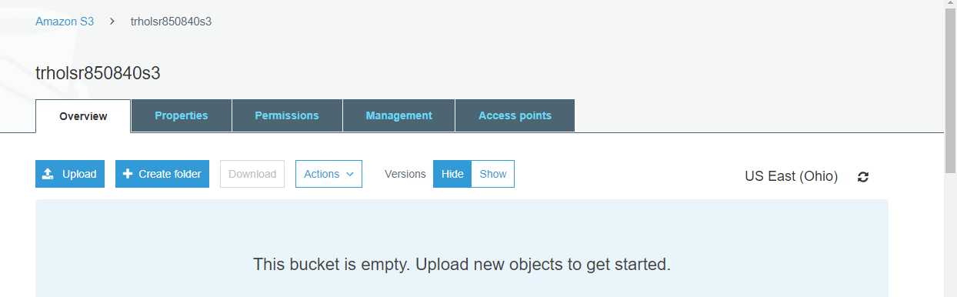

**Delete Marker and view the deleted object in Versioning Tab:**

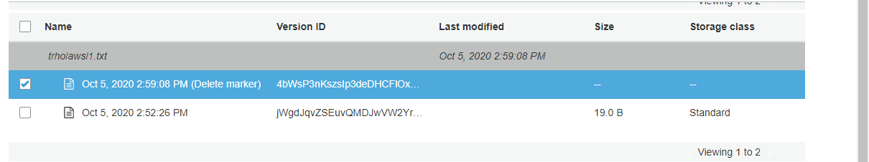

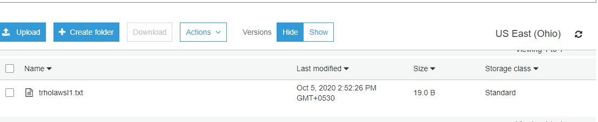

**Restoring the lost File**

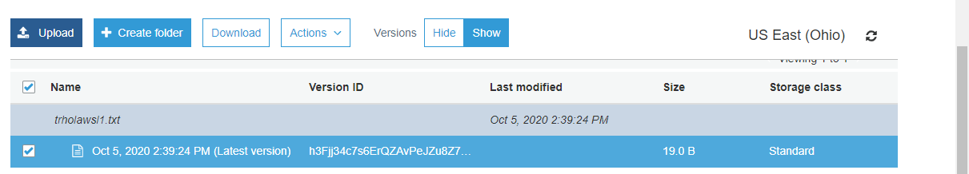

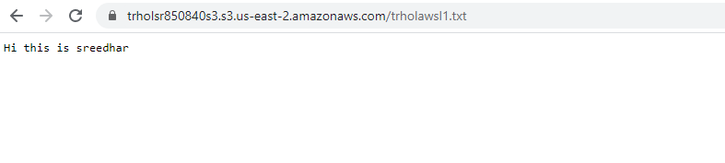

**Deleting the Bucket :**

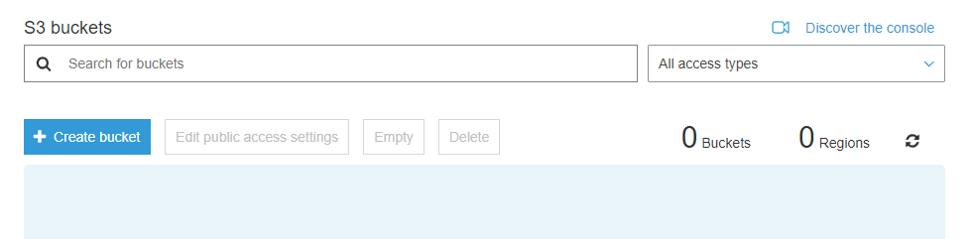

**Assignment 2:**

• Create S3 Bucket with name ““trhols3” • Create file name “trholawsl1” • Upload the object onto S3 • Setup lifecycle rule between Standard and Glacier. • Test the object movement using lifecycle rule.

**Created the Bucket again with trholsr850840s3 and Uploaded files and created Lifecycle rule policy for current version**

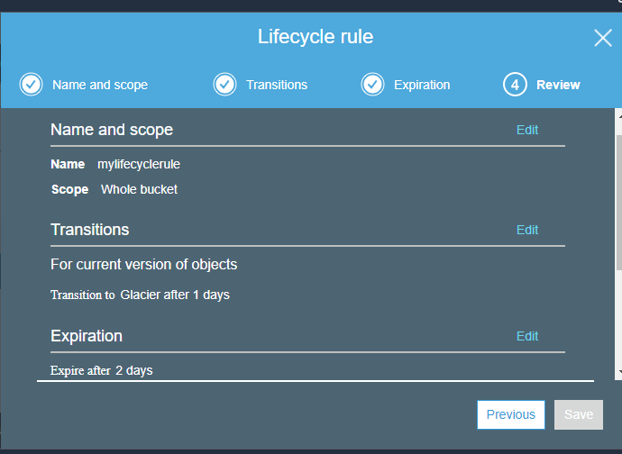

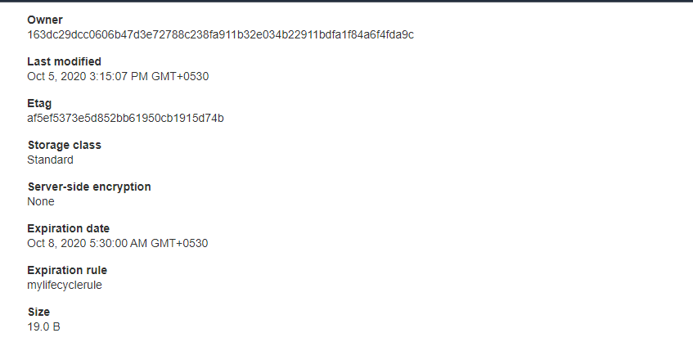

Assignment 3:

• Create VM (instance Type t2.micro) with tag “trholvm” using Amazon Linux AMI • Add ephemeral disks to the VM “trholeph” • Remove disks from VM “trholeph” • Delete VM “trholvm”

**Created VM: trholsr850840vm**

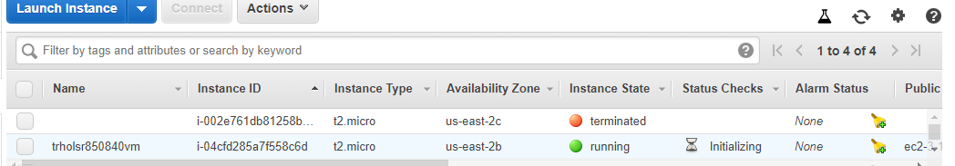

**Created Volume:trholsr850840eph**

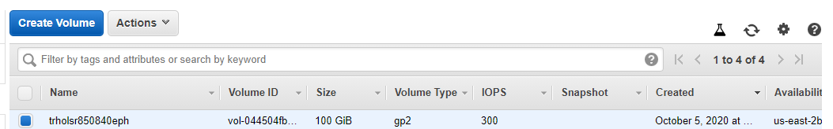

**Attach the Volume**

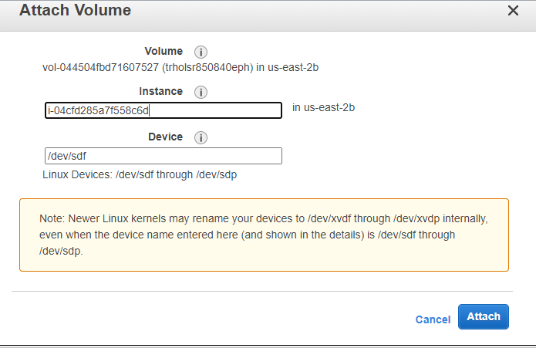

**The device is attached :**

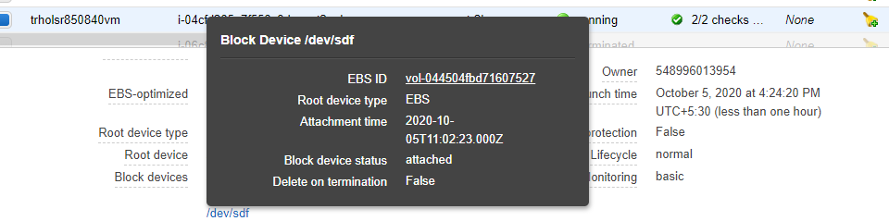

**Remove the Volume from Instance:**

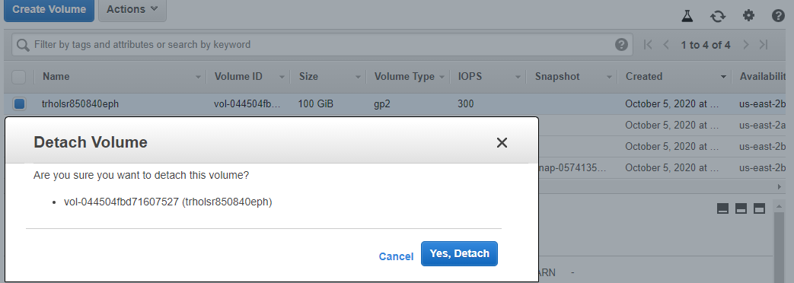



Topic 6: Management & Monitoring

Assignment 1:

• Create custom CloudWatch metric to monitor with tag “trholcwmetric”

**Created Custom metric for instance trholsr850840cwmetric regarding memory utilization**

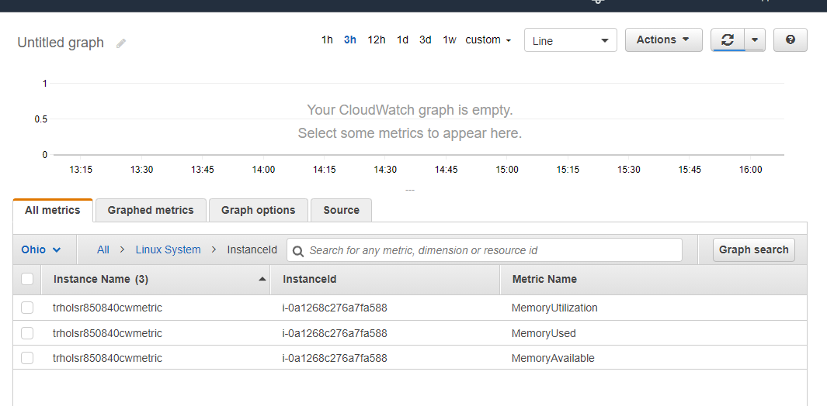

Assignment 2:

• Configure CloudWatch monitoring on an EBS backed EC2 instance with tag “trholcwebsm

**Created VM and Enabled Cloud Monitoring**

