Title of the Paper (Arial, 12 pt, bold)
by First Author¹*, Second Author*, Third Author*, Fourth Author*, and Corresponding Author¹*
* Affiliation institute and address.
¹email address of the corresponding author, correspondingauthor@affiliation.com
Abstract (Arial, 9pt, bold)
This is what the abstract text looks like (Arial, 9 pt, justified). This is what the abstract text looks like. This is what the abstract text looks like.
- Introduction (Arial, 9pt, bold)
This is what the normal text looks like (Arial, 9 pt, justified). This is what the normal text looks like. This is what the normal text looks like. This is what the normal text looks like.
- Other headings as required (Arial, 9pt, bold)
Further text: This is what the normal text looks like (Arial, 9 pt, justified). This is what the normal text looks like. This is what the normal text looks like. This is what the normal text looks like.
New paragraph: This is what the normal text looks like (Arial, 9 pt, justified). This is what the normal text looks like.
  - Subheading (Arial, 9 pt, bold)
This is what the normal text looks like (Arial, 9 pt, justified). This is what the normal text looks like. This is what the normal text looks like. This is what the normal text looks like.

    - Sub-subheading (Arial, 9pt, bold, italic)
This is what the normal text looks like (Arial, 9 pt, justified). This is what the normal text looks like.
References are referred to in the text in the style [1] and [1,2,3].
Equations are given as follows and referred to in the text as Eq. (1) or Eqs. (1) and (2). Note that it is preferred that all symbols are in italics both in equations and in the text. Please use the SI system for units.
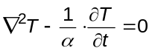 (1)
- Experimental Setup
Figure shows a schematic of the experimental setup used for laser line scan thermography. In this study, both the laser line source and an IR camera were mounted on a collaborative robotic arm to enable automated scanning across the sample surface. A FLIR A655sc infrared camera, operating in the long-wave IR range with a resolution of 640 × 480 pixels, was used to acquire thermal data. The camera frame rate was set to 200 Hz to enable capture of rapid transient thermal events during laser excitation. The excitation source was a continuous-wave laser with a center wavelength of 1080 nm and an output power of 22 W. The laser beam was shaped into a line profile and directed perpendicular to the surface of the aluminum sample. The 6-axis cobot used in the setup has a maximum payload capacity of 5 kg and was programmed to follow a predefined scan trajectory across the sample. The synchronized movement of the cobot ensured a uniform scanning velocity, while the thermal response of the sample was recorded in real time. This configuration enabled precise control of the excitation and data acquisition parameters, facilitating consistent crack detection during the scanning process.

- Figures and tables
All figures (i.e. graphs, data plots, illustrations, photographs, …) are to be numbered in the order that they are introduced and referred to as figure 1, figure 2, etc. Authors may choose to insert the figures in the text as they occur (full or part width of the page) or to put them all at the end of the paper after references. In both cases, each figure should have title under it in the style shown below (figure 1). To increase quality of figures the use of colors is recommended, but remember to adopt colors that remain clear if printed in black and white.
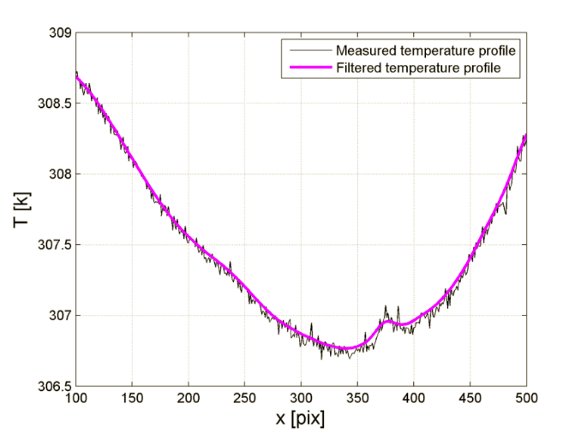
Fig. 1. Title (Arial, 9 pt, centered, italic)
Tables may also be in the text (full or part width of the page) or after references (and before the figures if placed at the end of the paper). The title of the table should be put on top of the table. Tables have to be referred to in the text as table 1, table 2, etc.
Table 1. This is what table caption looks like (Arial, 9 pt, centered, italic)
Column 1 | Column 2
Text 1 | Result 1
Text 2 | Result 2
Text 3 | Result 3

REFERENCES
- Martin H., “Heat and Mass Transfer between Impinging Gas Jets and Solid Surfaces”. Advances in Heat Transfer, vol. 13, pp. 1-60, Academic Press, New York, 1977.
- Kaczmarek M., Nowakowski A., Suchowirski M., Siebert J., Stojek W., Active dynamic thermography in cardiosurgery, Quantitative InfraRed Thermography Journal. - Vol. 4, no 1 (2007), pp. 107-123, 2007.
- St-Laurent L., Prévost D., Maldague X. "Fast and accurate calibration-based thermal/colour sensors registration", Proceedings of 10th Quantitative InfraRed Thermography conference, paper QIRT2010-126 Québec (Canada), 2010.
- Renkielska A., Nowakowski A., Kaczmarek M., et al., Burn depths evaluation based on active dynamic IR thermal imaging – a preliminary study. Burns; 32: pp. 867-875, 2006.

