Staff register

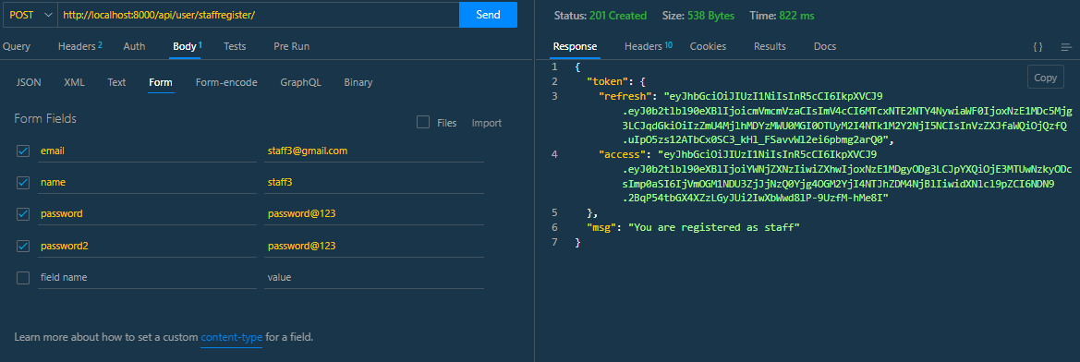

Stafflogin

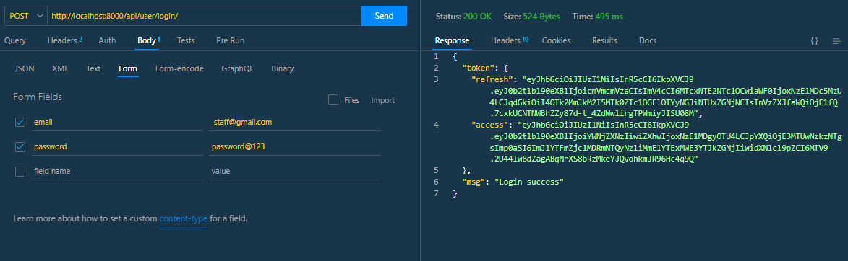

Customer registration

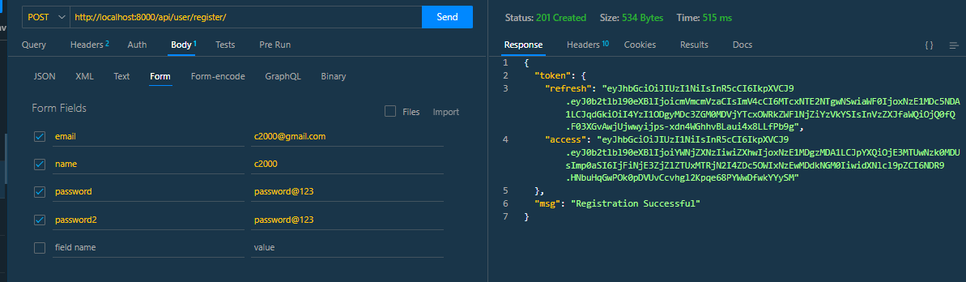

Account opening application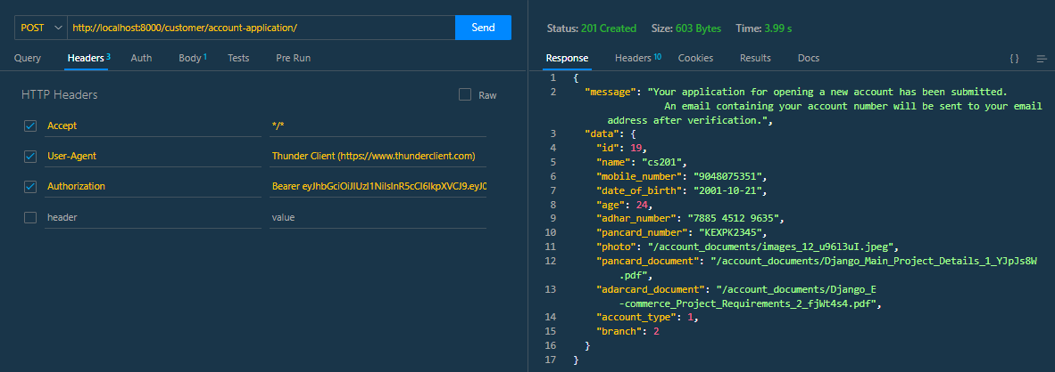

Customer profile with transaction history

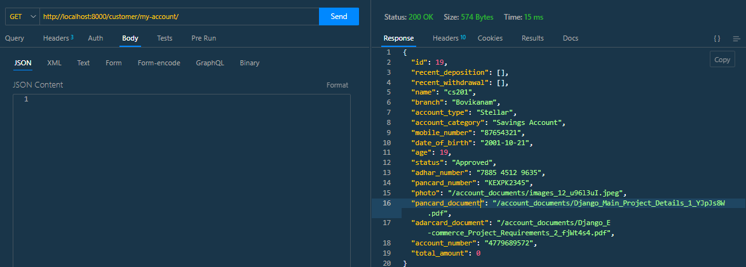

Account profile updation

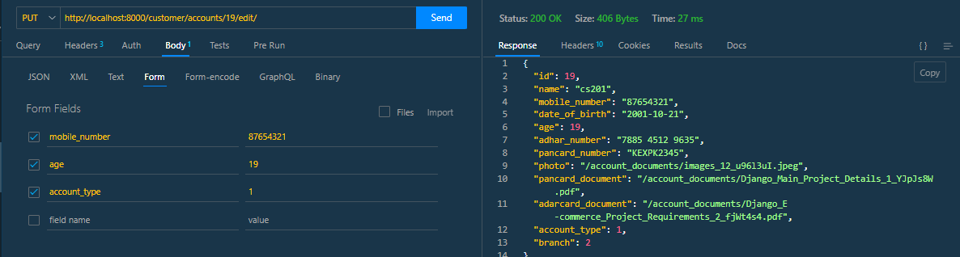

Account status change-staff

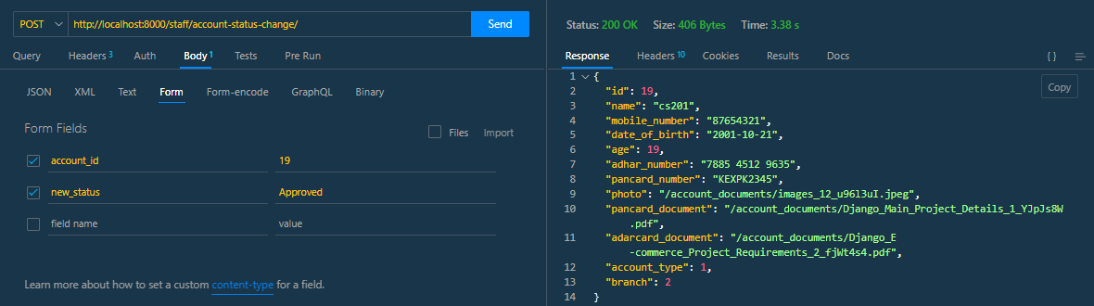

Staff profile with all account applications

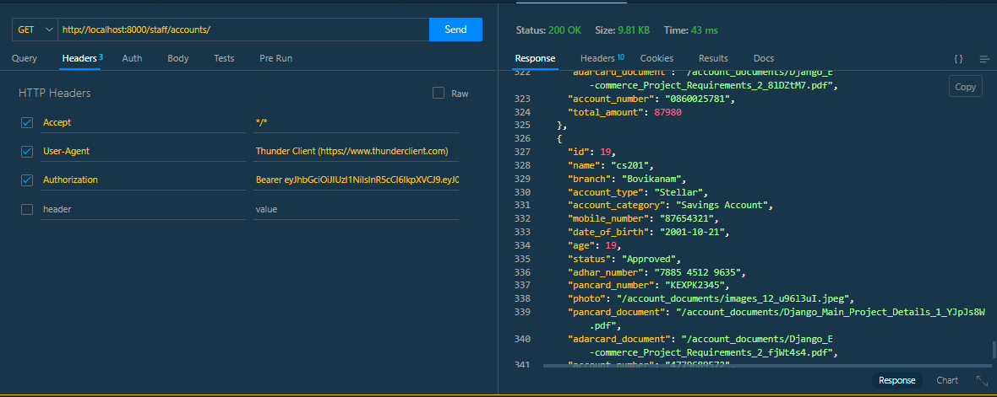

Amount deposition

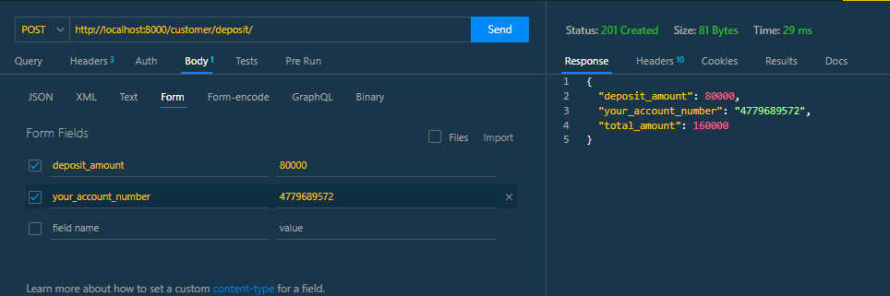

Amount withdrawal

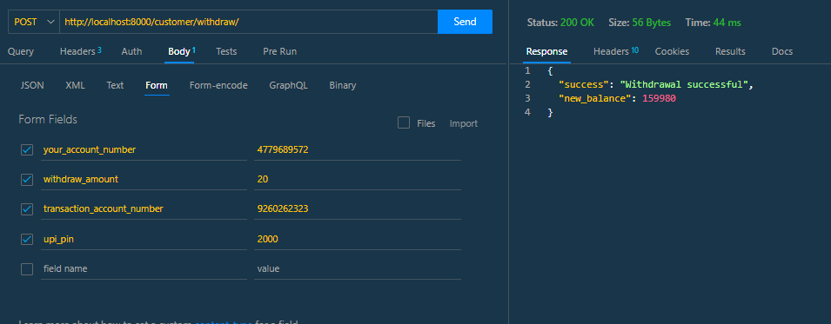

All loan available

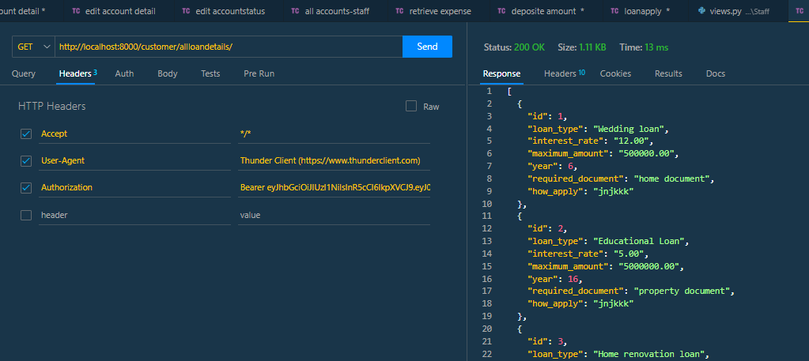

Loan apply

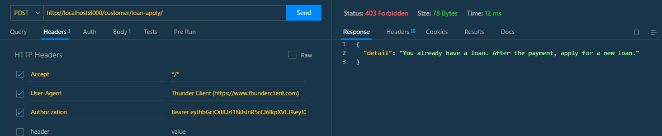

Loan applications- staff profile

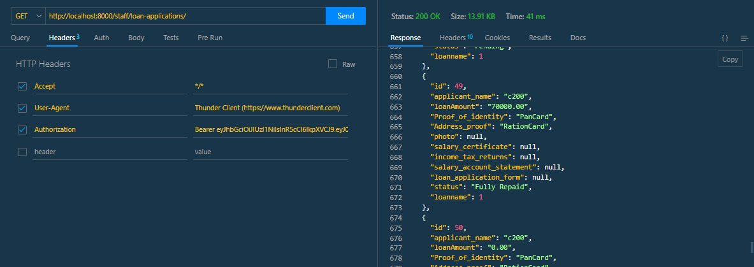

Loan status change by staff

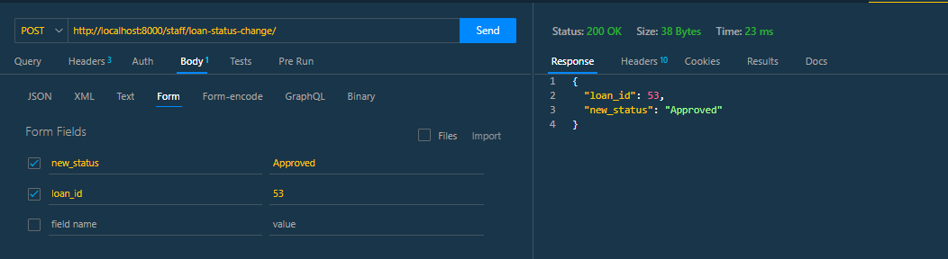

Loan application retrieve

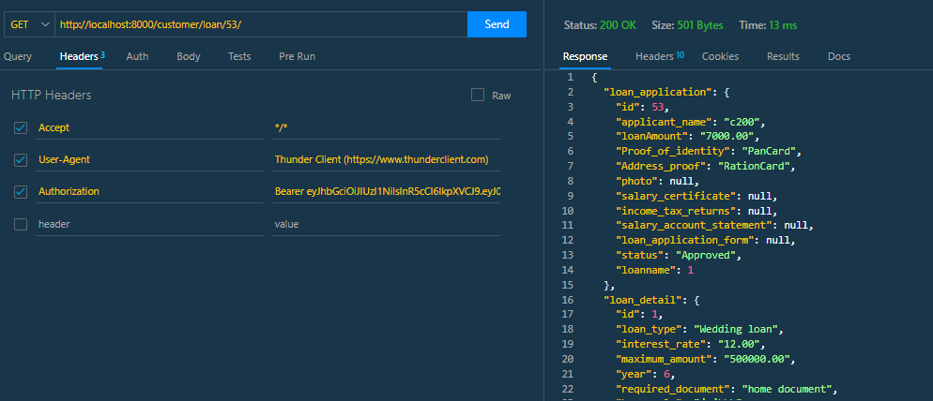

Loan application delete

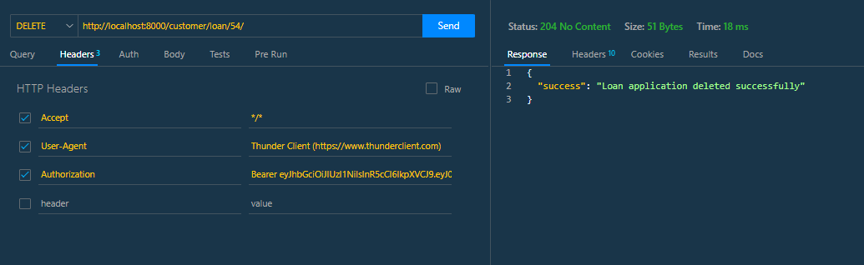

Budget plan add

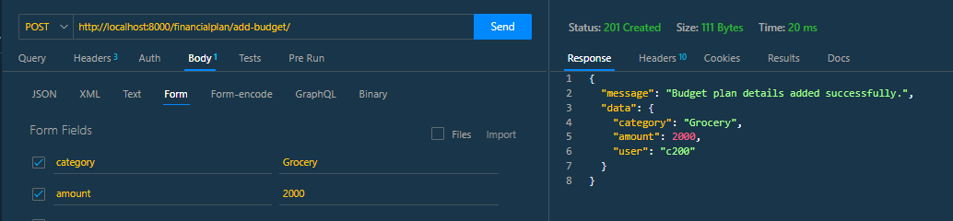

Budget plan update

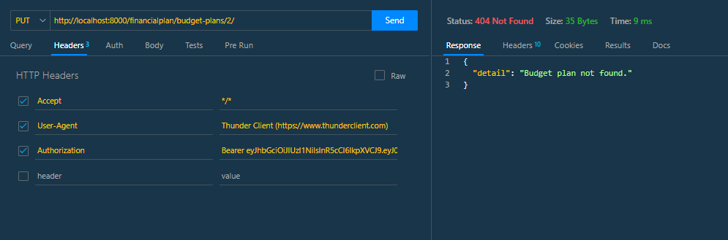

Budget plan delete

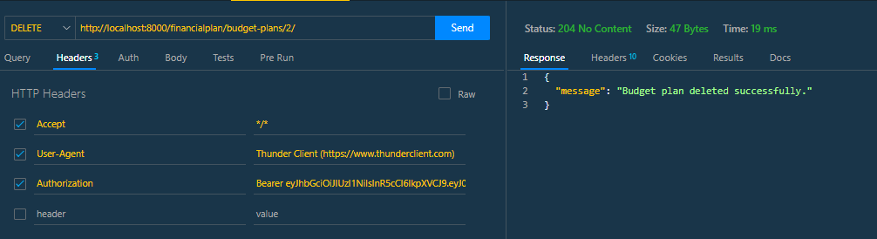

All budgets in profile

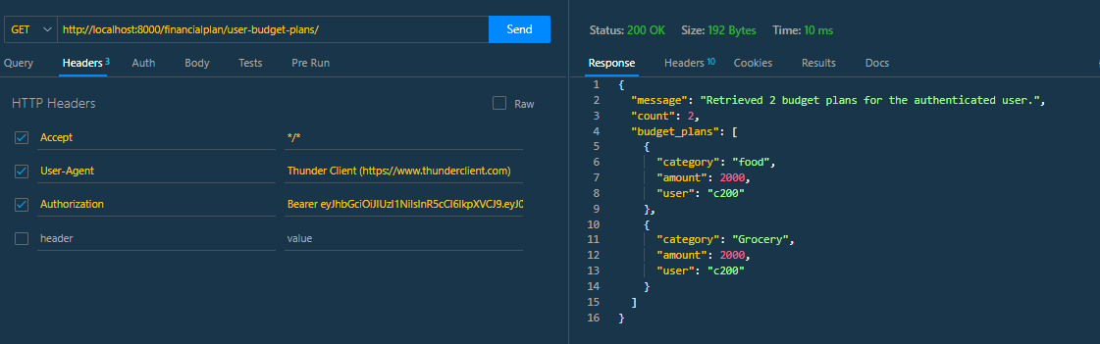

Expense add

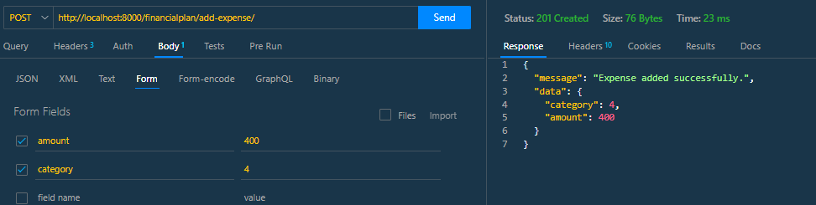

Expense edit

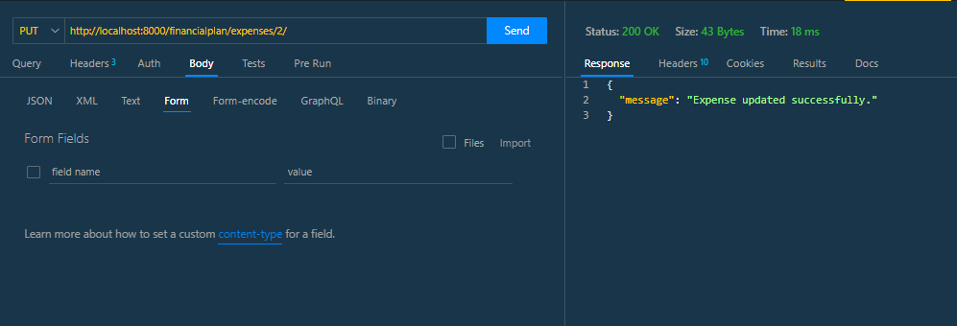

Delete expense

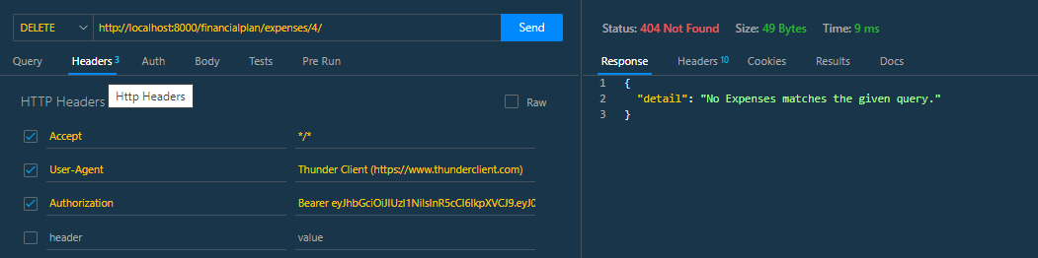

Retrieve expense

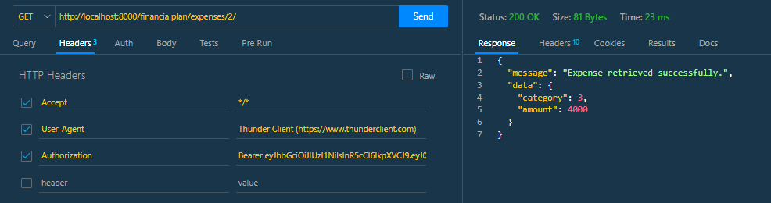

Loan repayment

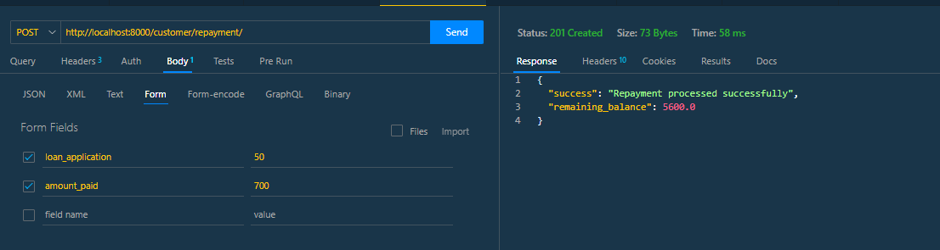

Adding saving goal

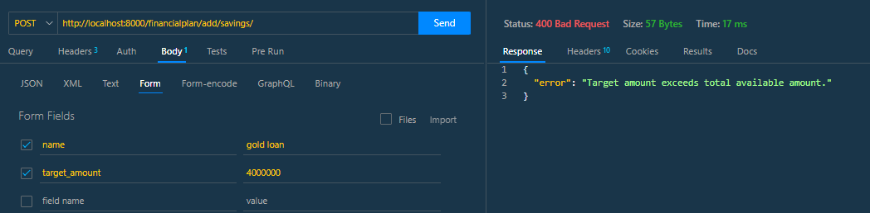

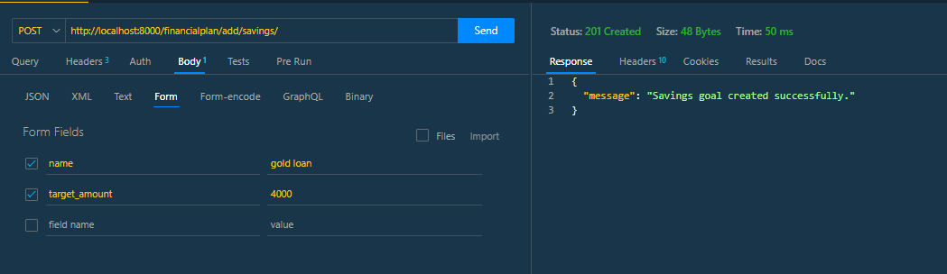

All saving plan

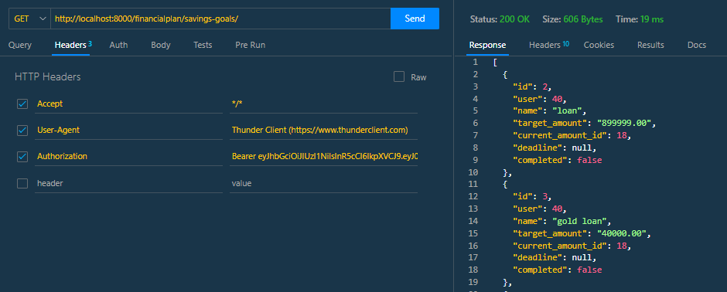

Update saving goal

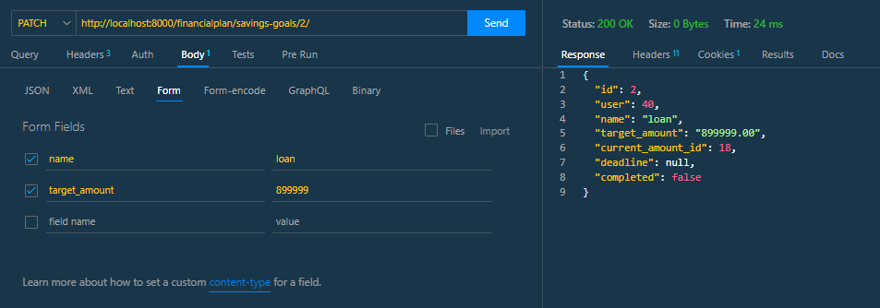

Api documentation

