Registration

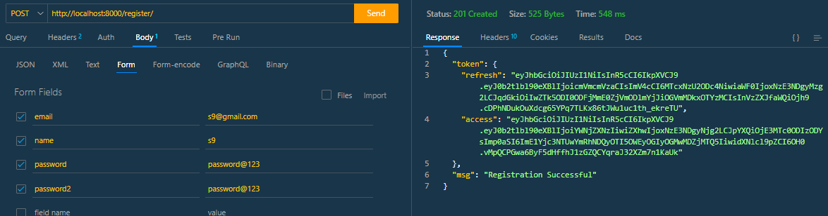

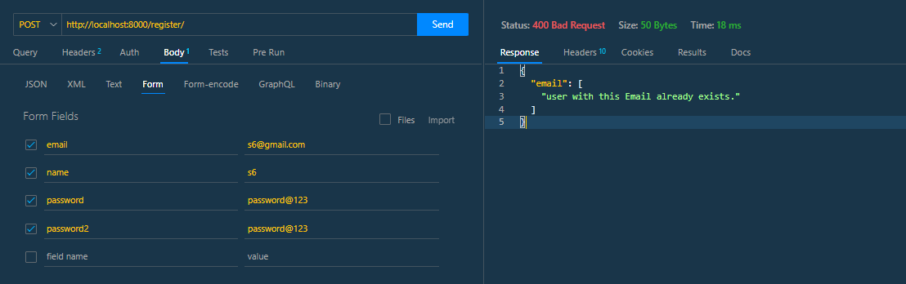

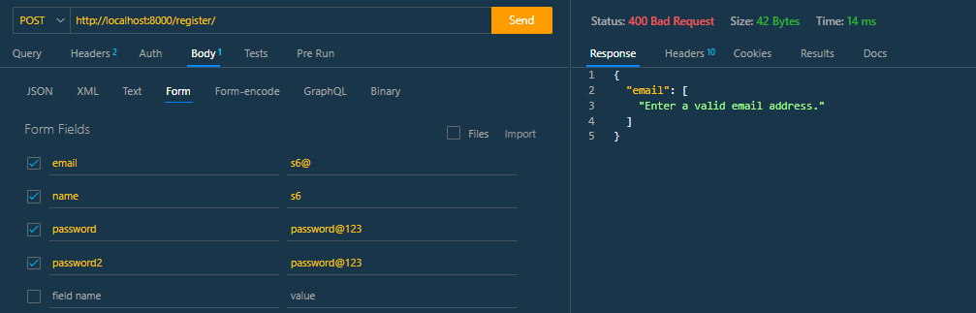­­­­

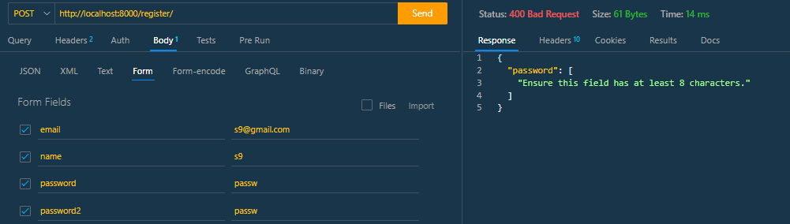

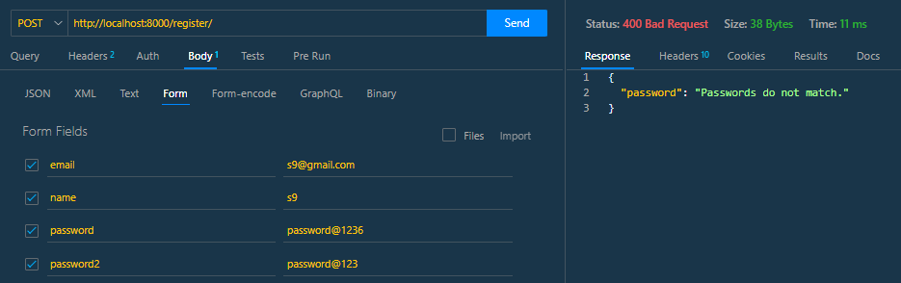

Login

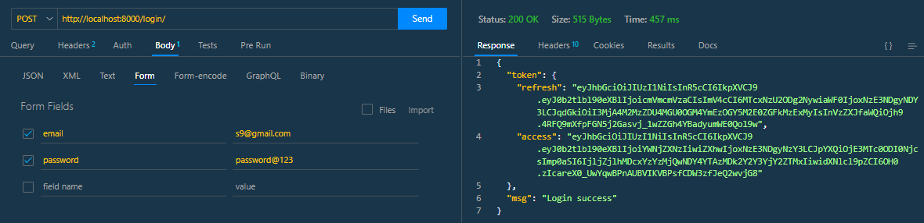

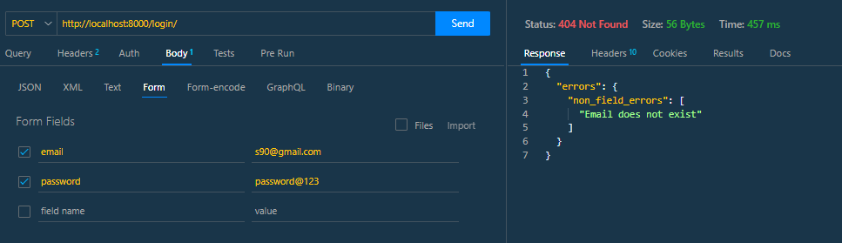

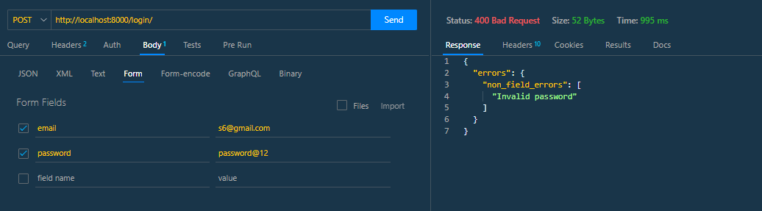

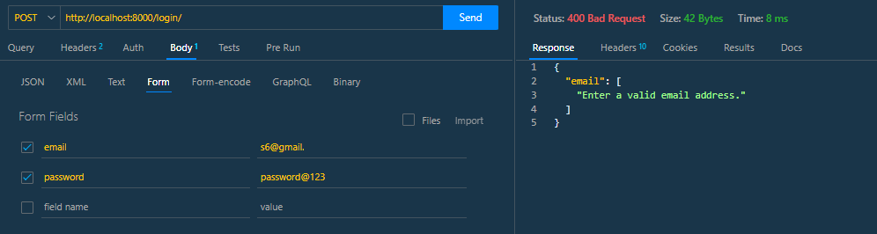

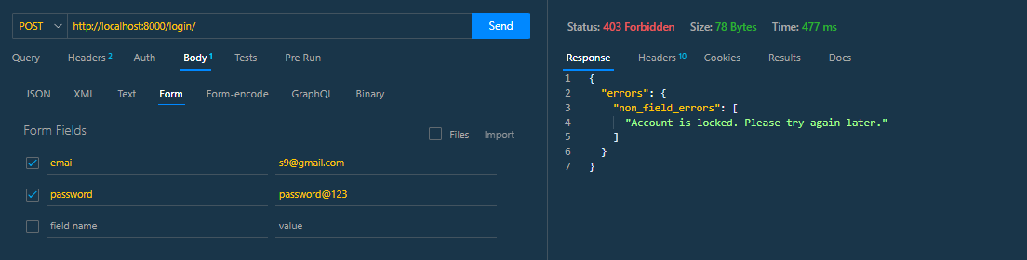

API Documentation





