Architecture

# Concrete Compressive strength Prediction

|  |  |
| --- | --- |
| Written by | Sesha Venkata Sriram Erramilli |
| Document version | 1.3 |
| Last revised date | 01 – Oct - 2021 |

**Document Version Control**

|  |  |  |  |
| --- | --- | --- | --- |
| **Date issued** | **Version** | **Description** | **Author** |
| 01-Oct-21 | 1.0 | First Draft | Sesha Venkata  Sriram Erramilli |
| 01-Oct-21 | 1.1 | Added Technical  specifications | Sesha Venkata  Sriram Erramilli |
| 01-Oct-21 | 1.2 | Added Technology stack, Proposed solution and  Workflow | Sesha Venkata Sriram Erramilli |
| 01-Oct-21 | 1.3 | Added Key  performance indicators (KPI) | Sesha Venkata Sriram Erramilli |
|  |  |  |  |
|  |  |  |  |

# Contents

Abstract 4

1. Introduction 5
   1. Why this Low-level design document? 5
   2. Scope 5
2. Technical specifications 6
   1. Dataset overview 6
   2. Predicting the Concrete compressive strength 7
   3. Logging 7
   4. Exception handling 7
3. Technology stack 8
4. Proposed solution 8
5. Workflow 9
6. Key performance indicators (KPI) 10

## Abstract

Being one of the most frequently used building materials, the quality of concrete is determined by its compressive strength, which is measured by crushing a concrete cube or a cylinder until it starts cracking and crushed. The pressure at which the concrete cube or a cylinder starts cracking and eventually crushes is called the Concrete compressive strength and is measured in megapascals (MPa). It takes a long period of 28 days to test like this. With the help of Data science and the Machine learning technology, I developed an application, which allows an engineer to determine the strength of a concrete in just a few seconds of time.

## Introduction

## Why this Low-level design document?

The goal of LLD or a Low-level design document is to give an internal logical design of the actual program code for the Concrete Compressive Strength Prediction System. LLD describes the class diagrams with the methods and relations between classes and program specs. It describes the modules so that the programmer can directly code the program from the document.

## Scope

Low-level design (LLD) is a component level design process that follows a step-by-step refinement process. This process can be used for designing data structures, required software architecture, source code and ultimately, performance algorithms. Overall, the data organization may be defined during requirement analysis and then defined during data design work.

## Technical specifications

## Dataset overview

For training and testing the model, we used the public data set available in Kaggle, “Concrete Compressive Strength Data Set” by Ahiale Darlington.

URL - [https://www.kaggle.com/elikplim/concrete-compressive-strength-](https://www.kaggle.com/elikplim/concrete-compressive-strength-data-set) [data-set](https://www.kaggle.com/elikplim/concrete-compressive-strength-data-set)

Following is the data dictionary

|  |  |  |  |
| --- | --- | --- | --- |
| Name | Data Type | Measurement | Description |
| Cement | Quantitative | kg in a m3  mixture | Input  variable |
| Blast Furnace Slag | Quantitative | kg in a m3  mixture | Input  variable |
| Fly Ash | Quantitative | kg in a m3  mixture | Input  variable |
| Water | Quantitative | kg in a m3  mixture | Input  variable |
| Superplasticizer | Quantitative | kg in a m3  mixture | Input  variable |
| Coarse Aggregate | Quantitative | kg in a m3  mixture | Input  variable |
| Fine Aggregate | Quantitative | kg in a m3  mixture | Input  variable |
| Age | Quantitative | Days (1~365) | Input  variable |
| Concrete Compressive  Strength | Quantitative | megapascals (MPa) | Output variable |

## Predicting the Concrete compressive strength

* + - The web application must be loaded properly for the users without any technical glitches like server timeouts.
    - It must display the input fields and the “Predict” button to the users who accessed the application and allow the user to enter the values with respect to the quantities of various raw materials used to build a concrete and its age.
    - The user gives the required information.
    - Then the application should be able to predict the compressive strength of the concrete based on the information given by the user.

## 

## Exception handling

Used exceptions handling to catch the errors, so that they will be recorded in logs and ensures the smooth run, without getting terminated in the middle. Once the run gets completed, we can check the log files for the errors and can take an appropriate debugging action.

## Technology stack

|  |  |
| --- | --- |
| Front-end | HTML with CSS styling |
| Back-end | Python version 3.9.12,  Flask version |
| Deployment | Heroku, gunicorn version |

## Proposed solution

The solution proposed here is a web application, which takes the details of the main ingredients of a concrete specimen which contributes to its compressive strength and those details will be taken by an XGBoost regressor model in the backend, which predicts the compressive strength in MPa and displays in the front-end page to the user.

## Workflow

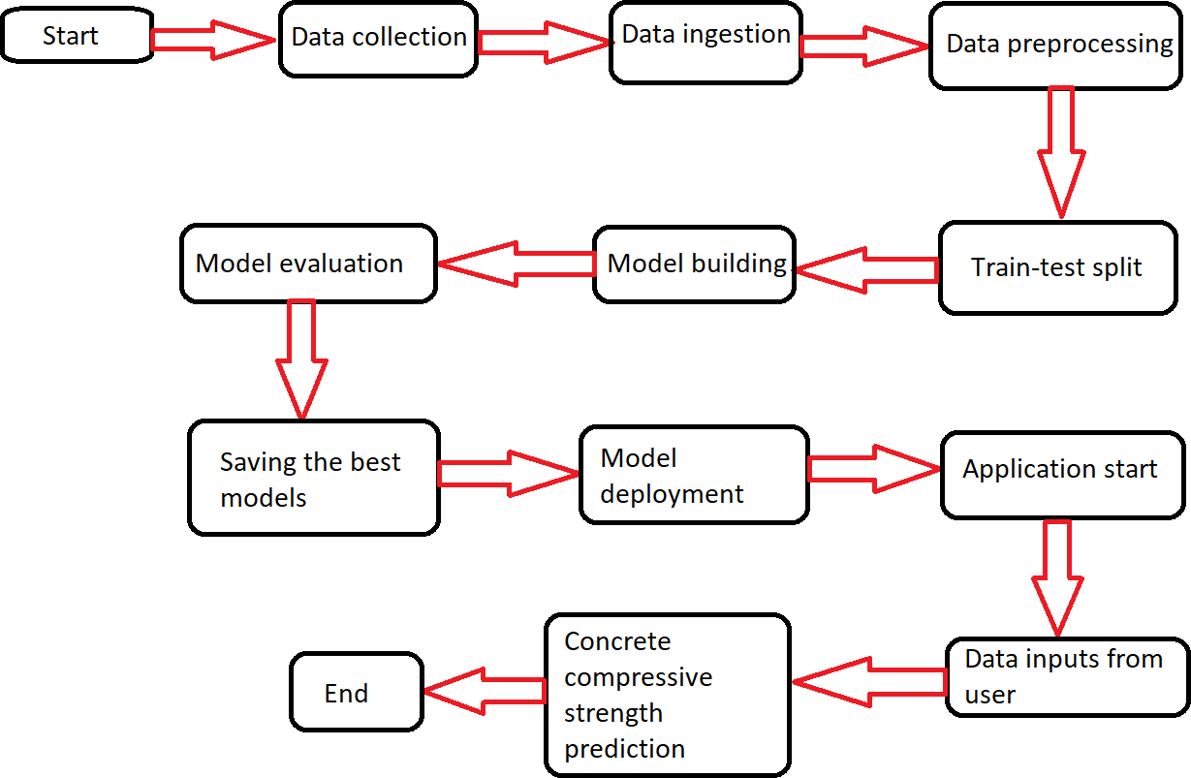

## Key performance indicators (KPI)

* Time and workload reduction using the regression models.
* Comparison of the R2 scores and the Adjusted R2 scores of the model on both the training and the testing data.

## Linear Regression-

## r 2_score in train model- 55%

## r 2_score in test model-63%

## Random forest Regressor-

## r 2_score in train model- 87%

## r 2_score in test model-98%

## Ada Boost Regressor

## r 2_score in train model- 78%

## r 2_score in test model-82%

## Xgboost

## r 2_score in train model- 99.9%

## r 2_score in test model-89.99%

## Grid Search CV is used to find the best parameters of the Xgboost

## r 2_score in train model- 99%

## r 2_score in test model-92%

* Feature importance by each model, as shown below

|  |  |
| --- | --- |
| Algorithm | Imp_Features |
| Linear Regression_ | 'cement', 'blast_furnace_slag', 'fly_ash', 'water', 'superplasticizer', 'coarse_aggregate', 'fine_aggregate ', 'age' |
| Random Forest  regressor | 'cement', 'blast_furnace_slag', 'fly_ash', 'water', 'superplasticizer', 'coarse_aggregate', 'fine_aggregate ', 'age' |
| Adaboost regressor | 'cement', 'blast_furnace_slag', 'fly_ash', 'water', 'superplasticizer', 'coarse_aggregate', 'fine_aggregate ', 'age' |
| XGBoost regressor | 'cement', 'blast_furnace_slag', 'fly_ash', 'water', 'superplasticizer', 'coarse_aggregate', 'fine_aggregate ', 'age' |

* Low water to cement ratio is proportional to the strength of the concrete.