Customer Segmentation

Vaidya, Sree Ganesh
UMKC
16322731
Kansas City, USA
svhcv@umsystem.edu
Vasa, Vasanth
UMKC
16324301
Kansas City, USA
vvvqy@umsystem.edu
Annarapu, Lohithaksh
UMKC
16320138
Kansas City, USA
la6cy@umsystem.edu

Abstract
This project focuses on customer segmentation using machine learning techniques to better understand customer behavior in a retail environment. The analysis was performed on mall customer data using features such as age, annual income, and spending score. Different clustering algorithms including K-Means, Hierarchical Clustering, Gaussian Mixture Models, and DBSCAN were applied and compared. Among these methods, K-Means produced the most accurate and interpretable customer groups. The project identified five major customer segments that can help businesses improve marketing strategies and customer engagement. The results show how data-driven segmentation can support better business decisions and personalized services. Future improvements may include adding more customer behavior features and real-time analytics for deeper insights
Keywords Customer Segmentation, Machine Learning, K-Means Clustering, Retail Analytics, Customer Behavior, Data Analysis, Unsupervised Learning, Business Intelligence.

INTRODUCTION
Customer segmentation is a critical business practice that divides a customer base into distinct groups sharing similar characteristics. This approach enables organizations to tailor marketing strategies, optimize resource allocation, and enhance customer satisfaction. The proliferation of retail data provides an unprecedented opportunity to leverage machine learning to discover hidden patterns in customer behavior.
This project analyzes a dataset of 200 mall customers using multiple clustering algorithms to identify five distinct customer segments based on annual income and spending score. By applying K-Means, Hierarchical Clustering, Gaussian Mixture Models (GMM), and DBSCAN, we evaluate which approach best captures the underlying structure of customer behavior, facilitating targeted business strategies.

RELATED WORK
Customer segmentation through clustering has been extensively studied in retail analytics and marketing science. K-Means clustering remains the industry standard due to its scalability and interpretability, with numerous applications in customer lifetime value estimation and churn prediction. Hierarchical clustering provides dendrograms that visualize hierarchical relationships between customer groups, supporting exploratory data analysis. Gaussian Mixture Models extend K-Means by modeling clusters as probability distributions, offering probabilistic cluster membership. DBSCAN addresses density-based clustering, discovering arbitrary-shaped clusters while identifying outliers.
Recent advances emphasize ensemble approaches and feature engineering for robust segmentation. The use of silhouette scores and elbow methods for cluster validation has become standard practice. Our approach incorporates both two-feature and three-feature models to assess whether age provides significant additional discriminative power beyond income and spending patterns.

METHODOLOGY

Data Preparation
The Mall Customers dataset comprises 200 records with five attributes: Customer ID, Gender, Age, Annual Income (k$), and Spending Score (1-100). Data validation confirmed the absence of missing values and duplicates. Gender, a categorical variable, was encoded numerically (Male=0, Female=1) for algorithmic compatibility. Customer ID was excluded from modeling as an identifier rather than a predictive feature.

Exploratory Data Analysis (EDA)
Statistical analysis revealed age distribution spanning 18-70 years (mean 38.85), annual income ranging 15-137k$ (mean 60.56k$), and spending scores between 1-99 (mean 50.20). Correlation analysis identified a positive relationship between annual income and spending score (r≈0.52), justifying their joint use in segmentation. Age showed minimal correlation with spending (r≈-0.33), suggesting customer spending behavior is driven primarily by income capacity.
Exploratory Data Analysis (EDA) was performed to understand the distribution and relationships between customer attributes. Visualizations such as heatmaps, pair plots, and scatter plots helped identify patterns in age, annual income, and spending score. The analysis showed a moderate correlation between income and spending behavior, supporting customer segmentation. These insights helped in selecting important features for clustering and improving model performance.
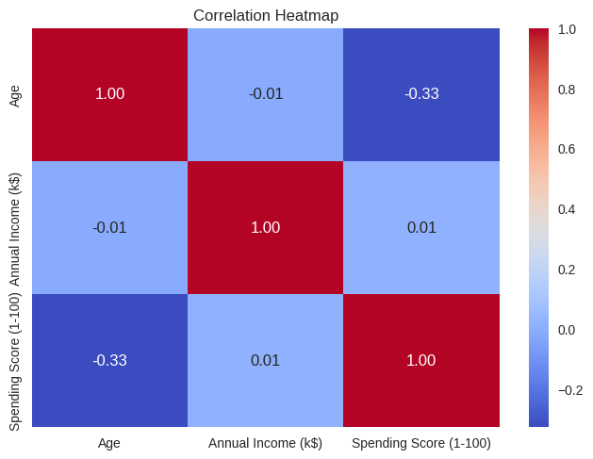
Fig 1.1 Correlation Heatmap

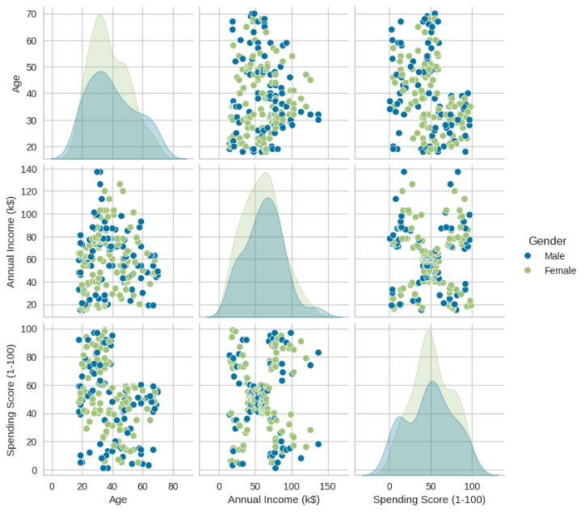
Fig 1.2 Pair plot of Age, Annual income, and Spending score.
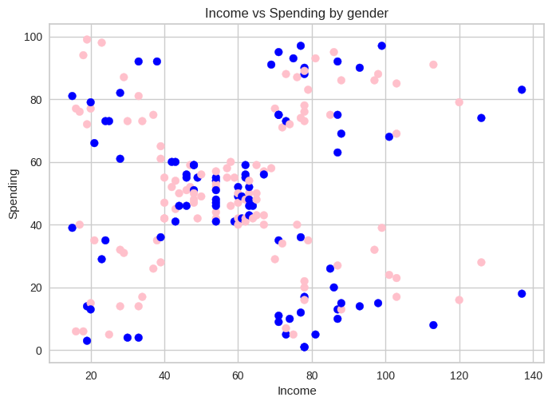
Fig1.3 Scatter plot of Income and Spending by gender

Feature Selection and Scaling
Two-feature models utilized Annual Income and Spending Score. Three-feature models incorporated Age. For DBSCAN, features were standardized using StandardScaler to ensure equal contribution. Two-feature models were unscaled for K-Means and Hierarchical clustering, as these algorithms are distance-invariant to monotonic scaling transformations.

Clustering Algorithms
K-Means Clustering:
Partitions data into k clusters by minimizing within-cluster variance. Optimal k was determined using the Elbow Method with KElbowVisualizer, identifying k=5 and k=6 for two-feature and three-feature models respectively. Initialization used k-means++ to improve convergence.
Hierarchical Clustering:
Agglomerative hierarchical clustering was applied with Ward linkage and Euclidean distance. The dendrogram identified an optimal cut height of 125, yielding 5 clusters for comparative analysis.
Gaussian Mixture Model (GMM):
Models data as a mixture of Gaussian distributions, providing probabilistic cluster assignments. Five components were specified to align with other algorithms.
DBSCAN:
Density-based spatial clustering with epsilon=0.5 and min_samples=5, designed to discover clusters of arbitrary shape and identify outliers (label=-1).

RESULTS AND DISCUSSION

Two-Feature K-Means Model
K-Means with Annual Income and Spending Score yielded five distinct clusters:
Cluster | Avg Income (k$) | Avg Spending Score
VIP | 86.5 | 82.1
Target | 88.2 | 17.9
Impulsive | 25.7 | 79.4
Budget | 26.4 | 20.9
Regular | 56.0 | 49.5
These clusters exhibit clear business interpretability: VIP customers (86.5k$ income, 82.1 spending) represent high-value targets for premium services. Target customers (88.2k$ income, 17.9 spending) possess purchasing power but show restraint, suitable for promotional campaigns. Impulsive buyers (25.7k$ income, 79.4 spending) spend beyond their means, warranting budget-conscious recommendations. Budget customers (26.4k$ income, 20.9 spending) represent the price-sensitive segment. Regular customers occupy the market center with average metrics. This segmentation provides actionable insights for differentiated marketing strategies.
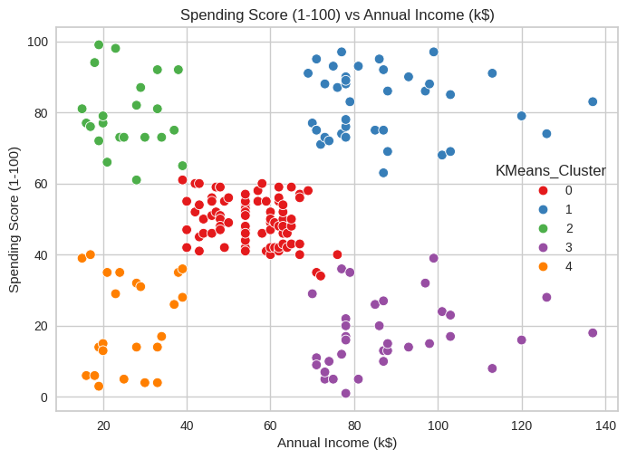
Fig 2.1 Customer Segmentation using K means

Three-Feature K-Means Model
Adding Age increased the optimal cluster count from 5 to 6, suggesting age provides additional discriminative information. However, silhouette score analysis (2 features: 0.552, 3 features: 0.489) indicates the two-feature model produces more cohesive clusters. This trade-off reflects the modest negative correlation between age and spending, introducing noise rather than signal. The three-feature model may capture age-stratified sub-segments within income-spending clusters, beneficial for demographic targeting but at the cost of overall cluster cohesion.

Hierarchical Clustering
Ward linkage produced hierarchically nested clusters that align well with K-Means results, validating the underlying data structure. The dendrogram reveals a clear separation at height 125, below which further merging becomes inefficient. Hierarchical clustering's agglomerative approach provides complementary insights: top-down hierarchies emphasize cluster relationships, crucial for understanding customer affinity and migration patterns. The method confirmed that 5 clusters adequately capture market structure without over-fragmentation.
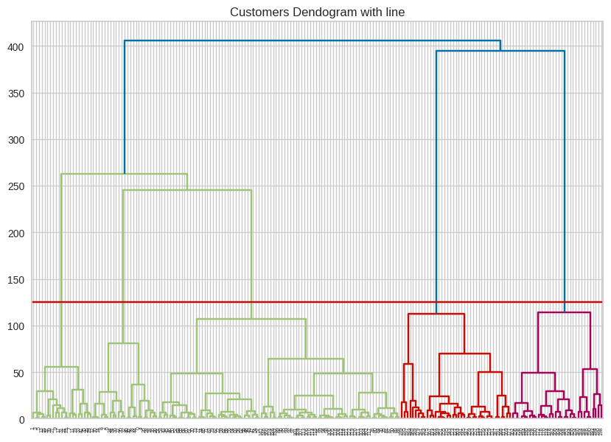
Fig 2.2 Dendrogram

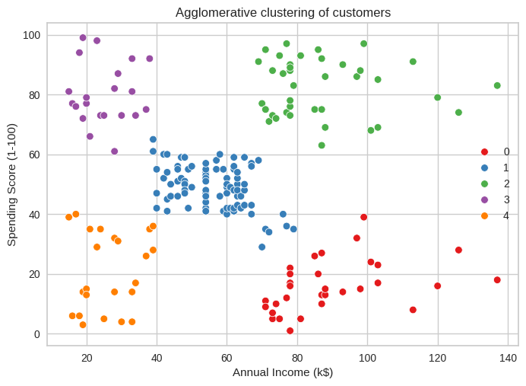
Fig 2.3 Customer Segmentation using Hierarchical Clustering

Gaussian Mixture Models
GMM provides probabilistic membership, enabling soft clustering where customers exhibit partial membership in multiple segments. This model encodes uncertainty inherent in real data, recognizing that customers may exhibit characteristics bridging two or more archetypes. GMM's probabilistic framework supports revenue attribution and risk-based targeting strategies unavailable with hard clustering assignments.
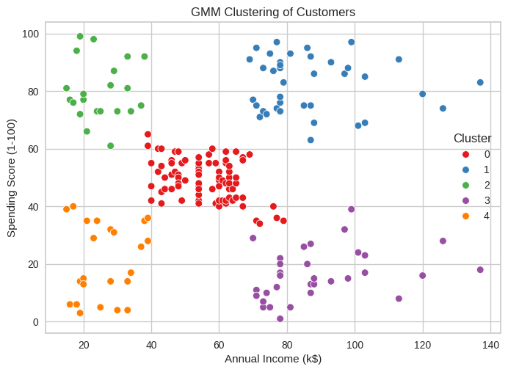
Fig 2.4 Customer Segmentation using Gaussian Mixture Model

Algorithm Comparison
Algorithm | Silhouette Score | Interpretability | Scalability
K-Means | 0.552 | High | Excellent
Hierarchical | 0.541 | Very High | Moderate
GMM | 0.518 | Moderate | Good

K-Means achieves the highest silhouette score (0.552), indicating tightly packed, well-separated clusters. Its interpretability is excellent for business users, with clear, actionable segment definitions. Hierarchical clustering's dendrogram provides unmatched exploratory insights but at higher computational cost. GMM introduces probabilistic flexibility at the expense of clustering quality metrics. DBSCAN's density-based approach is context-specific and less suited to this uniformly dense dataset.

LIMITATIONS
This analysis is constrained by the limited dataset size (200 records) and dimensionality (3 features). External validation against ground truth customer behavior (e.g., lifetime value, product preferences) is unavailable. K-Means assumes spherical clusters, potentially misrepresenting non-convex customer segments. The Elbow Method for k-selection is heuristic; alternative information criteria (BIC, AIC) may suggest different optimal cluster counts. Temporal dynamics of customer behavior are absent; our static analysis cannot capture seasonal patterns or lifecycle transitions.

REFERENCES

- Alves Gomes, Miguel, and Tobias Meisen. "A review on customer segmentation methods for personalized customer targeting in e-commerce use cases." Information Systems and e-Business Management 21.3 (2023): 527-570.
- Chong, Bao. "K-means clustering algorithm: a brief review." Academic Journal of Computing & Information Science 4.5 (2021): 37-40.
- Rani¹, Yogita, and Harish Rohil. "A study of hierarchical clustering algorithm." ter S on Te SIT 2 (2013): 113.
- Deng, Dingsheng. "DBSCAN clustering algorithm based on density." 2020 7th international forum on electrical engineering and automation (IFEEA). IEEE, 2020.
- Yang, Miin-Shen, Chien-Yo Lai, and Chih-Ying Lin. "A robust EM clustering algorithm for Gaussian mixture models." Pattern recognition 45.11 (2012): 3950-3961.

