**Q1**

**Stage 1: Data Collection**

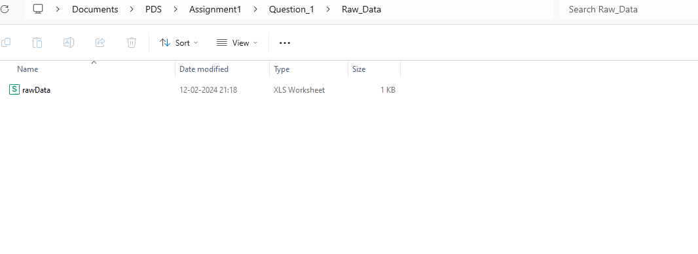

Data is collected and saved in .csv format

**Stage2: Data processing**

Collected data is processed by checking for missing values, converting categorical data to numerical values, and dropping NA values. The cleaned dataset is prepared.

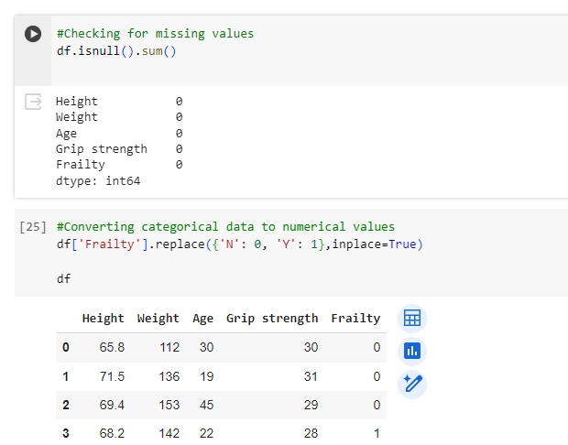

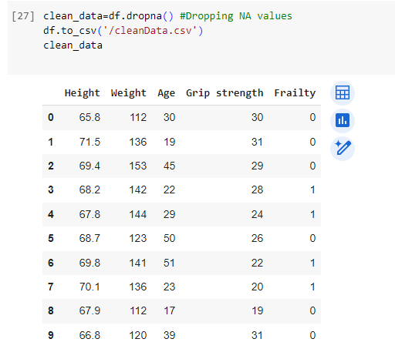

**Stage 3: Data Analysis**

Performed an unpaired two-sample t-test and plotted two visualizations.

The bar plot depicts the average grip strength grouped by frailty level. It indicates that those classified as "Y" (frail) have an average grip strength that is lower than that of people classified as "N" (not frail). This implies that there may be a relationship between physical weakness in frail people and a decline in grip strength.

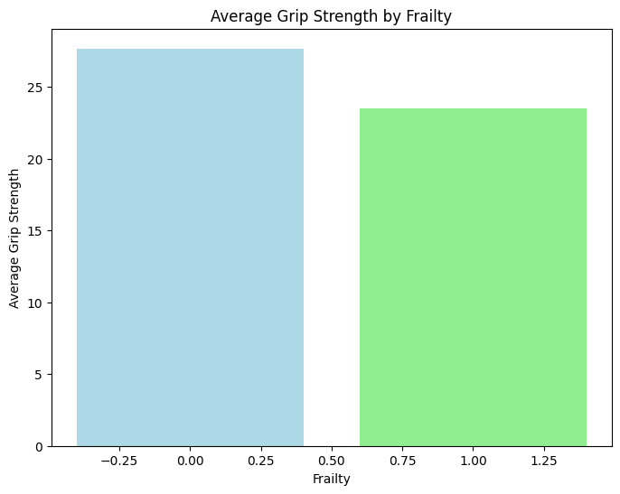

The scatterplot illustrates how grip strength and age relate to one another. It demonstrates a general pattern of decreasing grip strength with increasing age, showing a possible negative correlation between age and grip strength. There are some outliers, indicating that grip strength varies between age groups.

