1. Bar plot of average writing score by gender.

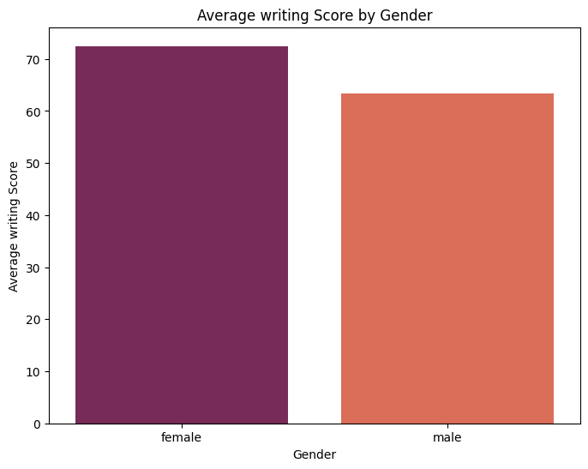

According to the plot, females had slightly higher average writing scores than males. This visualization aids in analyzing gender-based disparities in student writing performance.

1. Box Plot of Writing Scores Grouped by Test Preparation Course.

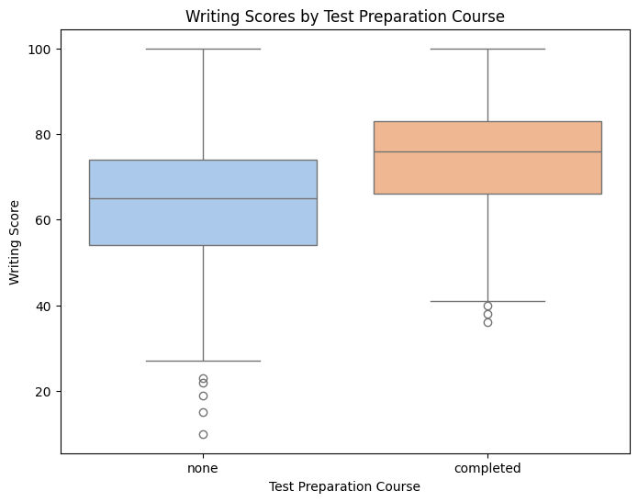  
According to the visualization, students who finished the course often scored better on writing tests than those who didn't.

1. Scatter plot of math score vs reading score.

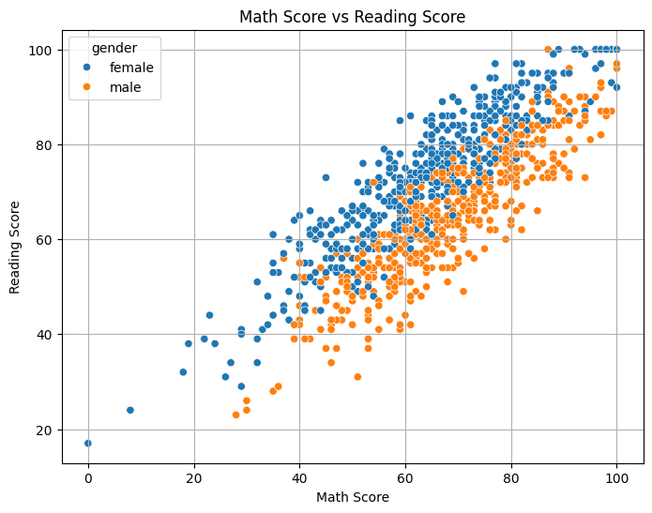

The figure indicates that the two subjects have a positive correlation, with comparable trends being shown by the male and female subjects. Gender differences in performance can be observed, however they are marginal and span the whole score range.

1. Histogram of math score.

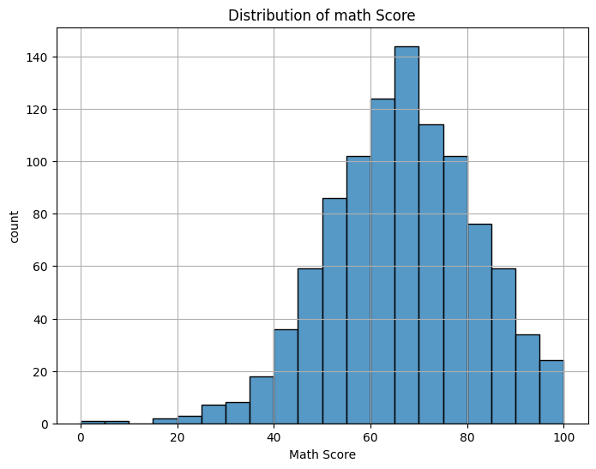

The resulting visualization aids in understanding the total number of math scores among students, as well as finding score patterns and outliers. It peaks at average scores, with very few students receiving extraordinarily high or low marks.

1. Correlation Heatmap of Test Scores.

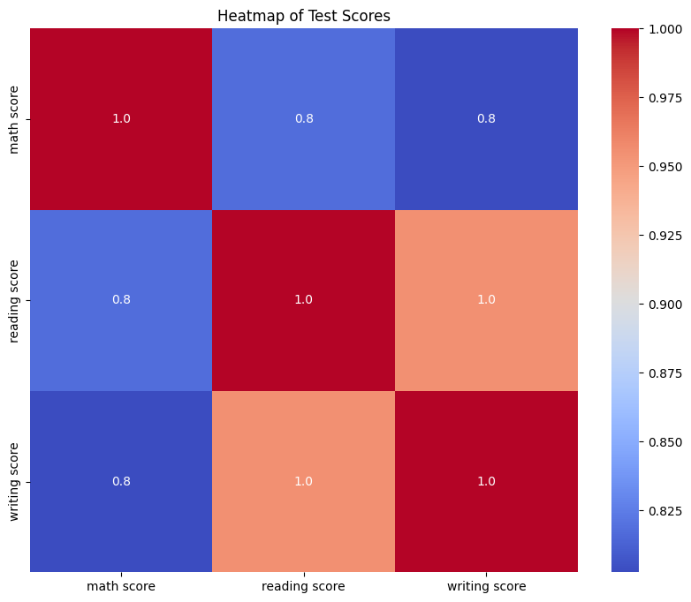

It visualizes the strength and direction of correlations between variables. Stronger correlations (about 1 or -1) signify more robust associations between scores, whereas reduced correlations indicate less robust interactions.