ASSIGNMENT-2

a) Look for the missing values in all the columns and either impute them (replace with mean,

median, or mode) or drop them. Justify your action for this task.

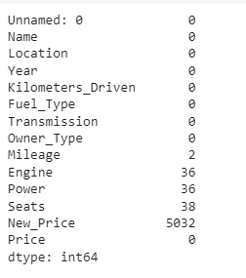

Found missing values in Mileage, Engine, Power, Seats, New_Price. Missing values are replaced with mean. Mean imputation replaces missing values with the column's average value based on observed data. This preserves the variable's central tendency and guarantees that the imputed values are compatible with the data's general distribution. New_Price column is dropped as it has more missing values.