## C:\Users\kaveti_s\Desktop\icons-facebook-facebook-icon-social-media-icon-ios-7-facebook-png--9.png

BitBucket

/[smlcodes](https://twitter.com/smlcodes) [/smlcodes](https://www.facebook.com/SmlCodes-216971275364320/) [/smlcodes](https://www.youtube.com/channel/UCO0JjZa8BcRvc3rTe0BL9HA)



***A*** [***SmlCodes.Com***](http://www.smlcodes.com/) ***Small presentation***

In Association with Idleposts.com

## BitBucket Tutorial

## TUTORIAL



**Small Codes**

Programming Simplified



Copyright © 2017 SmlCodes.com All rights Reserved.

**For more tutorials & Articles visit** [**SmlCodes.com**](http://www.smlcodes.com/)

**Copyright © 2016 Smlcodes.com**

All rights reserved. No part of this book may be reproduced, stored in a retrieval system, or transmitted in any form or by any means, **without the prior written permission** of the publisher, except in the case of brief quotations embedded in critical articles or reviews.

**Every effort has been made in the preparation of this book to ensure the accuracy of the information presented**. However, the information contained in this book is sold without warranty, either express or implied. Neither the author, SmlCodes.com, nor its dealers or distributors will be held liable for any damages caused or alleged to be caused directly or indirectly by this book.

**Smlcodes.com has endeavored to provide trademark information** about all the companies and products mentioned in this book by the appropriate use of capitals. However, SmlCodes.com Publishing cannot guarantee the accuracy of this information.

If you discover any errors on our website or in this tutorial, please notify us at [support@smlcodes.com](mailto:support@smlcodes.com) or [smlcodes@gmail.com](mailto:smlcodes@gmail.com)

**First published on** June 2017, Published by **SmlCodes.com**

Author Credits

Name : **Satya Kaveti**

Email : [satyakaveti@gmail.com](mailto:satyakaveti@gmail.com)

Website : smlcodes.com, satyajohnny.blogspot.com

Digital Partners



[  1](#_Toc466374769)

[- Satya Kaveti 1](file:///E:\users\Kaveti_s\Desktop\Hibernate%20-SmlCodes.com.docx#_Toc466374770)

[HIBERNATE 1](#_Toc466374771)

[HIBERNATE INTRODUCTION 4](#_Toc466374772)

[1. Introduction 4](#_Toc466374773)

[2. What is Hibernate 5](#_Toc466374774)

[3. Hibernate Architecture 6](#_Toc466374775)

[3. Hibernate Hello World Program 8](#_Toc466374776)

[References 11](#_Toc466374777)

# 1.Introduction

**Bitbucket** is a web-based hosting service that is owned by Atlassian, used for source code and development projects that use revision control systems.

Bitbucket offers both commercial plans and free accounts. It offers free accounts with an unlimited number of private. Bitbucket integrates with other Atlassian software **like Jira, HipChat, Confluence and Bamboo.**

It is similar to [GitHub](https://en.wikipedia.org/wiki/GitHub), which primarily uses [Git](https://en.wikipedia.org/wiki/Git_(software)" \o "Git (software)). Bitbucket has traditionally tailored itself towards helping professional developers with private proprietary code, especially since being acquired by Atlassian in 2010. In September 2016, Bitbucket announced it had reached 5 million developers and 900,000 teams on its platform.[[4]](https://en.wikipedia.org/wiki/Bitbucket#cite_note-4) Bitbucket has 3 deployment models: Cloud, Bitbucket Server and Data Center.

## Features

Bitbucket is mostly used **for code and code review**. Bitbucket supports the following features:

* Pull requests with code review and comments
* Bitbucket
* Merge Checks
* Code
* Git Large File Storage
* Documentation, including automatically rendered README files in a variety of Markdown-like file formats
* Issue tracking
* Add-ons and integrations
* REST APIs to build third party applications which can use any development language
* Snippets that allow developers to share code segments or files
* Smart Mirroring

## Installing BitBucket in windows

Follow this article to install BitBucket in Windows

<http://www.smlcodes.com/devops/how-to-install-bitbucket-on-windows/>

# 2. Working with BitBucket

For working with any Source control tool we need know how they perform the Operations like Creating Repository, adding files into repo & How to commit the changes.

Similarly, BitBucket also perform above operations in its own way.

* **Create a Git repository**
* **Copy your Git repository and add files**
* **Pull changes from your Git repository on Bitbucket Cloud**
* **Use a Git branch to merge a file**

Let’s see how we can do it in BitBucket.

## 2.1 Creating projects in BitBucket

Projects allow you to group repositories and to manage permissions for them in an aggregated way.

* To create a project, go to **Projects** & click on **Create project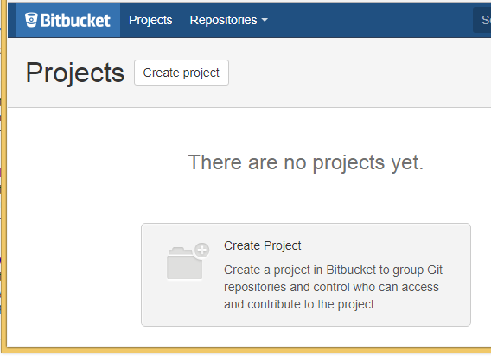**
* Fill out the form & Click **Create project** when you're done. 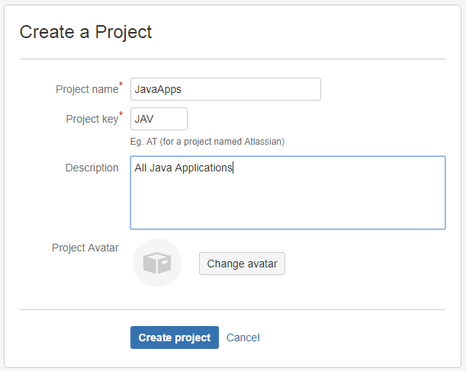
* It will show the Empty Project Dashboard as below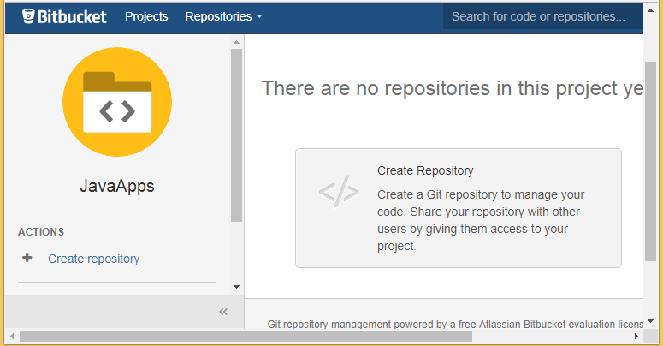

## 2.2 Creating new Repository in BitBucket

Initially, the repository you create in Bitbucket is going to be empty without any code in it. This Bitbucket repository will be the central repository for your files, which means that others can access that repository if you give them permission.

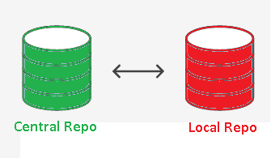

**Steps to create new repository:**

* **Repositories > Create repository** button at the top of the page
* It displays the **Create a new repository page**, fill the details & click on **Create repository** button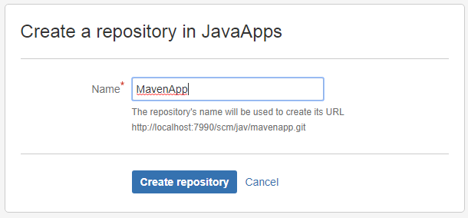
* It will show the Empty Repository as below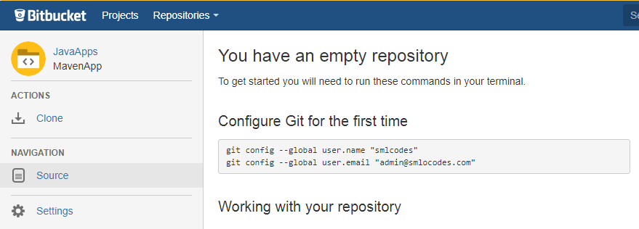

## 2.3 Cloning a repository

Before Cloning Repo, we need to add SSH key to our Repo.for doing this open command prompt & go to C:/Users/<Your\_Account> and type below command to generate SSH key

ssh-keygen -t rsa -C "admin@example.com"

If you already installed Git, then use **ssh-keygen** command & just press <Enter> key

$ ssh-keygen

Generating public/private rsa key pair.

Enter file in which to save the key (/c/Users/kaveti\_S/.ssh/id\_rsa):

Created directory '/c/Users/kaveti\_S/.ssh'.

Enter passphrase (empty for no passphrase):

Enter same passphrase again:

Your identification has been saved in /c/Users/kaveti\_S/.ssh/id\_rsa.

Your public key has been saved in /c/Users/kaveti\_S/.ssh/id\_rsa.pub.

The key fingerprint is:

SHA256:D2bOf2p8mlo3qAua8AWOtKjVjkyH/pTeHgVfGw7hrRs kaveti\_S@HYDPCM90480L

The key's randomart image is:

+---[RSA 2048]----+

| . |

| . o |

| . o + |

| o = o |

| . . E o |

| o \* o \* = . |

|. B \* + +.+ o |

|.= O = o +ooo. |

|. +.B.o ++== |

Key is generated in **C:\Users\<Your\_Account>\_S\.ssh\id\_rsa** file. On Windows, in your command prompt, change directory to your .ssh directory, and copy the public key file to your clipboard by running

cd %userprofile%/.ssh

clip < id\_rsa.pub

Go to **BitBucket Home> Manage Account > SSH Keys > Add Key** Paste the key in text box. 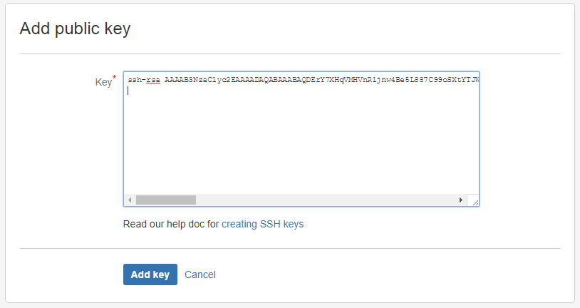

For Details Check this [article](https://confluence.atlassian.com/bitbucketserver046/using-bitbucket-server/controlling-access-to-code/using-ssh-keys-to-secure-git-operations/creating-ssh-keys?utm_campaign=in-app-help&utm_medium=in-app-help&utm_source=stash)

* From the repository, click **Clone** in the sidebar & Copy the clone command (SSH/HTTPS). 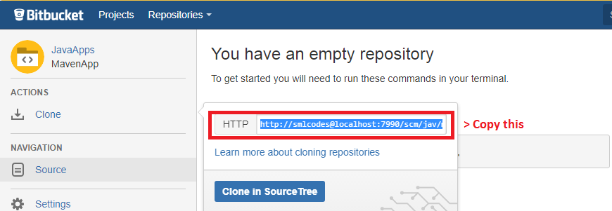
* From a terminal window, Paste the command you copied from Bitbucket.

# References

<https://www.atlassian.com/git/tutorials/learn-git-with-bitbucket-cloud>

<https://www.atlassian.com/git/tutorials/learn-git-with-bitbucket-cloud>