## C:\Users\kaveti_s\Desktop\icons-facebook-facebook-icon-social-media-icon-ios-7-facebook-png--9.png

/[smlcodes](https://twitter.com/smlcodes) [/smlcodes](https://www.facebook.com/SmlCodes-216971275364320/) [/smlcodes](https://www.youtube.com/channel/UCO0JjZa8BcRvc3rTe0BL9HA)



***A*** [***SmlCodes.Com***](http://www.smlcodes.com/) ***Small presentation***

In Association with Idleposts.com

## Hibernate Tutorial

HIBERNATE

## TUTORIAL



**Small Codes**

Programming Simplified



Copyright © 2017 SmlCodes.com All rights Reserved.

**For more tutorials & Articles visit** [**SmlCodes.com**](http://www.smlcodes.com/)

**Copyright © 2017 Smlcodes.com**

All rights reserved. No part of this book may be reproduced, stored in a retrieval system, or transmitted in any form or by any means, **without the prior written permission** of the publisher, except in the case of brief quotations embedded in critical articles or reviews.

**Every effort has been made in the preparation of this book to ensure the accuracy of the information presented**. However, the information contained in this book is sold without warranty, either express or implied. Neither the author, SmlCodes.com, nor its dealers or distributors will be held liable for any damages caused or alleged to be caused directly or indirectly by this book.

**Smlcodes.com has endeavored to provide trademark information** about all the companies and products mentioned in this book by the appropriate use of capitals. However, SmlCodes.com Publishing cannot guarantee the accuracy of this information.

If you discover any errors on our website or in this tutorial, please notify us at [support@smlcodes.com](mailto:support@smlcodes.com) or [smlcodes@gmail.com](mailto:smlcodes@gmail.com)

**First published on** Aug 2017, Published by **SmlCodes.com**

Author Credits

Name : **Satya Kaveti**

Email : [satyakaveti@gmail.com](mailto:satyakaveti@gmail.com)

Website : smlcodes.com, satyajohnny.blogspot.com

Digital Partners



[  1](#_Toc491771288)

[Hibernate Tutorial 1](#_Toc491771289)

[TUTORIAL 1](file:///E:\Users\kaveti_s.ITLINFOSYS\Desktop\Hibernate%20Tutorial%20PDF.docx#_Toc491771290)

[1. Introduction 5](#_Toc491771291)

[**JDBC vs HIBERNATE** 5](#_Toc491771292)

[Hibernate Architecture 6](#_Toc491771293)

[Hibernate Installation 8](#_Toc491771294)

[2. Hibernate Example Step by Step 9](#_Toc491771295)

[1. Choose Database Table 9](#_Toc491771296)

[2. POJO class / Persistance class 9](#_Toc491771297)

[3. Mapping File 10](#_Toc491771298)

[4. Configuration File 11](#_Toc491771299)

[5. Application class for main logic 12](#_Toc491771300)

[Dialects in Hibernate 15](#_Toc491771301)

[3. Hibernate CURD Operations 15](#_Toc491771302)

[1. SELECT Operation using Hibernate 17](#_Toc491771303)

[2. INSERT Operation using Hibernate 18](#_Toc491771304)

[3. UPDATE Operation using Hibernate 19](#_Toc491771305)

[4. DELETE Operation using Hibernate 20](#_Toc491771306)

[4. Hibernate POJO Class Lifecycle 21](#_Toc491771307)

[5. Hibernate Inheritance Mapping 22](#_Toc491771308)

[1. Table per class hierarchy 25](#_Toc491771309)

[2. Table per sub-class hierarchy 26](#_Toc491771310)

[3. Table per concrete class hierarchy 28](#_Toc491771311)

[6. Hibernate Generators <generator> 29](#_Toc491771312)

[List of generators 29](#_Toc491771313)

[Generators Example 33](#_Toc491771314)

[7. Hibernate Query Language (HQL) 35](#_Toc491771315)

[SQL vs HQL 35](#_Toc491771316)

[Query Interface 36](#_Toc491771317)

[HQL Examples 36](#_Toc491771318)

[HQL with Aggregate functions 40](#_Toc491771319)

[8. Hibernate Criteria Query Language(HCQL) 41](#_Toc491771320)

[Working with Criteria Query Language 41](#_Toc491771321)

[Hibernate Projections 45](#_Toc491771322)

[9. Native SQL Queries 47](#_Toc491771323)

[Working with Native SQL Queries 47](#_Toc491771324)

[10. Named Queries 49](#_Toc491771325)

[11. Hibernate Relationships 52](#_Toc491771326)

[Relationships in Hibernate 53](#_Toc491771327)

[1.One-to-One Relationship Mapping Example 54](#_Toc491771328)

[2.One-to-Many / Many-to-One Relationship 57](#_Toc491771329)

[3.Many to Many Relationship 60](#_Toc491771330)

[12. Hibernate Cache 63](#_Toc491771331)

[13. Hibernate with Annotations 67](#_Toc491771332)

[Commonly used Annotations in Hibernate 67](#_Toc491771333)

[Example : CURD oprations using Annotations 68](#_Toc491771334)

[Mappings using Annotations 71](#_Toc491771335)

[Errors & Solutions 77](#_Toc491771336)

[org.hibernate.HibernateException: Could not parse configuration: hibernate.cfg.xml 77](#_Toc491771337)

[References 77](#_Toc491771338)

# 1. Introduction

Hibernate is the ORM tool given to transfer the data between a java (object) application and a database (Relational) in the form of the objects.  Hibernate is the open source light weight tool given by **Gavin King**.

Hibernate is a non-invasive framework, means it won’t force the programmers to extend/implement any class/interface, and in hibernate we have all POJO classes so its light weight

## **JDBC vs HIBERNATE**

|  |  |
| --- | --- |
| **JDBC** | **HIBERNATE** |
| Programmer must close the connection. Jdbc doesn’t responsible to close the connection. | Hibernate will take care about closing the connections |
| if the table structure is modified then the JDBC program doesn’t work, again we need to modify and compile the programs | Hibernate has its own query language(HQL) and it is database independent. So if we change the database, then also our application will work, because HQL is database independent |
| In jdbc all exceptions are checked exceptions, so we must write code in try, catch and throws | hibernate we have only Un-checked exceptions, so no need to write try, catch, or throws |
| JDBC won’t generate primary keys automatically | Hibernate has capability to generate primary keys automatically while we are storing the records into database. |
| JDBC won’t support Caching mechanism | Hibernate supports caching mechanism by this, the number of round trips between an application and the database will be reduced, by using this caching technique an application performance will be increased automatically. |
| In JDBC , we need to write SQL queries manually | Hibernate provided Dialect classes, so we no need to write sql queries in hibernate, instead we use the methods provided by that API |

## Hibernate Architecture

The diagram below provides a high-level view of the Hibernate architecture:

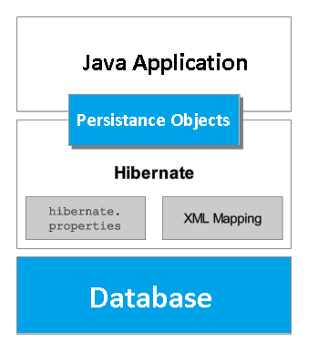

Following is a detailed view of the Hibernate Application Architecture

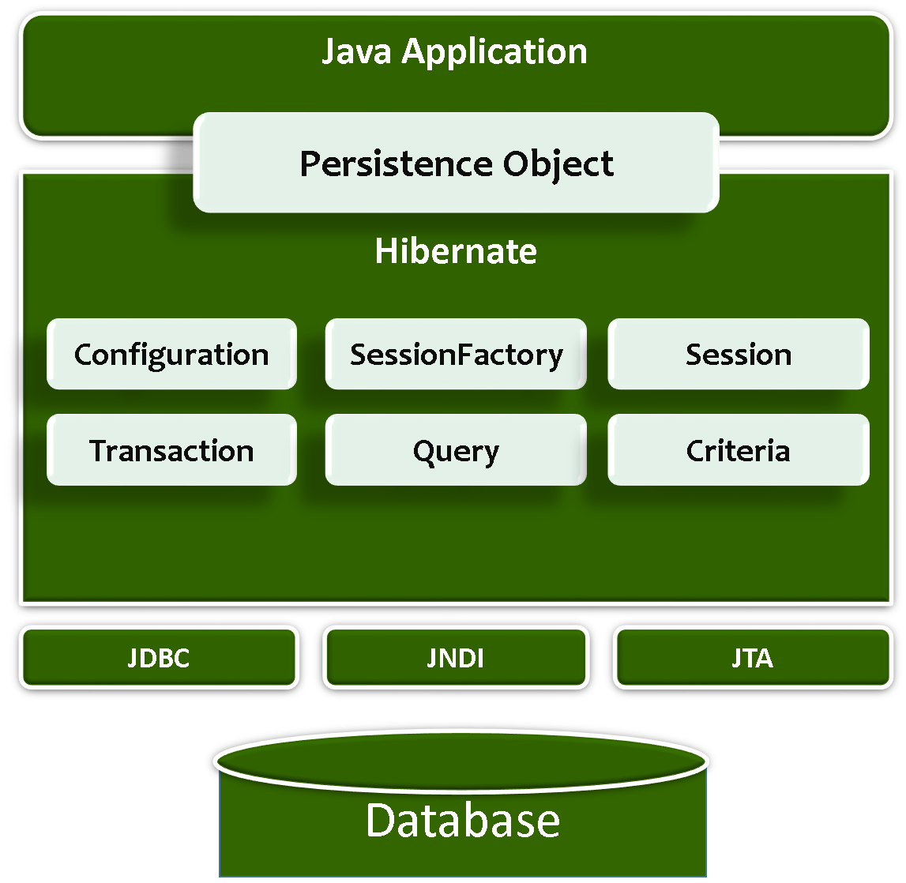

Hibernate uses various existing Java APIs, like JDBC, Java Transaction API(JTA), and Java Naming and Directory Interface (JNDI) along with its own API objects like SessionFactory, Session, Transaction etc.,

### 1. Configuration

It represents a **configuration or properties file required by the Hibernate**. Configuration is the file loaded into hibernate application when working with hibernate.

Configuration file contains 3 types of information.

1. **Connection Properties**
2. **Hibernate Properties**
3. **Mapping file name(s)**

  <? xml version=*'1.0'* encoding=*'utf-8'*?>

<! DOCTYPE hibernate-configuration PUBLIC

        "-//Hibernate/Hibernate Configuration DTD 3.0//EN"

        "http://hibernate.sourceforge.net/hibernate-configuration-3.0.dtd">

<hibernate-configuration>

    <session-factory>

        <! -- Database connection settings -->

        <property name=*"connection.driver\_class"*>com.mysql.jdbc.Driver</property>

        <property name=*"connection.url"*>jdbc:mysql://localhost:3306/mydb</property>

        <property name=*"connection.username"*>root</property>

        <property name=*"connection.password"*>root</property>

        <property name=*"connection.pool\_size"*>1</property>

        <!-- Hibernate Properties -->

        <property name=*"dialect"*>org.hibernate.dialect.MySQLDialect</property>

        <property name=*"show\_sql"*>true</property>

            <property name=*"hbm2ddl.auto"*>validate</property>

<!-- Mapping file name(s)-->

        <mapping resource=*"res/employee.hbm.xml"*/>

    </session-factory>

</hibernate-configuration>

### 2. SessionFactory Object

It holds second level cache (optional) of data like **Dialect, username and password**. The **org.hibernate.SessionFactory** interface provides factory method **to get the object of Session**

### 3. Session Object

It Opens a Session between Database and our Application. It holds a **first-level cache (mandatory**) of data. The **org.hibernate.Session** interface provides **methods to insert, update and delete** the object

### 4. Transaction Object

The **org.hibernate.Transaction** interface provides methods for transaction management.

### 5. Query Object

Query objects use SQL or Hibernate Query Language (HQL) string to retrieve data from the database and create objects.

### 6. Criteria Object

Criteria object are used to create and execute object oriented criteria queries to retrieve objects.

## Hibernate Installation

Working with the framework software is nothing but, adding the .jar(s) files provided by that framework to our java application. We can add hibernate jars in two ways

### 1.Hibernate install using maven

We just need to add hibernate maven dependencies in pom.xml

<dependency>

<groupId>org.hibernate</groupId>

<artifactId>hibernate-core</artifactId>

<version>5.2.10. Final</version>

</dependency>

### 2. Download Hibernate jars & add to project

Download jar from [hibernate.org](http://hibernate.org/orm/downloads/) / from here & extract the zip file. We don’t need to add all the jars. We need to add following jars.

Anttr-2.7.6.jar  
asm.jar  
asm-attrs.jar  
cglib-2.1.3.jar  
commons-collections-2.1.1.jar  
commons-logging-1.0.4.jar  
ehcash.jar  
dom4j-1.6.1.jar  
**hibernate3.jar**  
jta.jar  
log4j-1.2.3.jar

along with the hibernate jars we must include one more jar file, which is nothing but related to our database, this is depending on your database

# 2. Hibernate Example Step by Step

For Developing any hibernate application we need create below 4 files always

1. **Choose Database Table**
2. **POJO class**
3. **Mapping XML**
4. **Configuration XML**
5. **Application class for main logic**

Above are the minimum requirement to run any hibernate application, but we may create any number of POJO classes and any number of mapping xml files (**Number of POJO classes = that many number of mapping xmls**), and only **one configuration xml** and finally **one java file to write our logic**.

## 1. Choose Database Table

In this Example we are taking ‘**employee’** table of ‘mydb’ database.

**CREATE** **TABLE** `employee` (

`eid` **INT**(11) **NOT** **NULL** **AUTO\_INCREMENT**,

`name` **VARCHAR**(50) **NOT** **NULL** **DEFAULT** '0',

`address` **VARCHAR**(50) **NOT** **NULL** **DEFAULT** '0',

**PRIMARY** **KEY** (`eid`)

)

**COLLATE**='latin1\_swedish\_ci'

**ENGINE**=**InnoDB**

**AUTO\_INCREMENT**=5

;

mysql> select \* from employee;

+-----+-------+------------+

| eid | name | address |

+-----+-------+------------+

| 1 | SATYA | VIJAYAWADA |

| 2 | SURYA | HYDERABAD |

| 3 | RAVI | PUNE |

+-----+-------+------------+

## 2. POJO class / Persistance class

* **POJO is a simple java file**, no need to extend any class or implement any interface.
* Pojo class contains **table column names as data members,**
* In above table eid, name, address are columns
* **It contains column names as private data members with setters and getters**

**EmployeeBo.java**

**package** bo;

**public** **class** EmployeeBo {

**private** **int** eid;

**private** String name;

**private** String address;

**public** **int** getEid() {

**return** eid;

}

**public** **void** setEid(**int** eid) {

**this**.eid = eid;

}

**public** String getName() {

**return** name;

}

**public** **void** setName(String name) {

**this**.name = name;

}

**public** String getAddress() {

**return** address;

}

**public** **void** setAddress(String address) {

**this**.address = address;

}

}

## 3. Mapping File

* Mapping file contains **mapping from a pojo class name to a table name** and **pojo class variable names to table column names.**
* We can create any no. of mapping files
* Mapping can be done using 2 ways, using XML & using Annotations.

**Syntax of mapping xml (Pojaclassname.hbm.xml)**

<hibernate-mapping>

<class name=*"POJO class name"* table=*"table name in database"*>

<id name=*"variable name"* column=*"column name in db"* type=*"java/hib type"* />

<property name=*"var1 name"* column=*"column name in db"* type=*"java/hib type"* />

<property name=*"var2 name"* column=*"column name in db"* type=*"java/hib type"* />

</class>

</hibernate-mapping>

**Example: EmployeeBo.hbm.xml**

<hibernate-mapping>

<class name=*"bo.EmployeeBo"* table=*"employee"*>

<id name=*"eid"* column=*"eid"*>

<generator class=*"assigned"* />

</id>

<property name=*"name"* column=*"name"* />

<property name=*"address"* column=*"address"* />

</class>

</hibernate-mapping>

**Explanation**

* **<hibernate-mapping>** is the root element in the mapping file.
* **<class/>** specifies the Persistent/POJO class.
* **<id/>** specifies the primary key attribute in the class.
* **<generator>** is the sub element of id. It is used to generate the primary key. There are many generator classes such as assigned (It is used if id is specified by the user), increment, hilo, sequence, native etc. We will learn all the generator classes later.
* **property** It is the subelement of class that specifies the property name of the Persistent class.

## 4. Configuration File

* Configuration file contains 3 types of information.

1. **Connection Properties**
2. **Hibernate Properties**
3. **Mapping file name(s)**

* **We must create configuration file for each database we are going to use.**

No. of databases we are using = That many number of configuration files

**Syntax of Configuration file**

<hibernate-configuration>

<session-factory>

<!-- Related to the connection START -->

<property name=*"connection.driver\_class"*>Driver Class Name </property>

<property name=*"connection.url"*>URL </property>

<property name=*"connection.user"*>user </property>

<property name=*"connection.password"*>password</property>

<!-- Related to the connection END -->

<!-- Related to hibernate properties START -->

<property name=*"show\_sql"*>true/false</property>

<property name=*"dialet"*>Database dialet class</property>

<property name=*"hbm2ddl.auto"*>create/update or what ever</property>

<!-- Related to hibernate properties END-->

<!-- Related to mapping START-->

<mapping resource=*"hbm file 1 name .xml"* / >

<mapping resource=*"hbm file 2 name .xml"* / >

<!-- Related to the mapping END -->

</session-factory>

</hibernate-configuration>

**Example: hibernate.cfg.xml**

<?xml version=*'1.0'* encoding=*'UTF-8'*?>

<!DOCTYPE hibernate-configuration PUBLIC

"-//Hibernate/Hibernate Configuration DTD 3.0//EN"

"http://hibernate.sourceforge.net/hibernate-configuration-3.0.dtd">

<hibernate-configuration>

<session-factory>

<property name=*"hibernate.connection.driver\_class"*>com.mysql.jdbc.Driver</property>

<property name=*"hibernate.connection.url"*>jdbc:mysql://localhost:3306/smlcodes</property>

<property name=*"hibernate.connection.username"*>root</property>

<property name=*"hibernate.connection.password"*>root</property>

<property name=*"hibernate.dialect"*>org.hibernate.dialect.MySQLDialect</property>

<property name=*"show\_sql"*>true</property>

<property name=*"hbm2ddl.auto"*>update</property>

<mapping resource=*"EmployeeBo.hbm.xml"* />

</session-factory>

</hibernate-configuration>

## 5. Application class for main logic

We will create our application class with the **main()** method to run the application. We will use this application to save Employee data. Please follow the steps to write Application class

### 1. Load Hibernate API into Our Application

Load hibernate API by writing these two lines on the top of the application.

**import** org.hibernate.\*;

**import** org.hibernate.cfg.\*;

### 2. Load Configurations

Among **Configuration(hibernate.cfg.xml), Mapping xml files**, first we need to load configuration xml, because once we load the configuration file, automatically mapping xml file will also load, because it is defined it **Configuration(hibernate.cfg.xml) file**

We can load the configuration file by using **Configuration** class Object. **cfg.configure(“xml”)** loads the all the configurations from config file and save in **config object, now config object contains all configuration details.**

Configuration cfg = **new** Configuration();

cfg.configure("hibernate.cfg.xml");

### 3. Open Session

SessionFactory will produces the Session objects based on the requests. To get Session Object we have to call openSession() method on Sessionfactory Object.

Usually an application has a single [SessionFactory](https://docs.jboss.org/hibernate/orm/3.5/api/org/hibernate/SessionFactory.html) instance and threads servicing client requests obtain [Session](https://docs.jboss.org/hibernate/orm/3.5/api/org/hibernate/Session.html) instances from this factory.

Whenever session is opened then internally a database connection will be opened

SessionFactory factory = cfg.buildSessionFactory();

Session session = factory.openSession();

### 4. Create Transaction Object

While working with **insert, update, delete, operations** from a hibernate application onto the database then hibernate needs a logical Transaction, if we are **selecting an object** from the database then we do **not require any logical transaction** in hibernate.

To begin a logical transaction in hibernate then we need to call a method **beginTransaction()** given by Session Interface

Transaction tx = session.beginTransaction();

session.save(bo);

System.***out***.println("Employee Data saved successfully.....!!");

tx.commit();

We have following methods for performing CURD operations

**session.save(bo) - Inserting object "bo"into database**

**session.update(bo) - Updating object "bo" in the database**

**session.load(bo) - Selecting object "bo" object**

**session.delete(bo) - Deleting object "bo"from database**

Finally we need to call **commit()**in Transaction, like **tx.commit()**;

### 5. Close the Connections

Finally we need to close the all opend connections

session.close();

factory.close();

**Example : EmployeeSave.java**

**package** app;

**import** org.hibernate.\*;

**import** org.hibernate.cfg.\*;

**import** bo.EmployeeBo;

**public** **class** EmployeeSave {

**public** **static** **void** main(String[] args) {

Configuration cfg = **new** Configuration();

cfg.configure("hibernate.cfg.xml");

SessionFactory factory = cfg.buildSessionFactory();

Session session = factory.openSession();

EmployeeBo bo = **new** EmployeeBo();

bo.setEid(5);

bo.setName("DILEEP");

bo.setAddress("BANGLORE");

Transaction tx = session.beginTransaction();

session.save(bo);

System.***out***.println("Employee Data saved successfully.....!!");

tx.commit();

session.close();

factory.close();

}

}

log4j:WARN No appenders could be found for logger (org.hibernate.cfg.Environment).

log4j:WARN Please initialize the log4j system properly.

Employee Data saved successfully.....!!

Hibernate: insert into employee (name, address, eid) values (?, ?, ?)

Summarized Steps for creating Application class

Configuration

SessionFactory

Session

Transaction

Close Statements

## Dialects in Hibernate

For connecting any hibernate application with the database, you must specify the SQL dialects. There are many Dialects classes defined for RDBMS in the org.hibernate.dialect package. They are as follows:

|  |  |
| --- | --- |
| **RDBMS** | **Dialect** |
| **Oracle (any version)** | **org.hibernate.dialect.OracleDialect** |
| **Oracle9i** | **org.hibernate.dialect.Oracle9iDialect** |
| **Oracle10g** | **org.hibernate.dialect.Oracle10gDialect** |
| **MySQL** | **org.hibernate.dialect.MySQLDialect** |
| **MySQL with InnoDB** | **org.hibernate.dialect.MySQLInnoDBDialect** |
| **MySQL with MyISAM** | **org.hibernate.dialect.MySQLMyISAMDialect** |
| **DB2** | **org.hibernate.dialect.DB2Dialect** |
| **DB2 AS/400** | **org.hibernate.dialect.DB2400Dialect** |
| **DB2 OS390** | **org.hibernate.dialect.DB2390Dialect** |
| **Microsoft SQL Server** | **org.hibernate.dialect.SQLServerDialect** |
| **SAP DB** | **org.hibernate.dialect.SAPDBDialect** |
| **Informix** | **org.hibernate.dialect.InformixDialect** |

# 3. Hibernate CURD Operations

Now we will see how to insert, delete, update & select data from/into database using hibernate. Below files are common to all CURD operation examples, follow the Steps

### 1. Choose Database Table

mysql> select \* from employee;

+-----+--------+-------------+

| eid | name | address |

+-----+--------+-------------+

| 1 | Satya | VIJYAYAWADA |

| 2 | Ravi | HYDERABAD |

| 3 | SURYA | HYDERABAD |

| 4 | RAMAN | PUNE |

| 5 | DILEEP | BANGLORE |

| 6 | DILEEP | BANGLORE |

+-----+--------+-------------+

### 2. POJO class(EmployeeBo.java)

**package** bo;

**public** **class** EmployeeBo {

**private** **int** eid;

**private** String name;

**private** String address;

**//Setters& getters**

}

### 3. O/R Mapping XML(EmployeeBo.hbm.xml)

<?xml version=*"1.0"*?>

<!DOCTYPE hibernate-mapping SYSTEM

"hibernate-mapping-3.0.dtd">

<hibernate-mapping>

<class name=*"bo.EmployeeBo"* table=*"employee"*>

<id name=*"eid"* column=*"eid"*>

<generator class=*"assigned"* />

</id>

<property name=*"name"* column=*"name"* />

<property name=*"address"* column=*"address"* />

</class>

</hibernate-mapping>

### 4. Hibernate Configuration file

<?xml version=*'1.0'* encoding=*'utf-8'*?>

<!DOCTYPE hibernate-configuration SYSTEM

"hibernate-configuration-3.0.dtd">

<hibernate-configuration>

<session-factory>

<property name=*"hibernate.connection.driver\_class"*>com.mysql.jdbc.Driver</property>

<property name=*"hibernate.connection.url"*>jdbc:mysql://localhost:3306/smlcodes</property>

<property name=*"hibernate.connection.username"*>root</property>

<property name=*"hibernate.connection.password"*>root</property>

<property name=*"hibernate.dialect"*>org.hibernate.dialect.MySQLDialect</property>

<property name=*"show\_sql"*>true</property>

<property name=*"hbm2ddl.auto"*>update</property>

<mapping resource=*"EmployeeBo.hbm.xml"* />

</session-factory>

</hibernate-configuration>

## 1. SELECT Operation using Hibernate

We have following methods to perform SELECT Operation in Hibernate

Object load(Class theClass, Serializable id)

**package** curd;

**import** org.hibernate.\*;

**import** org.hibernate.cfg.\*;

**import** bo.EmployeeBo;

**public** **class** EmployeeSelect {

**public** **static** **void** main(String[] args) {

//1.Load Configuration

Configuration cfg = **new** Configuration();

cfg.configure("hibernate.cfg.xml");

//2.Create Session

SessionFactory sf = cfg.buildSessionFactory();

Session session = sf.openSession();

//3.Perform Operations

Object ob = session.load(EmployeeBo.**class**, **new** Integer(1));

EmployeeBo bo = (EmployeeBo) ob;

System.***out***.println("SELECTED DATA\n ================");

System.***out***.println("EID : "+bo.getEid());

System.***out***.println("NAME : "+bo.getName());

System.***out***.println("ADDRESS : "+bo.getAddress());

}

}

log4j:WARN No appenders could be found for logger org.hibernate.cfg.Environment).

log4j:WARN Please initialize the log4j system properly.

Hibernate: select employeebo0\_.eid as eid0\_0\_, employeebo0\_.name as name0\_0\_, employeebo0\_.address as address0\_0\_ from employee employeebo0\_ where employeebo0\_.eid=?

SELECTED DATA

================

EID : 1

NAME : Satya

ADDRESS : VIJYAYAWADA

## 2. INSERT Operation using Hibernate

We have Following methods to perform insert Operation in Hibernate

* Serializable **save(Object object)**
* void **persist(Object object)**
* void **saveOrUpdate(Object object)**

**package** curd;

**public** **class** EmployeeInsert {

**public** **static** **void** main(String[] args) {

// 1.Load Configuration

Configuration cfg = **new** Configuration();

cfg.configure("hibernate.cfg.xml");

// 2.Create Session

SessionFactory sf = cfg.buildSessionFactory();

Session session = sf.openSession();

// 3.Create Transaction Object

Transaction tx = session.beginTransaction();

EmployeeBo ob1 = **new** EmployeeBo(12, "KARTHIK", "ONGOLE");

session.save(ob1);

tx.commit();

tx.begin();

EmployeeBo ob3 = **new** EmployeeBo(10, "NAG", "HYD");

session.saveOrUpdate(ob3);

tx.commit();

EmployeeBo ob2 = **new** EmployeeBo(11, "PERSIST", "VIZAG");

session.persist(ob2);

System.***out***.println("Data Saved Sussesfully");

session.close();

sf.close();

}

}

mysql> select \* from employee;

+-----+---------+-------------+

| eid | name | address |

+-----+---------+-------------+

| 1 | Satya | VIJYAYAWADA |

| 2 | Ravi | HYDERABAD |

| 3 | SURYA | HYDERABAD |

| 4 | RAMAN | PUNE |

| 5 | DILEEP | BANGLORE |

| 6 | DILEEP | BANGLORE |

| 7 | ANANTH | CHENNAI |

| 8 | vijay | CHENNAI |

| 9 | KARTHIK | ONGOLE |

| 10 | NAG | HYD |

| 12 | KARTHIK | ONGOLE |

+-----+---------+-------------+

## 3. UPDATE Operation using Hibernate

We have two approaches for updating already saved data in database.

### Approach 1:

In this approach we load the existing row, and we will set the appropriate properties. On committing transaction hibernate automatically updates the data. But this is not recommended.

### Approach 2:

In this approach to modify object in the database, we need to create new object with same id and we must call **update()** given by session interface

We have following method to perform UPDATE Operation in Hibernate

void **update**(Object object)

**package** curd;

**public** **class** EmployeeUpdate {

**public** **static** **void** main(String[] args) {

// 1.Load Configuration

Configuration cfg = **new** Configuration();

cfg.configure("hibernate.cfg.xml");

// 2.Create Session

SessionFactory sf = cfg.buildSessionFactory();

Session session = sf.openSession();

//======Approach 1 ==========

Transaction tx = session.beginTransaction();

EmployeeBo ob1 = (EmployeeBo)session.load(EmployeeBo.**class**, **new** Integer(4));

ob1.setAddress("VIJAYAWADA");

tx.commit();

//======Approach 2 ==========

tx = session.beginTransaction();

EmployeeBo ob2 = **new** EmployeeBo(**new** Integer(5), "ANANTH", "HYDERABAD");

session.update(ob2);

tx.commit();

System.***out***.println("Update Completed!");

session.close();

sf.close();

}

}

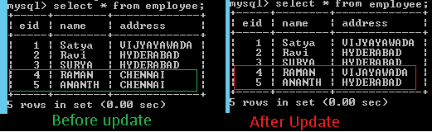

## 4. DELETE Operation using Hibernate

We have following method to perform DELETE Operation in Hibernate

void delete(Object object)

**package** curd;

**import** bo.EmployeeBo;

**public** **class** EmployeeDelete {

**public** **static** **void** main(String[] args) {

// 1.Load Configuration

Configuration cfg = **new** Configuration();

cfg.configure("hibernate.cfg.xml");

// 2.Create Session

SessionFactory sf = cfg.buildSessionFactory();

Session session = sf.openSession();

//======Load the Object & DELETE ==========

Transaction tx = session.beginTransaction();

EmployeeBo bo =(EmployeeBo)session.load(EmployeeBo.**class**, **new** Integer(4));

session.delete(bo);

tx.commit();

session.close();

sf.close();

}

}

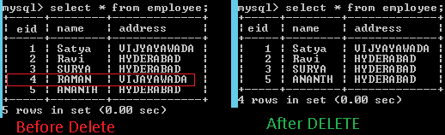

# 4. Hibernate POJO Class Lifecycle

In Hibernate POJO class (Persistance class) object will have 3 States

1. **Transient state**
2. **Persistent state**
3. **Detached state**

### 1. Transient state

* Whenever an object of a pojo class is created then it will be in the **Transient state**
* When the object is in a Transient state it **doesn’t represent any row of the database**
* If we modify the data of a pojo class object, when it is in transient state then **it doesn’t effect on the database table**

### 2. Persistent state

* When the object is in persistent state, then it represents one row of the database
* if the object is in persistent state then it is associated with the **unique Session**

### 3. Detached state

* After Persistent State Object will goes under Dethatched State
* if we want to move an object from persistent to detached state, we need to do either **closing that session** or need to **clear the cache of the session**

**package** curd;

**public** **class** POJOLifeCycle {

**public** **static** **void** main(String[] args) {

// 1.Load Configuration

Configuration cfg = **new** Configuration();

cfg.configure("hibernate.cfg.xml");

// 2.Create Session

SessionFactory sf = cfg.buildSessionFactory();

Session session = sf.openSession();

//======1.Transient State START==========

EmployeeBo bo = **new** EmployeeBo();

bo.setEid(6);

bo.setName("RAJESH");

bo.setAddress("NEWYORK");

//======1.Transient State END==========

//======2.Persistent state START==========

Transaction tx = session.beginTransaction();

session.save(bo);

tx.commit();

//======2.Persistent state END==========

//========3.Detached State START========

session.close();

bo.setEid(7);

bo.setName("MADHU");

bo.setAddress("COLOMBO");

//========3.Detached State END========

sf.close();

}

}

# 5. Hibernate Inheritance Mapping

In hibernate inheritance, if we have base and derived classes, now **if we save derived(sub) class object, base class object will also be stored into the database.**

Hibernate supports 3 types of Inheritance Mappings:

1. **Table per class hierarchy**
2. **Table per sub-class hierarchy**
3. **Table per concrete class hierarchy**

We will understand one by one with examples. Below tables are used in upcoming examples.

**CREATE** **TABLE** `vehicle` (

`vid` **INT**(11) **NOT** **NULL** **AUTO\_INCREMENT**,

`price` **DOUBLE** **NOT** **NULL** **DEFAULT** '0',

**PRIMARY** **KEY** (`vid`));

**CREATE** **TABLE** `bike` (

`type` **VARCHAR**(50) **NULL** **DEFAULT** **NULL**

);

**CREATE** **TABLE** `car` (

`type` **VARCHAR**(50) **NULL** **DEFAULT** **NULL**

);

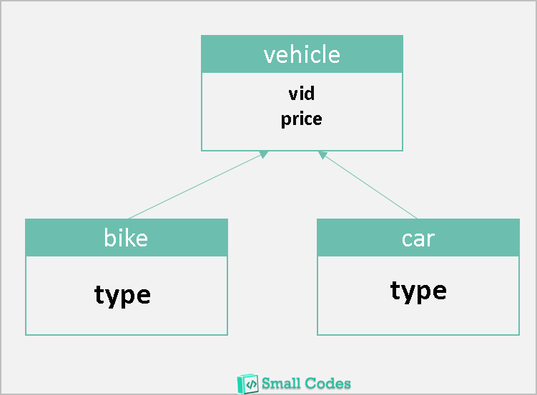

Following files are common to all examples, only we need to change mapping xml & Application class

**Vehicle.java**

**package** inheritance;

**public** **class** Vehicle {

**private** **int** vid;

**private** **double** price;

**public** **int** getVid() {

**return** vid;

}

**public** **void** setVid(**int** vid) {

**this**.vid = vid;

}

**public** **double** getPrice() {

**return** price;

}

**public** **void** setPrice(**double** price) {

**this**.price = price;

}

}

**Bike.java**

**package** inheritance;

**public** **class** Bike **extends** Vehicle {

**private** String biketype;

**public** String getBiketype() {

**return** biketype;

}

**public** **void** setBiketype(String biketype) {

**this**.biketype = biketype;

}

}

**Car.java**

**package** inheritance;

**public** **class** Car **extends** Vehicle {

**private** String cartype;

**public** String getCartype() {

**return** cartype;

}

**public** **void** setCartype(String cartype) {

**this**.cartype = cartype;

}

}

**hibernate.cfg.xml**

<?xml version=*'1.0'* encoding=*'utf-8'*?>

<!DOCTYPE hibernate-configuration SYSTEM

"hibernate-configuration-3.0.dtd">

<hibernate-configuration>

<session-factory>

<property name=*"hibernate.connection.driver\_class"*>com.mysql.jdbc.Driver</property>

<property name=*"hibernate.connection.url"*>jdbc:mysql://localhost:3306/smlcodes</property>

<property name=*"hibernate.connection.username"*>root</property>

<property name=*"hibernate.connection.password"*>root</property>

<property name=*"hibernate.dialect"*>org.hibernate.dialect.MySQLDialect</property>

<property name=*"show\_sql"*>true</property>

<property name=*"hbm2ddl.auto"*>update</property>

<!-- <mapping resource="EmployeeBo.hbm.xml" /> -->

<mapping resource=*"Vehicle.hbm.xml"* />

</session-factory>

</hibernate-configuration>

**InheritanceCommonApp.java**

**package** inheritance;

**import** org.hibernate.\*;

**import** org.hibernate.cfg.\*;

**public** **class** TablePerClassExample {

**public** **static** **void** main(String[] args) {

Configuration cfg = **new** Configuration();

cfg.configure("hibernate.cfg.xml");

SessionFactory factory = cfg.buildSessionFactory();

Session session = factory.openSession();

Bike bike = **new** Bike();

bike.setVid(101);

bike.setBiketype("HONDA");

bike.setPrice(50000);

Car car = **new** Car();

car.setVid(102);

car.setCartype("MARUTHI");

car.setPrice(600000);

Transaction tx = session.beginTransaction();

session.save(bike);

session.save(car);

tx.commit();

session.close();

factory.close();

}

}

## 1. Table per class hierarchy

If we **save** the derived class object in the database, then automatically base class data will also be saved into the database in base class Table

For example, if we save the **derived class** object like Car or Bike then automatically Vehicle class object will also be saved into the database, and in the **database** all the data will be stored into a **single table** only, which is base class table.

For this type of hierarchy, we must use one extra **discriminator column** in the database, to identify which **derived** class object we have been saved in the table along with the base class object, if we are not using this column hibernate will **throws the exception.**

**Vehicle.hbm.xml**

<hibernate-mapping>

<class name=*"inheritance.Vehicle"* table=*"vehicle"*>

<id name=*"vid"* column=*"vid"*></id>

<discriminator column=*"DISC"* type=*"string"*/>

<property name=*"price"* column=*"price"*></property>

<subclass name=*"inheritance.Bike"* discriminator-value=*"BIKE\_DISC"*>

<property name=*"biketype"* column=*"biketype"*></property>

</subclass>

<subclass name=*"inheritance.Car"* discriminator-value=*"CAR\_DISC"*>

<property name=*"cartype"* column=*"cartype"*></property>

</subclass>

</class>

</hibernate-mapping>

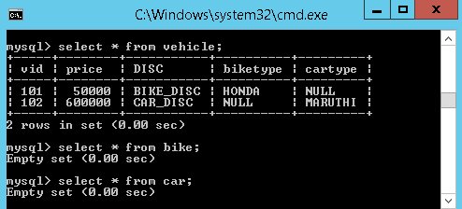

We added one new line discriminator, after the id element just to identify which derived class object we have been saved in the table. Here everything has been saved in a single table(vehicle)

## 2. Table per sub-class hierarchy

In this type of hierarchy**, if we save the Base class object, first hibernate will saves the Base class object into the base class table**, **then it will save the subclass object data into subclass table**. Here first it will save data into Base class table.

In below Example, if we save the Car/Bike class object, first hibernate will saves the data related to Vehicle class object into the vehicle table and then Car/Bike object data in Car/Bike related tables.so we can say, **No. of classes equals to No. of Tables**

No. of classes = No. of Tables

Here **<joined-subclass>** element of **<class>** is used to map the child class with parent class using the primary key and foreign key relation

**Vehicle.hbm.xml**

<hibernate-mapping>

<class name=*"inheritance.Vehicle"* table=*"vehicle"*>

<id name=*"vid"* column=*"vid"*></id>

<property name=*"price"* column=*"price"*></property>

<joined-subclass name=*"inheritance.Bike"* table=*"bike"*>

<key column=*"BIKE\_KEY"* />

<property name=*"biketype"* column=*"type"*></property>

</joined-subclass>

<joined-subclass name=*"inheritance.Car"* table=*"car"*>

<key column=*"CAR\_KEY"* />

<property name=*"cartype"* column=*"type"*></property>

</joined-subclass>

</class>

</hibernate-mapping>

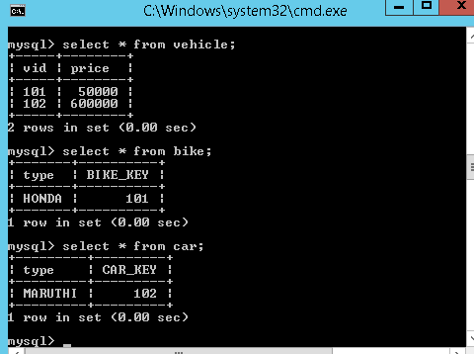

* Once we save the **derived** class object, then hibernate will first save the **base class** object then derived class object.
* At the time of saving the derived class object, hibernate will copy the **primary key** value of the base class into the corresponding derived class, by using **<key>** tag. From the above output
  + - 102 copied into **CAR\_KEY** column of **car** table
    - 101 copied into **BIKE\_KEY** column of the **bike** table

## 3. Table per concrete class hierarchy

* Once we save the **derived class object**, **then derived class data and base class data will be saved in the derived class related table** in the database
* for this type we **need** the tables for **derived classes**, but **not for the base class**
* we need to use one new element **<union-subclass>** under <class>

**Vehicle.hbm.xml**

<hibernate-mapping>

<class name=*"inheritance.Vehicle"* table=*"vehicle"*>

<id name=*"vid"* column=*"vid"*></id>

<property name=*"price"* column=*"price"*></property>

<union-subclass name=*"inheritance.Bike"* table=*"bike"*>

<property name=*"biketype"* column=*"type"*></property>

</union-subclass>

<union-subclass name=*"inheritance.Car"* table=*"car"*>

<property name=*"cartype"* column=*"type"*></property>

</union-subclass>

</class>

</hibernate-mapping>

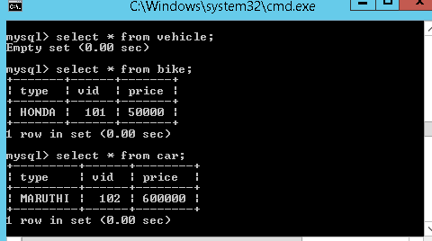

# 6. Hibernate Generators <generator>

The **<generator>** subelement of id used to **generate the unique identifier** for the objects of persistent class. There are many generator classes defined in the Hibernate Framework.

**Example:**

<hibernate-mapping>

<class name=*"bo.EmployeeBo"* table=*"employee"*>

<id name=*"eid"* column=*"eid"*>

<generator class=*"assigned"* />

</id>

<property name=*"name"* column=*"name"* />

<property name=*"address"* column=*"address"* />

</class>

</hibernate-mapping>

In Above example class=*"assigned"* means, while inserting data into database user will take care about generating Primary key value. But, hibernate can also generate the primary keys without user interaction, by using **Generators**.

## List of generators

* hibernate using different primary key generator algorithms, for each algorithm internally a class is created by hibernate for its implementation
* hibernate provided different primary key generator classes and all these classes are implemented from **org.hibernate.id.IdentifierGeneratar** Interface

The following are the list of main generators we are using in the hibernate framework

1. **assigned**
2. **increment**
3. **sequence**
4. **identity**
5. **hilo**
6. **native**
7. **foregin**
8. **uuid**

### 1.assigned

* This is the **default generator class** used by the hibernate, **if we do not specify <generator >** element under id element then hibernate by **default assumes it as “assigned”**
* If generator class is assigned, then the **programmer is responsible for assigning the primary key** value to object which is going to save into the database

<class name="bo.EmployeeBo" table="employee">

<id name="eid" column="eid">

<generator class="assigned" />

</id>

<property>....</property>

</class>

### 2.increment

* First select the max id if there, if no 1 as max
* for each record it **increments by 1 (i++)**
* Increment will take **care by Application Layer[Hibernate]**

<class name="bo.EmployeeBo" table="employee">

<id name="eid" column="eid">

<generator class="increment"/>

</id>

<property>....</property>

</class>

### 3.identity

* First select the max id if there, if no 1 as max
* for each record it **increments by 1 (i++)**
* Increment will **have taken care by DB Layer[MySQL]**
* MySQL, DB2 Support this. Oracle Won’t Support it.

<class name="bo.EmployeeBo" table="employee">

<id name="eid" column="eid">

<generator class=" identity"/>

</id>

<property>....</property>

</class>

### 4.sequence

* while inserting a new record in a database, **hibernate gets next value from the sequence** under assigns that value for the new record
* If programmer has created a sequence in the database, then that sequence name should be passed as the generator
* **Sequence start with 1 and Incremented by 1**
* Internally it creates Sequence table, and increment operations done here
* **Increment will take care by Both Application Layer[Hibernate] & DB Layer[MySQL]**
* MySQL, DB2 Support this. Oracle Wont

<class name="bo.EmployeeBo" table="employee">

<id name="eid" column="eid">

<generator class="sequence"/>

</id>

<property>....</property>

</class>

For defining your own sequence, use the param subelement of generator.

<class name="bo.EmployeeBo" table="employee">

<id name="eid" column="eid">

<param name="sequence">USER\_DEFIED\_SEQUENCE</param>

</id>

<property>....</property>

</class>

### 5.hilo

* hilo **start with 0**
* Internally it creates **hilo table**
* **It will take High value form Hilo table, and it will Increment**
* for each Deployment/Restart application, **High value increment by 32768**
* 1 st Deploy:  1,2,3,4...
* 2 nd Deploy: 32768,32769..........
* MySQL, DB2 Support this. Oracle Won’t Support it.

<class name="bo.EmployeeBo" table="employee">

<id name="eid" column="eid">

<generator class="hilo"/>

</id>

<property>....</property>

</class>

### 6.native

when we use this generator class, it first checks whether the database supports **identity or not**, if not checks for **sequence and if not**, then **hilo** will be used finally the order will be.

* **identity**
* **sequence**
* **hilo**

<class name="bo.EmployeeBo" table="employee">

<id name="eid" column="eid">

<generator class="native"/>

</id>

<property>....</property>

</class>

### 7.foregin

It uses the id of another associated object, mostly used with <one-to-one> association.

### 8.uuid

It uses 128-bit UUID algorithm to generate the id. The returned id is of type String, unique within a network (because IP is used). The UUID is represented in hexadecimal digits, 32 in length.

### Custom generator

 For ur application, you want to generate keys as per ur wish like **icici\_101, icici\_102, icici\_103, ..........**

* write **IciciGenerator** class implementing **IdentityGenerator**
* override generate method
* and write logic for keys

<class name="bo.EmployeeBo" table="employee">

<id name="eid" column="eid">

<generator class="IciciGenerator"/>

</id>

<property>....</property>

</class>

## Generators Example

**EmployeeBo.java**

package bo;

public class EmployeeBo {

private int eid;

private String name;

private String address;

//Setters & Getters

}

**GeneratorsExample.java**

**package** app;

**import** org.hibernate.\*;

**import** org.hibernate.cfg.\*;

**import** bo.EmployeeBo;

**public** **class** GeneratorsExample {

**public** **static** **void** main(String[] args) {

Configuration cfg = **new** Configuration();

cfg.configure("hibernate.cfg.xml");

SessionFactory factory = cfg.buildSessionFactory();

Session session = factory.openSession();

EmployeeBo bo = **new** EmployeeBo();

//bo.setEid(100);

bo.setName("sequence");

bo.setAddress("BANGLORE");

Transaction tx = session.beginTransaction();

session.save(bo);

tx.commit();

session.close();

factory.close();

}

}

**EmployeeBo.hbm.xml**

<hibernate-mapping>

<class name=*"bo.EmployeeBo"* table=*"employee"*>

<id name=*"eid"* column=*"eid"*>

<generator class=*"sequence"* />

</id>

<property name=*"name"* column=*"name"* />

<property name=*"address"* column=*"address"* />

</class>

</hibernate-mapping>

Here we are changing generator classes one-by-one, check the how data stored in DB in output window.

**hibernate.cfg.xml**

<?xml version=*'1.0'* encoding=*'utf-8'*?>

<!DOCTYPE hibernate-configuration SYSTEM

"hibernate-configuration-3.0.dtd">

<hibernate-configuration>

<session-factory>

<property name=*"hibernate.connection.driver\_class"*>com.mysql.jdbc.Driver</property>

<property name=*"hibernate.connection.url"*>jdbc:mysql://localhost:3306/smlcodes</property>

<property name=*"hibernate.connection.username"*>root</property>

<property name=*"hibernate.connection.password"*>root</property>

<property name=*"hibernate.dialect"*>org.hibernate.dialect.MySQLDialect</property>

<property name=*"show\_sql"*>true</property>

<property name=*"hbm2ddl.auto"*>update</property>

<mapping resource=*"EmployeeBo.hbm.xml"* />

<!-- <mapping resource="EmployeeBo.hbm.xml" /> -->

<!-- <mapping resource="Vehicle.hbm.xml" /> -->

</session-factory>

</hibernate-configuration>

**Output**

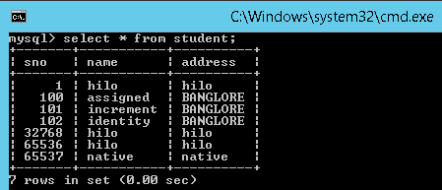

For Sequence,

Exception in thread "main" org.hibernate.MappingException: could not instantiate id generator

at org.hibernate.id.IdentifierGeneratorFactory.create(IdentifierGeneratorFactory.java:98)

# 7. Hibernate Query Language (HQL)

**Hibernate Query Language (HQL)** is same as SQL (Structured Query Language) but it doesn't depend on the table of the database. Instead of table name, we use class name in HQL. So it is database independent query language

* **HQL is database independent**, means if we write any program using HQL commands then our program will be able to execute in all the databases without doing any further changes to it.
* HQL supports object oriented features like **Inheritance, polymorphism, Associations (**Relationships)

## SQL vs HQL

If we want to select a **Complete Object** from the database, we use POJO class reference in place of   **\***while constructing the query

// In SQL

**sql> select \* from Employee**

Note: Employee is the table name.

// In HQL

**hql> select s from EmployeeBo s**

[ or ]

from EmployeeBo s

Note: here **s** is the reference of EmployeeBo

If we want to load the **Partial Object** from the database that is only selective properties of an objects, then we need to replace column names with POJO class variable names

// **In** **SQL**

**sql**> **select** eid,name,address **from** Employee

Note: eid,name,address are the **columns** of Employee the **table**.

// **In** HQL

hql> **select** s.eid,s.name,s.address **from** EmployeeBo s

It is also possible to **select** the object from the database **by passing run time values** into the query using **” ? ”**

**//In SQL**

**sql**> **select** \* **from** employee **where** eid=?

// **In** HQL

hql> **select** s **from** EmployeeBo s **where** s.eid=?

[ **or** ]

**select** s **from** EmployeeBo s **where** s.eid =:101

## Query Interface

If we want to execute a HQL query on a database, we need to create a **Query** interface object. To get query object, we need to call **session**. **createQuery()** method in the session Interface.

Following are the most commonly used methods in Query interface

* **public int executeUpdate()** -is used to execute **the update or delete query**.
* **public List list()**  -returns the result of the relation as a list.
* **public Query setFirstResult(int rowno)** - row number from where record will be retrieved.
* **public Query setMaxResult(int rowno)** - no. of records to be retrieved from the relation (table).
* **public Query setParameter(int position, Object value)** it sets the value to query parameter.
* **public Query setParameter(String name, Object value)** it sets the value to a named query param.

**Synatx:**

Query qry = session.createQuery("--- HQL command ---");

List l = qry.list();

Iterator it = l.iterator();

**while**(it.hasNext())

{

Object o = it.next();

EmployeeBo s = (EmployeeBo)o;

----- ------- ---------

}

## HQL Examples

Following files are common to all the examples

**Table :bank**

CREATE TABLE `bank` (

`accno` INT(11) NOT NULL AUTO\_INCREMENT,

`accname` VARCHAR(50) NULL DEFAULT NULL,

`balance` DOUBLE NULL DEFAULT NULL,

PRIMARY KEY (`accno`)

)

ENGINE=InnoDB

;

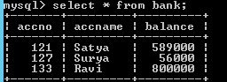

**BankBo.java**

**package** hql;

**public** **class** BankBo {

**private** **int** accno;

**private** String accname;

**private** **double** balance;

**public** **int** getAccno() {

**return** accno;

}

**public** **void** setAccno(**int** accno) {

**this**.accno = accno;

}

**public** String getAccname() {

**return** accname;

}

**public** **void** setAccname(String accname) {

**this**.accname = accname;

}

**public** **double** getBalance() {

**return** balance;

}

**public** **void** setBalance(**double** balance) {

**this**.balance = balance;

}

}

**BankBo.hbm.xml**

<?xml version=*"1.0"*?>

<!DOCTYPE hibernate-mapping SYSTEM "hibernate-mapping-3.0.dtd">

<hibernate-mapping>

<class name=*"hql.BankBo"* table=*"bank"*>

<id name=*"accno"* column=*"accno"* />

<property name=*"accname"* column=*"accname"* />

<property name=*"balance"* column=*"balance"* />

</class>

</hibernate-mapping>

**hibernate.cfg.xml**

<hibernate-configuration>

<session-factory>

<property name=*"hibernate.connection.driver\_class"*>com.mysql.jdbc.Driver</property>

<property name=*"hibernate.connection.url"*>jdbc:mysql://localhost:3306/smlcodes</property>

<property name=*"hibernate.connection.username"*>root</property>

<property name=*"hibernate.connection.password"*>root</property>

<property name=*"hibernate.dialect"*>org.hibernate.dialect.MySQLDialect</property>

<mapping resource=*"BankBo.hbm.xml"* />

</session-factory>

</hibernate-configuration>

### 1. HQL Select Query Example

**package** hql;

**import** java.util.Iterator;

**import** java.util.List;

**import** org.hibernate.Query;

**import** org.hibernate.SessionFactory;

**import** org.hibernate.cfg.Configuration;

**import** org.hibernate.classic.Session;

**public** **class** HQLSelect {

**public** **static** **void** main(String[] args) {

Configuration cfg = **new** Configuration();

cfg.configure("hibernate.cfg.xml");

SessionFactory factory = cfg.buildSessionFactory();

Session session = factory.openSession();

System.***out***.println("====1.Selecting Complete Object====== ");

Query query = session.createQuery("Select b from BankBo b");

List list = query.list();

Iterator it = list.iterator();

**while** (it.hasNext()) {

BankBo bo = (BankBo) it.next();

System.***out***.println("------------------------");

System.***out***.println("ACC No : " + bo.getAccno());

System.***out***.println("Name : " + bo.getAccname());

System.***out***.println("Balance : " + bo.getBalance());

}

System.***out***.println("====2.Selecting Partial Object====== ");

query = session.createQuery("Select b.accname, b.balance from BankBo b where b.accno=?");

query.setParameter(0, **new** Integer(127));

list = query.list();

it = list.iterator();

**while** (it.hasNext()) {

Object o[] = (Object[]) it.next();

System.***out***.println("Name : " + o[0]);

System.***out***.println("Balance : " + o[1]);

}

}

}

====1.Selecting Complete Object======

ACC No : 121

Name : Satya

Balance : 589000.0

------------------------

ACC No : 127

Name : Surya

Balance : 56000.0

====2.Selecting Partial Object======

Name : Surya

Balance : 56000.0

### 2. HQL Update/Delete Query Example

while working with DML operations in HQL we have to call **executeUpdate();** to execute the query, which **will returns one integer value** after the execution it will **tells the count of effected rows**.

**package** hql;

**import** org.hibernate.Query;

**import** org.hibernate.SessionFactory;

**import** org.hibernate.Transaction;

**import** org.hibernate.cfg.Configuration;

**import** org.hibernate.classic.Session;

**public** **class** HQLUpdateDelete {

**public** **static** **void** main(String[] args) {

Configuration cfg = **new** Configuration();

cfg.configure("hibernate.cfg.xml");

SessionFactory factory = cfg.buildSessionFactory();

Session session = factory.openSession();

System.***out***.println("====== UPDATE OPERATION =========");

Transaction tx = session.beginTransaction();

Query query = session.createQuery("update BankBo b set b.balance =? where b.accno=?");

query.setParameter(0, **new** Double(0));

query.setParameter(1, **new** Integer(127));

**int** rs = query.executeUpdate();

tx.commit();

System.***out***.println(rs + " :Rows are Updated");

System.***out***.println("====== DELETE OPERATION =========");

tx = session.beginTransaction();

query = session.createQuery("delete from BankBo b where b.accno=?");

query.setParameter(0, **new** Integer(133));

rs = query.executeUpdate();

System.***out***.println(rs + " :Rows are Updated");

tx.commit();

session.close();

}

}

mysql> select \* from bank;

+-------+---------+---------+

| accno | accname | balance |

+-------+---------+---------+

| 121 | Satya | 589000 |

| 127 | Surya | 0 |

+-------+---------+---------+

2 rows in set (0.00 sec)

### 3. HQL Insert Query Example

while writing the insert query, we need to select values from other table, we can’t insert our own values manually. Because, HQL supports only the **INSERT INTO………** **SELECT……… ;** it won’t support **INSERT INTO………..VALUES**

Query query = session.createQuery("insert into Stock(stock\_code, stock\_name)" +

"select stock\_code, stock\_name from backup\_stock");

int result = query.executeUpdate();

## HQL with Aggregate functions

We may call avg(), min(), max() etc. aggregate functions by HQL. Let's see some common examples:

**Example to get total salary of all the employees**

Query q=session.createQuery("select sum(salary) from Emp");

List<Integer> list=q.list();

System.out.println(list.get(0));

**Example to get maximum salary of employee**

Query q=session.createQuery("select max(salary) from Emp");

**Example to get minimum salary of employee**

Query q=session.createQuery("select min(salary) from Emp");

**Example to count total number of employee ID**

Query q=session.createQuery("select count(id) from Emp");

**Example to get average salary of each employees**

Query q=session.createQuery("select avg(salary) from Emp");

# 8. Hibernate Criteria Query Language(HCQL)

Criteria is nothing but a **Condition**. CQL is used to apply conditions on **SELECT** Queries. The **Criteria** **interface** provides methods to apply criteria on SELECT queries.

### Criteria Interface

The Criteria interface provides many methods to specify criteria. The object of Criteria can be obtained by calling the **createCriteria()** method of Session interface

**public Criteria createCriteria(Class c)**

 commonly used methods of Criteria interface are as follows:

1. **public Criteria add(Criterion c)** is used to add restrictions.
2. **public Criteria addOrder(Order o)** specifies ordering.
3. **public Criteria setFirstResult(int firstResult)** specifies the first number of record to be retreived.
4. **public Criteria setMaxResult(int totalResult)** specifies the total number of records to be retreived.
5. **public List list()** returns list containing object.
6. **public Criteria setProjection(Projection projection)** specifies the projection

## Working with Criteria Query Language

**Example Criteria**

**Criteria crit = session.createCriteria(Products.class);**

**Criterion c1=Restrictions.gt("price", new Integer(12000));**

**//price is our pojo class variable**

**crit.add(c1); // adding criterion object to criteria class object**

**List l = crit.list(); // executing criteria query**

* If we want to put, we need to create one **Criterion Interface** object and we need to **add()** this object to **Criteria Class object**
* In order to get Criterion object, we need to use **Restrictions class.** Restrictions is the factory for producing Criterion objects
* In **Restrictions class**, **we have all static methods** and each method of this class **returns Criterion object**

REMEMBER: CQL is only used on SELECT Queries

### Example: Get the details from bank table where balance>3000.

Table : Bank

**mysql> select \* from bank;**

+-------+---------+---------+

| accno | accname | balance |

+-------+---------+---------+

| 101 | Satya | 2000 |

| 102 | Surya | 3000 |

| 103 | Ravi | 1000 |

| 104 | Rakesh | 4000 |

| 105 | CHANDU | 5000 |

+-------+---------+---------+

5 rows in set (0.00 sec)

**BankBo.java**

**package** hql;

**public** **class** BankBo {

**private** **int** accno;

**private** String accname;

**private** **double** balance;

**public** **int** getAccno() {

**return** accno;

}

**public** **void** setAccno(**int** accno) {

**this**.accno = accno;

}

**public** String getAccname() {

**return** accname;

}

**public** **void** setAccname(String accname) {

**this**.accname = accname;

}

**public** **double** getBalance() {

**return** balance;

}

**public** **void** setBalance(**double** balance) {

**this**.balance = balance;

}

}

**BankBo.hbm.xml**

<?xml version=*"1.0"*?>

<!DOCTYPE hibernate-mapping SYSTEM "hibernate-mapping-3.0.dtd">

<hibernate-mapping>

<class name=*"hql.BankBo"* table=*"bank"*>

<id name=*"accno"* column=*"accno"* />

<property name=*"accname"* column=*"accname"* />

<property name=*"balance"* column=*"balance"* />

</class>

</hibernate-mapping>

**hibernate.cfg.xml**

<hibernate-configuration>

<session-factory>

<property name=*"hibernate.connection.driver\_class"*>com.mysql.jdbc.Driver</property>

<property name=*"hibernate.connection.url"*>jdbc:mysql://localhost:3306/smlcodes</property>

<property name=*"hibernate.connection.username"*>root</property>

<property name=*"hibernate.connection.password"*>root</property>

<property name=*"hibernate.dialect"*>org.hibernate.dialect.MySQLDialect</property>

<mapping resource=*"BankBo.hbm.xml"* />

</session-factory>

</hibernate-configuration>

**package** cql;

**import** java.util.Iterator;

**import** java.util.List;

**import** org.hibernate.\*;

**import** hql.BankBo;

**public** **class** CriteriaDemo {

**public** **static** **void** main(String[] args) {

Configuration cfg = **new** Configuration();

cfg.configure("hibernate.cfg.xml");

SessionFactory factory = cfg.buildSessionFactory();

Session session = factory.openSession();

Criteria criteria = session.createCriteria(BankBo.**class**);

Criterion cn = Restrictions.*gt*("balance", **new** Double(3000));

criteria.add(cn);

List list = criteria.list();

System.***out***.println("List Size : " + list.size());

Iterator it = list.iterator();

**while** (it.hasNext()) {

BankBo bo = (BankBo) it.next();

System.***out***.println(bo.getAccno() + ", " + bo.getAccname() + ", " + bo.getBalance());

}

session.close();

factory.close();

}

}

log4j:WARN No appenders could be found for logger (org.hibernate.cfg.Environment).

log4j:WARN Please initialize the log4j system properly.

Hibernate: select this\_.accno as accno0\_0\_, this\_.accname as accname0\_0\_, this\_.balance as balance0\_0\_ from bank this\_ where this\_.balance>?

List Size : 2

104, Rakesh, 4000.0

105, CHANDU, 5000.0

### Example: Adding ORDERBY Conditions to Criteria

If we want to add some sorting order for the objects, we need to add an **Order class** object to the Criteria class object by calling **addOrder() method.**In Order class, we have **asc() and dsc()** for getting an objects in required order.

**public** **class** CriteriaOrderExample {

**public** **static** **void** main(String[] args) {

Configuration cfg = **new** Configuration();

cfg.configure("hibernate.cfg.xml");

SessionFactory factory = cfg.buildSessionFactory();

Session session = factory.openSession();

Criteria criteria = session.createCriteria(BankBo.**class**);

Criterion cn = Restrictions.*gt*("balance", **new** Double(2000));

criteria.add(cn);

criteria.addOrder(Order.*asc*("balance"));

List list = criteria.list();

Iterator it = list.iterator();

**while** (it.hasNext()) {

BankBo bo = (BankBo) it.next();

System.***out***.println(bo.getAccno() + ", "+ bo.getBalance());

}

session.close();

factory.close();

}

}

log4j:WARN No appenders could be found for logger

102, 3000.0

104, 4000.0

105, 5000.0

hibernate will select the records (rows) from **BankBo** table and stores them into a **ResultSet** and then converts each row data of resultset into a **POJO class object** basing on our field type, then all these objects into a list according to the order you have given

### Example: Adding multiple conditions

If we want to put more conditions on the data (multiple conditions) then we can use **and** method, **or** method given by the Restrictions class

crit.add(Restrictions.and(Restrictions.like("accname","%satya%"),

Restrictions.eq("price",**new** Integer(12000))));

List l=crit.list();

Iterator it = l.iterator();

Like this we can add any number of conditions

## Hibernate Projections

In criteria, we are able to load complete object only, to load the partial objects (Selected Columns only) we need to use projections.

* **Projection** is an Interface, **Projections** is an class for producing projection objects.
* In **Projections** class, we have **all static methods** and each method of this class returns Projection interface object.
* If we want to add a Projection object to Criteria then we need to call a method **setProjection()**

### Projections Syntax

while adding projection object to criteria, it is possible to **add one object at a time**.  It means if we add 2nd projection object then this 2nd one will override the first one (first one won’t be work), so at a time we can only one projection object to criteria object.

Using criteria, if we want to load partial object from the database, then we need to create a **projection** **object for property** that is to be loaded from the database

**Example:**

Criteria crit = session.createCriteria(Products.**class**);

crit.setProjection(Projections.proparty("proName"));

List l=crit.list();

Iterator it=l.iterator();

**while**(it.hasNext())

{

String s = (String)it.next();

// ---- print -----

}

### Example 1: Load Single Column using Projections

In below example we are using same configuration files and BanlBo.java as above examples

**public** **class** ProjectionsDemo {

**public** **static** **void** main(String[] args) {

Configuration cfg = **new** Configuration();

cfg.configure("hibernate.cfg.xml");

SessionFactory factory = cfg.buildSessionFactory();

Session session = factory.openSession();

Criteria criteria = session.createCriteria(BankBo.**class**);

Criterion cn = Restrictions.*gt*("balance", **new** Double(2000));

criteria.add(cn);

criteria.setProjection(Projections.*property*("balance"));

List list = criteria.list();

System.***out***.println("List Size : " + list.size());

Iterator it = list.iterator();

**while** (it.hasNext()) {

Double bal = (Double) it.next();

System.***out***.println("Balance : " + bal);

}

session.close();

factory.close();

}

}

Hibernate: select this\_.balance as y0\_ from bank this\_ where this\_.balance>?

List Size : 3

Balance : 3000.0

Balance : 4000.0

Balance : 5000.0

### Example 2: Load Multiple Columns using Projections

If we want to **load partial object, with multiple columns** using criteria then we need to **create the ProjectionList with the multiple properties** and then we need to add that Projectionist to the criteria.

**public** **class** ProjectionsMultipleColumns {

**public** **static** **void** main(String[] args) {

Configuration cfg = **new** Configuration();

cfg.configure("hibernate.cfg.xml");

SessionFactory factory = cfg.buildSessionFactory();

Session session = factory.openSession();

Criteria criteria = session.createCriteria(BankBo.**class**);

Criterion cn = Restrictions.*gt*("balance", **new** Double(2000));

criteria.add(cn);

**ProjectionList projectionList = Projections.*projectionList*();**

**projectionList.add(Projections.*property*("accname"));**

**projectionList.add(Projections.*property*("balance"));**

**criteria.setProjection(projectionList);**

List list = criteria.list();

Iterator it = list.iterator();

**while** (it.hasNext()) {

Object[] o = (Object[]) it.next();

System.***out***.println(o[0]+" : " +o[1]);

}

session.close();

factory.close();

}

}

Hibernate: select this\_.accname as y0\_, this\_.balance as y1\_ from bank this\_ where this\_.balance>?

Surya : 3000.0

Rakesh : 4000.0

CHANDU : 5000.0

### Difference between HQL and CQL

|  |  |
| --- | --- |
| **HQL (Hibernate Query Language)** | **CQL (Criteria Query Language)** |
| We can perform **both select and non-select operations** | Criteria **is only for selecting** the data, we cannot perform non-select operations |
| suitable for executing **Static Queries** | suitable for executing **Dynamic Queries** |
| Takes less time to execute | Takes more time to execute |

# 9. Native SQL Queries

HQL or Criteria queries able to execute almost any SQL query you want. However, many developers are complaint about the Hibernate’s generated SQL statement is slow and more prefer to generated their own SQL (native SQL) statement.

Hibernate provide a **createSQLQuery()** method to let you call your native SQL statement directly. Your application will create a native SQL query from the session with the **createSQLQuery()** method on the Session interface.:

**public SQLQuery createSQLQuery(String sqlString) throws HibernateException**

* By using Native SQL, we can perform both **SELECT & NON- SELECT** operations on the data
* We can use the database specific keywords (commands), to get the data from the database
* The main drawback of Native SQL is it makes the hibernate application as **database dependent**.

## Working with Native SQL Queries

Even though we are selecting complete objects from the database **we need to type cast into Object[]** array only, **not into our pojo class type**, because we are giving direct table, column names in the Native SQL Query so it doesn’t know our class name

SQLQuery qry = session.createSQLQuery("select \* from EMPLOYEE");

// Here EMPLOYEE is the table in the database...

List l = qry.list();

Iterator it = l.iterator();

**while**(it.hasNext())

{

Object row[] = (Object[])it.next();

--- -------

}

In the above code, we typecast into the **object[]** , if we want to type cast into our POJO class , then we need to go with **entityQuery** concept. to make the query as an entityQuery, we need to call **addEntity()** method

//We are letting hibernate to know our pojo class too

SQLQuery q=session.createSQLQuery("select \*from EMPLOYEE").addEntity(EmployeeBo.**class**);

List l = q.list();

Iterator it = l.iterator();

**while**(it.hasNext())

{

EmployeeBo s = (EmployeeBo)it.next();

--- -------

}

### Example

**public** **class** NativeSqlDemo {

**public** **static** **void** main(String[] args) {

// 1.Load Configuration

Configuration cfg = **new** Configuration();

cfg.configure("hibernate.cfg.xml");

// 2.Create Session

SessionFactory sf = cfg.buildSessionFactory();

Session session = sf.openSession();

System.***out***.println("1.Simple Native SQL\n ========================");

SQLQuery query1 = session.createSQLQuery("select \*from EMPLOYEE");

List list1 = query1.list();

Iterator it1 = list1.iterator();

**while** (it1.hasNext()) {

Object[] ob = (Object[]) it1.next();

System.***out***.println(ob[0] + ", " + ob[1] + ", " + ob[2]);

}

System.***out***.println("2.Native SQL with entityQuery\n ==========");

SQLQuery query2 = session.createSQLQuery("select \*from EMPLOYEE");

query2.addEntity(EmployeeBo.**class**);

List list2 = query2.list();

Iterator it2 = list2.iterator();

**while** (it2.hasNext()) {

EmployeeBo bo = (EmployeeBo) it2.next();

System.***out***.println(bo.getEid() + ", " + bo.getName() + ", " + bo.getAddress());

}

session.close();

sf.close();

}

}

1.Simple Native SQL

========================

1, SATYA, VIJAYAWADA

2, SURYA, HYDERABAD

2.Native SQL with entityQuery

========================

1, SATYA, VIJAYAWADA

2, SURYA, HYDERABAD

# 10. Named Queries

if we want to execute the **same queries for multiple times** in our program then we can use the **Named Queries mechanism**

* In this Named Queries concept, **we use some name for the query configuration**, **and that name will be used whenever the same query is required to execute**
* If you want to create Named Query, in hibernate mapping file we need to configure a **query** by putting some name for it.
* In HQL, we need to use **<query name=”query\_name">** to configure query

<query name="bankHQLQuery">

<![CDATA[from BankBo b where b.balance>:bal ]]>

</query>

* In Native SQL, we need to use **<sql-queryname=”query\_name">** to configure query

<sql-query name=*"bankNativeQuery"*>

select \* from Employee

</sql-query>

* In our main program, we need to use **getNamedQuery()** given by **session** interface, for getting the **Query** reference and we need to execute that query by calling **list()**

Query qry = session.getNamedQuery("Name given in hib-mapping-xml");

qry.setParameter("bal",**new** Integer(3000));

List l = qry.list();

### Example 1 : HQL Named Query Example

<?xml version=*'1.0'* encoding=*'utf-8'*?>

<!DOCTYPE hibernate-configuration SYSTEM

"hibernate-configuration-3.0.dtd">

<hibernate-configuration>

<session-factory>

<property name=*"hibernate.connection.driver\_class"*>com.mysql.jdbc.Driver</property>

<property name=*"hibernate.connection.url"*>jdbc:mysql://localhost:3306/smlcodes</property>

<property name=*"hibernate.connection.username"*>root</property>

<property name=*"hibernate.connection.password"*>root</property>

<property name=*"hibernate.dialect"*>org.hibernate.dialect.MySQLDialect</property>

<property name=*"show\_sql"*>true</property>

<property name=*"hbm2ddl.auto"*>update</property>

<mapping resource=*"EmployeeBo.hbm.xml"* />

<mapping resource=*"BankBo.hbm.xml"* />

</session-factory>

</hibernate-configuration>

**BankBo.java**

**public** **class** BankBo {

**private** **int** accno;

**private** String accname;

**private** **double** balance;

//Setters & getters

**BankBo.hbm.xml**

<hibernate-mapping>

<class name=*"hql.BankBo"* table=*"bank"*>

<id name=*"accno"* column=*"accno"* />

<property name=*"accname"* column=*"accname"* />

<property name=*"balance"* column=*"balance"* />

</class>

<query name=*"bankHQLQuery"*>

<![CDATA[from hql.BankBo b where b.balance>:bal ]]>

</query>

</hibernate-mapping>

**HQLNamedQuery.java**

**package** namedQuery;

**public** **class** HQLNamedQuery {

**public** **static** **void** main(String[] args) {

// 1.Load Configuration

Configuration cfg = **new** Configuration();

cfg.configure("hibernate.cfg.xml");

// 2.Create Session

SessionFactory sf = cfg.buildSessionFactory();

Session session = sf.openSession();

System.***out***.println("HQL-NamedQuery Example\n----------");

Query qry = session.getNamedQuery("bankHQLQuery");

qry.setParameter("bal", **new** Double(3000));

List list = qry.list();

Iterator it = list.iterator();

**while** (it.hasNext()) {

BankBo bo = (BankBo) it.next();

System.***out***.println(bo.getAccname() + ", " + bo.getBalance());

}

session.close();

sf.close();

}

}

HQL-NamedQuery Example

------

Hibernate: select bankbo0\_.accno as accno1\_, bankbo0\_.accname as accname1\_, bankbo0\_.balance as balance1\_ from bank bankbo0\_ where bankbo0\_.balance>?

Rakesh, 4000.0

CHANDU, 5000.0

### Example 2 : Native SQL Named Query Example

**EmployeeBo.java**

**package** bo;

**public** **class** EmployeeBo {

**private** **int** eid;

**private** String name;

**private** String address;

**//Setters & getters**

}

**EmployeeBo.hbm.xml**

<hibernate-mapping>

<class name=*"bo.EmployeeBo"* table=*"employee"*>

<id name=*"eid"* column=*"eid"*>

<generator class=*"uuid"* />

</id>

<property name=*"name"* column=*"name"* />

<property name=*"address"* column=*"address"* />

</class>

<sql-query name=*"employeeNativeQuery"*>

select \* from Employee

</sql-query>

</hibernate-mapping>

**NamedQueryDemo.java**

**package** namedQuery;

**public** **class** NamedQueryDemo {

**public** **static** **void** main(String[] args) {

// 1.Load Configuration

Configuration cfg = **new** Configuration();

cfg.configure("hibernate.cfg.xml");

// 2.Create Session

SessionFactory sf = cfg.buildSessionFactory();

Session session = sf.openSession();

Query qry = session.getNamedQuery("employeeNativeQuery");

List list = qry.list();

Iterator it = list.iterator();

**while** (it.hasNext()) {

Object o[] = (Object[]) it.next();

System.***out***.println(o[0] + ", " + o[1] + ", " + o[2]);

}

session.close();

sf.close();

}

}

HQL-NamedQuery Example-------------------------

Hibernate: select bankbo0\_.accno as accno1\_, bankbo0\_.accname as accname1\_, bankbo0\_.balance as balance1\_ from bank bankbo0\_ where bankbo0\_.balance>?

Rakesh, 4000.0

CHANDU, 5000.0

# 11. Hibernate Relationships

In JAVA we have ***three types*** of relationships

1. ***IS – A***
2. ***HAS –A***
3. ***Uses – A***

**1.Is-a** relationship is one in which **data members of one class is obtained into another class through the concept of inheritance.**

class B{

}

public class A extends B{

}

**2.Has-a** relationship is one in which an **object of one class is created as a data member in another class**.

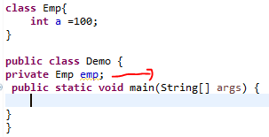

**3.Uses-a** relationship is one in which an **Object of one class is created inside a method of another class.**

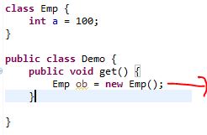

NOTE: But in Database We don’t have is-a,has-a,uses-a relationships like in java

## Relationships in Hibernate

In database we don’t have above mentioned relationships, but we can form the relationship between database tables by using **Primary Key (P.K), Foreign Key (F.K). We can only form HAS-A relationship in hibernate.**

We have four types of relationships

1. **One-To-One (P.K → P.K, F.K(Unique) → P.K)**
2. **One-To-Many (P.K → F.K)**
3. **Many-To-One (F.K → P.K)**
4. **Many-To-Many (Table1 → LinkTable → Table2)**

**If you see above replations One→P.K, Many→F.K. Just kidding☺**

### Mapping Directions

Each relationship can be achived in two directions

**1.Unidirectional** relationship refers to the case when relationship between two objects can be accessed by **one way only**. i.e. from Library we can access books, from book we can’t access Library, not vice versa.

**class** Book{

Long bookId;

String bookName;

…........

}

**class** Library{

Long libraryId;

String libraryName;

Set<Book> bookSet;

}

**2.Bidirectional** relationship refers to the case when relationship between two objects can be accessed both ways. i.e. From Library we can access books, from book we can access Library, vice versa.

**class** Book{

Long bookId;

String bookName;

Library library;

…........

}

**class** Library {

Long libraryId;

String libraryName;

Set<Book> bookSet;

}

|  |  |  |
| --- | --- | --- |
| **Relationship** | **Explanation** | **Example** |
| **One-To-One** | Each record in one table is related to exactly one record in the second table and vice versa. The other side could also be a zero record. | A car has only one engine. |
| **One-To-Many (or) Many-To-One** | Each record in one table is related to zero or more records in the second table. | A movie has many actors (one-to-many); an actor can act in many movies (manyto-one). |
| **Many-To-Many** | Each record in either of the tables is related to zero or more records in the other table | Each student can enroll in multiple courses, and each course can have manystudents registered. |

REMEMEBER: Object means one row in hibernate terminology

## 1.One-to-One Relationship Mapping Example

Using our **Car and Engine example**, we develop a one-to-one association. There are two ways of establishing a one-to-one association, **using a primary key using a foreign key.**

**Example: OneToOne Mapping (BiDirectional)**

CREATE TABLE CAR (

CAR\_ID int(10) NOT NULL,

NAME varchar(20) DEFAULT NULL,

COLOR varchar(20) DEFAULT NULL,

PRIMARY KEY (CAR\_ID));

CREATE TABLE ENGINE (

CAR\_ID int(10) NOT NULL,

SIZE varchar(20) DEFAULT NULL,

MODEL varchar(20) DEFAULT NULL,

PRIMARY KEY (CAR\_ID),

FOREIGN KEY (CAR\_ID) REFERENCES car (CAR\_ID));

* **CAR** table with a **CAR\_ID** as the primary key.
* **ENGINE** table, primary key is a **CAR\_ID**.
* **ENGINE** table has a foreign key constraint pointing to the primary key of the CAR table. So, an engine will always be created with the same id as that of a car. Thus, we say both tables share the same primary key.

**Car.java**

**package** onetoone;

**public** **class** Car {

**private** **int** id;

**private** String name;

**private** String color;

**private** Engine engine;

**//Setters & Getters**

}

**Engine.java**

**package** onetoone;

**public** **class** Engine {

**private** **int** id = 0;

**private** String model = **null**;

**private** String size = **null**;

// this engine is fitted to a car

**private** Car car = **null**;

**//Setters & Getters**

}

**Car.hbm.xml**

<hibernate-mapping package=*"onetoone"*>

<class name=*"Car"* table=*"CAR"*>

<id name=*"id"* column=*"CAR\_ID"*>

<generator class=*"assigned"* />

</id>

<property name=*"name"* column=*"NAME"* />

<property name=*"color"* column=*"COLOR"* />

<one-to-one name=*"engine"* class=*"Engine"* cascade=*"all"* />

</class>

</hibernate-mapping>

**Engine.hbm.xml**

<hibernate-mapping package=*"onetoone"*>

<class name=*"Engine"* table=*"ENGINE"*>

<id name=*"id"* column=*"CAR\_ID"*>

<generator class=*"foreign"*>

<param name=*"property"*>car</param>

</generator>

</id>

<one-to-one name=*"car"* class=*"Car"* constrained=*"true"* />

<property name=*"size"* column=*"SIZE"* />

<property name=*"model"* column=*"model"* />

</class>

</hibernate-mapping>

**hibernate.cfg.xml**

<hibernate-configuration>

<session-factory>

. . . . .

<mapping resource=*"onetoone/Car.hbm.xml"* />

<mapping resource=*"onetoone/Engine.hbm.xml"* />

. . . . .

</session-factory>

</hibernate-configuration>

**OneToOneTest.java**

**package** onetoone;

**public** **class** OneToOneTest {

**public** **static** **void** main(String[] args) {

Configuration cfg = **new** Configuration();

cfg.configure("hibernate.cfg.xml");

SessionFactory sf = cfg.buildSessionFactory();

Session session = sf.openSession();

Car car = **new** Car();

// Remember, we are using application generator for ids

car.setId(1);

car.setName("SWIFT");

car.setColor("BLUE");

// Next, create an instance of engine and set values.

// Note: you are not setting the id!

Engine engine = **new** Engine();

engine.setModel("2009");

engine.setSize("85KG");

// Now we associate them together using the setter on the car

car.setEngine(engine);

engine.setCar(car);

// Lastly, we are persisting them

Transaction tx = session.beginTransaction();

session.save(car);

session.save(engine);

tx.commit();

System.***out***.println("Succuess");

}

}

**mysql> select \* from car;**

+--------+--------------------+-------+

| CAR\_ID | NAME | COLOR |

+--------+--------------------+-------+

| 1 | SWIFT | BLUE |

+--------+--------------------+-------+

2 rows in set (0.00 sec)

**mysql> select \* from engine;**

+--------+------------+-------+

| CAR\_ID | size | MODEL |

+--------+------------+-------+

| 1 | 85KG | 2009 |

+--------+------------+-------+

## 2.One-to-Many / Many-to-One Relationship

To achieve one-to-many between two pojo classes in the hibernate, then the following two changes are required

* In the parent pojo class, we need to take a **collection property**, the collection can be either **Set, List, Map** .

**public** **class** Movie {

**private** **int** mid;

**private** String title;

**private Set<Actor> actors;**

**//Setters & Getters**

}

* In the mapping file of that parent pojo class, we need to configure the collection

<set name=*"actors"* table=*"actor"* cascade=*"all"*>

<key column=*"mid"* not-null=*"true"* />

<one-to-many class=*"Actor"* />

</set>

In this example we are taking Movie & Actor table, the relation between them is **“one” movie consists of “one or more (i.e., many)” actors**

**CREATE** **TABLE** `movie` (

`mid` **INT**(10) **NOT** **NULL** **AUTO\_INCREMENT**,

`title` **VARCHAR**(10) **NULL** **DEFAULT** **NULL**,

**PRIMARY** **KEY** (`mid`)

)

**CREATE** **TABLE** `actor` (

`actorid` **INT**(10) **NOT** **NULL** **AUTO\_INCREMENT**,

`name` **VARCHAR**(20) **NULL** **DEFAULT** **NULL**,

`age` **INT**(10) **NULL** **DEFAULT** **NULL**,

`mid` **INT**(10) **NULL** **DEFAULT** **NULL**,

**PRIMARY** **KEY** (`actorid`),

**INDEX** `FK585A9F550821B2A` (`mid`),

**INDEX** `FK585A9F578674FF6` (`mid`),

**CONSTRAINT** `FK585A9F550821B2A` **FOREIGN** **KEY** (`mid`) **REFERENCES** `movie` (`mid`)

)

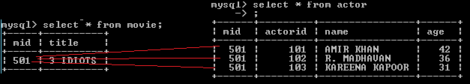

**Actor.java**

**package** onetomany;

**public** **class** Actor {

**private** **int** actorid;

**private** String actorname;

**private** **int** age;

//Setters & getters

}

**Movie.java**

**package** onetomany;

**public** **class** Movie {

**private** **int** mid;

**private** String title;

**private** Set<Actor> actors;

**//Setters & Getters**

}

**Actor.hbm.xml**

<hibernate-mapping package=*"onetomany"*>

<class name=*"Actor"* table=*"actor"*>

<id name=*"actorid"* column=*"actorid"*>

<generator class=*"assigned"* />

</id>

<property name=*"actorname"* column=*"name"* />

<property name=*"age"* column=*"age"* />

</class>

</hibernate-mapping>

**Movie.hbm.xml**

<hibernate-mapping package=*"onetomany"*>

<class name=*"Movie"* table=*"movie"*>

<id name=*"mid"* column=*"mid"*>

<generator class=*"assigned"*/>

</id>

<property name=*"title"* column=*"title"* />

<set name=*"actors"* table=*"actor"* cascade=*"all"*>

<key column=*"mid"* not-null=*"true"* />

<one-to-many class=*"Actor"* />

</set>

</class>

</hibernate-mapping>

* In order to transfer operations on parent object to child object we need to add **cascade** attribute
* By default, cascade value is none, it means even though relationship is exist, the operations we are doing on parent will not transfer to child.
* In above xml, we used **cascade =” all”** means all operations at parent object will be transfer to child
* Inthe mapping file, we need to use **<key />** **element to configure foregin key column name**, in this example “*mid”* is foreign key
* **<one-to-many>** is child class with which relation been done,  in our example**Actor** is the child class

**OneToManyTest.java**

**package** onetomany;

**import** java.util.HashSet;

**import** java.util.Set;

**import** org.hibernate.Session;

**import** org.hibernate.SessionFactory;

**import** org.hibernate.Transaction;

**import** org.hibernate.cfg.Configuration;

**public** **class** OneToManyTest {

**public** **static** **void** main(String[] args) {

Configuration cfg = **new** Configuration();

cfg.configure("hibernate.cfg.xml");

SessionFactory sf = cfg.buildSessionFactory();

Session session = sf.openSession();

Actor amir = **new** Actor();

amir.setActorname("AMIR KHAN");

amir.setAge(42);

amir.setActorid(101);

Actor madhav = **new** Actor();

madhav.setActorname("R. MADHAVAN");

madhav.setAge(36);

madhav.setActorid(102);

Actor kareena = **new** Actor();

kareena.setActorname("KAREENA KAPOOR");

kareena.setAge(31);

kareena.setActorid(103);

Set<Actor> actors =**new** HashSet<Actor>();

actors.add(amir);

actors.add(madhav);

actors.add(kareena);

Movie movie = **new** Movie();

movie.setTitle("3 IDIOTS");

movie.setActors(actors);

movie.setMid(501);

Transaction tx = session.beginTransaction();

session.save(movie);

tx.commit();

System.***out***.println("Succuess");

}

}

## 3.Many to Many Relationship

Applying many to many relationships between two pojo class objects is nothing but applying **one to many relationships on both sides**, which tends to Bi-Directional i mean many to many.

* when ever we are applying many to many relationships between two pojo class objects**, on both sides we need a collection property**
* While applying **many to many** relationships between pojo classes, a **mediator table is mandatory in the database**, to store primary key as foreign key both sides, we call this table as Join table

In the example of **Student and Course**, the relationship can be many-to-many: a student can take many courses, while a course may consist of many students

**CREATE** **TABLE** `course` (

`courseId` **INT**(11) **NOT** **NULL** **AUTO\_INCREMENT**,

`courseName` **VARCHAR**(50) **NULL** **DEFAULT** **NULL**,

**PRIMARY** **KEY** (`courseId`)

)

**CREATE** **TABLE** `student` (

`studentId` **INT**(11) **NOT** **NULL** **AUTO\_INCREMENT**,

`studentName` **VARCHAR**(50) **NULL** **DEFAULT** **NULL**,

**PRIMARY** **KEY** (`studentId`)

)

// **mediator table**

**CREATE** **TABLE** `student\_course` (

`COURSE\_ID` **INT**(10) **NOT** **NULL**,

`STUDENT\_ID` **INT**(10) **NOT** **NULL**,

**PRIMARY** **KEY** (`COURSE\_ID`, `STUDENT\_ID`),

**INDEX** `FKCB6FBEBFAD895D0F` (`COURSE\_ID`),

**INDEX** `FKCB6FBEBF88820545` (`STUDENT\_ID`),

**CONSTRAINT** `fk\_c\_id` **FOREIGN** **KEY** (`COURSE\_ID`) **REFERENCES** `course` (`courseId`),

**CONSTRAINT** `fk\_s\_id` **FOREIGN** **KEY** (`STUDENT\_ID`) **REFERENCES** `student` (`studentId`)

)

Course.java

**package** manytomany;

**public** **class** Course {

**private** **int** courseId;

**private** String courseName;

**private** Set<Student> students;

**//Setters & Getters**

}

Student.java

**package** manytomany;

**public** **class** Student {

**private** **int** studentId;

**private** String studentName;

**private** Set<Course> courses;

**//Setters & Getters**

}

**Course.hbm.xml**

<hibernate-mapping package=*"manytomany"*>

<class name=*"Course"* table=*"course"*>

<id name=*"courseId"* column=*"courseId"*>

<generator class=*"assigned"* />

</id>

<property name=*"courseName"* column=*"courseName"* />

<set name=*"students"* table=*"STUDENT\_COURSE"* inverse=*"true"*

cascade=*"all"*>

<key column=*"COURSE\_ID"* />

<many-to-many column=*"STUDENT\_ID"* class=*"Student"* />

</set>

</class>

</hibernate-mapping>

**Student.hbm.xml**

<hibernate-mapping package=*"manytomany"*>

<class name=*"Student"* table=*"student"*>

<id name=*"studentId"* column=*"studentId"*>

<generator class=*"assigned"* />

</id>

<property name=*"studentName"* column=*"studentName"* />

<set name=*"courses"* table=*"STUDENT\_COURSE"* cascade=*"all"*>

<key column=*"STUDENT\_ID"* />

<many-to-many column=*"COURSE\_ID"* class=*"Course"* />

</set>

</class>

</hibernate-mapping>

**package** manytomany;

**public** **class** ManyToManyTest {

**public** **static** **void** main(String[] args) {

Configuration cfg = **new** Configuration();

cfg.configure("hibernate.cfg.xml");

SessionFactory sf = cfg.buildSessionFactory();

Session session = sf.openSession();

Student s1 = **new** Student();

s1.setStudentId(101);

s1.setStudentName("SATYA");

Student s2 = **new** Student();

s2.setStudentId(102);

s2.setStudentName("ARJUN");

Course c1 = **new** Course();

c1.setCourseId(301);

c1.setCourseName("JAVA");

Course c2 = **new** Course();

c2.setCourseId(302);

c2.setCourseName(".NET");

Set<Student> students = **new** HashSet<Student>();

students.add(s1);

students.add(s2);

c1.setStudents(students);

c2.setStudents(students);

Set<Course> courses = **new** HashSet<Course>();

courses.add(c1);

courses.add(c2);

s1.setCourses(courses);

s2.setCourses(courses);

Transaction tx = session.beginTransaction();

session.save(s1);

session.save(s2);

tx.commit();

System.***out***.println("Succuess");

}

}

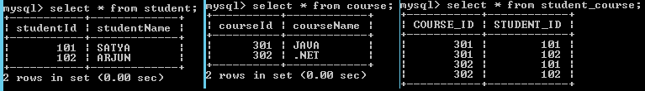

### Cascade Attribute In Hibernate

Cascade attribute is mandatory, whenever we apply relationship between objects, cascade attribute transfers operations done on one object onto its related child objects. default value of **cascade =”none”** means no operations will be transfers to the child class

If we write **cascade = “all”** then changes like insert, delete, update at parent object will be effected to child object.

Cascade having following values

* none (default), save, update, save-update, delete, all, all-delete-orphan

# 12. Hibernate Cache

Every fresh session having its own **cache memory**, **Caching is a mechanism for storing the loaded objects into a cache memory**.  The advantage of cache mechanism is, whenever again we want to load the same object from the database then instead of hitting the database once again, it loads from the local cache memory only**, so that the no. of round trips between an application and a database server got decreased**.  It means caching mechanism increases the performance of the application.

In hibernate we have two levels of caching

1. **First Level Cache (**Session Cache)
2. **Second Level Cache** (Session Factory Cache/ JVM Level Cache)

### 1.First Level Cache

* By default, for each hibernate application, **the first level cache is automatically enabled. We can’t Enable/Disable first level cache**
* the first level cache is associated with the **session** object and **scope** of the cache **is limited to one session only**
* When we load an object for the first time from the database then the object will be loaded from the database and the loaded object will be stored in the cache memory maintained by that session object
* If we load the same object once again, with in the same session, then the object will be loaded from the local cache memory not from the database
* If we load the same object by opening other session, then again the object will load from the database and the loaded object will be stored in the cache memory maintained by this new session

**Example:**

Session session = factory.openSession();

Object ob1 = session.get(Actor.class, new Integer(101)); //1

Object ob2 = session.get(Actor.class, new Integer(101));//2

Object ob3 = session.get(Actor.class, new Integer(101));//3

session.close();//4

Session ses2 = factory.openSession();

Object ob5 = ses2.get(Actor.class, new Integer(101));//5

1, We are loaded object with id 101, now it will load the object from the database only as its the first time, and keeps this object in the session cache

2,3 i tried to load the same object 2 times, but here the object will be loaded from the stored cache only not from the database, as we are in the same session

4, we close the first session, so the cache memory related this session also will be destroyed

5, again i created one new session and loaded the same object with id 101, but this time hibernate will loads the object from the database

if we want to remove the objects that are stored in the cache memory, then we need to call either **evict() or clear()** methods

### 2.Second Level Cache

Whenever we are loading any object from the database, then hibernate verify whether that object is available in the local cache(**first level cache**) memory of that particular session, if not available then hibernate verify whether the object is available in global cache(**second level cache)**, if not available then hibernate will hit the database and loads the object from there, and then **first stores in the local cache** of the session , then in the global cache

**SessionFactory** holds the second level cache data. It is global for all the session objects and not enabled by default.

Different vendors have provided the implementation of Second Level Cache

1. **EH Cache**
2. **OS Cache**
3. **Swarm Cache**
4. **JBoss Cache**

To enable second level cache in the hibernate, then the following **3** changes are required

1. **Add provider class** in hibernate configuration file

<property name="hibernate.cache.provider\_class">

**org.hibernate.cache.EhCacheProvider**

</property>

1. **Configure cache element** for a class in hibernate mapping file

<cache usage="read-only" />

* + **read-only:** caching will work for read only operation.
  + **nonstrict-read-write:** caching will work for read and write but one at a time.
  + **read-write:** caching will work for read and write, can be used simultaneously.
  + **transactional:** caching will work for transaction.

1. create xml file called **ehcache.xml** and place where you have mapping and configuration xml’s

**Example:**

**public** **class** Employee {

**private** **int** eid;

**private** String name;

**private** String address;

//Setters & Getteers

}

**Employee.hbm.xml**

<hibernate-mapping package=*"cache"*>

<class name=*"Employee"* table=*"employee"*>

<cache usage=*"read-only"* />

<id name=*"eid"* column=*"eid"*>

<generator class=*"native"*></generator>

</id>

<property name=*"name"*></property>

<property name=*"address"*></property>

</class>

</hibernate-mapping>

**ehcache.xml**

<?xml version=*"1.0"*?>

<ehcache>

<defaultCache maxElementsInMemory=*"100"* eternal=*"false"*

timeToIdleSeconds=*"120"* timeToLiveSeconds=*"200"* />

<cache name=*"cache.Employee"* maxElementsInMemory=*"100"*

eternal=*"false"* timeToIdleSeconds=*"5"* timeToLiveSeconds=*"200"* />

</ehcache>

**hibernate.cfg.xml**

<hibernate-configuration>

<session-factory>

<property> Driver Class, URL, Username, password, etc </property>

<property name=*"cache.provider\_class"*>org.hibernate.cache.EhCacheProvider</property>

<property name=*"hibernate.cache.use\_second\_level\_cache"*>true</property>

<mapping resource=*"cache/employee.hbm.xml"* />

</session-factory>

</hibernate-configuration>

**CacheDemo.java**

**package** cache;

**import** org.hibernate.\*;

**import** org.hibernate.cfg.\*;

**public** **class** CacheDemo {

**public** **static** **void** main(String[] args) {

//1.Load Configuration

Configuration cfg = **new** Configuration();

cfg.configure("hibernate.cfg.xml");

//2.Create Session

SessionFactory sf = cfg.buildSessionFactory();

Session session = sf.openSession();

//3.Perform Operations

Object ob = session.load(Employee.**class**, **new** Integer(1));

Employee bo = (Employee) ob;

System.***out***.println("SELECTED DATA\n ================");

System.***out***.println("SNO : "+bo.getEid());

System.***out***.println("NAME : "+bo.getName());

System.***out***.println("ADDRESS : "+bo.getAddress());

}

}

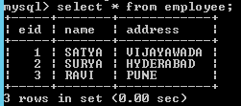

# 13. Hibernate with Annotations

The EJB 3 standard annotations are contained in the **javax.persistence** package, so we import this package.

* Use annotations in POJO classes. These classes are called Entity Bean Classes
* No need of xml files
* We use **AnnotationConfiguartion** class instead of Configuration class

Configuration cfg = new AnnotationConfiguartion ();

* From Hibernate 4.x version Configuration is enough for both annotation and xml configuration
* We have to configure POJO class in hbm.xml

<mapping class="bean.Student">

## Commonly used Annotations in Hibernate

**1.@Entity**

* Annotation marks this class as an entity.
* We have to place this annotation at the top of class

**2.@Table**

* Specifies Table to be connect with this class. If you don’t use **@Table** annotation, hibernate will use the **class name as the table name by default**.
* We have to **place this annotation at the top of class.**

**3.@Id**

 Every table has a primary key; we can make the data member as Primary Key using @Id annotation.

**4.@GeneratedValue**

      It will generate the Primary Key/ ID values automatically

**5.@Column**

* This Annotation specifies the details of the column for this property or field.
* If @Column is not specified, property name will be used as the column name by default.

**6.**    **@Transient**

We can declare the data members which are **not have columns in database table**

**7.@ManyToMany**

* **Cascade:** Marks this field as the owning side of the many-to-many relationship and cascade modifier specifies which operations should cascade to the inverse side of relationship
* **mappedBy:** This modifier holds the field which specifies the inverse side of the relationship

**8.@JoinTable**

* **Name**: For holding this many-to-many relationship, maps this field with an intermediary database join table specified by name modifier
* **joinColumns:** Identifies the owning side of columns which are necessary to identify a unique owning object
* **inverseJoinColumns:** Identifies the inverse (target) side of columns which are necessary to identify a unique target object

**9.@JoinColumn**

Maps a join column specified by the name identifier to the relationship table specified by @JoinTable

## Example: CURD operations using Annotations

**CREATE** **TABLE** `studenttable` (

`sno` **INT**(11) **NOT** **NULL** **AUTO\_INCREMENT**,

`name` **VARCHAR**(50) **NULL** **DEFAULT** **NULL**,

`address` **VARCHAR**(50) **NULL** **DEFAULT** **NULL**,

**PRIMARY** **KEY** (`sno`)

)

**StudentBo.java**

**package** annotations;

@Entity

@Table(name="studenttable")

**public** **class** StudentBo {

@Id

@Column(name="sno")

@GeneratedValue(strategy=GenerationType.***AUTO***)

**private** **int** sno; //PRIMARY\_KEY

@Column(name="name")

**private** String name;

@Column //By default it will take datamember name

**private** String address;

@Transient

**private** String iamnotindatabase;

//This column not their in db

**public** **int** getSno() {

**return** sno;

}

**public** **void** setSno(**int** sno) {

**this**.sno = sno;

}

**public** String getName() {

**return** name;

}

**public** **void** setName(String name) {

**this**.name = name;

}

**public** String getAddress() {

**return** address;

}

**public** **void** setAddress(String address) {

**this**.address = address;

}

**public** StudentBo( String name, String address) {

**super**();

**this**.name = name;

**this**.address = address;

}

**public** StudentBo() {

**super**();

}

}

<hibernate-configuration>

<session-factory>

<property name=*"hibernate.connection.driver\_class"*>com.mysql.jdbc.Driver</property>

<property name=*"hibernate.connection.url"*>jdbc:mysql://localhost:3306/smlcodes</property>

<property name=*"hibernate.connection.username"*>root</property>

<property name=*"hibernate.connection.password"*>root</property>

<property name=*"hibernate.dialect"*>org.hibernate.dialect.MySQLDialect</property>

<property name=*"show\_sql"*>true</property>

<property name=*"hbm2ddl.auto"*>update</property>

<property name=*"cache.provider\_class"*>org.hibernate.cache.EhCacheProvider</property>

<property name=*"hibernate.cache.use\_second\_level\_cache"*>true</property>

<mapping class=*"annotations.StudentBo"*/>

</session-factory>

</hibernate-configuration>

**AnnotationExample.java**

**package** annotations;

**public** **class** AnnotationExample {

**public** **static** **void** main(String[] args) {

Configuration cfg = **new** AnnotationConfiguration();

cfg.configure("hibernate.cfg.xml");

SessionFactory sf = cfg.buildSessionFactory();

Session session = sf.openSession();

Transaction tx = session.beginTransaction();

System.***out***.println("1.Save Operation");

System.***out***.println("===============================");

StudentBo e1 = **new** StudentBo("SATYA", "HYD");

StudentBo e2 = **new** StudentBo("RAM", "BANGLORE");

StudentBo e3 = **new** StudentBo("KIRAN", "MUMBAI");

session.save(e1);

session.save(e2);

session.save(e3);

System.***out***.println("2.Select Operation");

System.***out***.println("===============================");

List<StudentBo> ob = session.createQuery("FROM StudentBo").list();

**for** (StudentBo e : ob) {

System.***out***.println(e.getSno()+", "+e.getName()+", "+e.getAddress());

}

tx.commit();

session.close();

sf.close();

}

}

log4j:WARN No appenders could be found for logger (org.hibernate.cfg.annotations.Version).

log4j:WARN Please initialize the log4j system properly.

1.Save Operation

===============================

Hibernate: insert into studenttable (name, address) values (?, ?)

Hibernate: insert into studenttable (name, address) values (?, ?)

Hibernate: insert into studenttable (name, address) values (?, ?)

2.Select Operation

===============================

Hibernate: select studentbo0\_.sno as sno0\_, studentbo0\_.name as name0\_, studentbo0\_.address as address0\_ from studenttable studentbo0\_

1, SATYA, HYD

2, RAM, BANGLORE

3, KIRAN, MUMBAI

## Mappings using Annotations

### 1.one-to-one mapping using Annotations

Car.java

**package** annotations.onetoone;

@Entity

@Table(name="car")

**public** **class** Car {

@Id

@Column(name="CAR\_ID")

**private** **int** id;

@Column(name="NAME")

**private** String name;

@Column(name="COLOR")

**private** String color;

**//Setters & Getters**

}

Engine.java

**package** annotations.onetoone;

@Entity

@Table(name="engine")

**public** **class** Engine {

@Id

**private** **int** id = 0;

@Column

**private** String model = **null**;

@Column

**private** String size = **null**;

@OneToOne(targetEntity=Car.**class**,cascade=CascadeType.***ALL***)

@JoinColumn(name="CAR\_ID",referencedColumnName="CAR\_ID")

**private** Car car = **null**;

**//Setters & Getters**

}

OneToOneTest.java

**package** annotations.onetoone;

**public** **class** OneToOneTest {

**public** **static** **void** main(String[] args) {

Configuration cfg = **new** AnnotationConfiguration();

cfg.configure("hibernate.cfg.xml");

SessionFactory sf = cfg.buildSessionFactory();

Session session = sf.openSession();

Car car = **new** Car();

car.setId(2);

car.setName("BENZ");

car.setColor("RED");

Engine engine = **new** Engine();

engine.setModel("2209");

engine.setSize("815KG");

engine.setCar(car);

Transaction tx = session.beginTransaction();

session.save(car);

session.save(engine);

tx.commit();

System.***out***.println("Succuess");

}

}

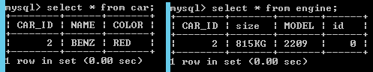

### 2.one-to-many Mapping Using Annotations

Actor.java

**package** annotations.onetomany;

@Entity

@Table(name="actor")

**public** **class** Actor {

@Id

@Column

**private** **int** actorid;

@Column(name="name")

**private** String actorname;

@Column

**private** **int** age;

**//Setters & Getters**

}

Movie.java

**package** annotations.onetomany;

@Entity

@Table(name="movie")

**public** **class** Movie {

@Id

@Column

**private** **int** mid;

@Column

**private** String title;

@OneToMany(cascade = CascadeType.***ALL***)

@JoinColumn(name="mid",referencedColumnName="mid")

**private** Set<Actor> actors;

**//Setters & Getters**

}

OneToManyTest.java

**package** annotations.onetomany;

**public** **class** OneToManyTest {

**public** **static** **void** main(String[] args) {

Configuration cfg = **new** AnnotationConfiguration();

cfg.configure("hibernate.cfg.xml");

SessionFactory sf = cfg.buildSessionFactory();

Session session = sf.openSession();

Actor amir = **new** Actor();

amir.setActorname("PRABAS");

amir.setAge(36);

amir.setActorid(106);

Actor madhav = **new** Actor();

madhav.setActorname("DAGGUBATI RANA");

madhav.setAge(31);

madhav.setActorid(107);

Actor kareena = **new** Actor();

kareena.setActorname("KATTAPPA");

kareena.setAge(61);

kareena.setActorid(108);

Set<Actor> actors =**new** HashSet<Actor>();

actors.add(amir);

actors.add(madhav);

actors.add(kareena);

Movie movie = **new** Movie();

movie.setTitle("BAAHUBALI");

movie.setActors(actors);

movie.setMid(502);

Transaction tx = session.beginTransaction();

session.save(movie);

tx.commit();

System.***out***.println("Succuess");

}

}

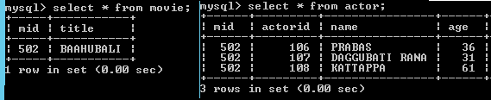

### 3.Many-to-many Mapping Using Annotations

Course.java

**package** annotations.manytomany;

@Entity

@Table(name="course")

**public** **class** Course {

@Id

@Column

**private** **int** courseId;

@Column

**private** String courseName;

@ManyToMany(fetch = FetchType.***LAZY***, cascade = CascadeType.***ALL***)

@JoinTable(name = "student\_course", joinColumns = {

@JoinColumn(name = "COURSE\_ID", nullable = **false**, updatable = **false**) },

inverseJoinColumns = { @JoinColumn(name = "STUDENT\_ID",

nullable = **false**, updatable = **false**) })

**private** Set<Student> students;

**//Setters & Getters**

}

Student.java

**package** annotations.manytomany;

@Entity

@Table(name="student")

**public** **class** Student {

@Id

@Column

**private** **int** studentId;

@Column

**private** String studentName;

@Column

@ManyToMany(mappedBy = "students")

**private** Set<Course> courses;

**//Setters & Getters**

}

ManyToMantTest.java

**package** annotations.manytomany;

**public** **class** ManyToManyTest {

**public** **static** **void** main(String[] args) {

Configuration cfg = **new** AnnotationConfiguration();

cfg.configure("hibernate.cfg.xml");

SessionFactory sf = cfg.buildSessionFactory();

Session session = sf.openSession();

Student s1 = **new** Student();

s1.setStudentId(105);

s1.setStudentName("SACHIN");

Student s2 = **new** Student();

s2.setStudentId(112);

s2.setStudentName("DHONI");

Course c1 = **new** Course();

c1.setCourseId(303);

c1.setCourseName("DEVOPS");

Course c2 = **new** Course();

c2.setCourseId(304);

c2.setCourseName("HACKING");

Set<Student> students = **new** HashSet<Student>();

students.add(s1);

students.add(s2);

c1.setStudents(students);

c2.setStudents(students);

Set<Course> courses = **new** HashSet<Course>();

courses.add(c1);

courses.add(c2);

s1.setCourses(courses);

s2.setCourses(courses);

**//we have to save the Course object, because we defiend M2M in Course class only**

Transaction tx = session.beginTransaction();

session.save(c1);

session.save(c2);

tx.commit();

System.***out***.println("Succuess");

}

}

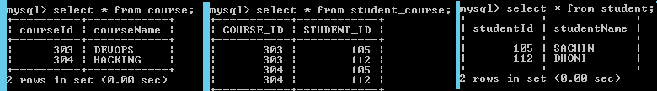

# Errors & Solutions

## org.hibernate.HibernateException: Could not parse configuration: hibernate.cfg.xml

It was failing because there was no internet connection / you are behind proxy. To solve this issues

* Extract hibernate3.jar file find hibernate-mapping-3.0.dtd, hibernate-configuration-3.0.dtd files
* Paste the above two files root folder of your project

In **hibernate.cfg.xml** change lines to

<?xml version=*'1.0'* encoding=*'utf-8'*?>

<!DOCTYPE hibernate-configuration SYSTEM

"hibernate-configuration-3.0.dtd">

In **<Class>.hbm.xml** change lines to

<?xml version=*"1.0"*?>

<!DOCTYPE hibernate-mapping SYSTEM

"hibernate-mapping-3.0.dtd">

# References



<http://www.java4s.com/hibernate>

Mappings: OReilly.Just.Hibernate.Jun.2014.ISBN.1449334377.pdf

[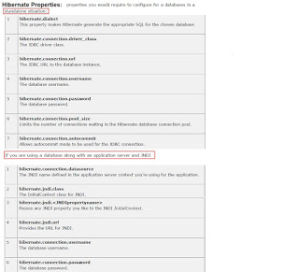](https://2.bp.blogspot.com/-RoXW3oPsFlY/V8Gmr2T_VwI/AAAAAAAABb4/HcDoxQphLs4IJAVmSk4Xn-J6nFbatfYnQCLcB/s1600/3.+Properties.JPG)

[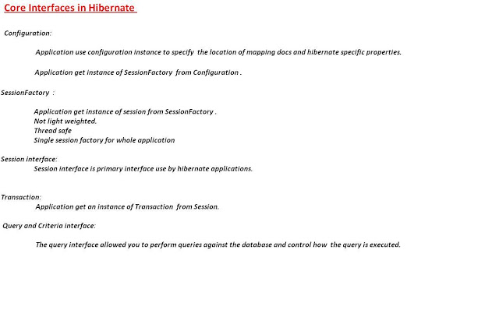](https://2.bp.blogspot.com/-SBXCv-6GGCQ/V8Gmr1UV-4I/AAAAAAAABbw/flbMV6YdORI-gq8sCJSooLcVyYMxk1D0wCLcB/s1600/4.Objects.JPG)

[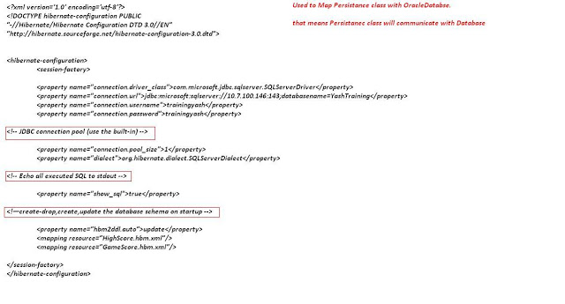](https://4.bp.blogspot.com/-OiQIOkzLK20/V8Gmr7zufqI/AAAAAAAABb0/JL_GNCQypaU1L_C3F6UvJf2dTxa5rjh7QCLcB/s1600/5.hibernate.cfg.xmlfile.JPG)

[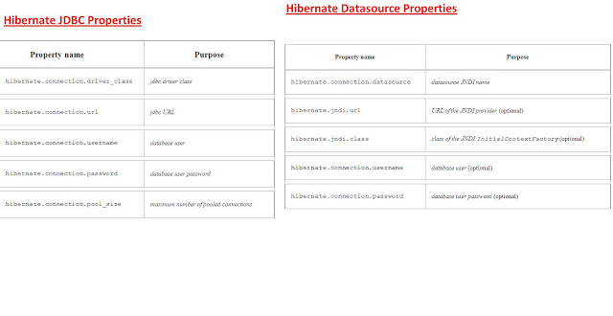](https://3.bp.blogspot.com/-xjC8aEzEynQ/V8GmsiQTwCI/AAAAAAAABb8/wmmQZFGV_Cwm1XxW4FhTcpMslxF6vj0OQCLcB/s1600/6.HibernateXml+Propetres.JPG)

[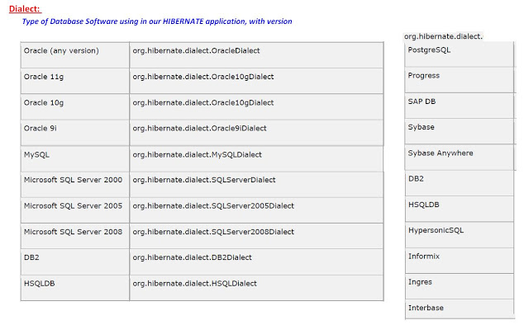](https://3.bp.blogspot.com/-5c6zwqFWrLU/V8Gms1P113I/AAAAAAAABcA/dU2dM4CWw5UGI36Z8kbjrmTnoMh3_gOfQCLcB/s1600/7.Dialect.JPG)

[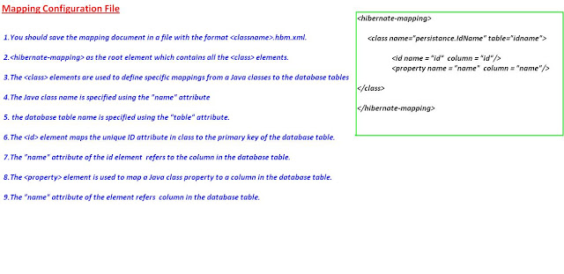](https://2.bp.blogspot.com/-NV5HXpO_CI0/V8Gmtijwd6I/AAAAAAAABcI/H0isBZ4dyGg1XHtqTJzL_N6vINodeVk8gCLcB/s1600/9.Mapping+File.JPG)