Sqoop

- Transferring an Entire Table

You have a table in a relational database (e.g., MySQL) and you need to transfer the
table’s contents into Hadoop’s Distributed File System (HDFS).

sqoop import --connect jdbc:mysql://localhost/mysql --username root --password root --table books
// Sql Server
sqoop import --connect "jdbc:sqlserver://IMPC0937:1433;database=Northwind" --table Books --username sa --password 123Welcome
hadoop fs -cat /user/htcprasad/books/part-m-00000

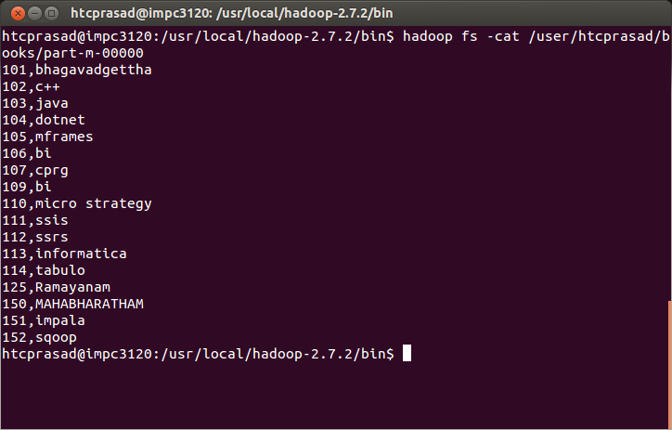
- Specifying a Target Directory

The previous example worked well, so you plan to incorporate Sqoop into your Hadoop
workflows. In order to do so, you want to specify the directory into which the data
should be imported.

sqoop import --connect jdbc:mysql://localhost/mysql --username root --password root --table books --target-dir /myresult_books

hadoop fs -cat /myresult_books/part-m-00000

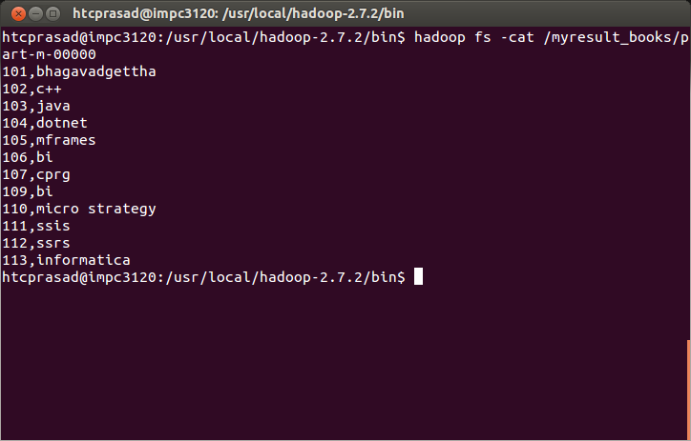
- Importing Only a Subset of Data

Instead of importing an entire table, you need to transfer only a subset of the rows based
on various conditions that you can express in the form of a SQL statement with a WHERE
clause.

sqoop import --connect jdbc:mysql://localhost/mysql --username root --password root --table help_keyword --where "help_keyword_id=7"

hadoop fs -cat /user/htcprasad/help_keyword/part-m-00000
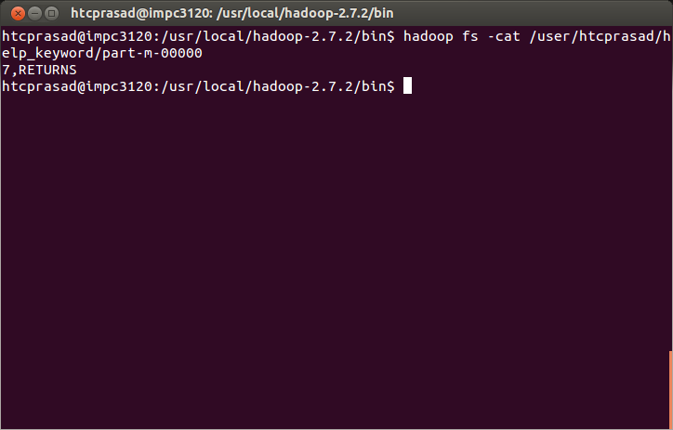
- Protecting Your Password

Typing your password into the command-line interface is insecure. It can be easily
retrieved from listing the operating system’s running processes.

sqoop import --connect jdbc:mysql://localhost/mysql --username root --table books -P

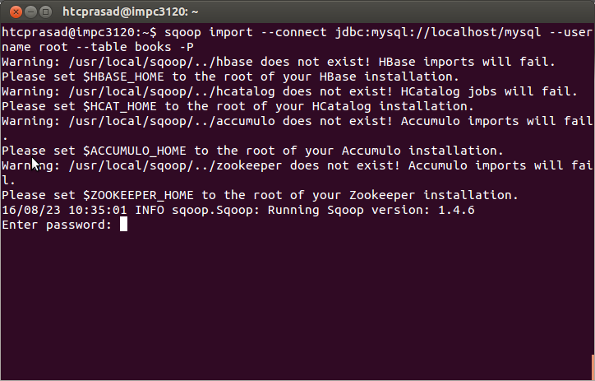
- Speeding Up Transfers

Sqoop is a great tool, and it’s processing bulk transfers very well. Can Sqoop run faster?
Rather than using the JDBC interface for transferring data, the direct mode delegates
the job of transferring data to the native utilities provided by the database vendor.

sqoop import --connect jdbc:mysql://localhost/mysql --username root --password root --table books –direct

hadoop fs -cat /user/htcprasad/books/part-m-00000

- Overriding Type Mapping

The default type mapping that Sqoop provides between relational databases and Hadoop usually works well. You have use cases requiring you to override the mapping.

sqoop import --connect jdbc:mysql://localhost/mysql --username root --password root --table books --map-column-java bookid=Long

hadoop fs -cat /user/htcprasad/books/part-m-00000
- Controlling Parallelism
Sqoop by default uses four concurrent map tasks to transfer data to Hadoop. Transfer‐
ring bigger tables with more concurrent tasks should decrease the time required to
transfer all data. You want the flexibility to change the number of map tasks used on a
per-job basis.

sqoop import --connect jdbc:mysql://localhost/mysql --username root --password root --table help_keyword --num-mappers 5 --target-dir usemappers/
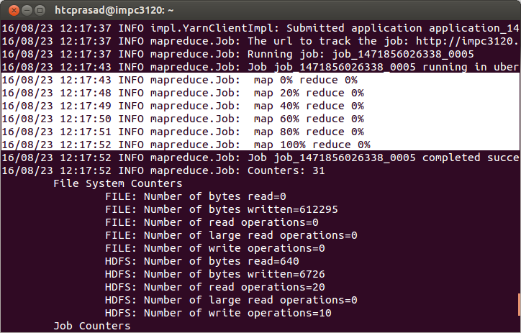
- Encoding NULL Values
Sqoop encodes database NULL values using the null string constant. Your downstream
processing (Hive queries, custom MapReduce job, or Pig script) uses a different constant
for encoding missing values. You would like to override the default one.

sqoop import --connect jdbc:mysql://localhost/mysql --username root --password root --table novels --input-null-string '\\N' --split-by bookid --target-dir siva/novel4/

hadoop fs -cat siva/novel4/part-m-00000
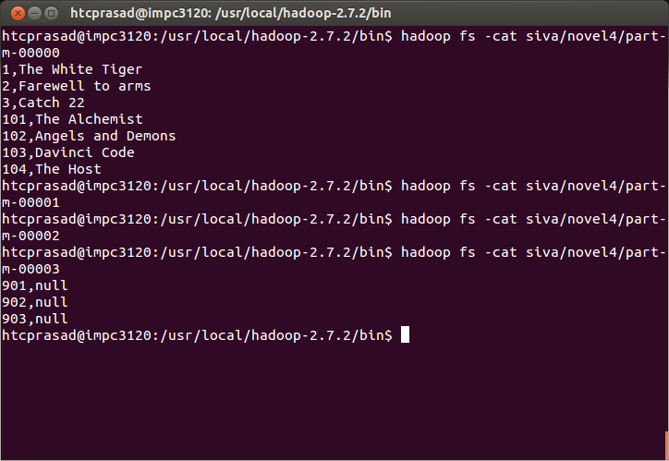
hadoop fs -cat siva/novel4/part-m-00003

- Importing All Your Tables

You would like to import all tables from your database at once using one command
rather than importing the tables one by one.

sqoop import-all-tables --connect jdbc:mysql://localhost/mysql --username root --password root

- Importing Only New Data

You have a database table with an INTEGER primary key. You are only appending new rows, and you need to periodically sync the table’s state to Hadoop for further processing.

sqoop import --connect jdbc:mysql://localhost/mysql --username root --password root --table help_keyword --incremental append --check-column help_keyword_id --last-value 529

hadoop fs -cat /user/htcprasad/help_keyword/part-m-00001
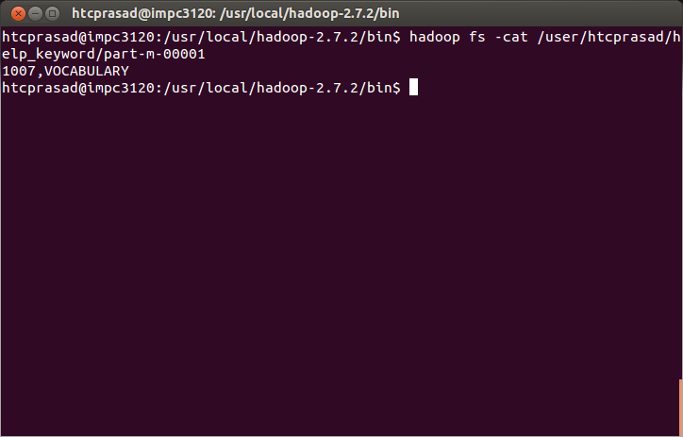

- Importing Data from Two Tables

The free-form query import is one of the advanced features of Sqoop. As with all ad‐
vanced software features, it gives you great power. Instead of the parameter --table,
use the parameter --query with the entire query for obtaining the data you would like
to transfer.

sqoop import --connect jdbc:mysql://localhost/mysql --username root --password root --query 'SELECT books.bookname,authors.authorname FROM books JOIN authors USING(bookid) WHERE $CONDITIONS' --split-by books.bookname --target-dir /siva/join/

hadoop fs -cat /siva/join/part-m-00001
hadoop fs -cat /siva/join/part-m-00002
hadoop fs -cat /siva/join/part-m-00003
hadoop fs -cat /siva/join/part-m-00004

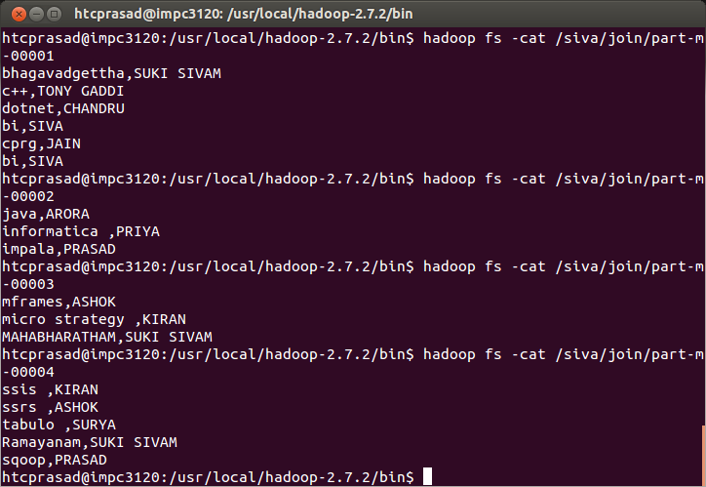
12) Using Custom Boundary Queries
You found free-form query import to be very useful for your use case. Unfortunately,
prior to starting any data transfer in MapReduce, Sqoop takes a long time to retrieve
the minimum and maximum values of the column specified in the --split-by param‐
eter that are needed for breaking the data into multiple independent tasks.

sqoop import --connect jdbc:mysql://localhost/mysql --username root --password root --query 'SELECT books.bookname,authors.authorname
FROM books JOIN authors USING(bookid) WHERE $CONDITIONS' --split-by books.bookid --target-dir /siva/join_boundary --boundary-query "SELECT MIN(bookid), MAX(bookid) FROM books"
hadoop fs -cat /siva/join_boundary/part-m-00000
hadoop fs -cat /siva/join_boundary/part-m-00001
hadoop fs -cat /siva/join_boundary/part-m-00002
hadoop fs -cat /siva/join_boundary/part-m-00003
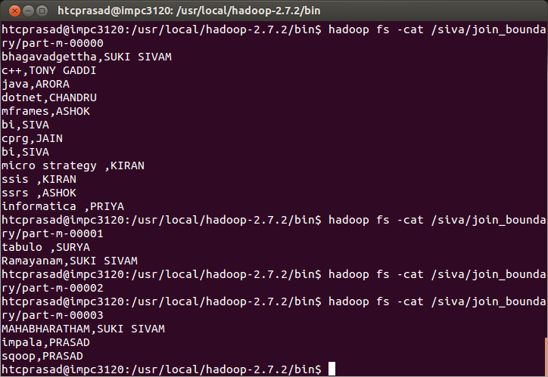
13) Importing Queries with Duplicated Columns

You have more than one table that you’re joining in your free-form query. Your Sqoop
import is failing with an error message about duplicate columns, similar to the following
one: Imported Failed: Duplicate Column identifier specified: 'id'

sqoop import --connect jdbc:mysql://localhost/mysql --username root --password root --query 'SELECT novels.bookname AS Novel,books.bookname AS Textbook FROM novels JOIN books USING(bookid) WHERE $CONDITIONS' --split-by novels.bookid --target-dir duplicate_columns2 --boundary-query "SELECT MIN(bookid), MAX(bookid) FROM novels"

hadoop fs -cat duplicate_columns2/part-m-00003

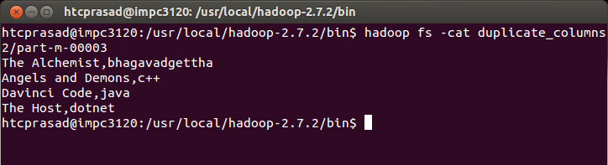
14) Transferring Data from Hadoop

You have a workflow of various Hive and MapReduce jobs that are generating data on
a Hadoop cluster. You need to transfer this data to your relational database for easy
querying.

sqoop export --connect jdbc:mysql://localhost/mysql --username root --password root --table books_export --export-dir /user/htcprasad/books

SELECT * FROM books_export;

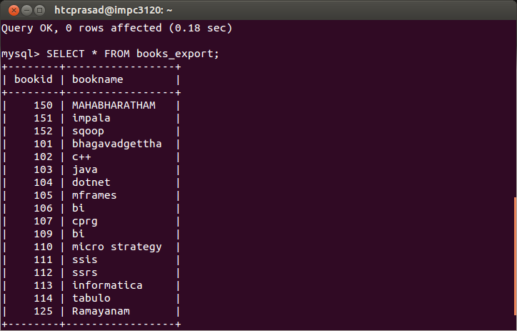
15) Inserting Data in Batches

While Sqoop’s export feature fits your needs, it’s too slow. It seems that each row is
inserted in a separate insert statement. Is there a way to batch multiple insert statements
together?

--batch

sqoop export --connect jdbc:mysql://localhost/mysql --username root --password root --table books_export --export-dir /user/htcprasad/books –batch

SELECT * FROM books_export;

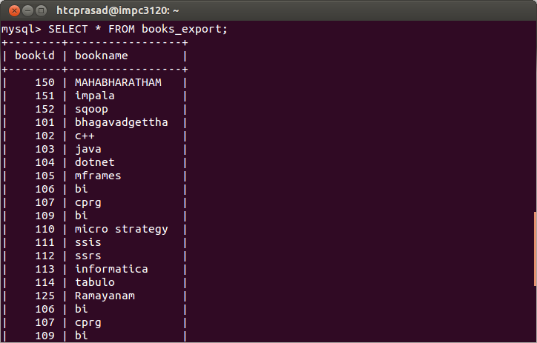
-Dsqoop.records.per.statement

sqoop export -Dsqoop.export.records.per.statement=5 --connect jdbc:mysql://localhost/mysql --username root --password root --table books_export --export-dir /user/htcprasad/books

-Dsqoop.statements.per.transaction

sqoop export -Dsqoop.export.records.per.statement=5 -Dsqoop.export.statements.per.transaction=2 --connect jdbc:mysql://localhost/mysql --username root --password root --table books_export --export-dir /user/htcprasad/books

16) Exporting with All-or-Nothing Semantics

You need to ensure that Sqoop will either export all data from Hadoop to your database
or export no data (i.e., the target table will remain empty).

sqoop export -Dsqoop.export.records.per.statement=5 -Dsqoop.export.statements.per.transaction=2 --connect jdbc:mysql://localhost/mysql --username root --password root --table books_export --staging-table staging_books --export-dir /user/htcprasad/books

SELECT * FROM books_export;
SELECT * FROM staging_books;

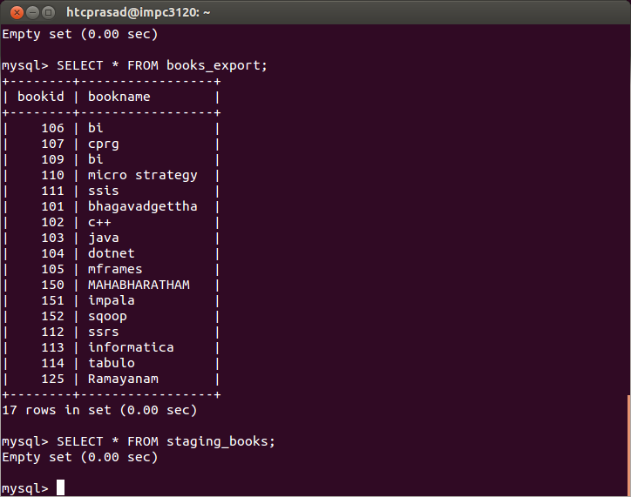
17) Exporting into a Subset of Columns

You have data in Hadoop that you need to export. Unfortunately, the corresponding
table in your database has more columns than the HDFS data.

sqoop export --connect jdbc:mysql://localhost/mysql --username root --password root --table book_details --columns bookid,bookname --export-dir /user/htcprasad/books/

SELECT * FROM book_details;
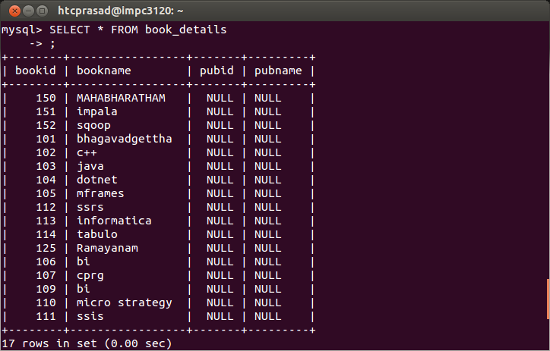

sqoop job --create myjob \
--import \
--connect jdbc:mysql://localhost/db \
--username root \
--table employee --m 1

18) To list the jobs
sqoop job --list

sqoop job --show myjob

sqoop job --exec myjob

19) To generate the DAO class:

sqoop codegen \
--connect jdbc:mysql://localhost/userdb \
--username root \
--table emp
20) To list the databases:

sqoop list-databases \
--connect jdbc:mysql://localhost/ \
--username root
21) To list the tables :

sqoop list-tables \
--connect jdbc:mysql://localhost/userdb \
--username root
22) To view the description of the commands:
sqoop help import

