Business Insights Report

Exploratory Data Analysis of Marketing Campaign Dataset

SkillCraft Technology
Data Analyst Internship
Task 04

Submitted By
AemiReddy Sreeja

Table of Contents

1. Introduction
2. Objective
3. Dataset Description
4. Data Cleaning and Preprocessing
5. Exploratory Data Analysis
6. Business Insights
7. Recommendations
8. Conclusion
9. Tools Used

Introduction

In today's digital world, marketing campaigns play a crucial role in attracting customers, increasing brand awareness, and driving sales. Businesses use multiple marketing channels such as Email, Facebook, Google, Instagram, WhatsApp, and YouTube to reach their target audience. However, simply running campaigns is not enough; organizations must analyze campaign performance to understand which channels deliver the best results and maximize return on investment (ROI).
Exploratory Data Analysis (EDA) is a fundamental step in the data analysis process that helps uncover patterns, trends, relationships, and anomalies within a dataset. By analyzing marketing campaign data, businesses can evaluate customer engagement, measure campaign effectiveness, identify high-performing channels, and make informed decisions regarding future marketing strategies.
This project focuses on performing Exploratory Data Analysis on a marketing campaign dataset. Instead of developing a machine learning model, the objective is to gain meaningful business insights through data cleaning, visualization, and statistical analysis. The findings from this analysis help identify effective marketing channels and provide recommendations for optimizing marketing budget allocation based on ROI and overall campaign performance.

Objective

The main objectives of this project are:
- To clean and preprocess the marketing campaign dataset for accurate analysis.
- To understand the overall structure and quality of the dataset.
- To perform Exploratory Data Analysis (EDA) using descriptive statistics and visualizations.
- To analyze important marketing metrics such as Revenue, ROI, Acquisition Cost, Impressions, Clicks, Leads, and Conversions.
- To evaluate the performance of different marketing channels.
- To visualize the marketing funnel and identify customer drop-off at different stages.
- To provide business recommendations on budget allocation based on campaign performance and ROI.

Dataset Description

Dataset Overview
The dataset used in this project contains information related to digital marketing campaigns conducted through various online marketing channels. It includes campaign details, customer engagement metrics, financial performance indicators, and campaign outcomes. The dataset is designed to evaluate the effectiveness of different marketing strategies by analyzing metrics such as impressions, clicks, leads, conversions, revenue, acquisition cost, and return on investment (ROI).
The dataset was loaded into Python using the Pandas library and explored to understand its structure, identify data quality issues, and prepare it for further analysis.
First Five Records of the Dataset
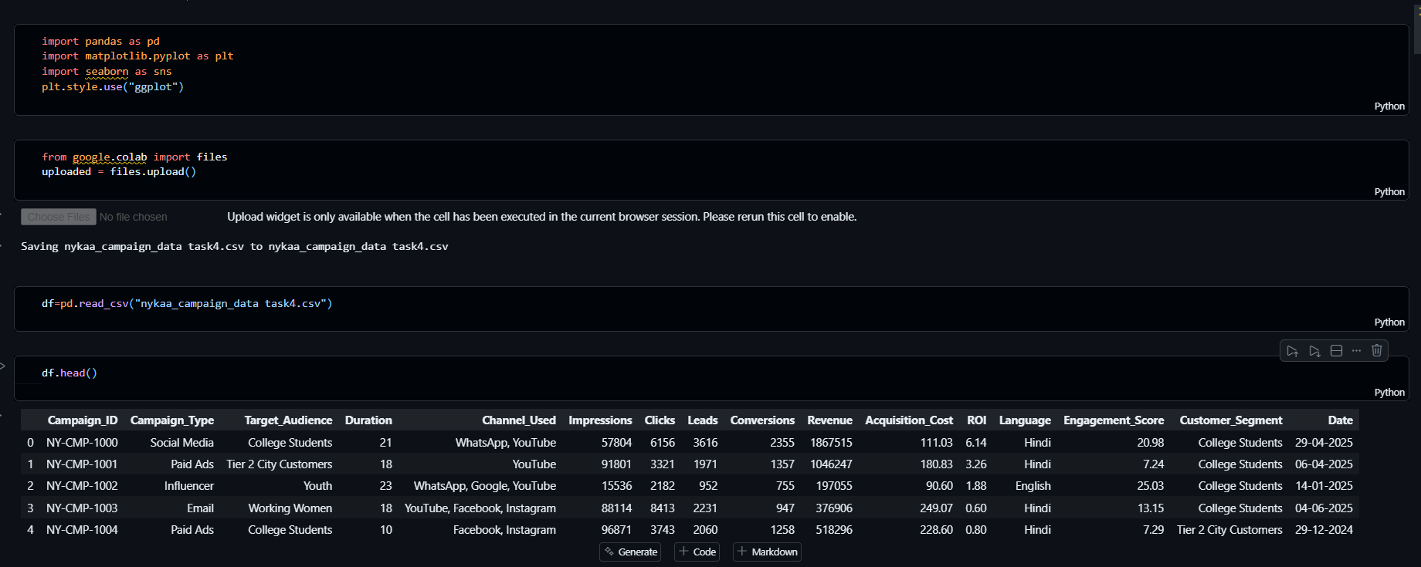

Dataset Dimensions

Dataset Information
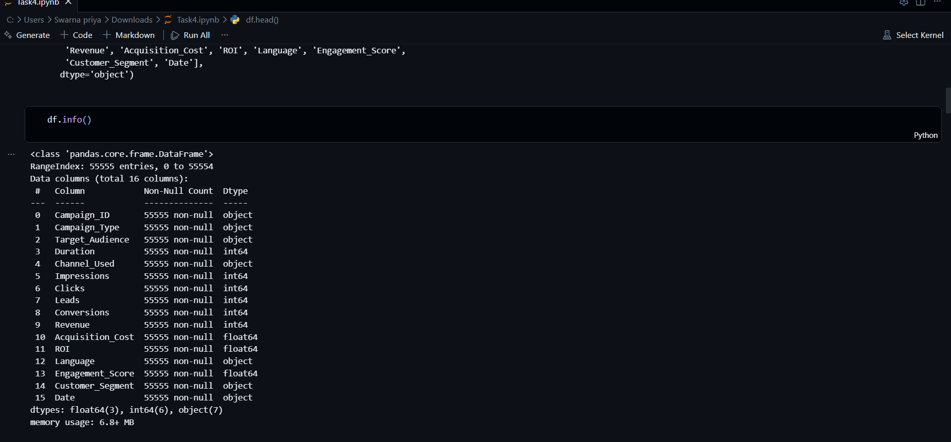
Feature | Description
Campaign_ID | Unique identifier for each campaign
Campaign_Type | Type of marketing campaign
Channel_Used | Marketing channel used
Target_Audience | Intended customer group
Customer_Segment | Customer category
Impressions | Number of times the advertisement was viewed
Clicks | Number of user clicks
Leads | Number of potential customers generated
Conversions | Number of successful conversions
Acquisition_Cost | Total marketing cost
Revenue | Revenue generated from the campaign
ROI | Return on Investment
Engagement_Score | Customer engagement score
Date | Date of the campaign

Data Cleaning and Preprocessing
Data cleaning is an essential step in Exploratory Data Analysis (EDA) as it ensures that the dataset is accurate, consistent, and ready for analysis. Before creating visualizations and extracting business insights, the dataset was examined for missing values, duplicate records, incorrect data types, and other potential data quality issues. The following preprocessing steps were performed to prepare the dataset for analysis.

First Five Records of the Dataset
The dataset was imported into a Pandas DataFrame and the first five records were displayed using the head() function. This helped verify that the dataset was loaded successfully and provided an initial understanding of the available features.
Dataset Information

The info() function was used to examine the dataset structure, including the number of rows, columns, data types, and non-null values. This step confirmed that the dataset was properly loaded and identified the data types of each feature.

Missing Values Analysis
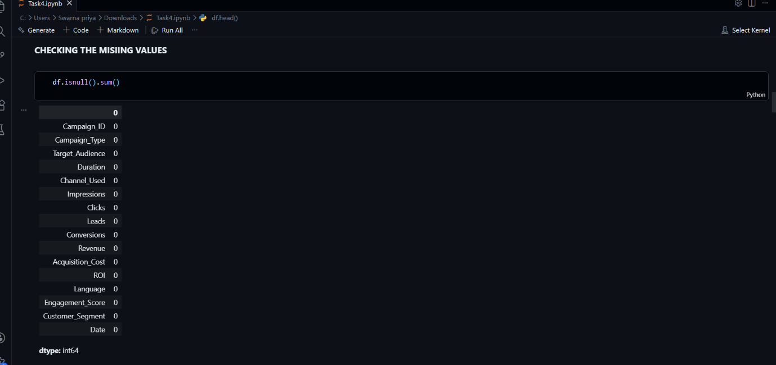
The dataset was checked for missing values using the isnull().sum() function. No significant missing values were found, indicating that the dataset was complete and suitable for analysis without requiring imputation.
Duplicate Records Check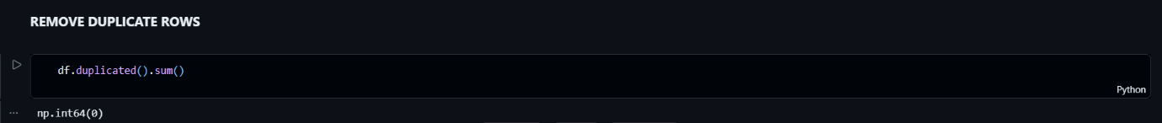
Duplicate records were identified using the duplicated() function. Any duplicate entries were removed to prevent repeated observations from affecting the analysis and business insights.
Date Column Conversion
The Date column was converted to the datetime format using the Pandas to_datetime() function. This ensured that date-related information was stored correctly and could be used for any future time-based analysis.
Descriptive Statistics
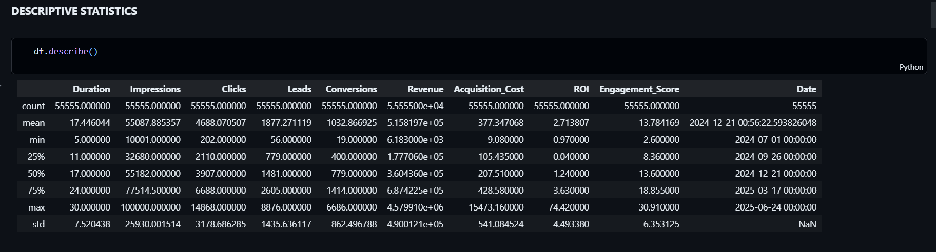
Descriptive statistics were generated to summarize the numerical features in the dataset. Metrics such as mean, standard deviation, minimum, maximum, and quartiles provided an overview of the distribution of campaign performance indicators.

Exploratory Data Analysis (EDA)
Exploratory Data Analysis (EDA) was performed to understand the characteristics of the marketing campaign dataset and uncover meaningful business insights. Various visualizations were created to analyze campaign performance, customer engagement, revenue generation, acquisition cost, return on investment (ROI), and conversion trends. These analyses help identify the most effective marketing channels and support data-driven business decisions.
Marketing Channel Distribution

The distribution chart illustrates how marketing campaigns are spread across different marketing channels. It helps identify the channels that were used most frequently throughout the dataset and provides an overview of campaign allocation.
Average Revenue by Channel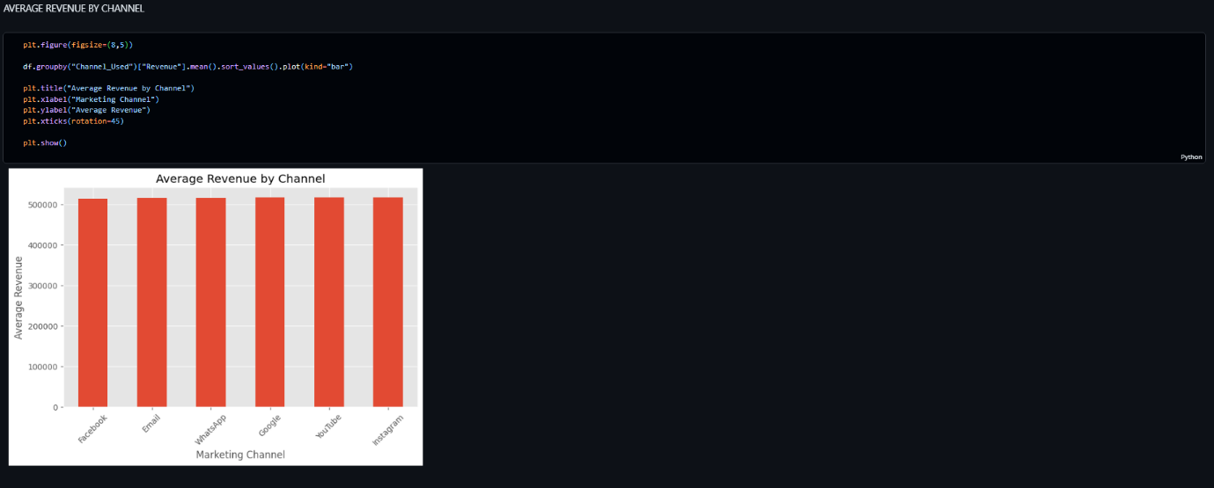
This visualization compares the average revenue generated by different marketing channels. It helps evaluate which channels contribute more effectively to overall business revenue.
Average ROI by Channel
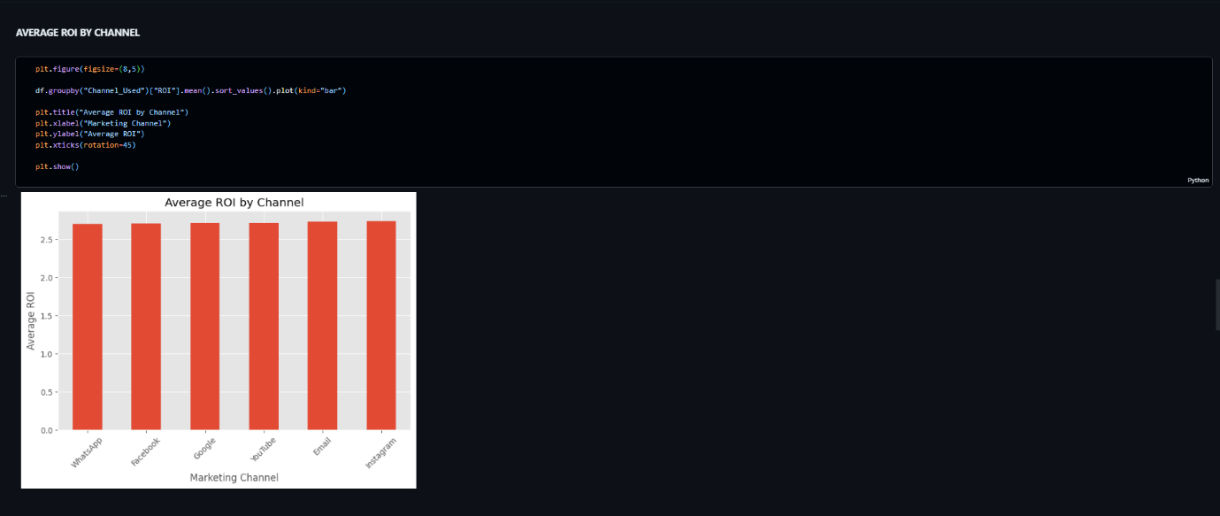
Return on Investment (ROI) measures the profitability of each marketing channel. Comparing average ROI across channels helps determine which channels provide the greatest return for every unit of marketing expenditure.
Average Acquisition Cost by Channel
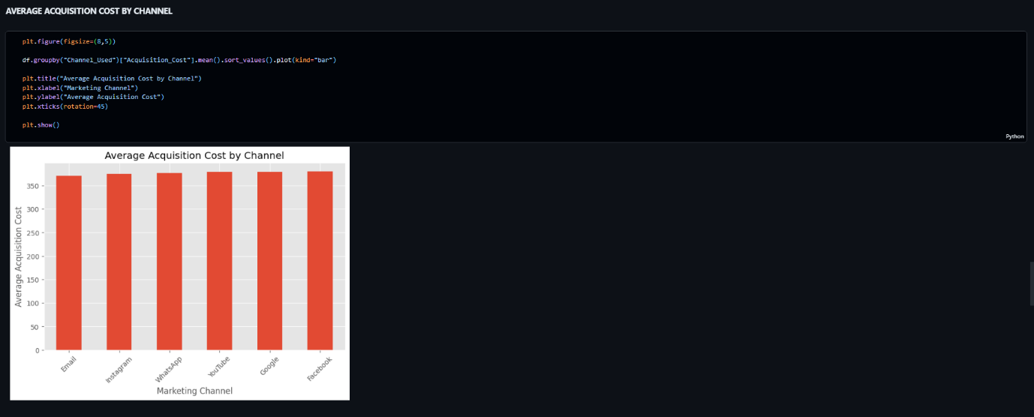
The acquisition cost analysis compares the average marketing expenditure required to acquire customers through different channels. It highlights the cost efficiency of each marketing platform.
Average Conversions by Channel
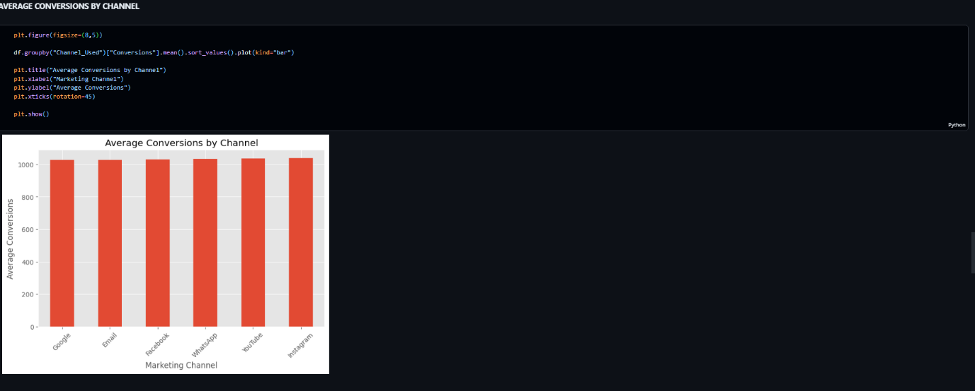
This visualization compares the average number of successful customer conversions achieved through different marketing channels. Higher conversions indicate better campaign effectiveness and customer engagement.
Correlation Heatmap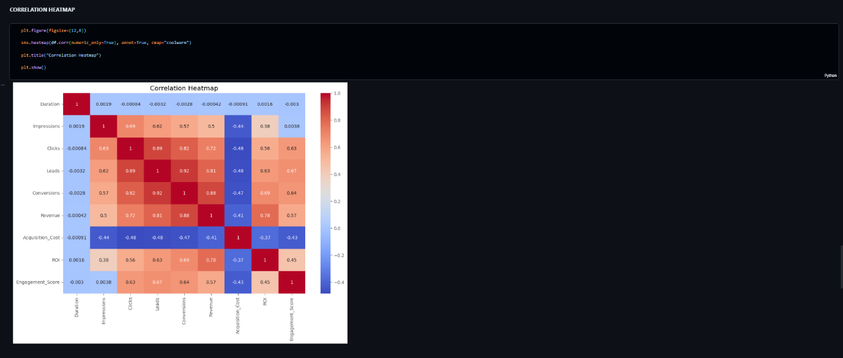
The correlation heatmap illustrates the relationships between numerical variables in the dataset. Strong positive correlations indicate variables that increase together, while negative correlations indicate inverse relationships.

Marketing Funnel
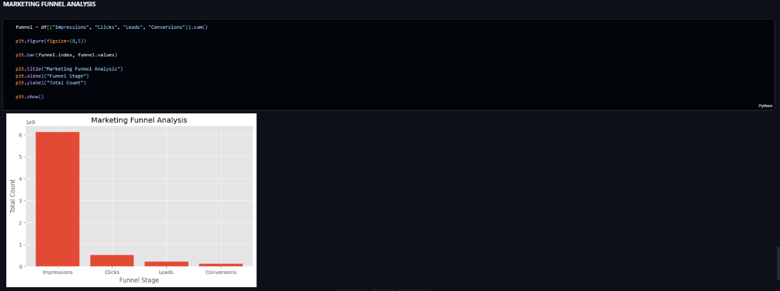
The marketing funnel visualizes the customer journey from impressions to clicks, leads, and conversions. It highlights how customers progress through each stage of the marketing process and identifies where the largest drop-offs occur.

Business Insights
The exploratory data analysis provided several valuable insights into the performance of the marketing campaigns.
- The dataset contained complete and consistent information after preprocessing, making it suitable for analysis.
- Marketing campaigns were conducted across multiple digital channels, with each channel contributing differently to campaign performance.
- Revenue and ROI varied across marketing channels, indicating that some channels were more effective in generating returns than others.
- The marketing funnel showed a gradual decrease in customers from the impressions stage to the final conversion stage, highlighting opportunities to improve customer engagement and conversion rates.
- The correlation analysis indicated positive relationships among clicks, leads, conversions, and revenue, suggesting that improving engagement at earlier stages can positively impact overall campaign performance.
- Acquisition cost differed across channels, emphasizing the need to balance marketing expenditure with the revenue generated to maximize profitability.

Recommendations
Based on the exploratory data analysis, the following recommendations are proposed:
- Allocate a larger portion of the marketing budget to the channels with the highest Return on Investment (ROI), as they generate greater revenue for the investment made.
- Review and optimize the performance of channels with high acquisition costs but relatively low conversions or ROI.
- Improve campaign content, targeting strategies, and audience segmentation to increase customer engagement and conversion rates.
- Regularly monitor key performance indicators (KPIs) such as Revenue, ROI, Acquisition Cost, Click-Through Rate (CTR), and Conversion Rate to evaluate campaign effectiveness.
- Continue performing periodic data analysis to identify changing customer preferences and optimize future marketing campaigns.
- Use data-driven decision-making to allocate marketing resources efficiently and maximize overall business profitability.

Conclusion
This project successfully performed Exploratory Data Analysis (EDA) on a marketing campaign dataset to evaluate campaign performance and identify meaningful business insights. The data was cleaned, explored, and visualized to understand customer engagement, revenue generation, acquisition cost, conversions, and return on investment (ROI).
The analysis demonstrated that different marketing channels contribute differently to business performance. By focusing on channels with higher ROI and optimizing underperforming campaigns, organizations can improve marketing efficiency and maximize returns on investment.
Overall, this project highlights the importance of data-driven decision-making in digital marketing and demonstrates how exploratory data analysis can support effective business strategies and resource allocation.

Tools and Technologies Used
Tool | Purpose
Python | Programming Language
Pandas | Data Cleaning & Analysis
NumPy | Numerical Computations
Matplotlib | Data Visualization
Seaborn | Statistical Visualization
Jupyter Notebook | Development Environment
Git & GitHub | Version Control & Project Submission

