|  |  |  |
| --- | --- | --- |
| **Tech Saksham**  Final Project Report  **FSWD** |  |  |

**“CLASSIFICATION OF MALARIA INFECTED CELLS USING MACHINE LEARNING”**

|  |  |
| --- | --- |
| **ROLL NO** | **NAME** |
| R170424 | Miss Sreeja |
| R170423 | Miss Lakshmi Pravallika |
| R170410 | Miss Sai Prasanna |
| R170426 | Miss Nandini |
| R170425 | Miss Mani Varsha |

**“RGUKT RK VALLEY”**

|  |  |
| --- | --- |
|  |  |
|  |  |
|  |  |

|  |
| --- |
| Trainer Name |
| Poovaragavan velumani |

**ABSTRACT**

The detection of malaria infection using infected cells is a critical aspect of early diagnosis and treatment of the disease. One approach to detecting malaria is the examination of blood samples under a microscope to Identify the presence of infected red blood cells. However, this method can be time-consuming and subject to human error. Recently, advances in image analysis and machine learning have led to the development of new methods for the automated detection of infected cells. One such method is the use of Convolutional Neural Networks (CNNs) to classify infected cells based on microscopic images. CNNs are deep learning algorithms that are particularly well-suited to image classification tasks and have been shown to achieve high accuracy in detecting malaria infected cells

**INDEX**

|  |  |  |
| --- | --- | --- |
| **Sr. No.** | **Table of Contents** | **Page No.** |
| 1 | Chapter 1: Introduction | 1-2 |
| 2 | Chapter 2: Services and Tools Required | 3-4 |
| 3 | Chapter 3: Project Architecture | 5 |
| 4 | Chapter 4: Architecture Blocks Detail Working | 6 |
| 5 | Chapter 5: Project Budget | 7 |
| 6 | Conclusion | 8 |
| 7 | References | 9 |
| 8 | Code | 10 |

**CHAPTER 1**

**INTRODUCTION**

* 1. **Overview**

Malaria is a life-threatening disease caused by parasites that are transmitted to people through the bites of infected mosquitoes. Automation of the diagnosis process will enable accurate diagnosis of the disease and hence holds the promise of delivering reliable healthcare to resource scarce areas. Machine learning technologies have been used for automated diagnosis of malaria.

Malaria is a disease which, despite being present for over a century, still claims a significant number of lives every year. The advancement of artificial intelligence have opened the door to developing innovative methods in malaria treatment. Introducing machine learning approaches to this field can be beneficial in the disease prevention therapy.

* 1. **Feature**

In this work, convolutional neural networks for malaria detection are developed , based on the classification of thin blood smear images of the potentially infected cells . Input data was preprocessed using the image segmentation, file organization, image size standardization, color channel adjustment, and data splitting. Further, the proposed methodology included image conversion, network architecture defining , parameter tuning and network training. In addition, multiple values of different network layer parameters were assessed. This study was implemented in Clojure programming language. Proposed network architecture includes two convolutional and pooling layers followed by activation functions, batch normalization and two linear layers.

The primary goal of this research is to develop an ML model that can diagnose whether a

person is healthy or infected with malaria. The models are developed using thin blood smear images. A classifier that successfully performs the recognition of infected cells can add great value to traditional medical methods of malaria identification and treatment. Furthermore, computer-aided detection and diagnosis in medical imaging offers a beneficial second opinion to the doctors and assists them in the screening process.

The aim of this paper is also to develop a generic model that can be adapted for the detection of other viruses based on the cell image. Proposed CNN architecture performs described classification task with 96% accuracy. This model also provides low complexity and requires minimal technical resources.

CNNs are a type of deep neural networks based on a multilayer perception. Their

fundamental architecture includes an input layer, one or more hidden layers, and an output layer. The input layer represents the image being tested. The hidden layer consists of the convolutional and the pooling layer which alternate. The output layer includes a flattening function, a fully connected layer, and a softmax function.

* 1. **Advantages**
* The proposed system achieves the greater accuracy than the existing system models.
* The proposed system has low complexity.
* The proposed system model requires only minimal technical resources for the classification.
* The proposed system is computationally not so expensive than the existing system models.
  1. **Scope**

Furthermore, the application of proposed CNN architectures for the detection of other diseases based on the blood smear images could be investigated.

* 1. **Future Work**

In the future research, testing the performance of other ML algorithms should be considered, especially hybrid and ensemble models. Another improvement of this work could be achieved through the enrichment of the data set with a larger number of images of infected and healthy cells further evaluate the effectiveness of the proposed data augmentation methods.

**CHAPTER 2**

**SERVICES AND TOOLS REQUIRED**

**2.1 Services Used**

**2.1.1 Liberty Profile**

**2.2 Tools and Softwares used**

**HARDWARE REQUIREMENTS**

* System : Pentium i3 Processor.
* Hard Disk : 500 GB.
* Monitor : 15’’ LED
* Input Devices : Keyboard, Mouse
* Ram : 4 GB

**SOFTWARE REQUIREMENTS**

* Operating system : Windows 10.
* Coding Language : Python
* Web Framework : Flask

**2.2.1 NodeJS**

Node.js is an open-source and cross-platform JavaScript runtime environment. It is a popular tool for almost any kind of project!

Node.js runs the V8 JavaScript engine, the core of Google Chrome, outside of the browser. This allows Node.js to be very performant.

A Node.js app runs in a single process, without creating a new thread for every request. Node.js provides a set of asynchronous I/O primitives in its standard library that prevent JavaScript code from blocking and generally, libraries in Node.js are written using non-blocking paradigms, making blocking behavior the exception rather than the norm.

When Node.js performs an I/O operation, like reading from the network, accessing a database or the filesystem, instead of blocking the thread and wasting CPU cycles waiting, Node.js will resume the operations when the response comes back.

This allows Node.js to handle thousands of concurrent connections with a single server without introducing the burden of managing thread concurrency, which could be a significant source of bugs.

Node.js has a unique advantage because millions of frontend developers that write JavaScript for the browser are now able to write the server-side code in addition to the client-side code without the need to learn a completely different language.

In Node.js the new ECMAScript standards can be used without problems, as you don't have to wait for all your users to update their browsers - you are in charge of deciding which ECMAScript version to use by changing the Node.js version, and you can also enable specific experimental features by running Node.js with flags.

**2.2.2 HTML**

HTML is an acronym which stands for **Hyper Text Markup Language** which is used for creating web pages and web applications. Let's see what is meant by Hypertext Markup Language, and Web page.

**Hyper Text:** HyperText simply means "Text within Text." A text has a link within it, is a hypertext. Whenever you click on a link which brings you to a new webpage, you have clicked on a hypertext. HyperText is a way to link two or more web pages (HTML documents) with each other.

**Markup language:** A markup language is a computer language that is used to apply layout and formatting conventions to a text document. Markup language makes text more interactive and dynamic. It can turn text into images, tables, links, etc.

**Web Page:** A web page is a document which is commonly written in HTML and translated by a web browser. A web page can be identified by entering an URL. A Web page can be of the static or dynamic type. **With the help of HTML only, we can create static web pages.**

Hence, HTML is a markup language which is used for creating attractive web pages with the help of styling, and which looks in a nice format on a web browser. An HTML document is made of many HTML tags and each HTML tag contains different content.

**CHAPTER 3**

**PROJECT ARCHITECTURE**

**3.1 Architecture**

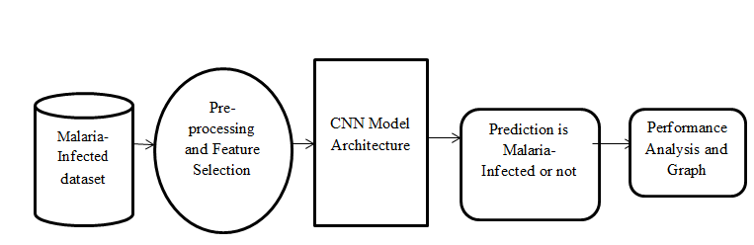

**CHAPTER 4**

**ARCHITECTURE BLOCKS DETAIL WORKING**

**4.1 Blocks**

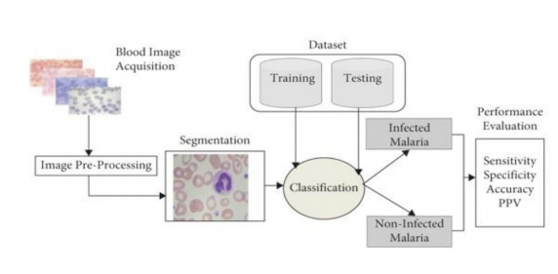

In a Convolutional Neural Network, the input data is passed through several layers in a sequential manner.

The main building blocks of a CNN are:

**1. Convolutional Layers**: These layers perform convolution operations on the input data, which involves multiplying a small matrix (also called a kernel or filter) with overlapping parts of the input data and summing the results. The output of the convolution operation is called a feature map, which represents a specific aspect of the input data. Multiple filters can be applied to the input data, resulting in multiple feature maps.

**2. Pooling Layers**: These layers down-sample the feature maps, reducing their dimensions while retaining the most important information. This helps to reduce the computational cost of the network and prevent overfitting.

**3. Activation Layers**: These layers introduce non-linearity into the network,allowing it to learn more complex relationships between the input and output.Common activation functions include ReLU (rectified linear unit), tanh(hyperbolic tangent), and sigmod**.**

**4. Fully Connected Layers**: These layers connect every neuron in a previous layer to every neuron in the next layer, allowing the network to learn complex relationships between the input and output. The final fully connected layer outputs the final classification

**CHAPTER 5**

**PROJECT BUDGET**

|  |  |  |  |
| --- | --- | --- | --- |
| **Sr. No** | **Cloud Services and Coding Cost** | **Single Price (Rs)** | **Total** |
| 1. | 0 | 0 | 0 |
|  |  |  |  |
|  |  |  |  |
| Total | | | 0 |

**CONCLUSION**

Malaria is a disease that has been present for a long time, but despite the fact that various traditional methods for prevention, identification, and treatment have been developed, the mortality rate from this disease is still high. The development of artificial intelligence enabled modern practices and applications for the suppression of this disease. In this research, several CNNs were developed in order to obtain a network that will classify the cell image into healthy or malaria infected with high accuracy. The final results showed that the CNN with two convolutional and two pooling layers followed by ReLU activation functions achieved the highest accuracy. This paper offers a straightforward and rapid solution for malaria-infected cell classification. The proposed networks demand low memory and time requirements and achieve satisfactory results.

**REFERENCES**

[1] E. A. Ashley, A. P. Phyo, and C. J. Woodrow, “Malaria,” The Lancet 391, no. 10130,2018, pp. 1608-1621. [2] “World malaria report 2020”, World Health Organization, 2020. [Online] Available:https://www.who.int/teams/global-malariaprogramme/ reports/world-malaria-report-2020. [Accessed January 15, 2021]. [3] J. Jackovich, and R. Richards, “Machine learning with AWS,” Packt, 2018. [4] S. Ardabili, A. Mosavi, and A. R. Varkonyi-Koczy, “Advances in machine learning modeling reviewing hybrid and ensemble methods,” International Conference on Global Research and Education, Springer, Cham, 2019, pp. 215-227.

**CODE**

**Please Provide Code through Git Hub Repo Link**

https://github.com/sreeja878/Tech_Sakhyam_FSWD