**Global Economic and Demographic Trends Analysis**

Sreejaa R G

DA&DS

2025 May Batch

**1.INTRODUCTION**

This project focuses on analyzing global development indicators across different countries and regions. The main areas of study include population, GDP, GDP per capita, literacy rate, infant mortality, and population density. The analysis covers trends from 1960 to 2016 and aims to highlight key patterns, correlations, and inequalities in social and economic development. Tools such as Excel, SQL, Power BI, and statistical methods were used to clean, process, analyze, and visualize the data. An interactive Power BI dashboard was developed to provide decision-makers with clear insights supported by charts, maps, and KPIs.

**2.PROJECT OVERVIEW**

The project uses multiple datasets including the CountriesWorld dataset, global population data (1960–2016), GDP data (1960–2016), and metadata mapping countries to regions and income groups. The overall objective is to analyze population growth, economic development, and social indicators across nearly 190 countries. The key metrics studied were population, GDP, GDP per capita, literacy, infant mortality, and population density. The project outcome was a comprehensive and interactive dashboard that provides users with a visual understanding of long-term trends, regional inequalities, and cross-variable relationships.

**3. DATA UNDERSTANDING**

The analysis was based on four key datasets: CountriesWorld.xlsx containing socio-economic attributes by country, PopulationPerCountry.csv containing population data from 1960 to 2016, GDP by Country.xlsx containing GDP figures for the same period, and MetaData Country.csv which mapped countries to regions and income groups. Together, these datasets cover around 190 countries and capture major global development indicators.

**4.DATA CLEANING**

The datasets required significant preprocessing before analysis. Missing values and duplicates were removed, while inconsistent country names were standardized to ensure accurate merging across files. Data types were converted so that numerical fields such as GDP, population, literacy, and infant mortality could be properly analyzed. Column names were also renamed for clarity, and calculated fields such as GDP per capita and population density were created to derive additional insights. After cleaning, the data was consistent, accurate, and ready for analysis and visualization.

**5.DESCRIPTIVE STATISTICS**

* Mean (Average): Mean→ Example: Avg GDP per capita
* Median: Middle value → Example: Median literacy rate.
* Mode: Most frequent value → Example: Common income group.
* Min & Max: Range → Example: Lowest vs highest infant mortality.
* Standard Deviation (σ): Spread of values → Example: GDP variation across countries.
* Correlation: Relation between 2 variables → Example: GDP per capita vs infant mortality.

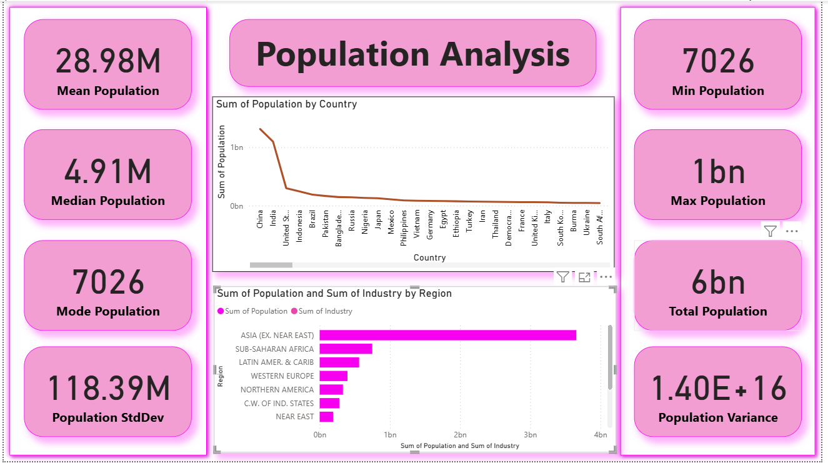

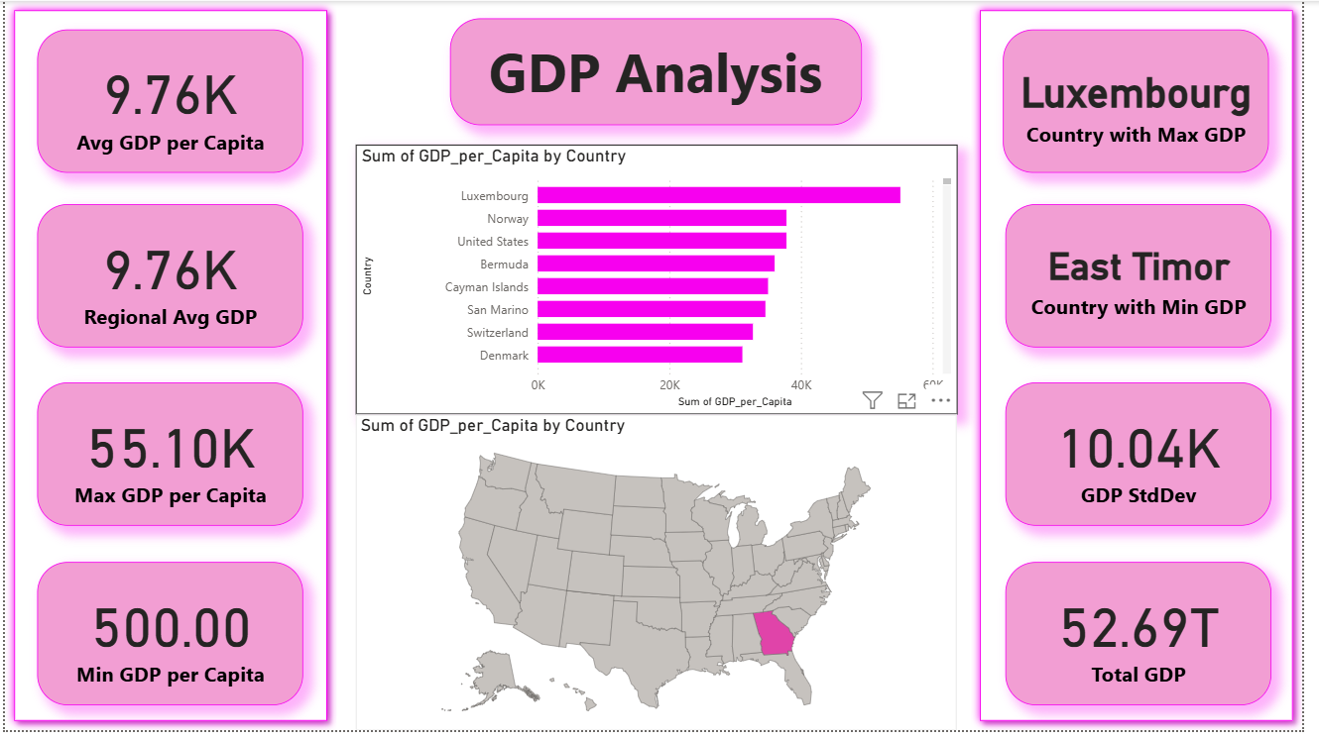

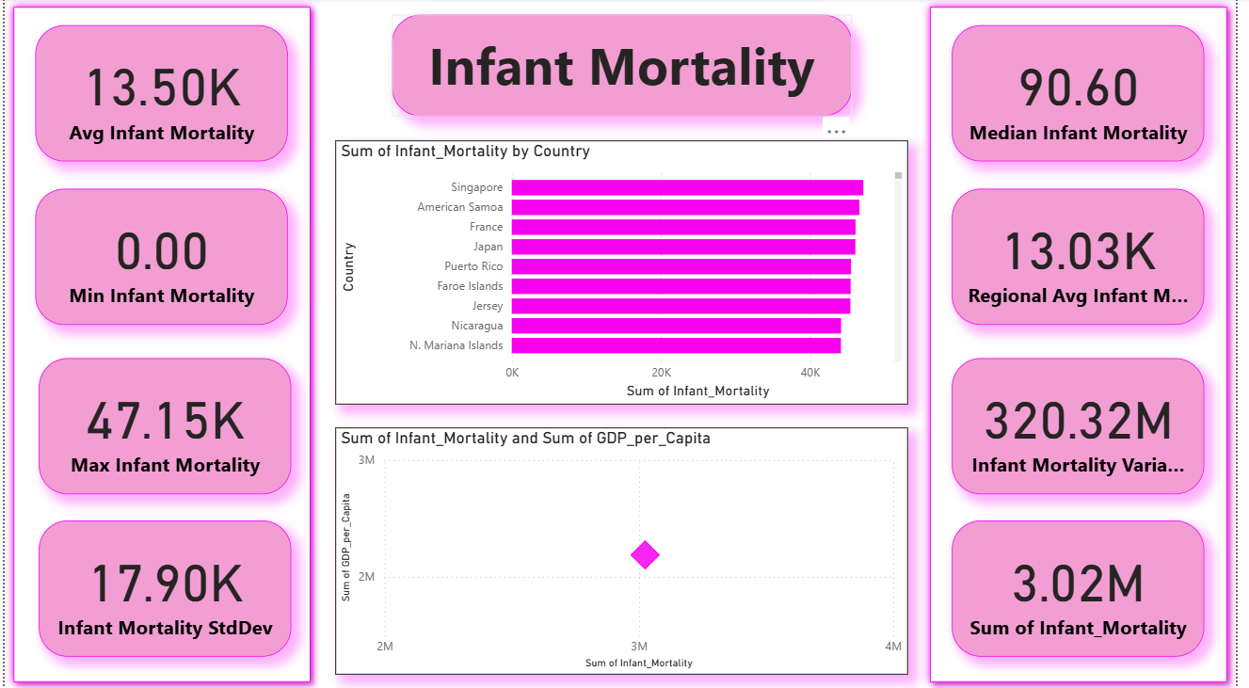

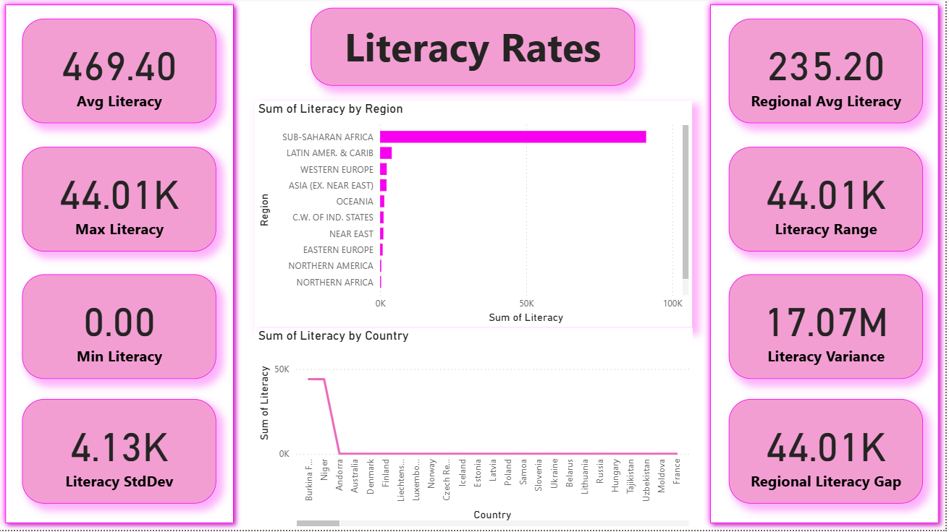

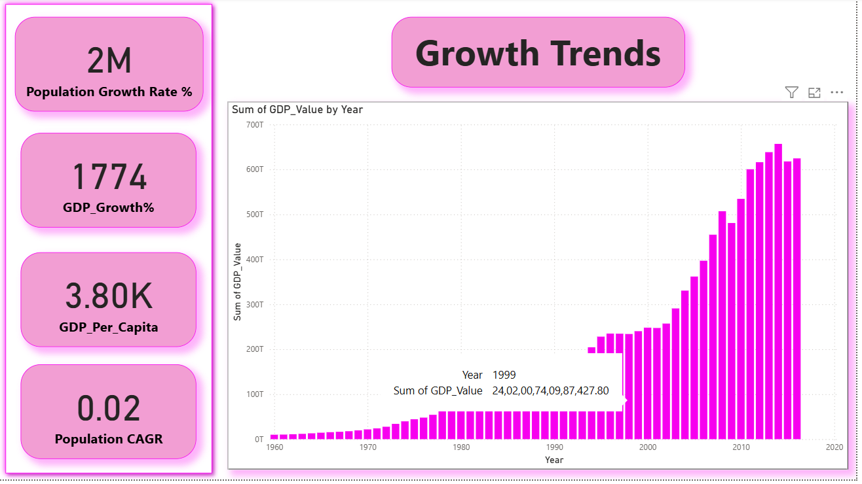

**6.DAX FUNCTIONS**

* Total Population:  
  Total Population = SUM(Population[Value])  
  → Adds population for selected filters.
* Total GDP:  
  Total GDP = SUM(GDP[Value])  
  → Overall GDP for region/year.
* GDP per Capita:  
  GDP per Capita = DIVIDE([Total GDP], [Total Population])  
  → Average output per person.
* Population Density:  
  Population Density = DIVIDE([Total Population], [Land Area])  
  → People per sq. km.
* Population Growth %:  
  ((This Year Pop – Last Year Pop) ÷ Last Year Pop) * 100  
  → Annual growth rate.
* GDP Growth %:  
  ((This Year GDP – Last Year GDP) ÷ Last Year GDP) * 100  
  → Yearly GDP change.
* Avg Literacy:  
  Avg Literacy = AVERAGE(Countries[LiteracyRate])  
  → Mean literacy rate.
* Avg Infant Mortality:  
  Avg Infant Mortality = AVERAGE(Countries[InfantMortality])  
  → Mean infant mortality rate.

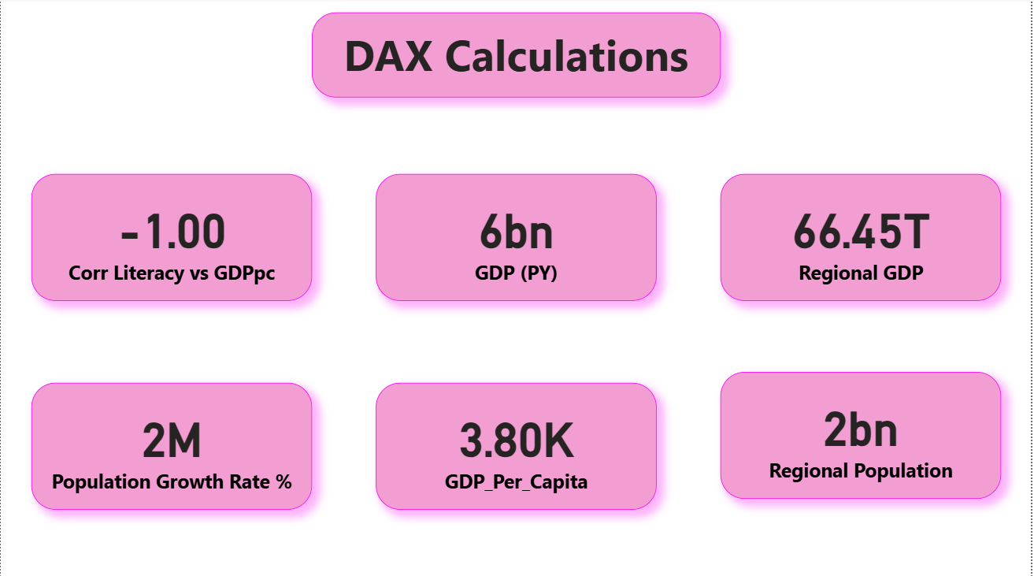

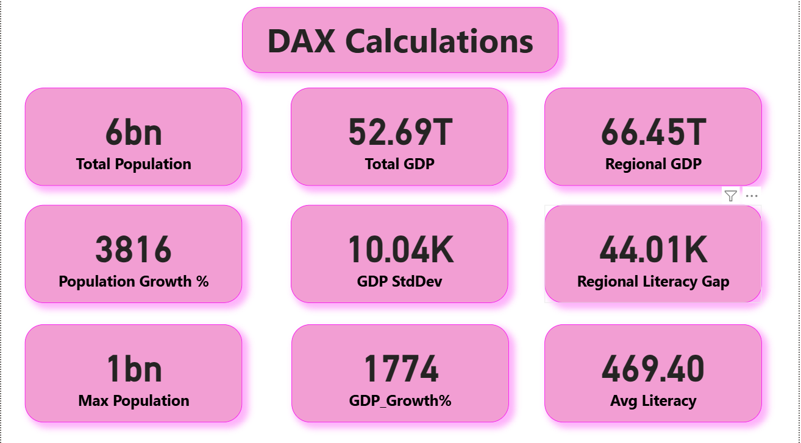

**7.DASHBOARD OVERVIEW**

**Population Trends** → Asia has the largest share of the global population, while Africa shows the fastest growth in recent decades.

**GDP per Capita** → There is a wide gap between rich and poor nations; the richest exceed 55,000 USD per person, while the poorest remain below 500 USD.

**Population Density** → High density and urbanization pressures are most visible in Asia and Europe compared to other regions.

**Infant Mortality vs GDP** → Countries with higher GDP per capita consistently show lower infant mortality rates, proving a strong negative correlation.

**Overall View** → Dashboards also included KPIs (population, GDP, growth %) and slicers (year, region, country) for flexible analysis.

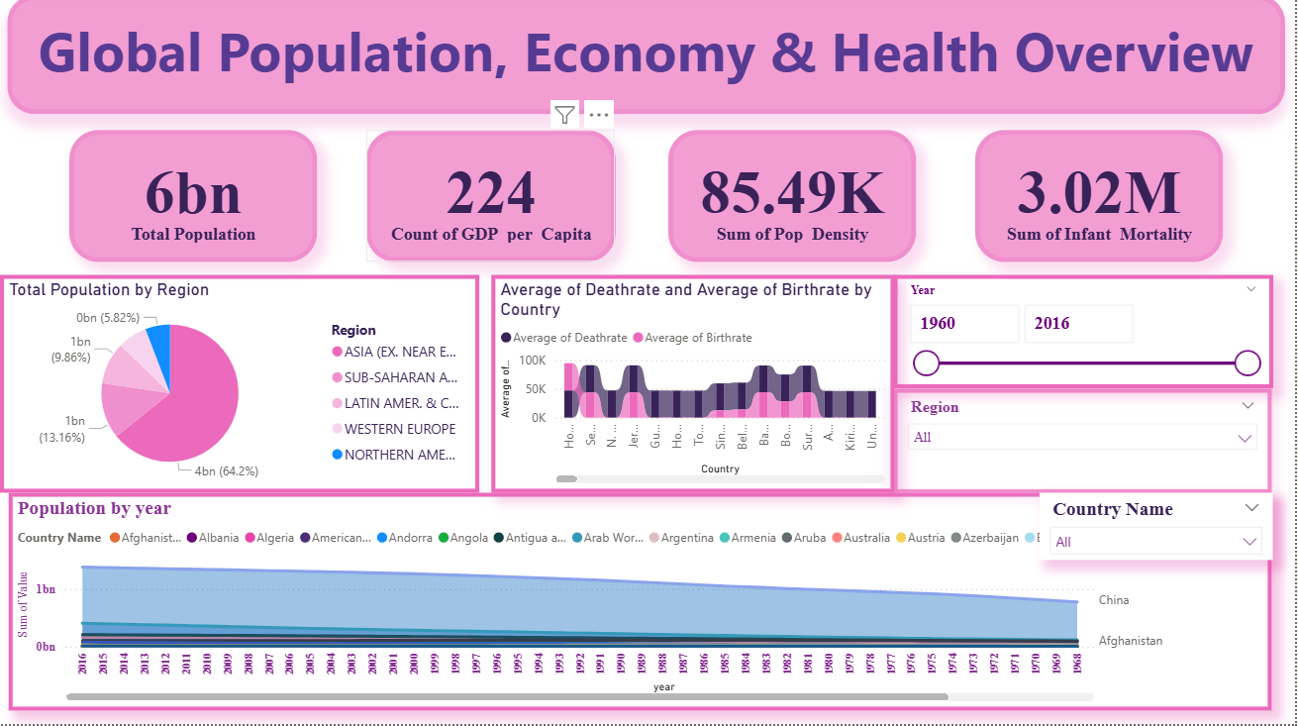

**8.KEY INSIGHTS**

**Population Trends Over Time**

-Global population grew from **~3B in 1960 to ~6B+** in dataset snapshot.

**-Asia (China & India)** contributes the largest share (>35% combined).

-Africa shows **rapid growth post-1980s**, expected to lead future growth.

- Urbanized regions (Europe, North America) show **slower growth & stabilization**.

-Some small countries (Andorra, Baltic nations) show stagnation or decline.

-Population distribution is **highly unequal** → 10 countries hold >60% of global population.

**GDP & Economy**

-Global GDP expanded to **~52.7 Trillion USD** in dataset period.

-Steady increase from 1960 → acceleration after 1990s → globalization effect.

**-High-income countries** dominate GDP share despite smaller population.

**-GDP per Capita gap**: >55K (richest) vs <500 (poorest).

-Clear economic inequality → rich countries grow faster than poor ones.

-Map confirms concentration of wealth in **North America, Europe, East Asia**.

**-GDP Growth %** shows Asia’s rising economic power (China, India, SE Asia).

**Social Indicators (Health & Literacy)**

- **Literacy Rates**: Some regions near 100% (Europe, North America), others still very low (<50%).

- **Infant Mortality**: Highest in Sub-Saharan Africa (>100 deaths per 1000 births).

-Clear divide between developed & developing regions.

**-Correlation**: Higher literacy strongly linked with lower infant mortality.

-Regions with weak education systems also show poor health outcomes.

-Oceania and parts of Asia show mid-level literacy and health improvements.

-Variability within regions → not all countries in the same region perform equally.

**Global Population, Economy & Health Overview**

-World population is **~6 billion**, with Asia holding the largest share (~64%).

-GDP per Capita records exist for **224 countries**, but values vary widely.

-Population density is high in specific regions, highlighting urbanization trends.

-Infant mortality remains high in low-income regions, dragging the global average.

-Population trends by year show steady growth across most countries.

**9. KEY RECOMMENDATIONS**

**Population & Growth**

- **Promote family planning** in rapidly growing regions (Africa, South Asia).

**-Urban planning investments** in high-density countries to manage housing, jobs, and infrastructure.

- Ensure **sustainable use of resources** (water, food, energy) for large populations.

-Encourage **policies balancing population growth with economic capacity**.

**Economy & GDP**

Support **diversification of economies** in developing countries to reduce dependency on single industries.

-Encourage **fair trade policies** to reduce inequality between nations.

-Provide **financial aid & investments** to low-income countries for infrastructure and innovation.

-Strengthen **regional economic cooperation** (e.g., African Continental Free Trade Area).

-Monitor GDP growth against **inflation and inequality metrics** to ensure inclusive development.

**Education & Literacy**

**-Universal access to primary & secondary education**, especially in rural and poor regions.

-Promote **digital literacy & e-learning platforms** to close education gaps.

-Increase **teacher training and funding** in low-income countries.

-Link **education with employability programs** to reduce unemployment and poverty.

-Partner with NGOs & international organizations to **support education in conflict zones**.

**Health & Infant Mortality**

-Invest in **maternal and child healthcare** to reduce infant mortality.

-Expand **vaccination programs** in developing regions.

-Improve **hospital infrastructure and healthcare access** in rural areas.

-Train and deploy **more healthcare workers** in underserved regions.

-Focus on **preventive healthcare** rather than only reactive treatments.

**Inequality & Social Development**

-Implement **progressive taxation policies** in high-income nations to redistribute wealth.

-Focus on **job creation** in emerging economies to reduce unemployment.

-Track **gender equality in education and workforce participation**.

-Invest in **social welfare programs** to support the most vulnerable populations.

-Strengthen **international aid programs** with accountability to reduce misuse of funds.

**Environment & Sustainability (Linked to Population Density)**

- Promote **renewable energy adoption** in fast-growing countries.

-Develop **green cities and sustainable urban models**.

- Protect **natural resources and forests** against overpopulation-driven exploitation.

-Reduce **pollution and waste mismanagement** in urbanized areas.

-Link development policies with **climate change mitigation strategies**.

**10.CONCLUSION**

This project successfully demonstrated how data analysis can provide valuable insights into global development. The world has experienced both rapid population growth and economic expansion since 1960, but progress has been uneven. Wealth and opportunity remain concentrated in high-income nations, while poorer countries continue to face challenges such as low literacy and high infant mortality. Education and healthcare stand out as the most important levers for creating positive change, as both are strongly linked to improved economic and social outcomes. The overall conclusion is that while the world has made remarkable progress, significant inequalities remain, and future development will depend heavily on addressing these disparities. Africa’s demographic surge and Asia’s rising economic power will play a defining role in shaping the global balance of the future.