3M Project Plan
3M Datananite-equivalent Platform (React.js UI)
Requirements & Schedule

OWNER | Palash Ghosh — Palash.Ghosh2@cognizant.com
VERSION | 0.2
CREATED | 2026-06-02
STATUS | DRAFT

Contents
1. Requirements 3
1.1 Functional Deliverables 3
1.2 Non-functional Deliverables 3
1.3 React UI requirements 3
1.4 Open decisions required from 3M 4
1.5 Mobilization inputs required from 3M (before kickoff / M1) 4
2. Gantt Chart 5
2.1 Phase Deliverables 6

Objective — Build a 3M-branded AI-native metadata intelligence platform with the same feature set as Datananite, delivered through a single React.js SPA.

1. Requirements

1.1 Functional Deliverables
ID | Deliverables | Priority
FD-1 | Metadata extraction — schema, stats, functional & inclusion dependencies | Must
FD-2 | Ontology generation — OWL/RDF with LLM concept annotation (industrial domain) | Must
FD-3 | Knowledge Graph — OWL → Neo4j/Gremlin with multi-KG isolation by kg_id | Must
FD-4 | Dialog with Data — NL → SQL → narrative (GraphRAG) | Must
FD-5 | Orchestrator API + SSE pipeline events | Must
FD-6 | Instrumentation Workbench — 7 engineer views (see 1.3) | Must
FD-7 | DataChat — business-user NL interface | Must

1.2 Non-functional Deliverables
ID | Deliverables | Target
NFD-1 | NL-query response time (p95) on benchmark set | Best-effort; no sub-45s
NFD-2 | Zero row-level data egress to LLM provider (schema + stats only) | 0 rows
NFD-3 | All SQL execution read-only; row limits enforced post-LLM | Enforced

1.3 React UI requirements
Workbench (engineer) 7 views:
- Pipeline Monitor
- Graph Explorer
- Schema Catalog
- Ontology Viewer
- Redundancies
- SQL Console
- Change Log
DataChat (business user):
- Conversational NL panel (multi-turn + session history)
- Source selector / multi-source toggle
- Streaming pipeline progress (SSE)
- Results renderer — Summary / Key Findings / Analysis + tables/charts
Note on scope: the requirements in 1.1–1.3 are proposed by the delivery team, baselined on the Datananite feature set. They are not yet confirmed by 3M. Sections 1.4 and 1.5 list the inputs and decisions 3M must supply before this plan is executable.

1.4 Open decisions required from 3M
ID | Decision needed from 3M | Needed by
Q-1 | Confirm 3M IdP (Azure AD / Okta / other) for OIDC integration | Phase 0
Q-2 | Confirm graph DB, RDMS choice — managed Neo4j Neptune, PostgreSQL vs self-hosted in GKE | Phase 0
Q-3 | Confirm LLM provider stance — Anthropic-direct OK, or route via 3M gateway? | Phase 0
Q-4 | List of pilot business units and their priority source systems | Phase 0
Q-5 | Access to external Cognizant github access to bring datananite code base to 3M. | Phase 0
Cost note (Q-3): if Anthropic-direct is approved, Claude (LLM) usage is the only metered cost — ≈ $0.03–0.04 per natural-language query (schema + statistics only, no row-level egress). Routing via a 3M gateway may add a per-call surcharge. Indicative monthly volumes:
NL queries / month | Estimated Claude cost (@ $0.03–0.04 / query)
1,000 | $30 – $40
5,000 | $150 – $200
10,000 | $300 – $400

1.5 Mobilization inputs required from 3M (before kickoff / M1)
ID | Input required | Owner
MI-1 | Named Executive Sponsor (CDO or designate) | 3M PMO
MI-2 | Confirmed kickoff date | 3M Sponsor
MI-3 | Pilot BU #1 — named BU + owner + priority sources | 3M PMO
MI-4 | Named Data Platform lead (decision-maker) | 3M PMO
MI-5 | Data classification tiering + per-source classification | 3M Security
MI-6 | Approval of sending schema (no row data) to 3M sponsored /advocated LLM | 3M Legal
MI-7 | Kubernetes cluster access + namespace + RBA | 3M IT
MI-8 | Virtual linux box (medium size) + Static IP | 3M IT
MI-9 | Graph DB hosting decision (Neo4j Neptune vs self-hosted on GKE) | 3M Architecture
MI-10 | LLM gateway decision (direct LLM vs internal proxy) | 3M Architecture
MI-11 | Source DB read-replica credentials (per source, per env) | 3M Data Platform
MI-12 | Source system inventory with classifications | 3M Data Platform

2. Gantt Chart
Delivery window: ~4 weeks. Phases 1–4 overlap — front-end and back-end run in parallel against an agreed OpenAPI contract. Diamonds mark milestones (M1–M5/GA).
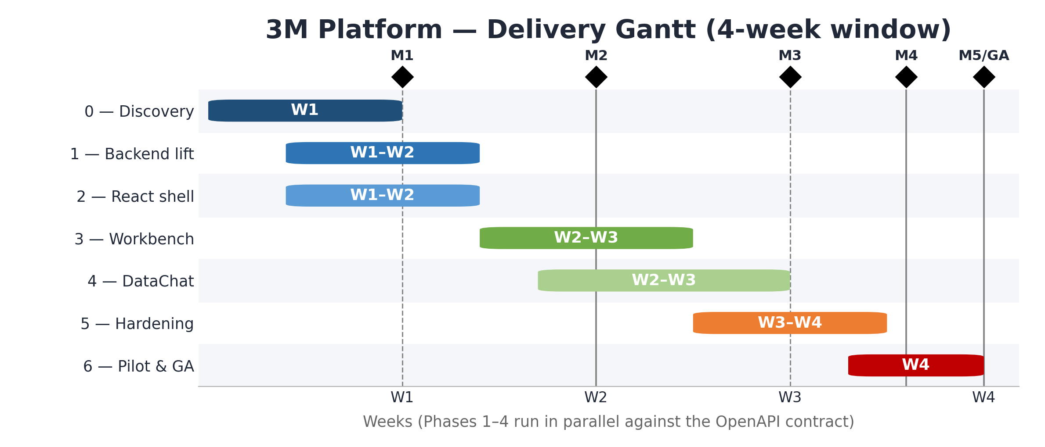
3M Platform delivery Gantt — 7 phases across a 4-week window, with milestone markers M1–M5/GA

2.1 Phase Deliverables
Phase | Weeks | Deliverables
0 — Discovery | 1 | Source inventory, branding kit, security/legal sign-off, repo scaffolding
1 — Backend lift | 1–2 | Fork Datananite agents, add 3M connectors, deploy to dev GKE, smoke tests
2 — React shell | 1–2 | Vite scaffold, auth, routing, design system, REST + SSE plumbing, Pipeline Monitor + Graph Explorer e2e
3 — Workbench | 2–3 | Ontology + SHACL modal, SQL Console, Catalog, Redundancies, Glossary, KPI, Change Log
4 — DataChat | 2–3 | Chat UI, multi-source, streaming results, narrative renderer
5 — Hardening | 3–4 | E2E tests, perf tuning, security review, observability, docs, training
6 — Pilot & GA | 4 | Pilot with 1–2 3M business units, feedback loop, GA

