Introduction
This document is to be used as guide for installation and configuration of the Secure Invocation Web Service. Two installer files that are needed to install SI Web Services would be:
Further information regarding how the Secure Invocation works can be found in Secure Invocation Overview and Configuration document.
Requirements for the Secure Invocation Web Service can be found in the Secure Invocation Overview and Configuration document.

How the Secure Invocation Web Services Works
The Secure Invocation Web Service wraps the existing Secure Invocation inside a Web Service. All the existing Secure Invocation functionalities still exist and are exposed by the Web Service.
To ensure the identity of the entity that accesses the web service, an authentication mechanism is implemented in the web service. The authentication mechanism works by only allowing entities that present a valid Pre-Shared Key (PSK).
When the entity that tries to access the Web Service is authenticated by providing a valid PSK, the Secure Invocation Web Service returns a token to the entity that is used to launch a MedChart session.
These PSKs can be generated by a Random Key Generator (the generator is included in the Test Client that can be used as a test harness).
These generated PSKs would then need to be stored manually in the configuration file of the Web Service (web.config).
PSKs can be added and removed as desired by editing the PSKs inside the configuration file. A sample on how to generate and updating PSKs inside configuration file will be shown later in this document.

Presenter | Ram K
Demo Order | 2
PBI Description | As a data preparer I want the setting of the AIS prescribability to exclude 'for ECP' ACForms as neither the ACForm or the Product are prescribable. Currently the AIS has prescribe status = 1 where an ACForm is prescribe_by_brand = 0 even when that ACForm is an ECP item that cannot be prescribed.  This is an additional change to the work done in PBI 236869 to set the prescribe status of an AIS. It is needed so that in the MedChart UI the Rx icon behaves consistently when an AIS only has ACForms with a prescribe status = 0 (prescribe by brand) i.e the Rx icon shows grey and if user hovers over the icon the appropriate message regarding brand prescribing is displayed. Currently if there is an ECP item for the AIS but all other ACForms are prescribe by brand then the AIS is set to prescribe status = 1 and the ECP item does not display in the UI so the Rx icon behaves differently for the user with no apparent reason.

Components
The Secure Invocation Web Service uses HTTPS to wrap the existing COM components, adding a transport level security between external application and the Secure Invocation Host. This requires configuration on the IIS web server which would be explained further in this document.
The Test Client for Secure Invocation Web Service can be used to verify the set configurations. How the test client can be used to verify and generate PSKs will be explained further in this document.

IIS Configurations
If the IIS installed in the server/computer is an older version of IIS (e.g. IIS 5.1 or later), please go to section 3.5 – Older IIS Settings and Configurations. It is still important to note that the SI Web Service will only run on HTTPS and application pool(s) that are configured to have a .NET Framework Version 4.0. It will not run correctly on any older .NET framework versions application pools.

Creating a self-signed Certificate
In enabling https, we have to first ensure a valid certificate exists.
When IIS 7.5 Manager is launched, the following screen should appear, showing Server Certificates under IIS.
If we don’t have any certificates, the table should be blank. Otherwise, if we already have existing certificates we can skip the next few steps and move on to Section 3.2: Enabling HTTPS in IIS.
To create a Self-Signed Certificate, select the “Create Self-Signed Certificate...” option on the right-hand side.

Presenter | Ram K
Demo Order | 2
PBI Description | As a data preparer I want the setting of the AIS prescribability to exclude 'for ECP' ACForms as neither the ACForm or the Product are prescribable. Currently the AIS has prescribe status = 1 where an ACForm is prescribe_by_brand = 0 even when that ACForm is an ECP item that cannot be prescribed.  This is an additional change to the work done in PBI 236869 to set the prescribe status of an AIS. It is needed so that in the MedChart UI the Rx icon behaves consistently when an AIS only has ACForms with a prescribe status = 0 (prescribe by brand) i.e the Rx icon shows grey and if user hovers over the icon the appropriate message regarding brand prescribing is displayed. Currently if there is an ECP item for the AIS but all other ACForms are prescribe by brand then the AIS is set to prescribe status = 1 and the ECP item does not display in the UI so the Rx icon behaves differently for the user with no apparent reason.

Enabling SSL on Secure Invocation Web Service
After installing our web service application on IIS,
We should now see that we have a new application under the HTTPS Site we created.
In this image, it is named SI_WebServices (by Default, the installer names the application SI Web Services).

Configuring Application Pool Framework
To configure the Application Pool Framework, open IIS Manager and select “Application Pools” option on the left hand side corner. This would give an overview on each application pool settings.
Select the one that is being used by the SI Web Service, and on the right hand side, choose “Advanced Settings...”
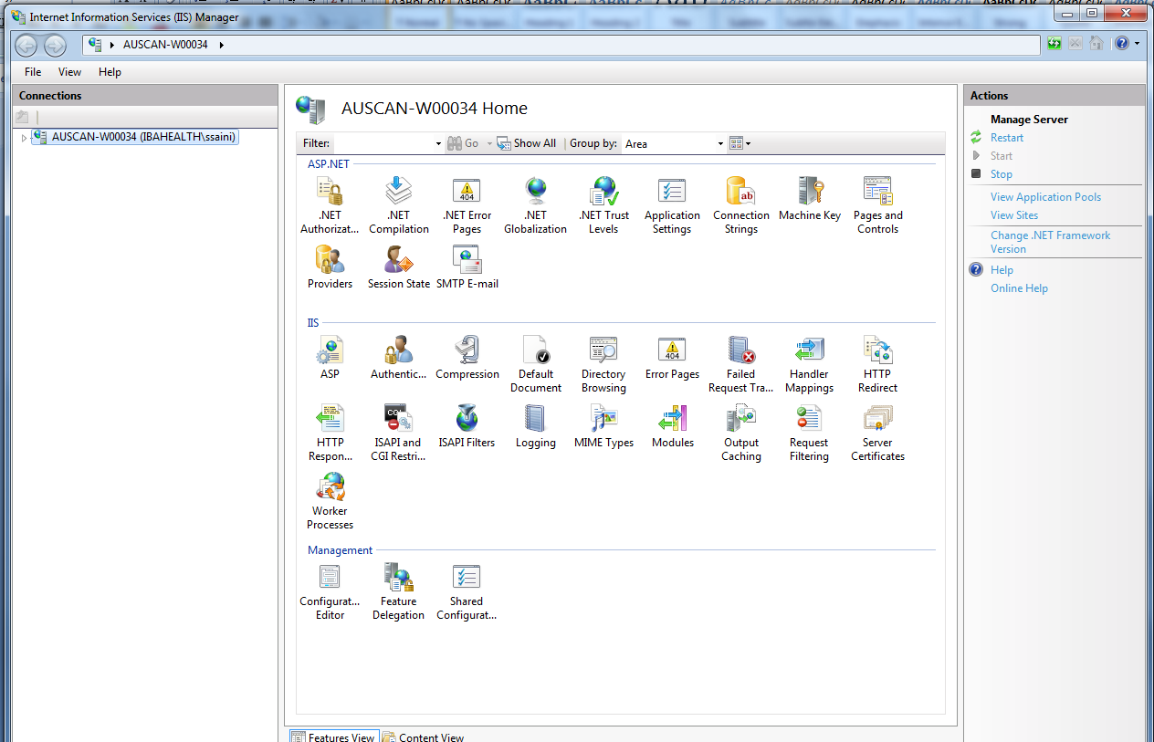

Creating a Self-Signed Certificate using OpenSSL
Continuing in the wizard, choose "Prepare the request now, but send it later." The next four dialogs will ask you about the names that should be in the certificate. You can leave the defaults, or enter a name and location for your company. Finally, the wizard will ask you to save the certificate request to a file named certreq.txt.

In order to create a private key and sign the certificate, you will need to download the free OpenSSL for Windows Binaries and Source packages, courtesy of the GnuWin32 project on SourceForge. From the GnuWin32 project downloads page, download the two OpenSSL zip files labeled as "src" and "bin" for i386.

