COMPUTERNETWORKSLAB1

Sreeja Katta - 1BM22CS267

Create a topology consisting of two or more end devices connected with the help of hub and switch and simulate a simple PDU.

# Hub

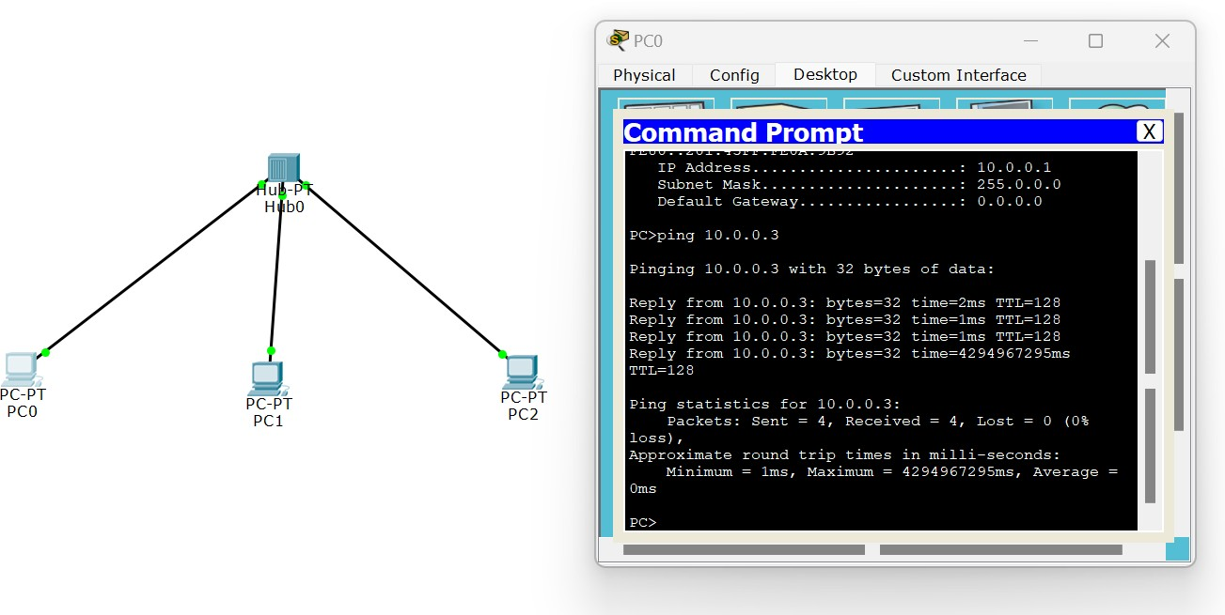

**SIMULATION:**

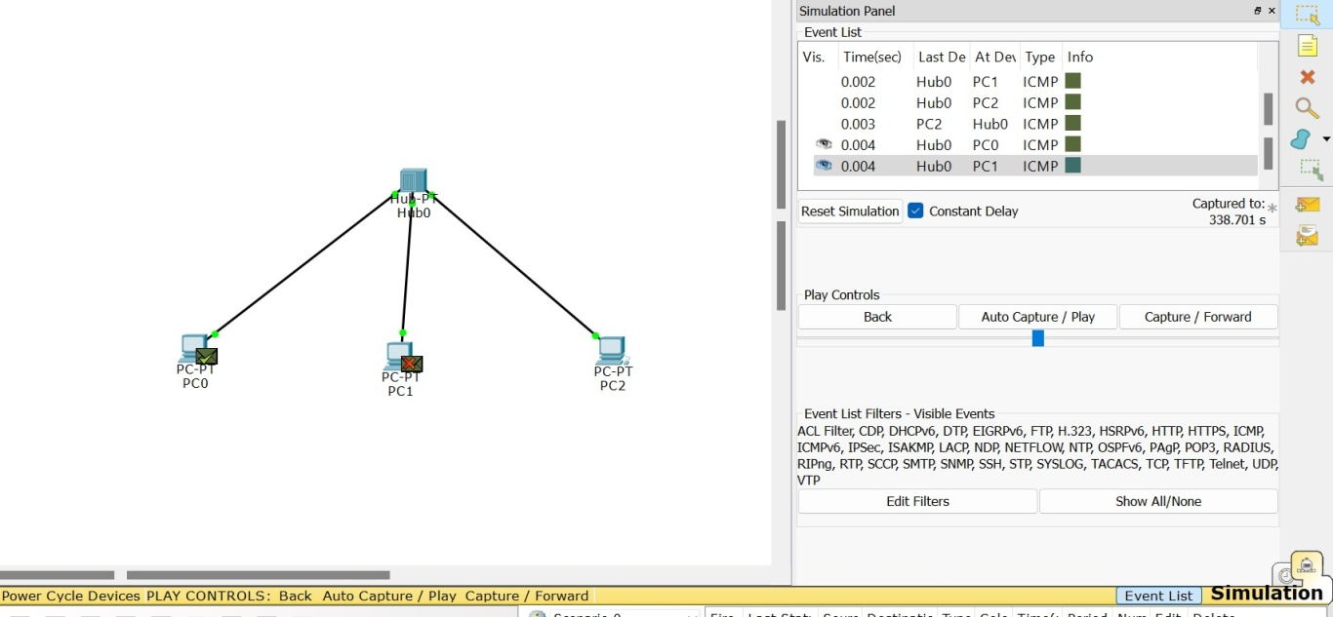

# SWITCH

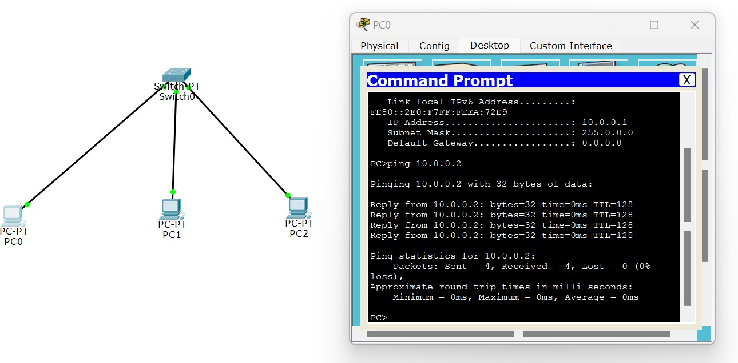

**Simulation:**

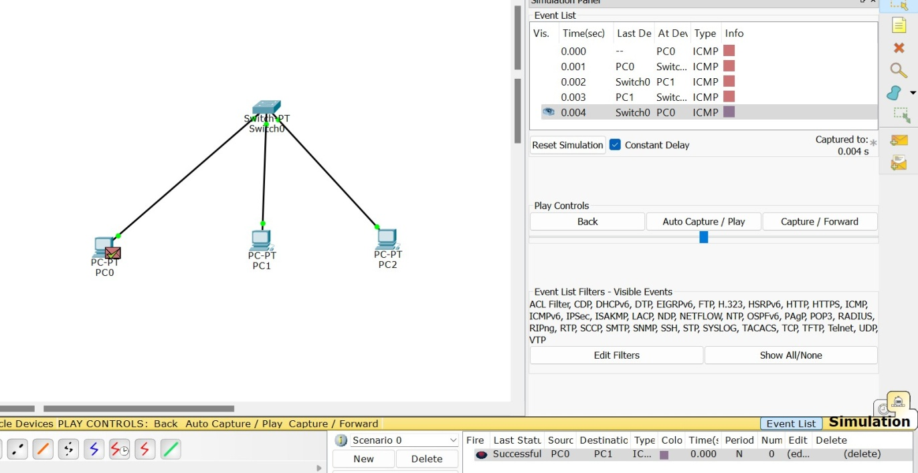

# SwitchandHubHybrid

