**CN LAB2**

**Sreeja Katta-1BM22CS267**

Configure IP address to routers in packet tracer. Explore the following messages: ping responses, destination unreachable, request timed out, reply.

**TOPOLOGY:**

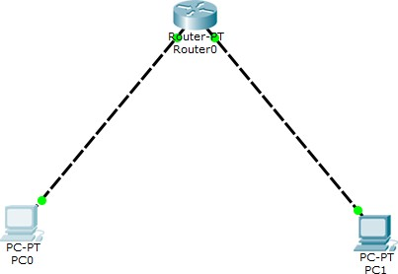

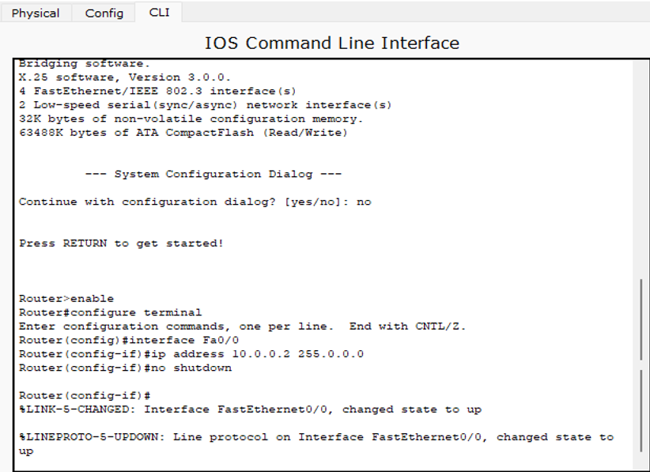

**OUTPUT WITHOUT SETTING DEFAULT GATEWAY**:

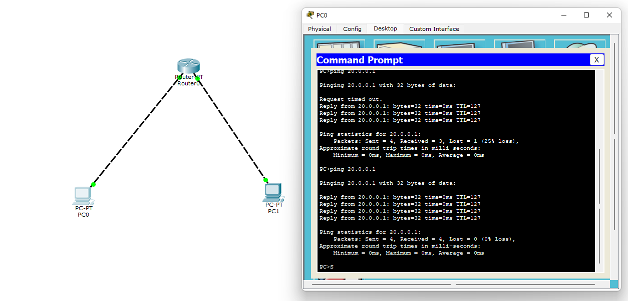

**OUTPUT AFTER SETTING DEFAULT GATEWAY**

