**Common Threats**

- Phishing : Can be mitigated using MFA

- Exposure of Access Keys : Can use STS or IAM Roles

- Network Threats like brute force attacks, DDoS : Can use firewalls, anti-viruses, perform vulnerability scans.

**AWS Shared Responsibility Model**

AWS is responsible for the Security of the Cloud, and Customer is responsible for Security in the Cloud.

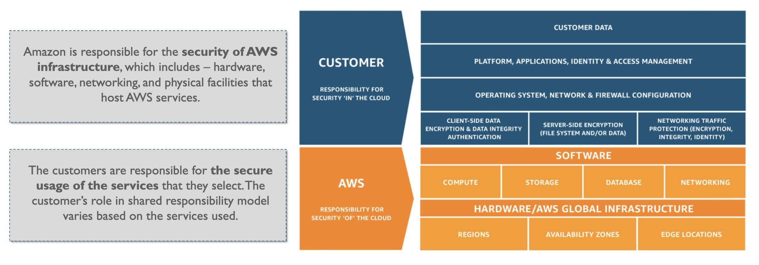

**AWS Security Solutions**

* *Identity and Access Management* : Manage identity, resources and permissions. e.g AWS IAM, AWS Cognito, AWS Resource Access Manager.
* *Detection Control* : Detect potential security threats or incidents. e.g Amazon Guard Duty.
* *Infra Protection* : Can protect web apps by filtering traffic. e.g AWS Shield and AWS Web Application Firewall (WAF)
* *Data Protection* : e.g AWS Key Management Service (KMS) and AWS Cloud HSM.