**Network Task**

**Task Description:**

1.  
Get me the IP address of a particular domain (guvi.in).   
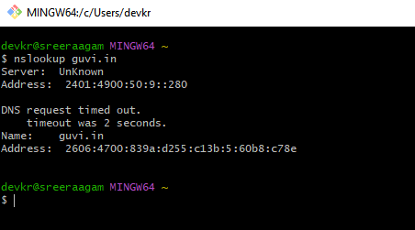  
How do I find my CPU/memory usage of my server?   
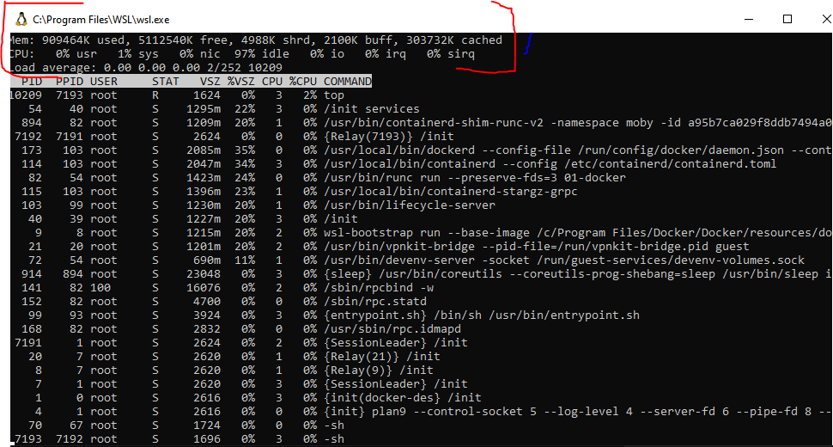

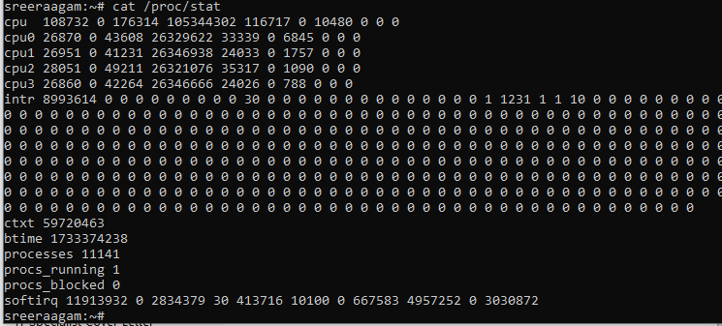

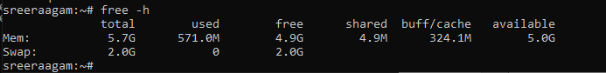

Test the connectivity between 2 nodes?

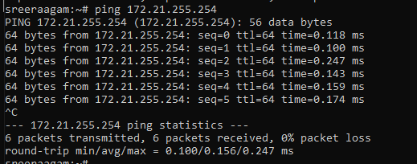

2.I have deployed an application in guvi.com:9000,   
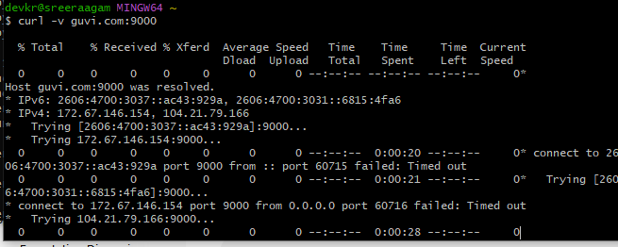  
and logs show my app is running, but I’m unable to view the page.   
Check whether my port is open or not?

**Test the Application Endpoint:**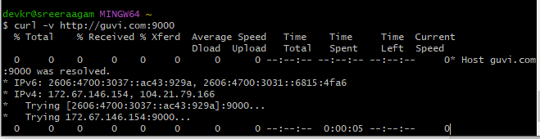

**Check Port on localhost:**

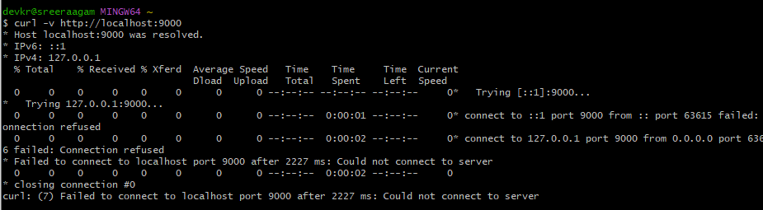

**Test Port Accessibility from Client Machine:**  
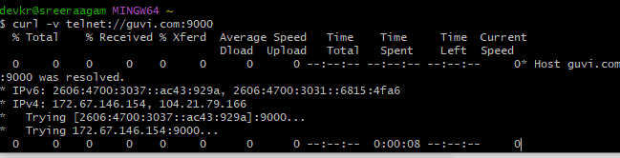

**1. Testing Application Endpoint (curl http://guvi.com:9000)**

**===========================================================**

Result: The curl command is unable to connect to the application endpoint. The error indicates a timeout, meaning the server did not respond on port 9000.

Implication: The port might not be open, the application may not be accessible publicly, or there is a firewall blocking the connection.

**2. Testing Port on Localhost (curl http://localhost:9000)**

**===========================================================**

Result: The connection to localhost on port 9000 also fails with a similar timeout error.

Implication: Even on the server where the application is hosted, the application may not be actively listening on port 9000. This could mean:

The application is not correctly bound to the port.

There might be a misconfiguration in the application's networking settings.

**3. Testing Port Accessibility from Client Machine**

**==================================================**

Result: Again, the curl command fails when accessing guvi.com:9000 from the client machine.

Implication: This confirms that the issue is not specific to the client machine but is related to the server-side configuration or firewall rules.

**Potential Causes of the Issue**

**===============================**

The application is not running or listening on port 9000.

Firewall rules on the server or network are blocking inbound connections on port 9000.

The application is misconfigured (e.g., bound to a different IP or port).

The server's security group settings (if hosted on cloud infrastructure like AWS) are not allowing traffic on port 9000.