**Test Cases**

**Using File as input**

1. Provide the complete path of the file but do no create a file in that location. It should throw java.nio.file.NoSuchFileException exception
2. Provide the incorrect path of the file . It should throw java.nio.file.NoSuchFileException exception
3. Provide the proper file name path and the correct file name. It should read the file and should provide proper input as shown below

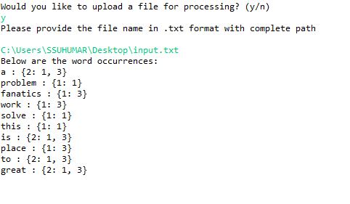

1. Provide a file name in a different format. It should throw error as we support only .txt format

**Using command Line**

1. Input the text through command line . Press enter for next line. Press ~ to indicate that the input process is done. It should read the input line by line and should provide the output as shown below

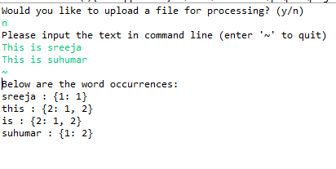

1. Copy and paste a text through command line . Press ~ to indicate that the input process is done. It should read the input line by line and should provide the output as shown above

**Common Test cases:**

1. Provide input with a combination of words ,numbers and special characters. It should only consider the words and numbers for processing
2. Provide input that contains ~ character . It will take only the input before ~ since we are using ~ as a delimiter.
3. Provide input with a combination of words, numbers and special characters with no spacing. It will consider only number and words and will ignore the special characters