Name: Nair Sreejith Sreekumar

Roll No: 19

Advanced Embedded System Mini Project

**Aim:**

To display numbers on LCD display which are being key pressed on keypad.

**Description:**

* Arduino :

[Arduino](http://arduino.cc/) is an open-source platform used for building electronics projects. Arduino consists of both a physical programmable circuit board and a piece of [software](http://arduino.cc/en/Main/Software), or IDE runs on your computer, used to write and upload computer code to the physical board. Arduino UNO has 14 digital pins and 6 analog pins.

* Breadboard :

It is a way of constructing electronics without having to use a soldering iron. Components are pushed into the sockets on the breadboard and then extra 'jumper' wires are used to make connections.

## LCD:

A liquid-crystal display (LCD) is a [flat-panel display](https://en.wikipedia.org/wiki/Flat_panel_display) or other [electronically modulated optical](https://en.wikipedia.org/wiki/Electro-optic_modulator) [device](https://en.wikipedia.org/wiki/Electro-optic_modulator) that uses the light-modulating properties of [liquid crystals](https://en.wikipedia.org/wiki/Liquid_crystal) combined with [polarizer’s.](https://en.wikipedia.org/wiki/Polarizer) Liquid crystals do not emit light directly, instead using a [backlight](https://en.wikipedia.org/wiki/Backlight) or [reflector](https://en.wikipedia.org/wiki/Reflector_(photography)) to produce images in colour or [monochrome.](https://en.wikipedia.org/wiki/Monochrome) It is 16*2 LCD display. That is it has 16 columns and 2 rows.

* Keypad :

The buttons on a keypad are arranged in rows and columns. A 3X4 keypad has 4 rows and 3 columns, and a 4X4 keypad has 4 rows and 4 columns.Keypad 4x4 is used for loading numerics into the microcontroller. It consists of 16 buttons arranged in a form of an array containing four lines and four columns. It is connected to the development system by regular IDC 10 female connector plugged in some development system's port.

**Hardware Requirement:**

* Arduino
* LCD
* Breadboard
* Keypad
* Jump Wires

**Hardware Configurations:**

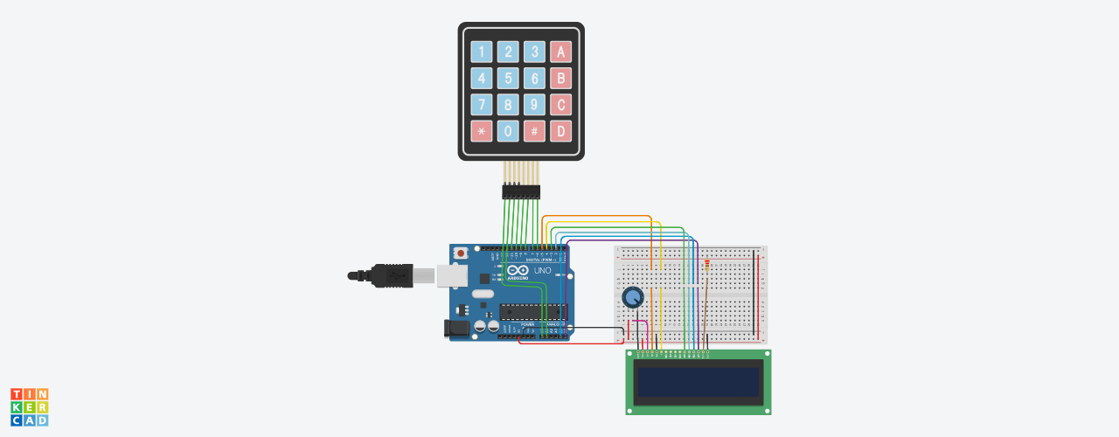**Code:**

#include <Keypad.h>

#include <LiquidCrystal.h>

LiquidCrystal lcd(5, 4, 3, 2, A4, A5);

const byte ROWS = 4; //four rows

const byte COLS = 4; //three columns

char keys[ROWS][COLS] = {

{'1','2','3','A'},

{'4','5','6','B'},

{'7','8','9','C'},

{'*','0','#','D'}

};

byte rowPins[ROWS] = {A0, A1, 11, 10}; //connect to the row pinouts of the keypad

byte colPins[COLS] = {9, 8, 7, 6}; //connect to the column pinouts of the keypad

int LCDRow = 0;

Keypad keypad = Keypad( makeKeymap(keys), rowPins, colPins, ROWS, COLS );

void setup(){

Serial.begin(9600);

lcd.begin(16, 2);

lcd.setCursor(LCDRow, 0);

}

void loop(){

char key = keypad.getKey();

if (key){

Serial.println(key);

lcd.print(key);

lcd.setCursor (++LCDRow, 0);

}

}

**Output:**

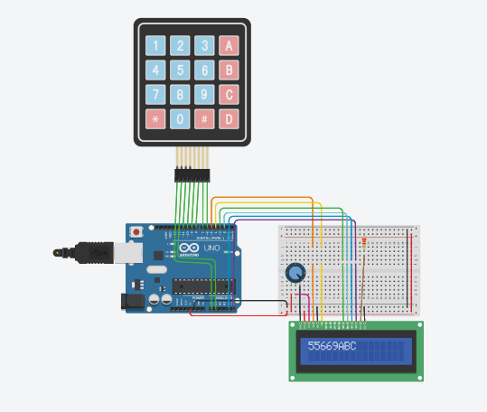

**Tinkercad Simulator:**

<https://www.tinkercad.com/things/9O4kauYTKr2-aesmini-project/editel>