Name: Sreejith Nair
Roll No: 19
Social Network Analysis
Index
Sr. No. | Title | Page No.
1 | Write a program to compute the following for a given a network: number of edges, number of nodes, degree of node, node with lowest degree, the adjacency list, matrix of the graph. | 2
2 | Perform following tasks: View data collection forms and/or import onemode/two-mode datasets, Basic Networks matrices transformations | 11
3 | Compute the following node level measures: Density; Degree; Reciprocity; Transitivity; Centralization; Clustering. | 15
4 | For a given network find the following: Length of the shortest path from a given node to another node; the density of the graph; Draw egocentric network of node G with chosen configuration parameters. | 22
5 | Write a program to distinguish between a network as a matrix, a network as an edge list, and a network as a sociogram (or “network graph”) using 3 distinct networks representatives of each. | 29
6 | Write a program to exhibit structural equivalence, automatic equivalence, and regular equivalence from a network. | 33
7 | Perform SVD analysis of a network. | 38

Practical 1
Aim: Write a program to compute the following for a given a network:
- number of edges
- number of nodes
- degree of node
- node with lowest degree  the adjacency list
- matrix of the graph.
Software(s) used:
- R ver. 4.1.3
- RStudio ver. 2022.02.0+433
External packages required:
- igraph
Description:
● The igraph package: igraph is a library and R package for network analysis.
The main goals of the igraph library is to provide a set of data types and functions for:
- pain-free implementation of graph algorithms,
- fast handling of large graphs, with millions of vertices and edges, allowing rapid prototyping via high level languages like R.
●library(): library() loads and attach add-on packages.
●graph.formula():
- Creating (small) graphs via a simple interface
- This function is useful if you want to create a small (named) graph quickly, it works for both directed and undirected graphs.
●plot(): Use to plot any graph.
●ecount(): Returns the count of number of edges in graph ●vcount(): Returns the count of number of vertices in graph
●E():
- Edges of a graph
- An edge sequence is a vector containing numeric edge ids, with a special class attribute that allows custom operations:
selecting subsets of edges based on attributes, or graph structure, creating the intersection, union of edges, etc.
●V():
- Vertices of a graph
- Create a vertex sequence (vs) containing all vertices of a graph.
●degree():
- Degree and degree distribution of the vertices
- The degree of a vertex is its most basic structural property, the number of its adjacent edges.
- Mode-Character string, “out” for out-degree, “in” for indegree or “total” for the sum of the two. For undirected graphs this argument is ignored. “all” is a synonym of “total”.
●max() and min():
- Maxima and Minima
- Returns the (regular or parallel) maxima and minima of the input values.
●get.adjacency(): Convert a graph to an adjacency matrix
●get.adjlist():
- Adjacency lists
- Create adjacency lists from a graph, either for adjacent edges or for neighboring vertices
Source Code: library(igraph)
u_graph <- graph.formula(A - B, A - C, A - D, B - C, B - F, C D, C - E, C - F, D - E, E - F, F - G, G - H)
d_graph <- graph.formula(A <+ B, A <+ D, A -+ C, B -+ C, B -+
E, B -+ F, C -+ D, C -+ F, D -+ E)
e_count(u_graph) e_count(d_graph)
v_count(u_graph) v_count(d_graph)
E(u_graph)
E(d_graph)
V(u_graph)
V(d_graph)
degree(u_graph) degree(u_graph, mode = "in") degree(u_graph, mode = "out")
degree(d_graph) degree(d_graph, mode = "in") degree(d_graph, mode = "out")
V(u_graph)$name[degree(u_graph) <= min(degree(u_graph))] V(d_graph)$name[degree(d_graph, mode = "in") <= min(degree(d_graph, mode = "in"))]
V(d_graph)$name[degree(d_graph, mode = "out") <= min(degree(d_graph, mode = "out"))]
get.adjacency(u_graph) get.adjacency(d_graph)
get.adjlist(u_graph) get.adjlist(d_graph)
Output:
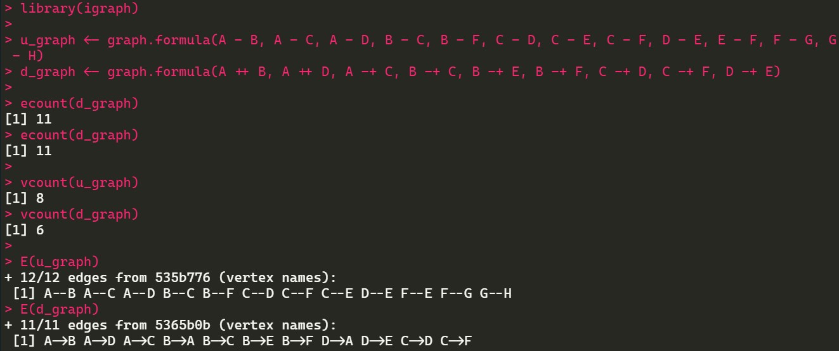
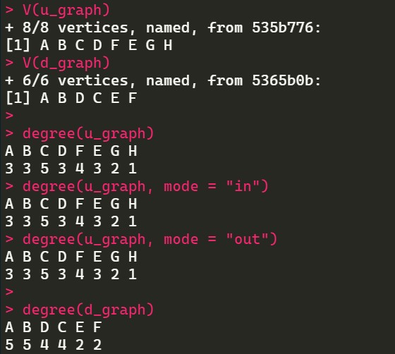
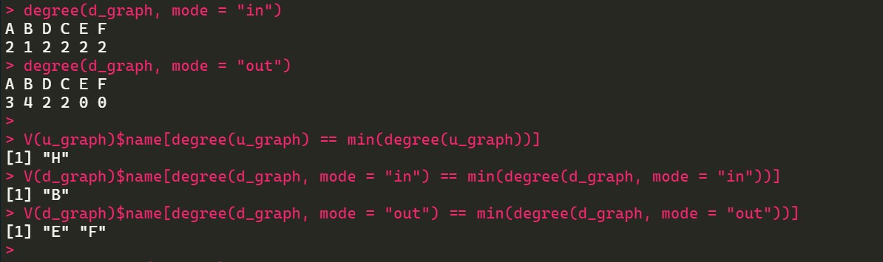
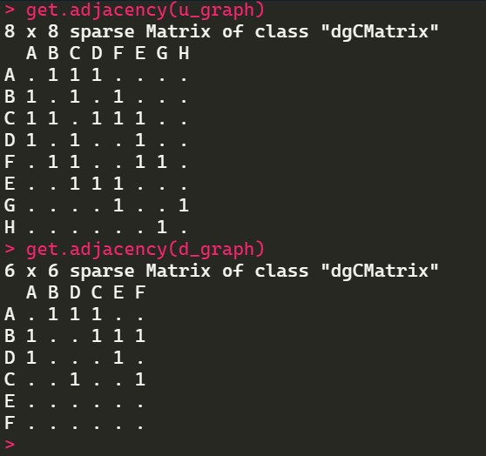
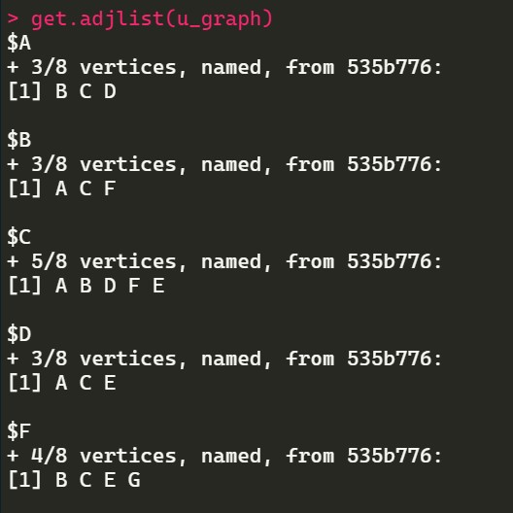
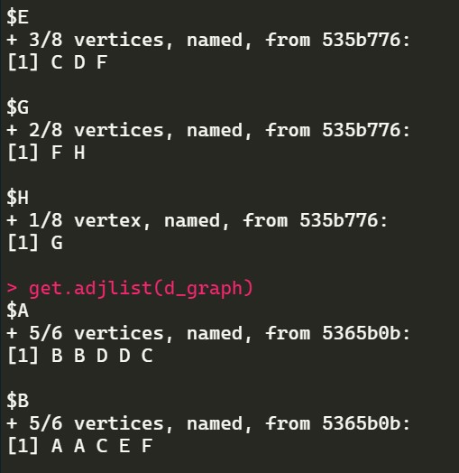
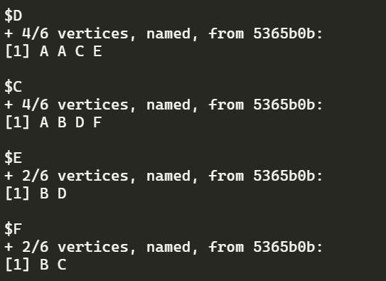

Practical 2
Aim: Perform following tasks:
- View data collection forms and/or import onemode/two-mode datasets.
- Basic Networks matrices transformations.
Software(s) used:
- R ver. 4.1.3
- RStudio ver. 2022.02.0+433
External packages required:
- igraph
Description:
● The igraph package: igraph is a library and R package for network analysis.
The main goals of the igraph library is to provide a set of data types and functions for:
- pain-free implementation of graph algorithms,
- fast handling of large graphs, with millions of vertices and edges, allowing rapid prototyping via high level languages like R.
●getwd(): Used to get the absolute filepath of the current R session.
●require(): library() and require() load and attach addon packages.
●read.csv(): Reads a file in table format and creates a data frame from it, with cases corresponding to lines and variables to fields in the file.
●head(): Returns the first part of a vector, matrix, table, data frame or function. Since head() and tail() are generic functions, they may also have been extended to other classes.
●graph.data.frame(): This function creates an igraph graph from one or two data frames containing the (symbolic) edge list and edge/vertex attributes.
●get.adjacency(): Sometimes it is useful to work with a standard representation of a graph, like an adjacency matrix.
●plot(): Draw a scatter plot with decorations such as axes and titles in the active graphics window.
Source Code:
require("igraph")
edges <- read.csv("C:/Temp/input_files/edges.csv") nodes <- read.csv("C:/Temp/input_files/nodes.csv")
head(edges) head(nodes)
dir_graph <- graph.data.frame(d = edges, vertices = nodes,
directed = T) get.adjacency(dir_graph) plot(dir_graph)
Output:
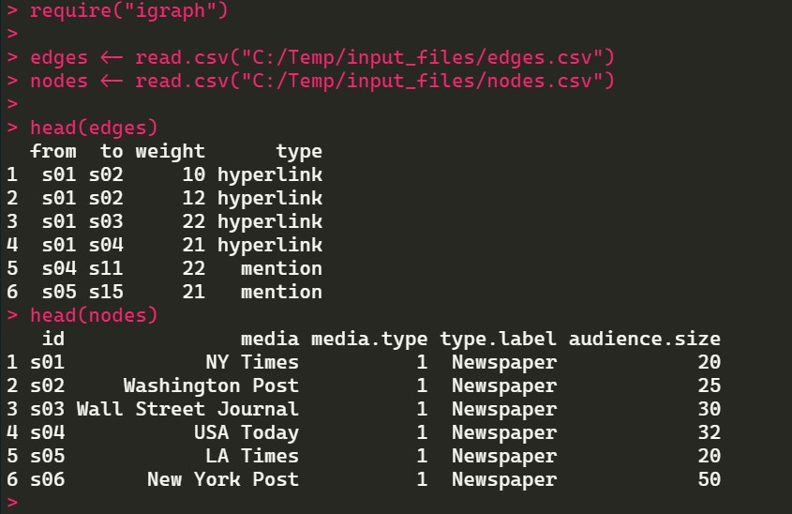
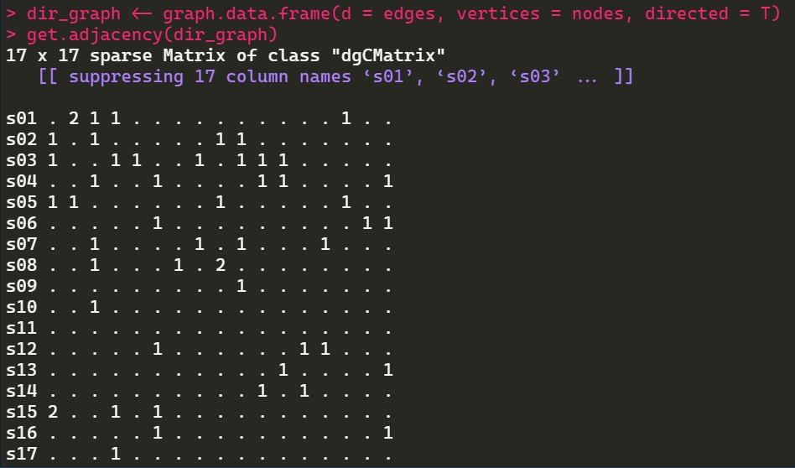
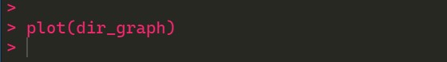
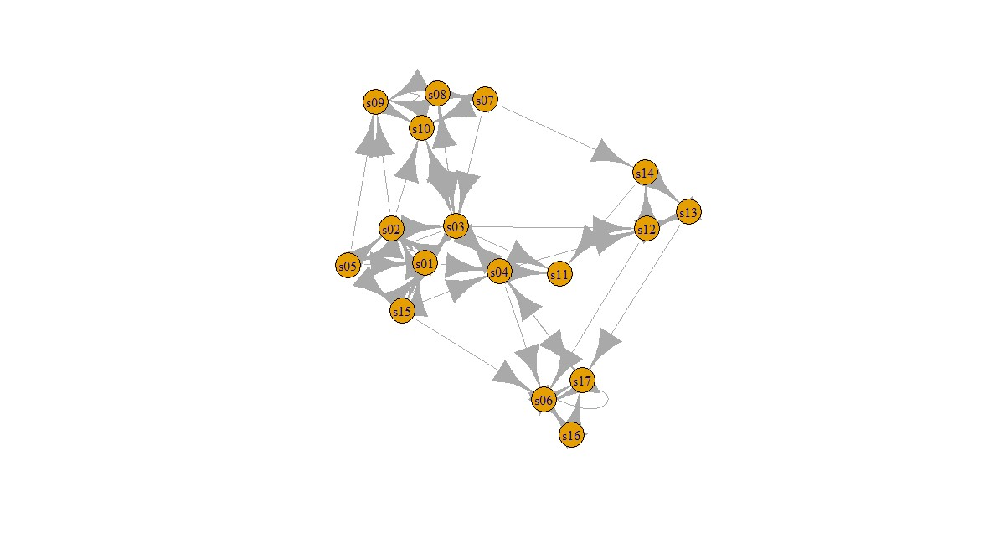

Practical 3
Aim: Compute the following node level measures:
- Density
- Degree
- Reciprocity
- Transitivity
- Centralization  Clustering.
Software(s) used:
- R ver. 4.1.3
- RStudio ver. 2022.02.0+433
External packages required:
- igraph
Description:
● The igraph package: igraph is a library and R package for network analysis.
The main goals of the igraph library is to provide a set of data types and functions for:
- pain-free implementation of graph algorithms,
- fast handling of large graphs, with millions of vertices and edges, allowing rapid prototyping via high level languages like R.
●library(): library() and require() load and attach addon packages.
●graph.famous(): Create an igraph graph from a list of edges, or a notable graph.
●ecount(): Returns the count of number of edges in graph
●vcount(): Returns the count of number of vertices in graph
●graph.formula(): This function is useful if you want to create a small (named) graph quickly, it works for both directed and undirected graphs.
●plot(): Draw a scatter plot with decorations such as axes and titles in the active graphics window.
●reciprocity(): Calculates the reciprocity of a directed graph.
●dyad.census(): Classify dyads in a directed graphs. The relationship between each pair of vertices is measured. It can be in three states: mutual, asymmetric or non-existent.
●adjacent.triangles(): Count how many triangles a vertex is part of, in a graph, or just list the triangles of a graph.
●transitivity(): Transitivity measures the probability that the adjacent vertices of a vertex are connected. This is sometimes also called the clustering coefficient.
●degree(): The degree of a vertex is its most basic structural property, the number of its adjacent edges. ●barabasi.game(): The BA-model is a very simple stochastic algorithm for building a graph.
●watts.strogatz.game(): Generate a graph according to the Watts-Strogatz network model.
●graph.union(): The union of two or more graphs are created. The graphs may have identical or overlapping vertex sets.
●simplify(): Simple graphs are graphs which do not contain loop and multiple edges.
Source Code: library("igraph")
kite <- graph.famous("Krackhardt_Kite") vcount(kite) ecount(kite)
ecount(kite) / (vcount(kite) * (vcount(kite) - 1) / 2)
dir_graph <- graph.formula(A <+ B, A <+ D, A -+ C, B -+ C, B -+ E, B -+ F, C -+ D, C -+ F, D -+ E) plot(dir_graph) reciprocity(dir_graph) dyad.census(dir_graph)
mutual <- dyad.census(dir_graph)$mut
mutual / (ecount(dir_graph))
atri <- adjacent.triangles(kite) plot(kite, vertex.label = atri) transitivity(kite, type = "local")
adjacent.triangles(kite) / (degree(kite) * (degree(kite) - 1) /
2)
graph_2 <- barabasi.game(50, p = 2, directed = F)
graph_1 <- watts.strogatz.game(1, size = 100, nei = 5, p =
0.05)
graph <- graph.union(graph_1, graph_2) graph <- simplify(graph) plot(graph) Output:
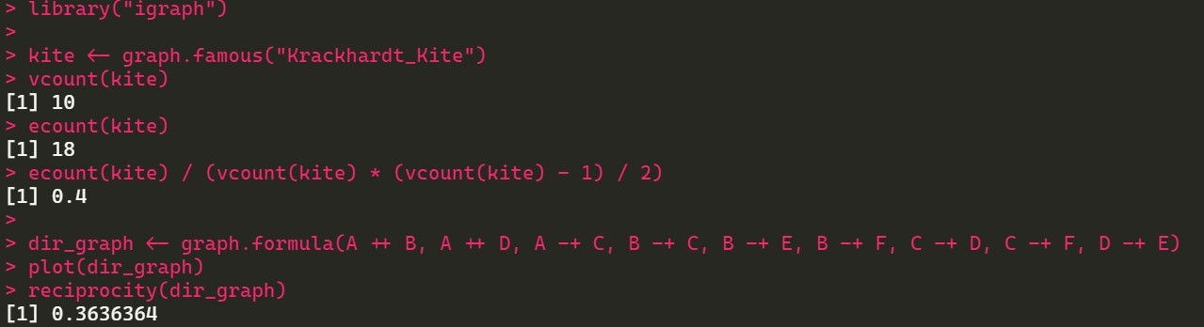
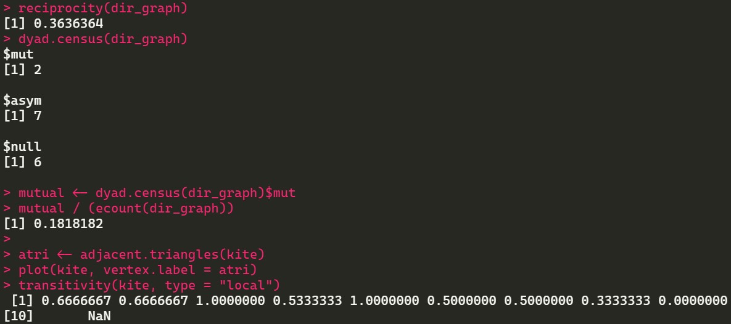
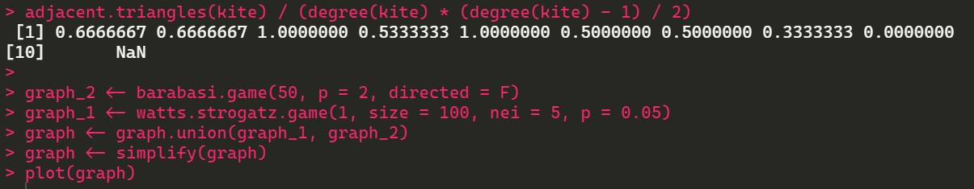
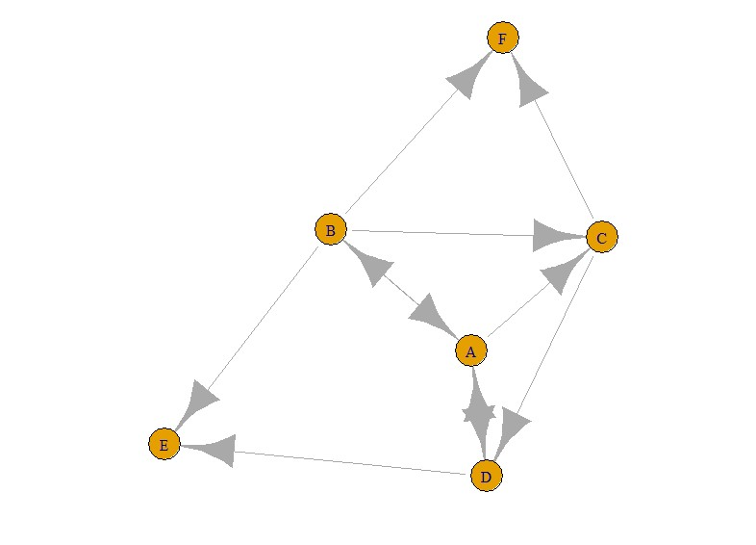
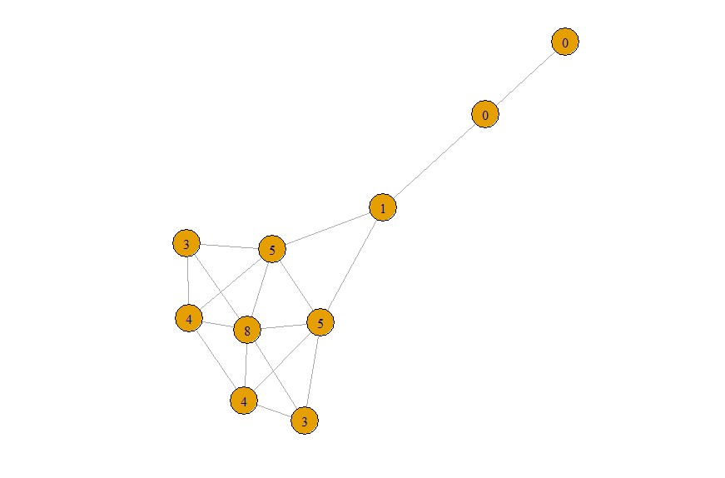
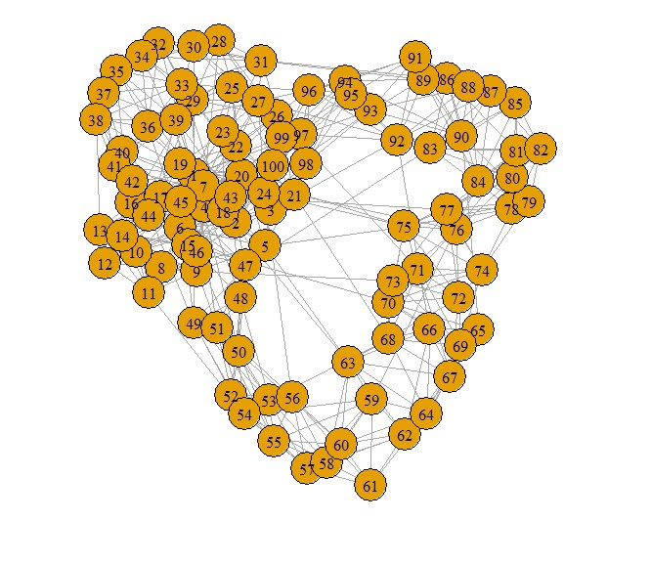

Practical 4
Aim: For a given network find the following:
- Length of the shortest path from a given node to another node
- The density of the graph
- Draw egocentric network of node G with chosen configuration parameters.
Software(s) used:
- R ver. 4.1.3
- RStudio ver. 2022.02.0+433
External packages required:
- igraph
Description:
● The igraph package: igraph is a library and R package for network analysis.
The main goals of the igraph library is to provide a set of data types and functions for:
- pain-free implementation of graph algorithms,
- fast handling of large graphs, with millions of vertices and edges, allowing rapid prototyping via high level languages like R.
●library(): library() and require() load and attach addon packages.
●as.matrix(): matrix() creates a matrix from the given set of values. as.matrix() attempts to turn its argument into a matrix.
●read.table(): Reads a file in table format and creates a data frame from it, with cases corresponding to lines and variables to fields in the file.
●colnames() and rownames(): Retrieve or set the row or column names of a matrix-like object.
●is.na(): The generic function is.na() indicates which elements are missing.
●graph.adjacency(): graph_from_adjacency_matrix() is a flexible function for creating igraph graphs from adjacency matrices.
●plot(): Draw a scatter plot with decorations such as axes and titles in the active graphics window.
●shortest.paths(): shortest_paths() calculates one
shortest path (the path itself, and not just its length) from or to the given vertex.
●print(): print() prints its argument and returns it invisibly.
●graph.formula(): This function is useful if you want to create a small (named) graph quickly, it works for both directed and undirected graphs.
●graph.density(): The density of a graph is the ratio of the number of edges and the number of possible edges. ●simplify(): Simple graphs are graphs which do not contain loop and multiple edges.
Source Code: library(igraph)
matt <- as.matrix(read.table(text=
"node R S T U
- 7 5 0 0
- 7 0 0 2
- 0 6 0 0
- 4 0 1 0", header=T))nms <- matt[, 1] matt <- matt[, -1]
colnames(matt) <- rownames(matt) <- nms matt[is.na(matt)] <- 0
g <- graph.adjacency(matt,weighted=TRUE) plot(g)
s.paths <- shortest.paths(g, algorithm = "dijkstra") print(s.paths)
shortest.paths(g, v="R", to="S") plot(g, edge.label=E(g)$weight) dg <- graph.formula(1-+2, 1-+3, 2<+3) plot(dg)
graph.density(dg, loops=TRUE) graph.density(simplify(dg), loops=FALSE)
Output:
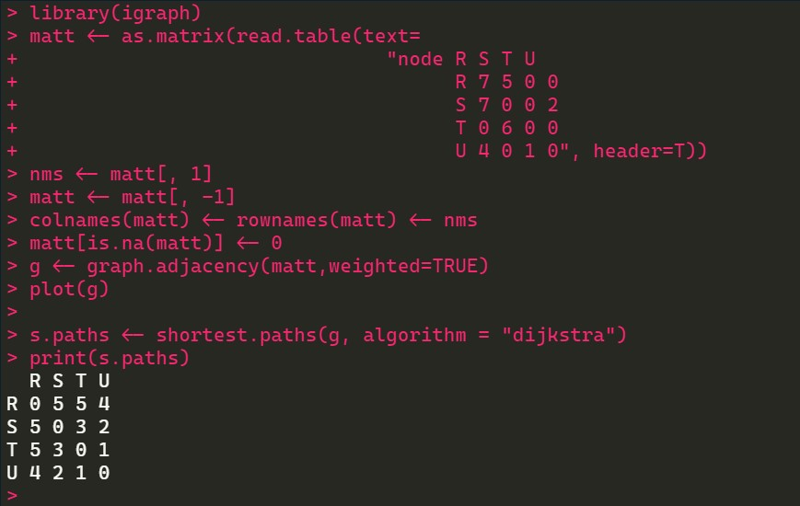
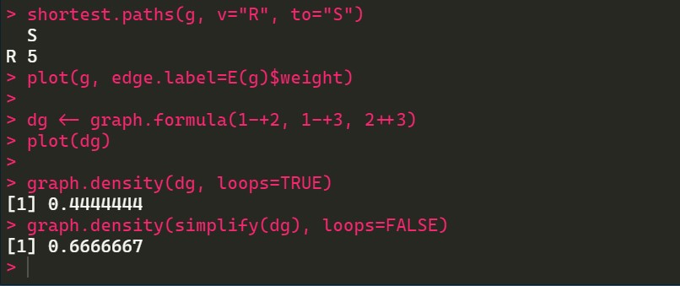
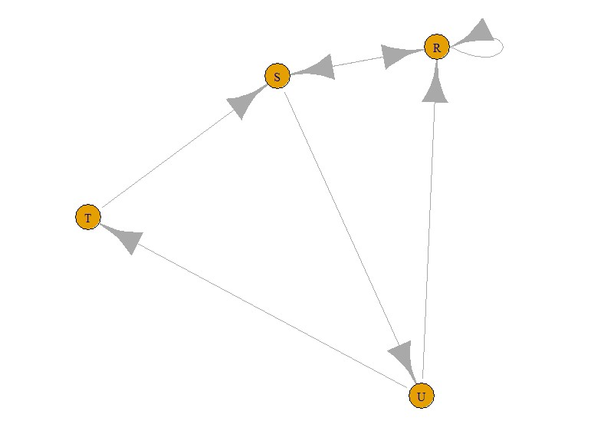
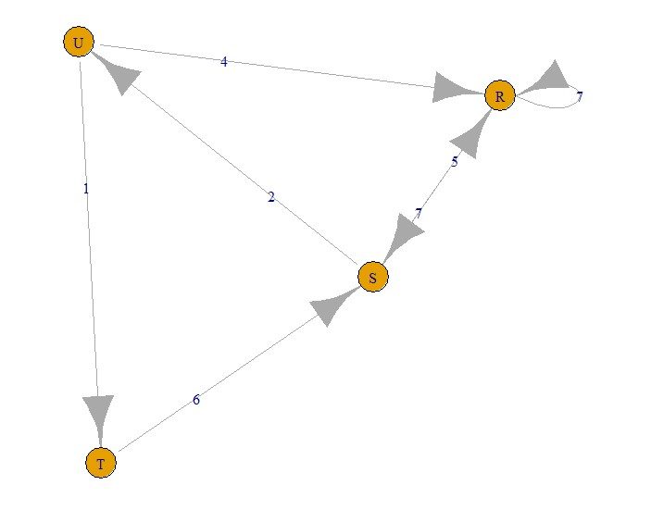
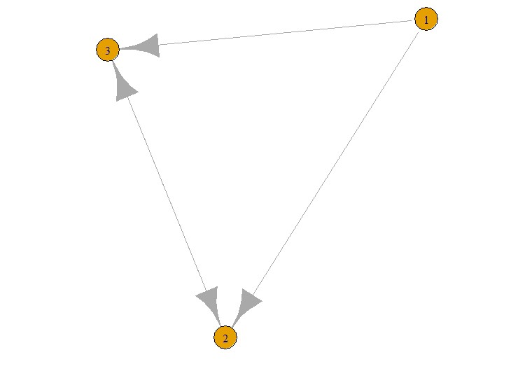

Practical 5
Aim: Write a program to distinguish between a network as a matrix, a network as an edge list and a network as a sociogram (or “network graph”) using 3 distinct networks representatives of each.
Software(s) used:
- R ver. 4.1.3
- RStudio ver. 2022.02.0+433
External packages required:
- igraph
Description:
● The igraph package: igraph is a library and R package for network analysis.
The main goals of the igraph library is to provide a set of data types and functions for:
- pain-free implementation of graph algorithms,
- fast handling of large graphs, with millions of vertices and edges, allowing rapid prototyping via high level languages like R.
●library(): library() and require() load and attach addon packages.
●graph.formula(): This function is useful if you want to create a small (named) graph quickly, it works for both directed and undirected graphs.
●plot(): Draw a scatter plot with decorations such as axes and titles in the active graphics window.
●get.adjacency(): Sometimes it is useful to work with a standard representation of a graph, like an adjacency matrix.
●E(): An edge sequence is a vector containing numeric edge ids, with a special class attribute that allows custom operations: selecting subsets of edges based on attributes, or graph structure, creating the intersection, union of edges, etc.
●get.adjedgelist(): Create adjacency lists from a graph, either for adjacent edges or for neighboring vertices.
Source Code: library(igraph)
sociogram <- graph.formula(Andy<+Garth,Garth-+Bill,Bill-
+Elena,Elena<+Frank,Carol-
+Andy,Carol-+Elena,Carol+
+Dan,Carol<+Bill,Dan<+Andy, Dan<+Bill)
plot(sociogram)
get.adjacency(sociogram) E(sociogram) get.adjedgelist(sociogram)
Output:
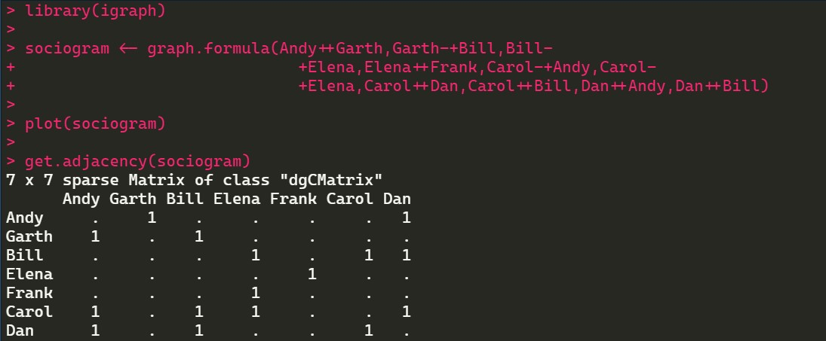
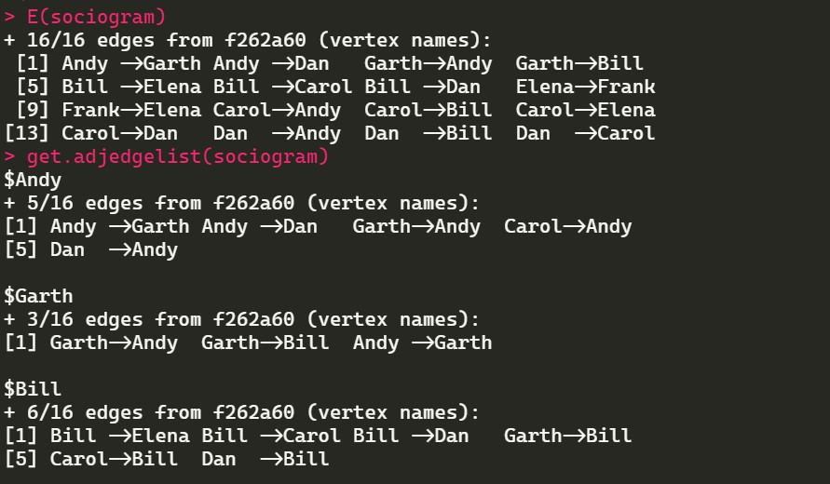
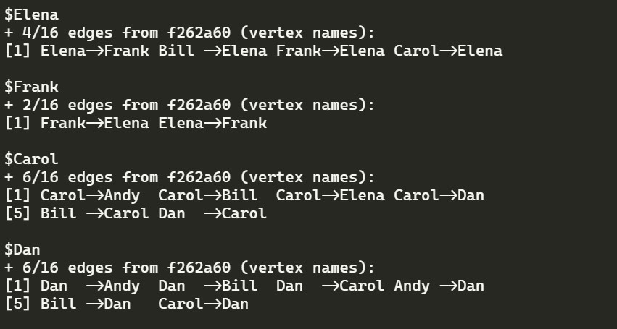
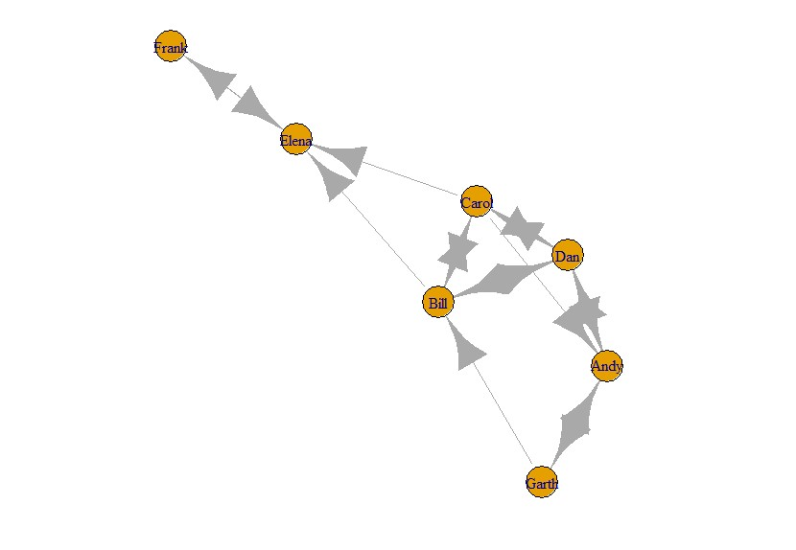

Practical 6
Aim: Write a program to exhibit structural equivalence, automatic equivalence, and regular equivalence from a network.
Software(s) used:
- R ver. 4.1.3
- RStudio ver. 2022.02.0+433
External packages required:
- igraph
- sna
Description:
  - The igraph package: igraph is a library and R package for network analysis.
The main goals of the igraph library is to provide a set of data types and functions for:
- pain-free implementation of graph algorithms,
- fast handling of large graphs, with millions of vertices and edges, allowing rapid prototyping via high level languages like R.
  - The sna package: sna is a package containing a range of tools for social network analysis. Supported functionality includes node and graph-level indices, structural distance and covariance methods, structural equivalence detection, p* modeling, random graph generation, and 2D/3D network visualization (among other things).
●library(): library() and require() load and attach addon packages.
●read.csv(): Reads a file in table format and creates a data frame from it, with cases corresponding to lines and variables to fields in the file.
●equiv.clust(): equiv.clust() uses a definition of approximate equivalence (equiv.fun()) to form a hierarchical clustering of network positions.
●plot(): Draw a scatter plot with decorations such as axes and titles in the active graphics window.
●sedist(): sedist() uses the graphs indicated by g in the arguments to assess the extent to which each vertex is structurally equivalent.
●cmdscale(): Classical multidimensional scaling (MDS) of a data matrix.
●as.dist(): This function computes and returns the distance matrix computed by using the specified distance measure to compute the distances between the rows of a data matrix.
●blockmodel(): Given a set of equivalence classes and one or more graphs, blockmodel will form a blockmodel of the input graph(s) based on the classes in question
Source Code: library(sna) library(igraph)
links2 <- read.csv("C:/Temp/input_files/edges1.csv", header=T, row.names=1) eq<-equiv.clust(links2) plot(eq)
g.se<-sedist(links2)
plot(cmdscale(as.dist(g.se))) b<-blockmodel(links2,eq,h=10) plot(b)
Output:
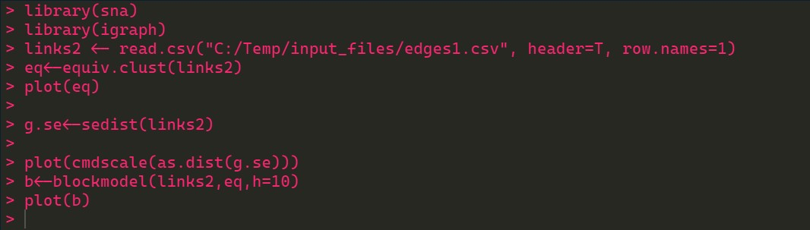
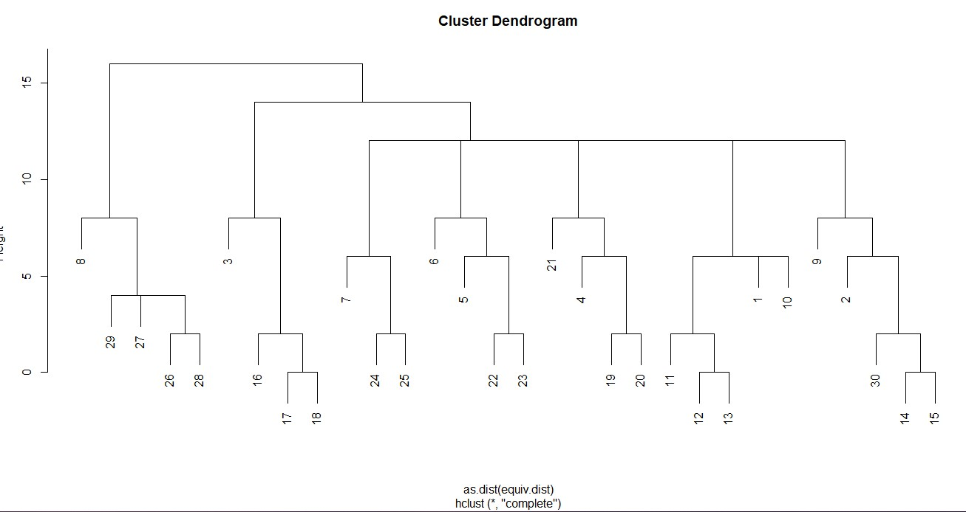
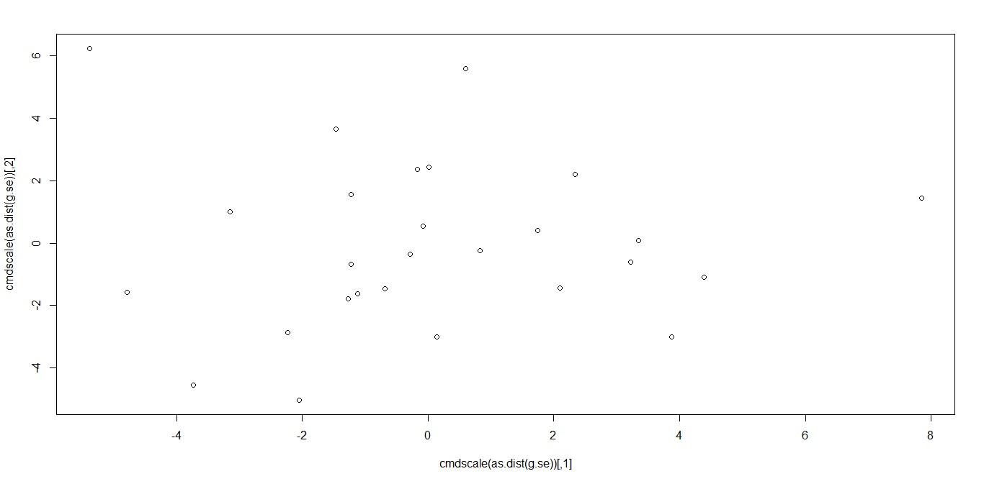
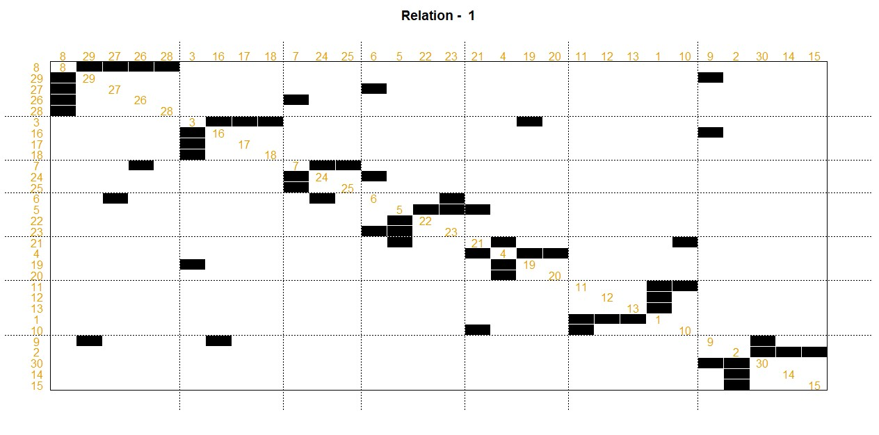

Practical 7
Aim: Perform SVD analysis of a network.
Software(s) used:
- R ver. 4.1.3
- RStudio ver. 2022.02.0+433
External packages required:
- igraph
Description:
● The igraph package: igraph is a library and R package for network analysis.
The main goals of the igraph library is to provide a set of data types and functions for:
- pain-free implementation of graph algorithms,
- fast handling of large graphs, with millions of vertices and edges, allowing rapid prototyping via high level languages like R.
●matrix(): matrix() creates a matrix from the given set of values.
●c(): Combines values into a vector or list.
●print(): print() prints its argument and returns it invisibly. ●svd(): Compute the singular-value decomposition of a rectangular matrix.
Source Code:
library(igraph)
a <- matrix(c(1, 1, 1, 1, 1, 1, 1, 1, 1, 1, 1, 1, 0, 0, 0, 0,
0, 0, 0, 0, 0, 1, 1, 1, 0, 0, 0, 0, 0, 0, 0, 0, 0, 1, 1,
1), 9, 4) print(a) svd(a)
Output:
