

S.I.E.S College of Arts, Science and Commerce (Autonomous) Sion (W), Mumbai– 400 022.

**Certificate**

This Is to certify that **MR. Nair Sreejith Sreekumar** Roll No TCS2021053 of **T.Y.B.Sc. (Computer Science)** has successfully completed the project work entitled as **“ Restaurant Billing System”** as the partial fulfillment of B.Sc. (Computer Science) during **Semester VI** of the academic year **2020-2021.**

**Head of Department Project Guide**

Prof. Manoj Singh Prof. Manoj Singh

**Examiner**

College Seal & Date

**TEAM MEMBERS:**

**Sreejith Nair (TCS2021053)**

**Abhishek Yadav (TCS2021099)**

**Yatin Satheeshan (TCS2021 100)**

**Acknowledgement**

The success of this project would not have been possible without the help and guidance of teachers. However, we would like to extend our sincere thanks to all of them.

We respect and thank our Head of Department **Mr. Manoj Singh** for giving us an opportunity and support to complete this project.

We sincerely thank to all our teachers for their timely and prestigious guidance.

Synopsis

The project Restaurant Billing System gives us the facility to manage the Restaurants billing system. This application is helpful for staff or admin for billing of food order and managing customers details. This application is access by only staff and admin.

The project is very useful for those who want to know about Restaurants Billing System. This application maintains the records related to Customers, and Sales etc.

We can enter the details of new food items and retrieve the details of food items and employees available in the System. We can generate the bills for the customers. We can generate the membership card for the customers. We can also maintain the records of customers .In this project we can maintain the GST calculation of every food item. GST can be issued according to Govt. specified categories of all the food itmes. Total sales can also be maintain in this project. All necessary requirements for the Restaurants Billing System has presented in this project.

RESTAURANT BILLING SYSTEM

Abstract

The project is “Restaurant Billing System” software for monitoring and controlling the transactions in a Restaurant. Restaurant Billing System is a windows application designed to help users maintain & organize Restaurant. The system processes transaction and stores the resulting data. Reports will be generated from these data which help the manager to make appropriate business decisions for the restaurant.

Existing System

The current system is paper based. Papers are used in restaurants for displaying the traditional menu cards, writing down the orders of customers, storing the records of customers. The disadvantages of paper based system are that papers can get easily damaged by stain marks; they can be lost due to fire or accidents or can get lost in general. Hence, time and money is wasted.

As traditional menu cards are paper based, any changes that need to be made in the menu will require reprinting of the entire menu card, leading to wastage. For small changes, reprinting the entire menu card is impossible. Changes in the menu card cannot be made dynamically. It is inefficient to access a particular record from the stack of papers. This system is time consuming. One has to call a waiter number of times till he notices it, and wait for him to arrive at their table to take their order. Also the waiter can misinterpret the customer’s order since he is writing the order on paper, and the case of serving a wrong dish is possible.

• For placing any orders customers have to visit hotels or restaurants to know about food items and then place order and pay. In this method time and manual work is required.

• While placing an order over the phone, customer lacks the physical copy of the menu item, lack of visual confirmation that the order was placed correctly.

• Every restaurant needs certain employees to take the order over phone or in-person, to offer a rich dining experience and process the payment. In today’s market, labor rates are increasing day by day making it difficult to find employees when needed.

PROPOSED SYSTEM

To solve the inconveniences as mentioned in the existing system, an Online Library is proposed. The proposed system contains the following features:

1. Automated Reports

A billing system ensures the elimination of excessive manual intervention, and this also applies to the performance reports to keep track of the business’ growth. The software ensures automated report generation that you can view on your dashboard to keep track of how well the business is performing. This reduces the time you would otherwise have to spend.

1. All-Round Management

Your restaurant billing software can not only manage the billing aspect of the business but also manage orders, taxes, performance tracking, and more, all through a single software.

1. Anytime Access to the System

Just because your restaurant is open a certain amount in no way means that you cannot have access to the system or its data anytime or anywhere. With portable billing systems, you can have access to the systems from any location, as long as you have a working internet connection.

1. Management of Takeaways and Deliveries

In the case of takeaways and deliveries, while there are no tables occupied or customers coming in, the sales need to be tracked irrespective. While billing softwares are usually efficient in managing the crowds coming in to dine, they also come with the feature to track and manage orders for takeaway and delivery.

1. Accuracy

The application provides the user a quick response with very accurate information regarding the user etc. any details or system in an accurate manner, as when required.

1. User Friendly

The application Restaurant Billing System has a very user friendly interface. Thus the users will full very easy to work on it. The application provides accuracy along with a pleasant interface. Make the present manual system more interactive, speedy and user friendly.

1. Availability

The all transaction of restaurant stored permanently in the database admin can see the data in the availability of any information, whatever needed.

1. Maintain Cost

Reduce the cost of maintenance. It is standalone application so no required of cost for maintain it.

SDLC MODEL

**AGILE MODEL:**

The meaning of Agile is swift or versatile. "Agile process model" refers to a software development approach based on iterative development. Agile methods break tasks into smaller iterations, or parts do not directly involve long term planning. The project scope and requirements are laid down at the beginning of the development process. Plans regarding the number of iterations, the duration and the scope of each iteration are clearly defined in advance.

Each iteration is considered as a short time "frame" in the Agile process model, which typically lasts from one to four weeks. The division of the entire project into smaller parts helps to minimize the project risk and to reduce the overall project delivery time requirements. Each iteration involves a team working through a full software development life cycle including planning, requirements analysis, design, coding, and testing before a working product is demonstrated to the client.

REQUIREMENTS AND BASIC INFORMATION ABOUT TECHNOLOGY USED FOR THE PROJECT

**Front end**: C#

**Back end**: MySQL

**Software used**: Microsoft Visual Studio

**HARDWARE AND SOFTWARE REQUIREMENTS**

* Processor : i3 (minimum)
* RAM :4GB (minimum)
* HDD 500 GB / 1 TB or more
* OS Window 7 or Later
* Database Microsoft SQL server (2019)

Advantages of billing systems:

* We can curate accurate and professional looking invoices with multiple templates.
* Reduces material costing that comes with manual billing and filing.
* Automatic update features keep business deals, changes, and offers in the loop within customers.
* Retail billing software helps small businesses to penetrate offline and online much conveniently.
* Effective communication is established without constant personal calls for a reminder of payments.
* The instant invoice helps the customers understand a clear breakup of charges and deductions involved in that particular transaction.
* Within the touch of your fingers, your software and records can be checked and maintained via mobile devices; even while you are away.
* Combined with external software that will help in smoother tracking of the business.
* Helps in GST Tax calculation.

Disadvantages of billing systems:

* It is not cost-effective for small scale business owners.
* Invoices can go into spam folders due to flagging by email servers; that leads to delay of payments.
* Reaching offline customers who do not access the internet makes the process difficult.
* Automatic invoices and management system reduces human mediation, which reduces personal touch for the business.
* Irregularity of updates can lead to hardships and hassles between purchases and credits.

LIMITATIONS

* Sales module – which checks sales of products.
* SMS module – SMS system which sends the bill to the corresponding customers contact number.

MODULES

* Place order module
* Items module
* User module
* Bills module
* Customer module
* Transaction module

**FUNCTION POINT ANALYSIS**

EI: 60

EO: 41

EQ: 24

EIF : 1

ILF: 5

1] Login:

EI: 3(username, password, login(C))

EO: 3(Admin Dashboard,Place Order,Not Found)

EQ: 1(Login Successful)

ILF: 1(User table)

Admin:

2] Add User:

EI: 9(User Role, Name, DOB, MobileNo., Email, Userame, Password ,Add User,Clear)

EO: 2(User Added,Reset Field)

EQ: 1(User Table Updated)

3] Update User:

EI: 8(User id, User Role, Name, DOB, MobileNo., Email, Password ,Update User,)

EO: 3(Users Grid View, User Data Updated, Not Found)

EQ: 3(User table Updated, User Details, Search User)

4] Delete User:

EI: 3(User id, Delete,OK)

EO: 3(Users Grid View, User Data Updated, Not Found)

EQ: 3(User table Updated, User Details, Search User)

5] Add Items:

EI: 5(Category,Item Name,Price,Add Item,Clear)

EO: 2(Items Added,Fields Reset)

EQ: 1(Item Table Updated)

ILF: 1(Items Table)

6] Update Items:

EI: 5(Category,Price,Item Name,Update)

EO: 4(Items Updated,Items Grid view,Items Found,Item Not Found)

EQ: 3(Items table Updated, Items Details, Search Items)

7] Delete Items:

EI: 3(Item id,YES,OK)

EO: 6(Item Grid View,Warning, Confirm,Item Removed,Item Found,Item Not Found)

EQ: 3(Item Table Updated,Item Details,Search Item From Item Table)

Search Bill

EI: 3(Bill id,Search,OK)

EO: 4(Bill Grid View,Bill Removed,Bill Found,Not Found)

EQ: 2(Bill Details,Bill Table Updated)

ILF:1(Bills Table)

Search Customer

EI: 4(Customer id,Customer Name,Search,OK)

EO: 4(Customer Grid View, Customer Removed, Customer Found,Not Found)

EQ: 2(Customer Details, Customer Table Updated)

ILF:1(Customer Table)

Search Transaction

EI: 4(Transaction id, Transaction Name,Search,OK)

EO: 4(Transaction Grid View, Transaction Removed, Transaction Found,Not Found)

EQ: 2(Transaction Details, Transaction Table Updated)

ILF:1(Transaction Table)

Cashier:

Add To Cart

EI: 5(Add to Cart,Quantity,Category,Item id,Search)

EO: 5(Added to Cart,Item Name, Price,Total,Not Found)

EQ: 1(Search Item From Item Table)

Remove From Cart

EI: 2(Remove,Item id)

EO: 1(Removed From Cart)

Print Bill

EI: 1(Print Bill)

EIF=1(Printing Bill)

Save Bill

EI: 1(Save)

EO=1(Data Processed Successfully)

EQ=1(bills saved successfully)

Clear Cart

EI: 1(Clear)

EO=1(Cart Cleared)

EI: 60

EO: 41

EQ: 24

EIF : 1

ILF: 5

|  |  |  |  |  |
| --- | --- | --- | --- | --- |
|  | **SIMPLE** | **AVERAGE** | **COMPLEX** | **TOTAL** |
| **EI** | 3(43) | 4(12) | 6(5) | 207 |
| **EO** | 4(25) | 5(10) | 7(6) | 192 |
| **EQ** | 3(12) | 4(8) | 6(4) | 92 |
| **ILF** | 7(2) | 10(3) | 15(0) | 44 |
| **EIF** | 0 | 0 | 10(1) | 10 |

TOTAL = 545

**Fi** = 5+3+1+2+3+0+0+0+3+3+4+2+2+4  
 = 32

**FP** = COUNT TOTAL * (0.65 + 0.01 * Fi)  
 = 545 *(0.65+0.01*32)

=545*0.97

= 528.65

**LINE OF CODE (LOC)**

|  |  |  |  |
| --- | --- | --- | --- |
|  | Optimistic | Pessimistic | Realistic |
| Login Module | 60 | 115 | 75 |
| Admin Module | 75 | 125 | 100 |
| Cashier Module | 50 | 100 | 75 |
| Place Order Module | 250 | 325 | 300 |
| Item Module | 200 | 300 | 250 |
| Users Module | 275 | 350 | 325 |
| Bills Module | 50 | 120 | 80 |
| Customer Module | 75 | 150 | 100 |
| Transaction Module | 70 | 140 | 90 |
| Backend | 45 | 100 | 70 |
| Total | 1150 | 1825 | 1465 |

**Note:** Values are assumed and not accurate.

LOC = (O+ P + (4*R)) / 6

Where,

O is Optimistic

P is Pessimistic

R is Realistic

LOC = (1150+ 1825+ (4*1465)) / 6

= (1150 + 1825 + 5860)/6

= 8835/6

LOC = 1473

**CHI SQUARE TEST**

* **H0:** Gender and Preference for Restaurant Billing System are **independent**.
* **H1:** Gender and Preference for Restaurant Billing System are **not independent**.
* **OBSERVED DATA**

|  |  |  |  |  |
| --- | --- | --- | --- | --- |
|  |  | **GENDER** |  |  |
|  |  | **MALE** | **FEMALE** | **TOTAL** |
|  | **YES** | 56 | 36 | 92 |
| **If yes, would you prefer to use such restaurant billing system?** | **NO** | 1 | 0 | 1 |
|  | **MAYBE** | 6 | 1 | 7 |
|  | **TOTAL** | 63 | 37 | 100 |

* **EXPECTED DATA**

|  |  |  |  |  |
| --- | --- | --- | --- | --- |
|  |  | **GENDER** |  |  |
|  |  | **MALE** | **FEMALE** | **TOTAL** |
|  | **YES** | 57.96 | 11.1042 | 92 |
| **WOULD YOU PREFER TO USE SUCH FOOD ORDERING SYSTEMS** | **NO** | 0.63 | 0.37 | 1 |
|  | **MAYBE** | 4.41 | 2.59 | 7 |
|  | **TOTAL** | 63 | 37 | 100 |

|  |  |  |  |  |
| --- | --- | --- | --- | --- |
|  |  | **GENDER** |  |  |
|  |  | **MALE** | **FEMALE** | **TOTAL** |
|  | **YES** | 0.66 | 0.11 | 92 |
| **WOULD YOU PREFER TO USE SUCH FOOD ORDERING SYSTEMS** | **NO** | 0.22 | 0.37 | 1 |
|  | **MAYBE** | 0.57 | 0.98 | 7 |
|  | **TOTAL** | 63 | 37 | 100 |

Chi square = 0.66+0.11+0.22+0.37+0.57+0.98

= 2.91

Degree of Freedom(df) = (r-1)*(c-1)

= (2-1)*(3-1)

= 1*2 = 2

Using the table, the critical value for 0.05 significance level with df=2 is 5.99

That means that out of 100, a survey agrees they prefer the Restaurant Billing System will have a χ2 value of 5.99 or less.

The Chi Square Statistic is only 2.91, so we will accept the null hypothesis.

EVENT TABLE : -

* Admin

|  |  |  |  |  |  |
| --- | --- | --- | --- | --- | --- |
| Event | Trigger | Source | Activity | Response | Destination |
| Login | Login page | Admin | Enters username or password | Log in successful or log in failed | Admin |
| Select Category | Homepage | Admin | Select a category | The selected category is displayed. | Admin |
| Search bill | Bills | Admin | Enter bill id | Searches for the corresponding bill | Admin |
| Remove bill | Bills | Admin | Admin removes bill | Bill is removed | Admin |
| Search bill transaction by bill ID | Transaction | Admin | Searches bill using bill id | Searches for corresponding bill | Admin |
| Search bill by customer id | Transaction | Admin | Searches bill using customer id | Searches for corresponding bill | Admin |
| Remove bill transaction | Transaction | Admin | Admin removes bill | Bill is removed | Admin |
| Search customer by id | Search customer | Admin | Enters customer id | Searches for the customer | Admin |
| Search customer by name | Search customer | Admin | Enters customer name | Searches for the customer | Admin |
| Remove customer | Remove customer | Admin | Admin removes customer | Selected customer is removed | Admin |
| Add item | Add items | Admin | Enters category name and price | Item is added | Admin |
| Update item | Update items | Admin | Enters category name and price of selected item | Item details are updated | Admin |
| Remove item | Remove items | Admin | Enters item name | Selected item is removed | Admin |
| Add user | Add user | Admin | Enter details of user | User is added | Admin |
| Update user details | Update user | Admin | Enter details of user | User details are updated | Admin |
| Remove user | Remove user | Admin | Enter username of user | Selected user is removed | Admin |
| Search item | Search item | Admin | Enter item name | Searches for particular item | Admin |
| Search user | Search user | Admin | Enter user details | Searchers for particular user | Admin |
| Logout | Logout button | Admin | Admin logging out | Admin is logged out | Admin |

* Cashier

|  |  |  |  |  |  |
| --- | --- | --- | --- | --- | --- |
| Event | Trigger | Source | Activity | Response | Destination |
| Login | Login page | Cashier | Enters credentials | Log in successful or failed | Cashier |
| Select Category | Homepage | Cashier | Select a category | The selected category is displayed. | Cashier |
| Select Items | Item list | Cashier | Selects a item from list | The highlighted item is selected | Cashier |
| Search Items | Search bar | Cashier | Search for an item | Item searched is displayed | Cashier |
| Select Quantity | Select quantity | Cashier | Choose quantity of an item | The given quantity is chosen for that item | Cashier |
| Add to cart | Adds to cart | Cashier | Adds to cart | Adds selected items to cart | Cashier |
| Enter Discount | Enter discount | Cashier | Enters discount percentage | Given discount is applied to the bill | Cashier |
| Enter SGST | Enter SGST | Cashier | Enter SGST percent | Given SGST is applied to the bill | Cashier |
| Enter CGST | Enter CGST | Cashier | Enter CGST percent | Given CGST is applied to the bill | Cashier |
| Remove from cart | Remove item | Cashier | Select item to be removed | Selected Item is removed from cart | Cashier |
| Save bill | Save bill | Cashier | Save the bill | Bill is saved to device | Cashier |
| Print bill | Print bill | Cashier | Prints the bill | Bill is printed | Cashier |
| Clear cart | Clear cart | Cashier | Clears the cart | Cart is cleared | Cashier |
| Enter customer name | Customer details | Cashier | Enters customer name | Entered customer name | Cashier |
| Enter phone number | Customer details | Cashier | Enters customer’s phone number | Entered customer phone number | Cashier |
| Enter address of customer | Customer details | Cashier | Enters customer address | Entered customer address | Cashier |
| Logout | Logout button | Cashier | Cashier logging out | Cashier is logged out | Cashier |

**ENTITY RELATIONSHIP DIAGRAM:**

An ER model is a design or blueprint of a database that can later be implemented as a database. The main components of E-R model are: entity set and relationship set. An ER diagram shows the relationship among entity sets. An entity set is a group of similar entities and these entities can have attributes. In terms of DBMS, an entity is a table or attribute of a table in database, so by showing relationship among tables and their attributes, ER diagram shows the complete logical structure of a database

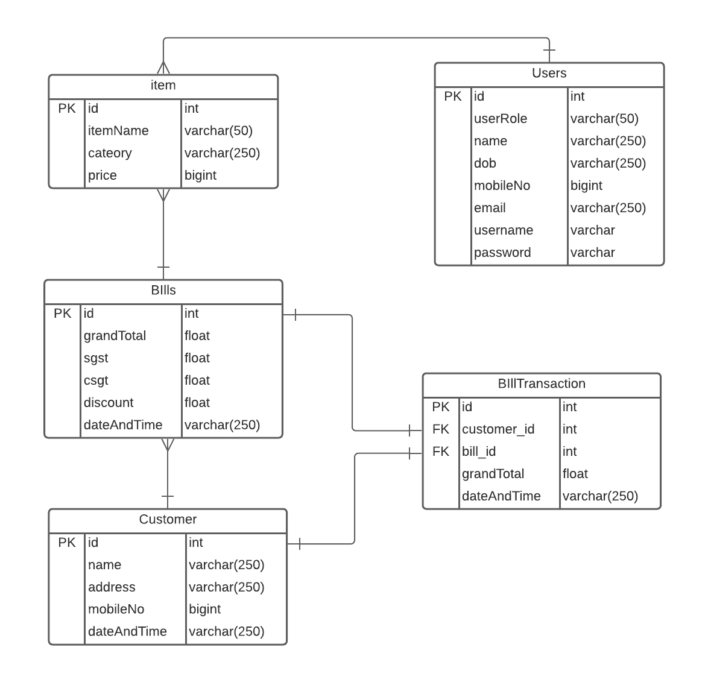

Gantt Chart

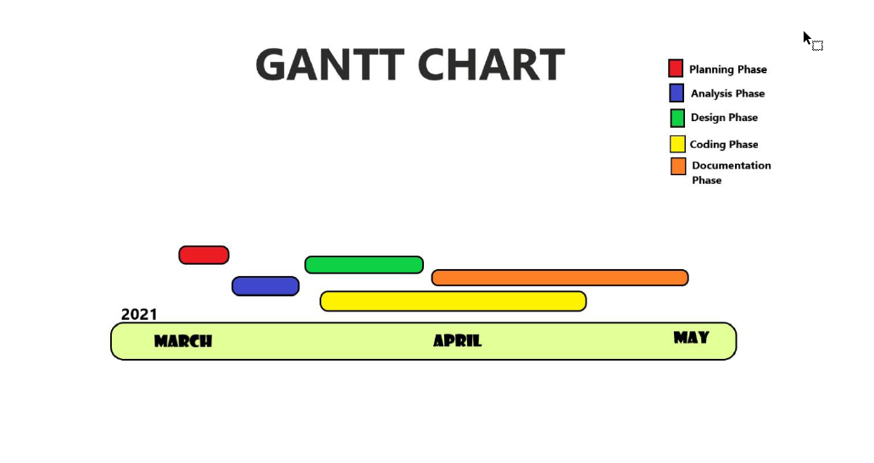

USE CASE DIAGRAMS

* Admin

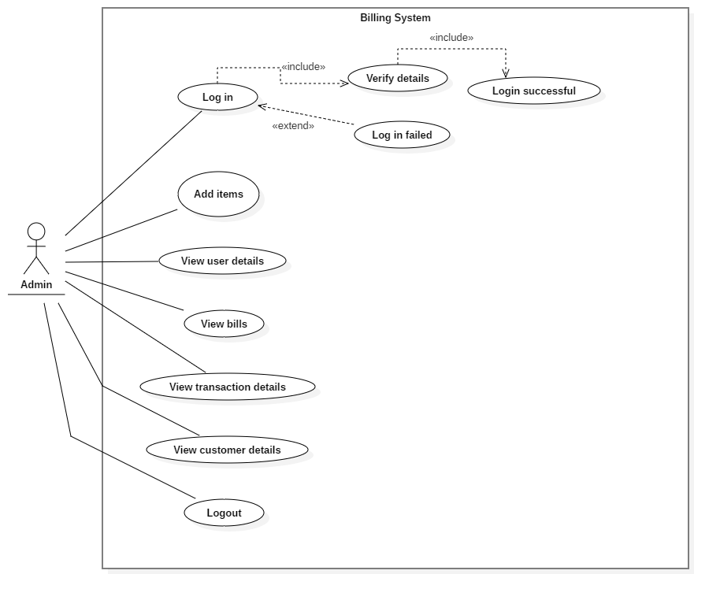

* Cashier

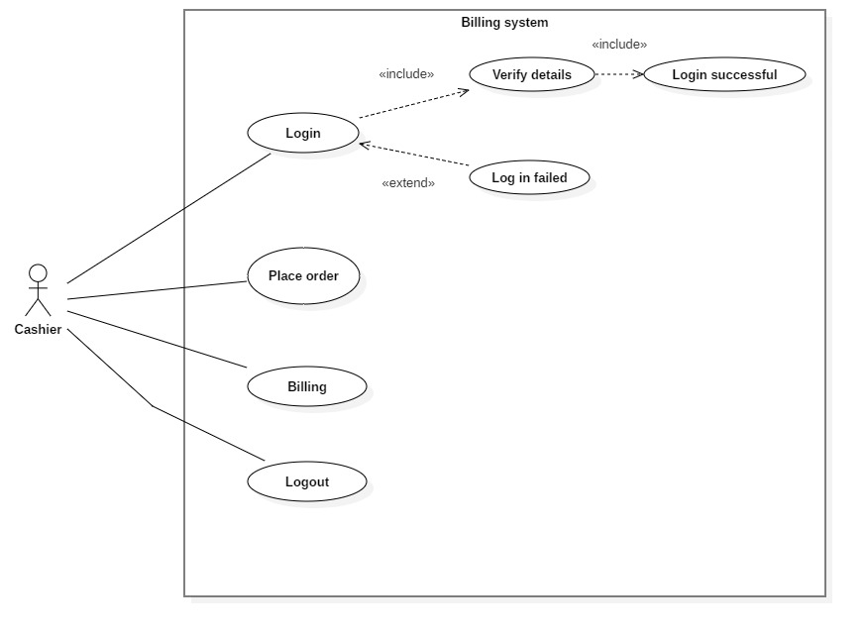

Class diagram

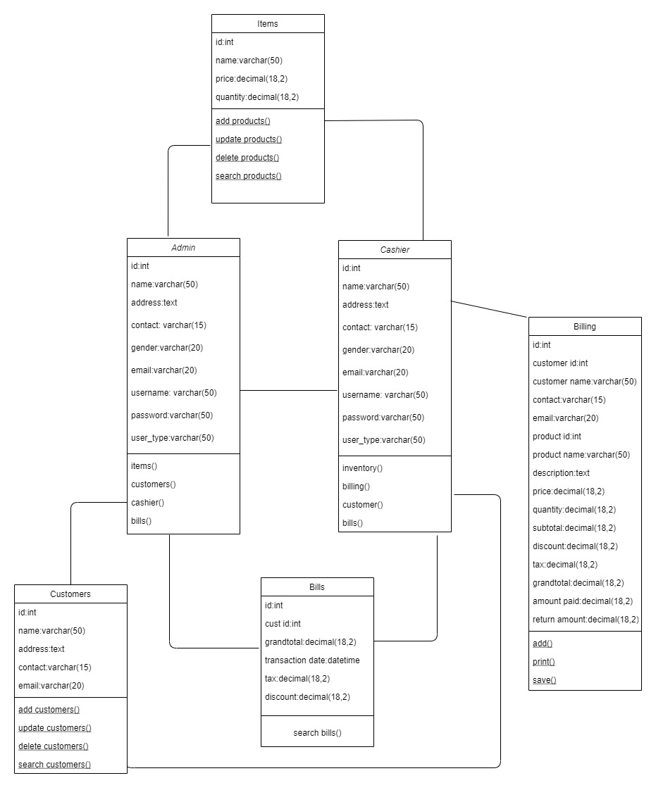

Activity diagram

* Admin

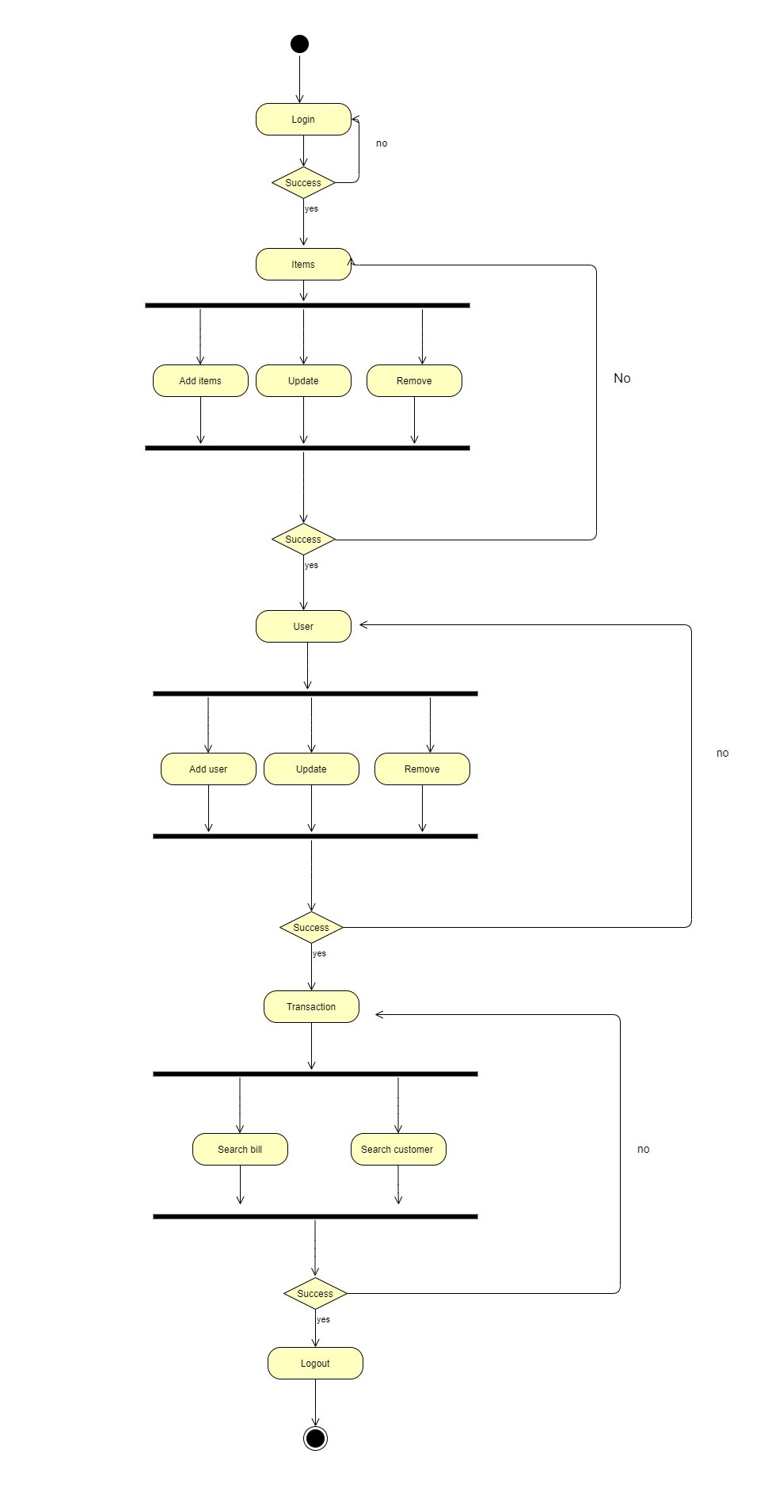

* Cashier

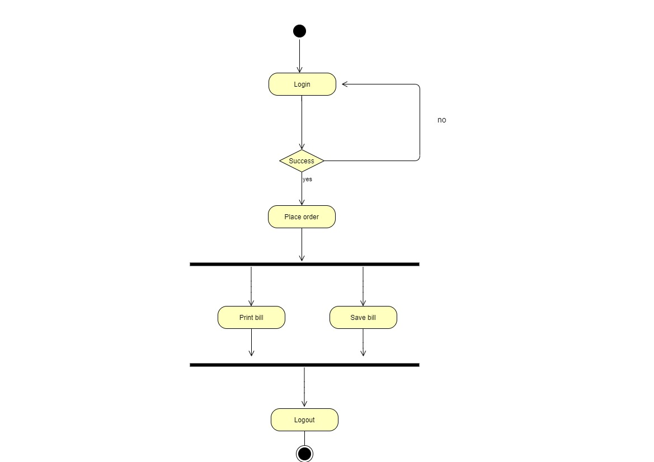

Sequence diagrams:

* Admin

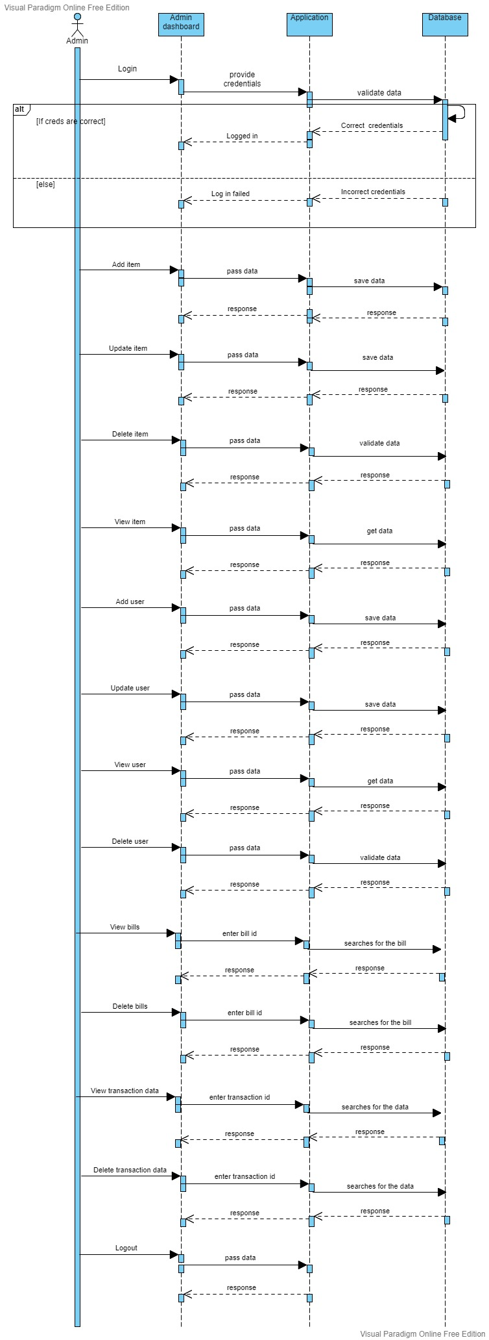

* Cashier

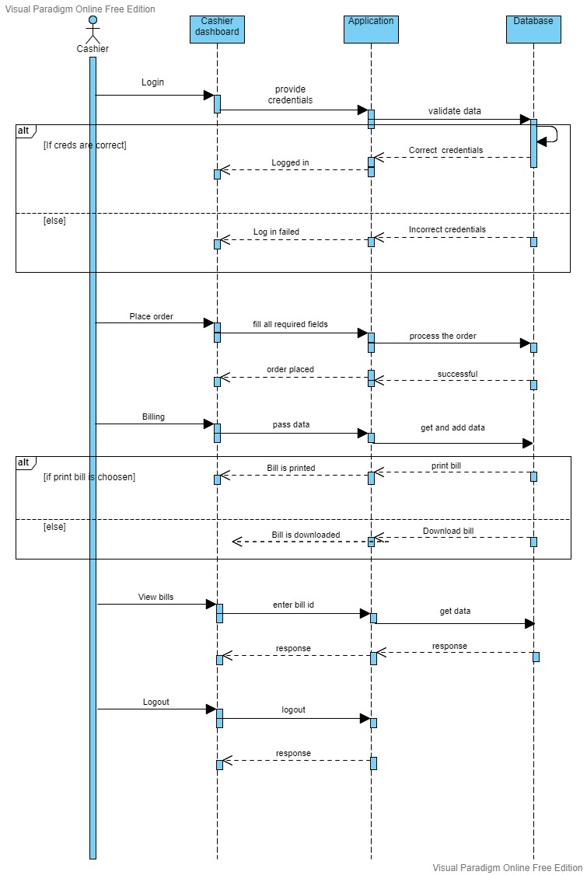

**DATABASE TABLES**

* User database table

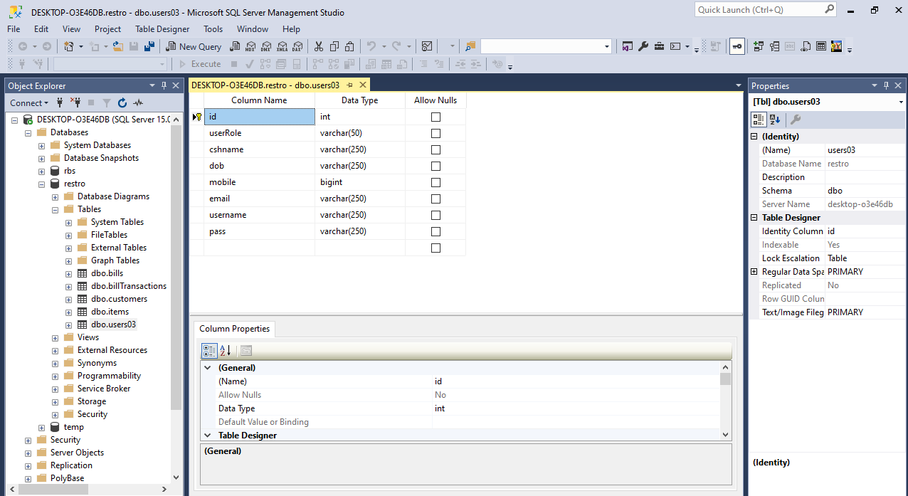

* Items database table

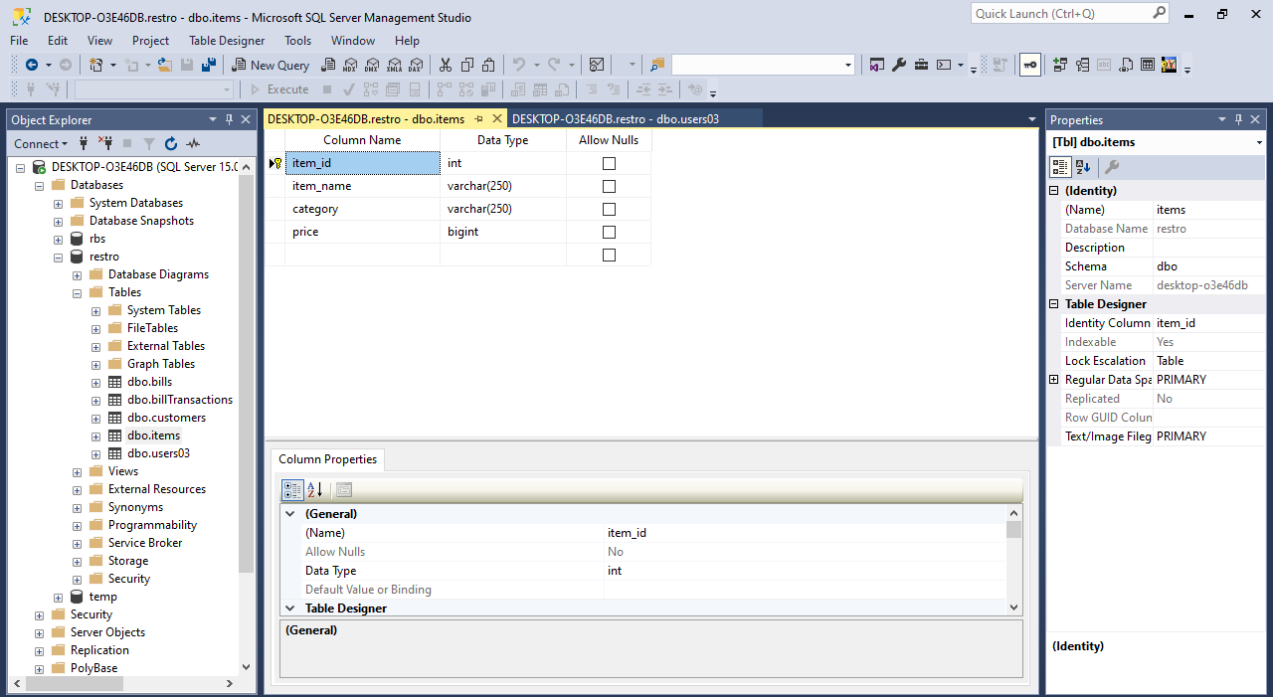

* Customer database table

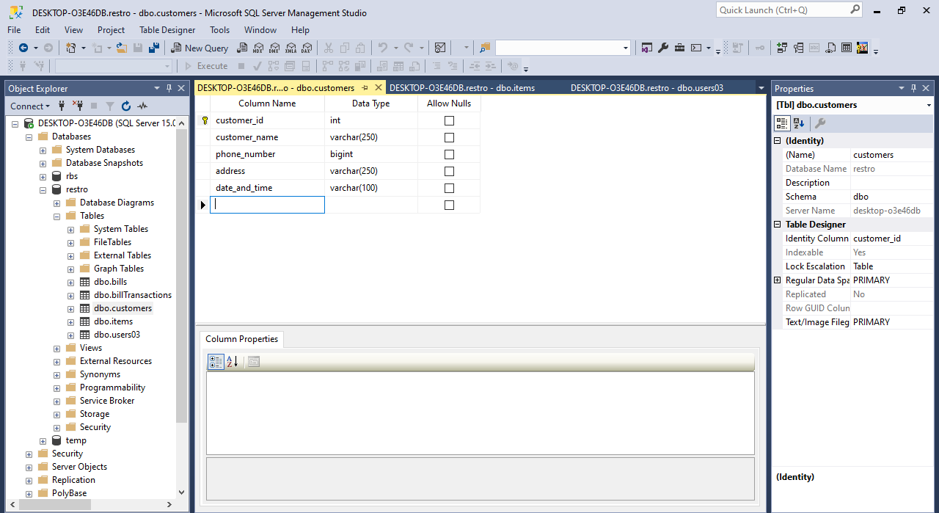

* Bills database table

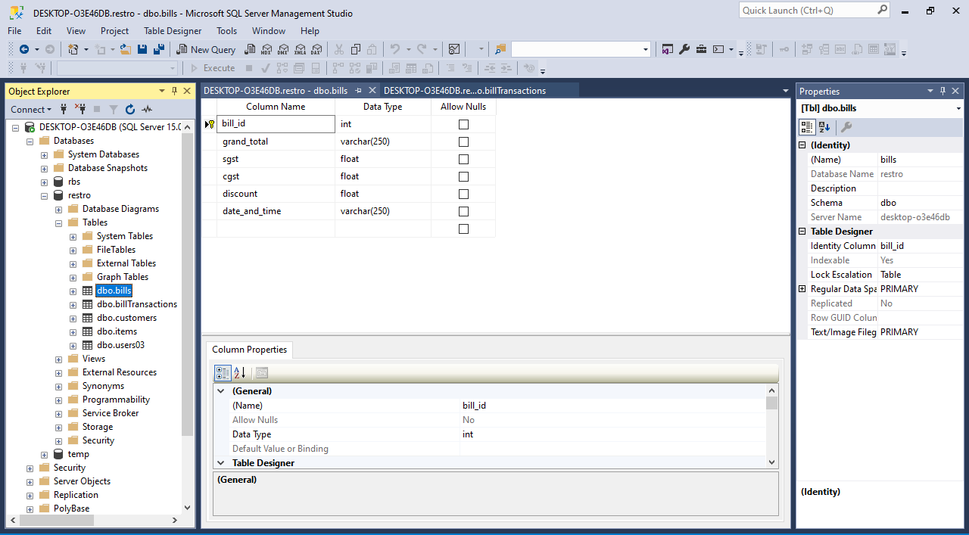

* Transaction database table

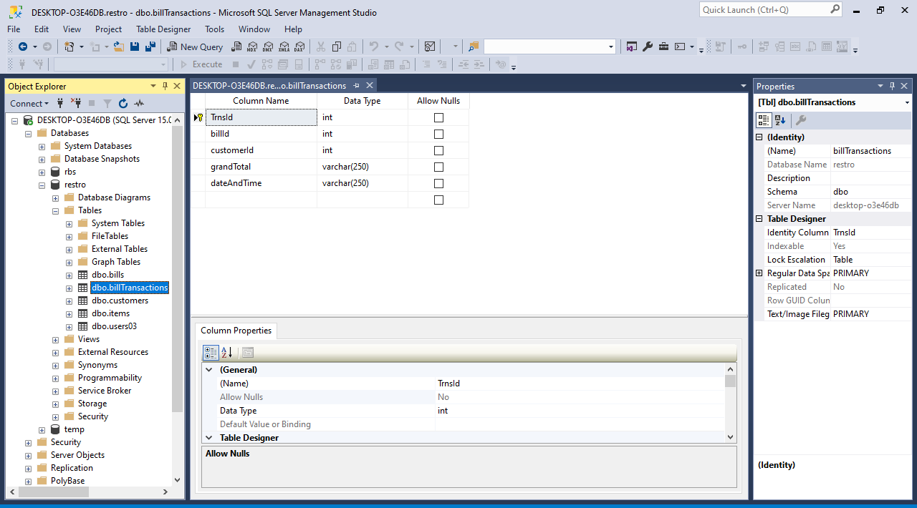

Software Screenshots

Login Page

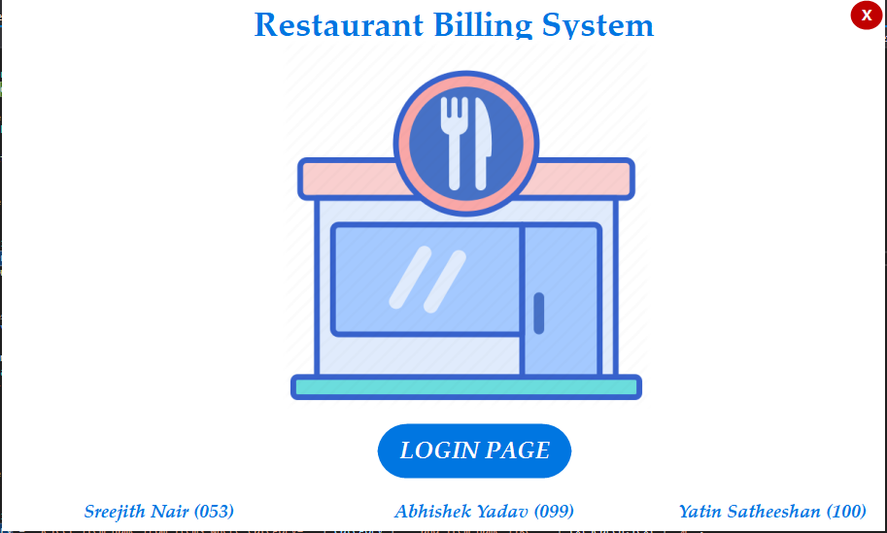

Login form

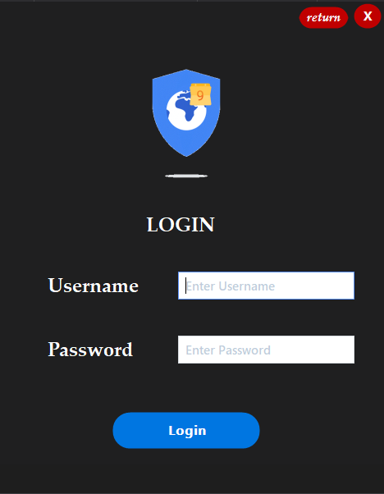

Main menu

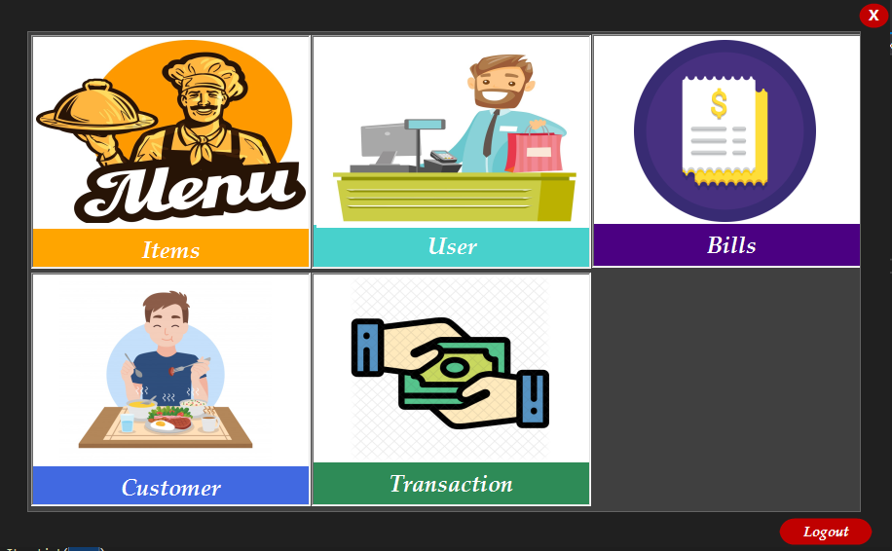

Items Menu

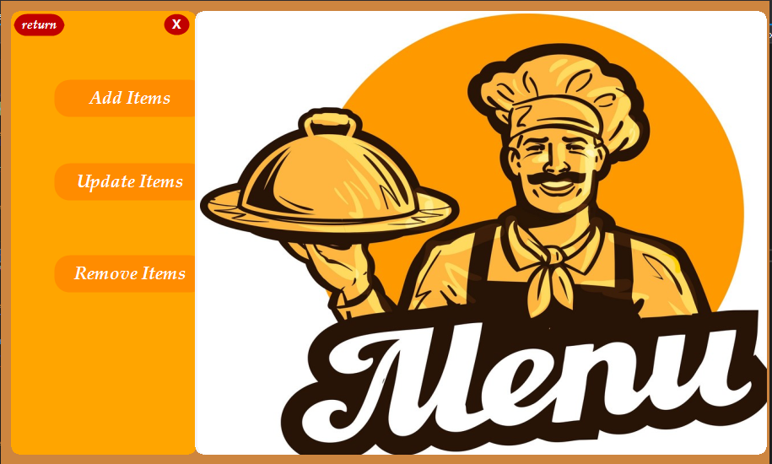

Add items

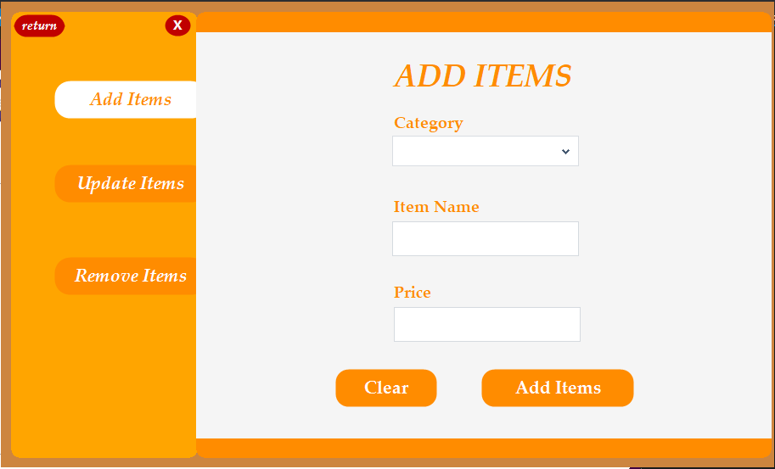

Update items

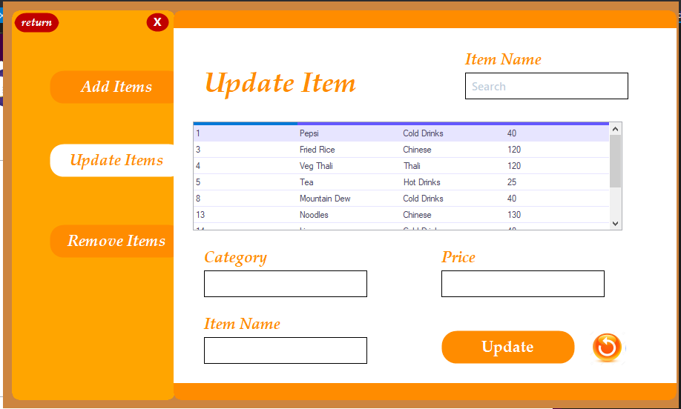

Remove items

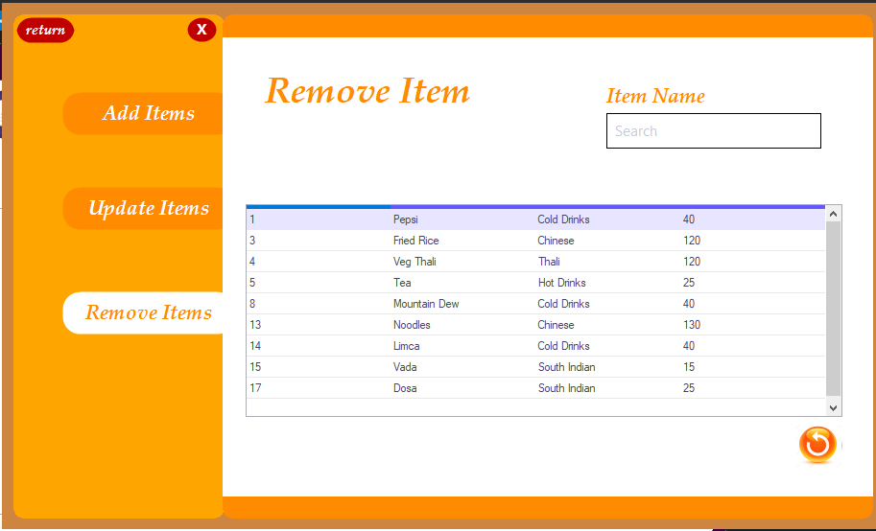

User menu

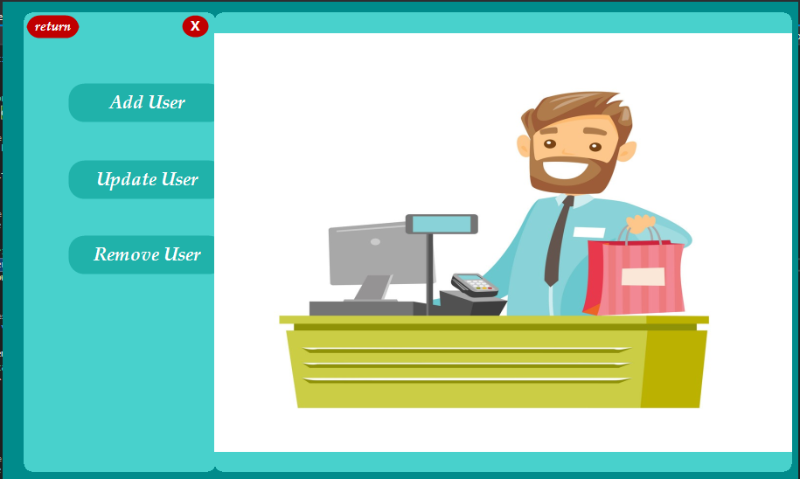

Add user

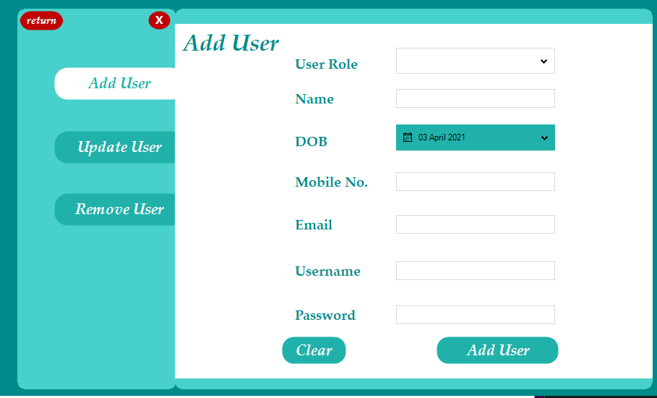

Update user

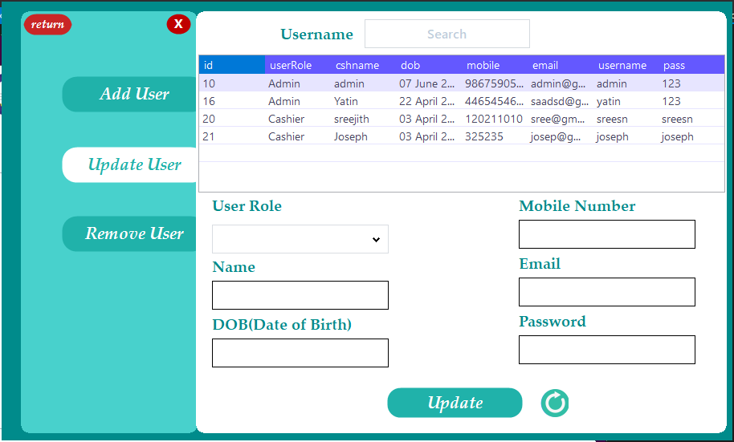

Remove user

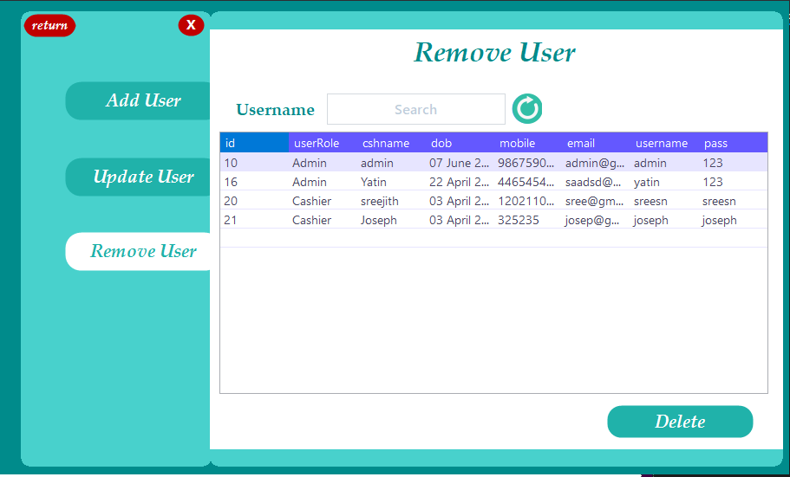

Bill module

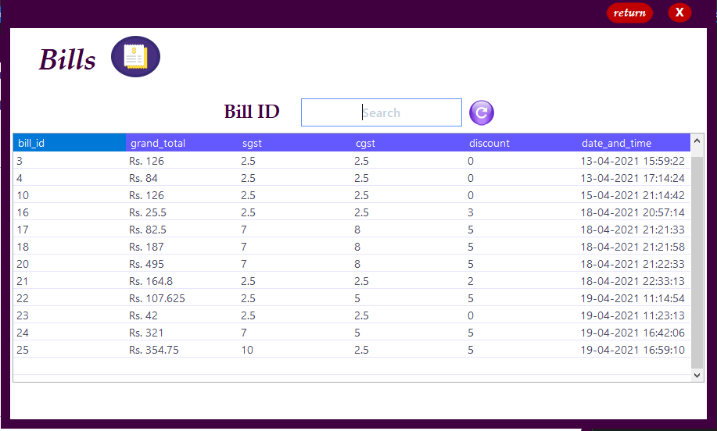

Customer module

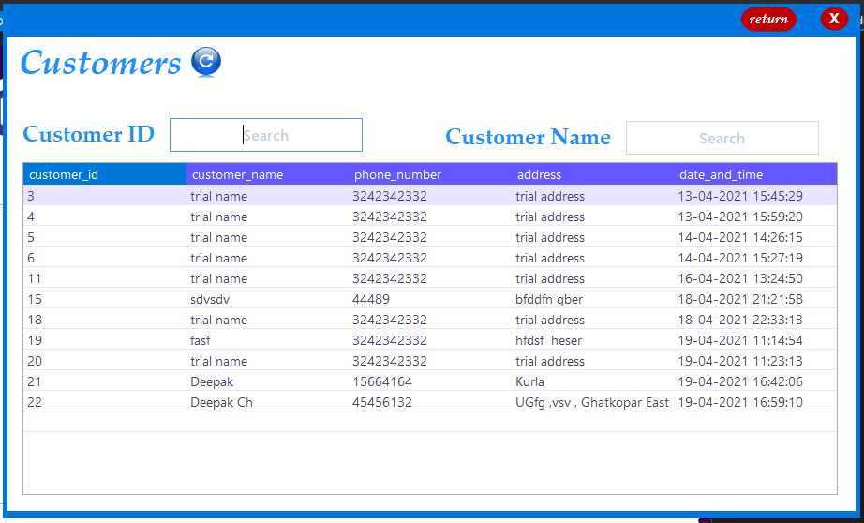

Transaction module

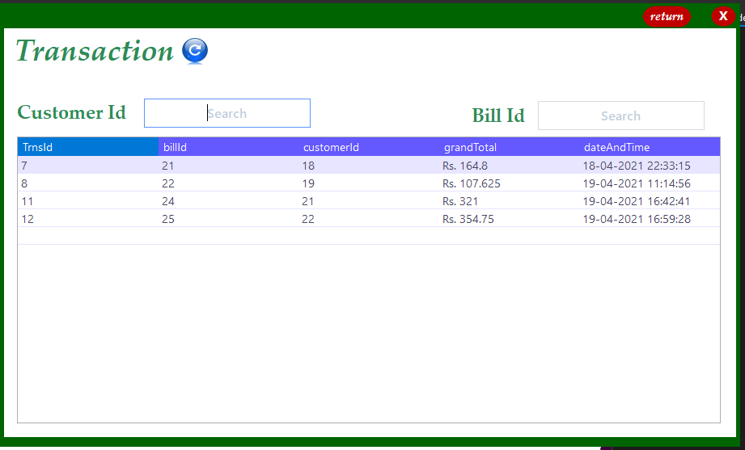

Place order module

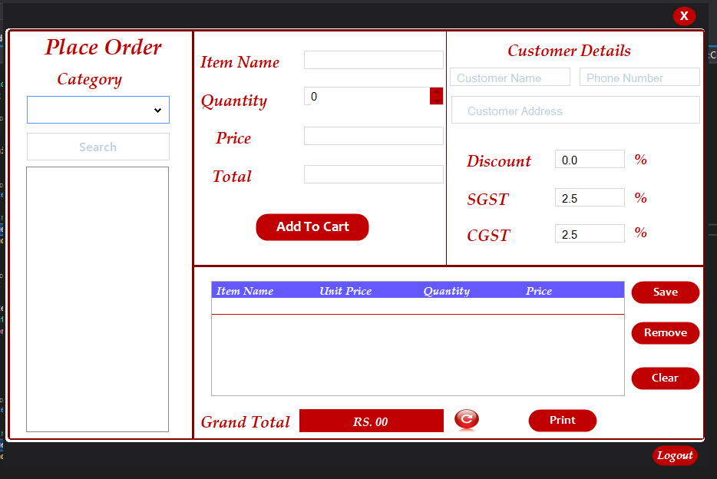

Future Enhancements

* To add these modules which were our limitations - Sales module,Inventory module and SMS module.

References –

* Stackoverflow
* W3schools
* Youtube