**Survey Manager App – Back End**

The project is development of simple back end services for Survey Management application. In high level it convers uses cases as in below diagram.

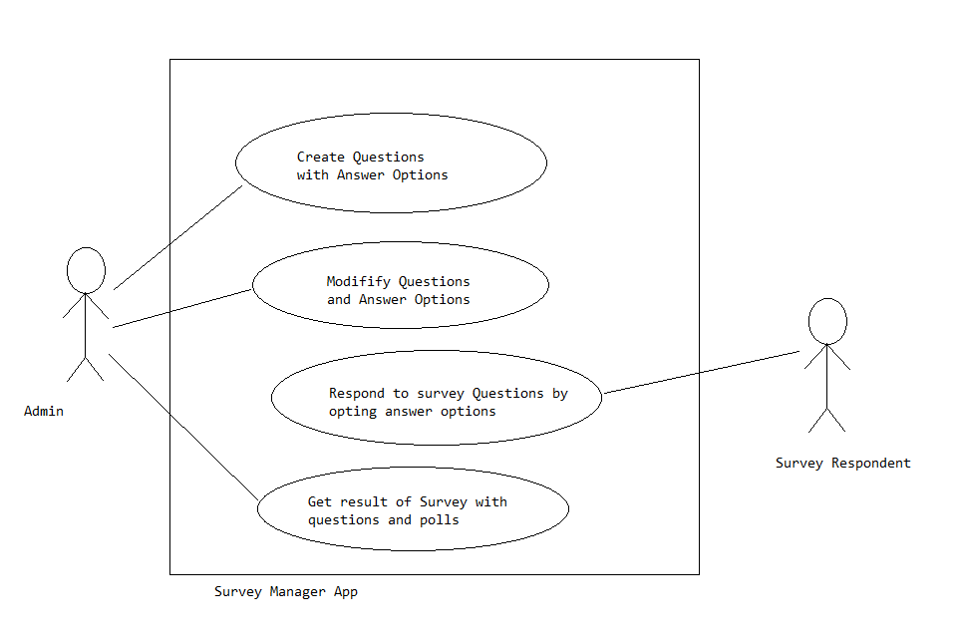

API Details

1. Save Survey Questions (with Answer options)

Request

POST */surveyQuestion*

Sample Body:

*{"questionText": "How do you prefer to buy grocery items?"}*

Sample Response:

HTTP Status: 201

*{"questionId":1,"options":[]}*

1. Update a Survey Questions (with Answer modified answer options)

Request

PUT */surveyQuestion/{questionId}*

Sample Body:

*{"questionText" : "What do you consider most while buying new Mobile Phone?",*

*"options" : [*

*{"optionId":4,"description":"Lower Price"},*

*{"optionId":3,"description":"Advanced Features"}*

*}}*

Sample Response:

HTTP Status: 204

1. Get all Survey Questions

Request:

GET */surveyQuestion*

Sample Response:

HTTP Status: 200

*[{"questionId":1,*

*"questionText":"What do you consider most while buying new Handy?",*

*"modifiedTime":"2019-05-17T14:04:39.843Z",*

*"options":[]}]*

1. Delete a Survey Question and associated Answer options

Request:

DELETE */surveyQuestion/{questionId}*

Sample Response:

HTTP Status: 204

1. Add new Answer option against a question

Request:

POST */surveyQuestion/{questionId}/answerOption*

Sample Body:

*{"description": "Buy online from trusted stores."}*

Sample Response:

HTTP Status: 201

1. Update an Answer option against a question

Request:

PUT */surveyQuestion/{questionId}/answerOption/{optionId}*

Sample Body:

*{"description": "Online Stores"}*

Sample Response:

HTTP Status: 204

1. Get all Answer options belongs to a question

Request:

GET */surveyQuestion/{questionId}/answerOption*

Sample Response:

*[{"optionId":4,"description":"Lower Price"},*

*{"optionId":3,"description":"Advanced Features"},*

*{"optionId":2,"description":"Higher Discounts"},*

*{"optionId":1,"description":"Wel known Brand Name"}]*

1. Delete an Answer option

Request:

DELETE */surveyQuestion/{questionId}/answerOption/{optionId}*

Sample Response:

HTTP Status: 204

1. Save response to survey from a User

Request:

POST */surveyQuestion/poll*

Sample Body:

*{"surveyResponse": [*

*{"questionId": "1", "optionId": "1"},*

*{"questionId": "2", "optionId": "5"},*

*{"questionId": "3", "optionId": "8"}*

*]}*

Sample Response:

HTTP Status: 204

1. View survey results

Request:

GET */surveyQuestion/results*

Sample Response:

HTTP Status: 200

*{"surveyResponse":[],*

*"surveyResult":[*

*{"questionId":1,*

*"questionText":"How often you buy Nutrition supplements through online stores?",*

*"options":[*

*{"optionId":3,"description":"Never","voteCount":0,"percent":0.0},*

*{"optionId":2,"description":"Once in a while","voteCount":1,"percent":33.33},*

*{"optionId":1,"description":"Very Often","voteCount":2,"percent":66.66}],*

*"totalResponse":3},*

*{"questionId":2,"questionText":"Do you consumes Vitamins suppliments?",*

*"options":[*

*{"optionId":5,"description":"No","voteCount":1,"percent":33.33},*

*{"optionId":4,"description":"Yes","voteCount":2,"percent":66.66}],*

*"totalResponse":3},*

*{"questionId":3,"questionText":"Where do you prefer buying Nutrition suppliments from?",*

*"options":[*

*{"optionId":9,"description":"Other sources","voteCount":0,"percent":0.0},*

*{"optionId":8,"description":"Online stores","voteCount":1,"percent":33.33},*

*{"optionId":7,"description":"Brands own stores","voteCount":0,"percent":0.0},*

*{"optionId":6,"description":"Medical stores","voteCount":2,"percent":66.66}],*

*"totalResponse":3}]*

*}*

Error Responses:

1. Input validation error

*Http Status: 400*

*Body: { “error” : “<error message.>”}*

1. Input parameter or request body syntax error

*Http Status: 400*

*Body: {“error” : “<error message.>”}*

1. Requested entity not found error

*Http Status: 400*

*Body: {“error” : “<error message.>”}*

1. Other system error

*Http Status: 500*

*Body: {“error” : “Something wrong with Survey Apps services. Please try later.”}*

Data Model

Table: survey_question

|  |  |  |  |
| --- | --- | --- | --- |
| **Column** | **Type** | **Constraints** | **Comments** |
| question_id | Integer | PK | Auto increment with sequence |
| question_text | Character varying | Size 250 | Question |
| status | Integer |  | 1. Deleted 2. Active |
| modified_time | Timestamp with zone |  | UTC timestamp of created or last modified time |

Table: answer_option

|  |  |  |  |
| --- | --- | --- | --- |
| **Column** | **Type** | **Constraints** | **Comments** |
| option_id | Integer | PK | Auto increment with sequence |
| question_id | Integer | FK | Refer survey_question |
| description | Character varying | Size 250 | Answer option |
| vote_count | Big int |  | Incremented value with each poll for this answer |

Sequences:

1. answer_option_option_id_seq
2. survey_question_question_id_seq

Deployment Details

The project require Java 1.8, Maven and Postgresql 10.

The DB set up script is saved in *file <project_root>/src/schema.sql*