If you need to install Eclipse, you can download it from [eclipse.org/downloads/](http://www.eclipse.org/downloads/).

**Get the Android SDK**

1. Go to <http://developer.android.com/sdk/index.html>
2. In Download section, you can download the ADT Bundle (Download the SDK ADT bundle) if you are doing from scratch Eclipse and bunch of other things.
3. BUT if you already have Eclipse installed and you need only the ADT plugin, go to DOWNLOAD FOR OTHER PLATFORMS > **SDK Tools Only >** Windows  
   32 & 64-bit > [android-sdk_r22.2-windows.zip](http://dl.google.com/android/android-sdk_r22.2-windows.zip)
4. Download the Android SDK and unzip into the Program Files subdirectory. 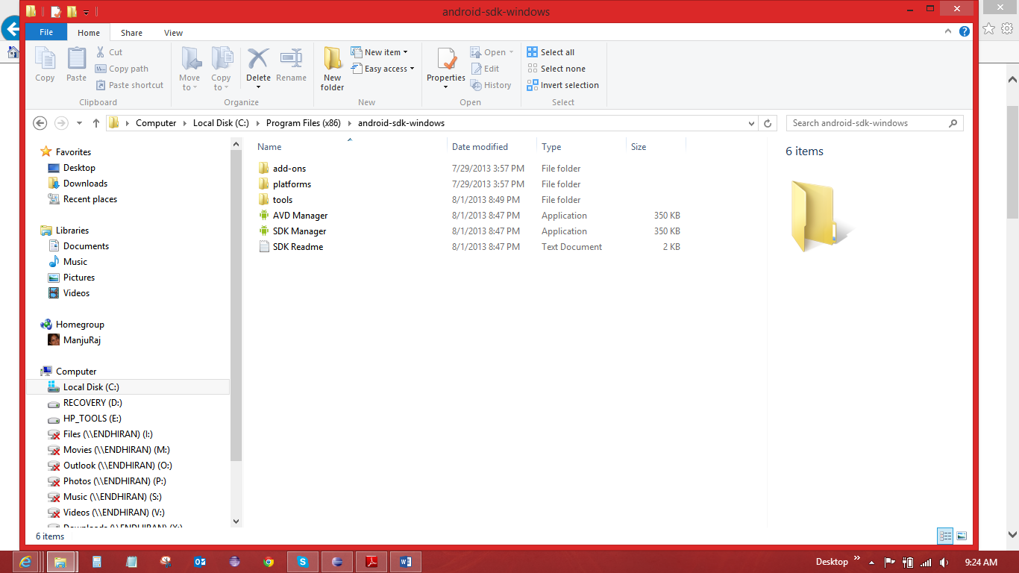
5. Ready for Android Plug In into Eclipse. First Check for Updates in Eclipse. Help > Check Updates

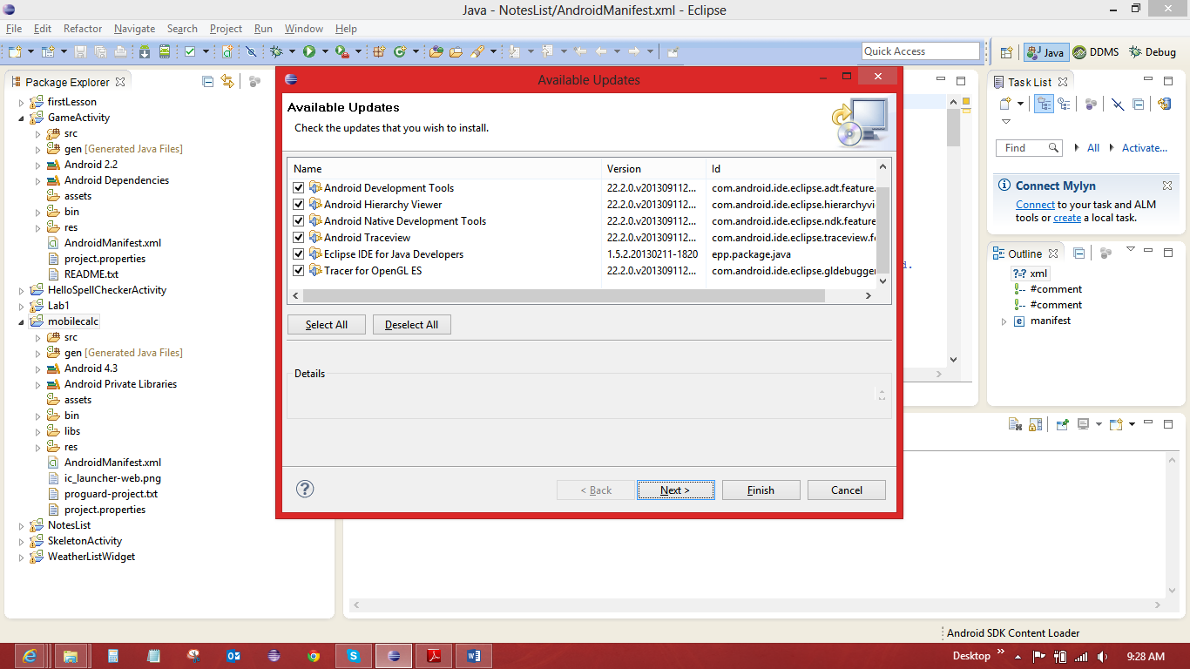

1. Help > Install New Software > Work With : [**https://dl-ssl.google.com/android/eclipse**](https://dl-ssl.google.com/android/eclipse) **and check Developer Tools and NDK tools > click next and Finish Install.**
2. Restart Eclipse
3. Install SDK Platform Tools Component. Windows > Android SDK Manager. Make sure the essential packages are installed. Android SDK Tools and Android SDK Platform (latest one).

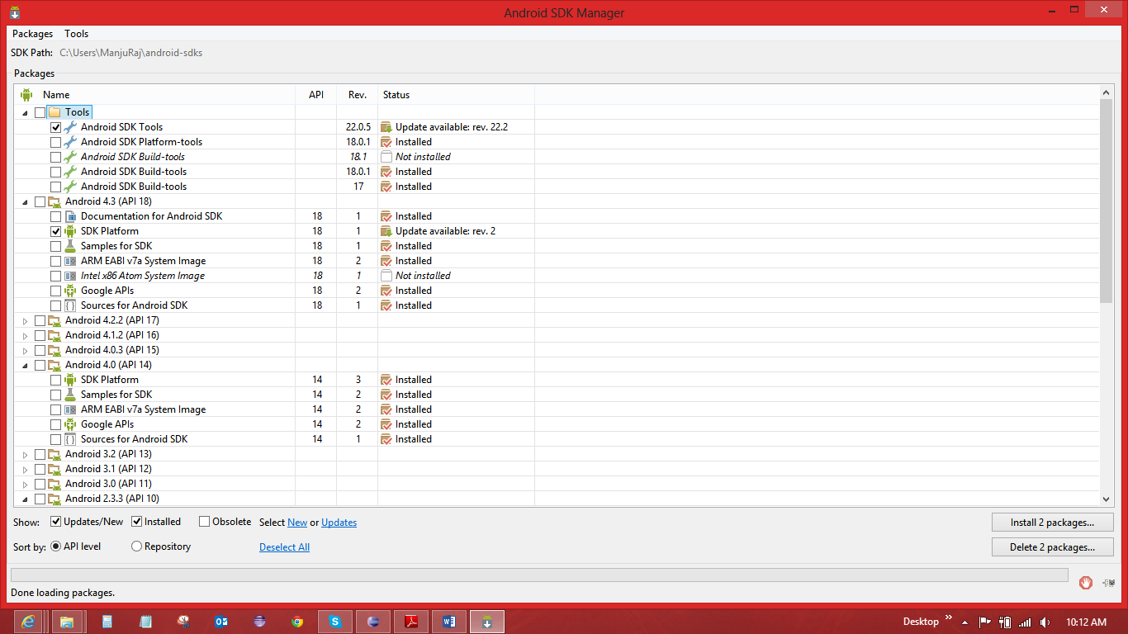

1. Set Android Preference. Windows > Preference > Android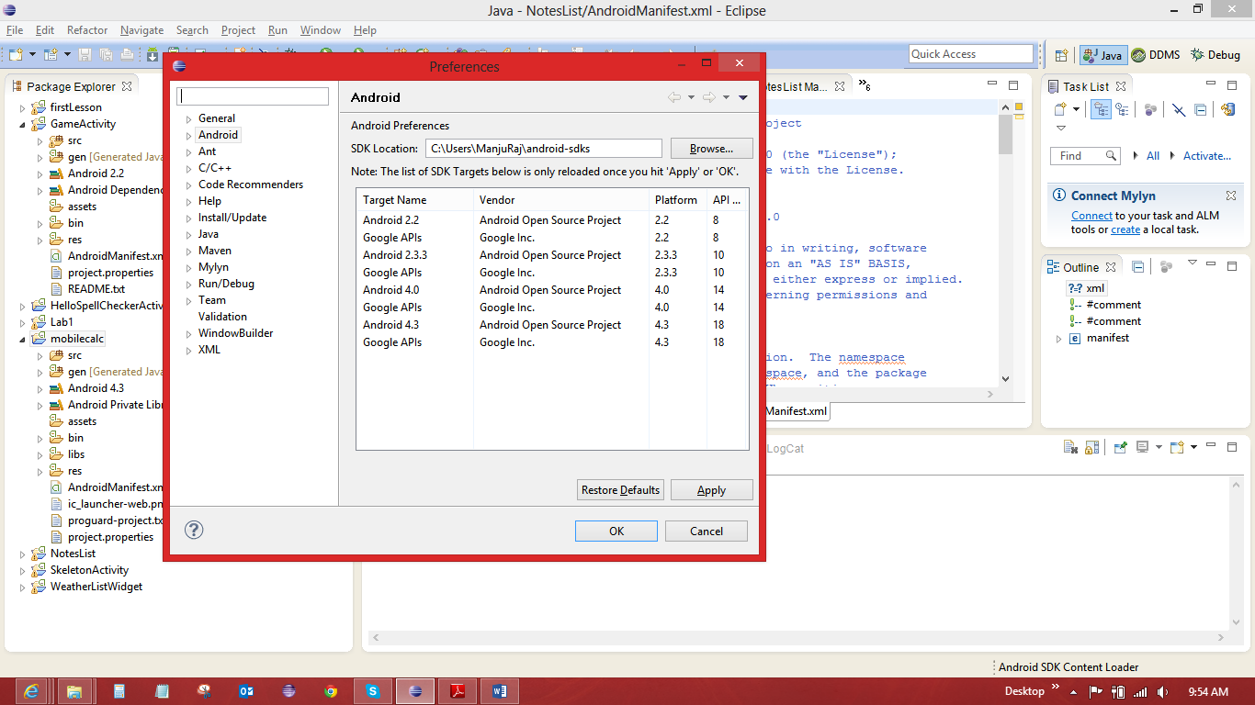
2. Open the Android Application. File > New > Android Application Project. If not available under the New menu, look under the Other…, you will find Android as an option. 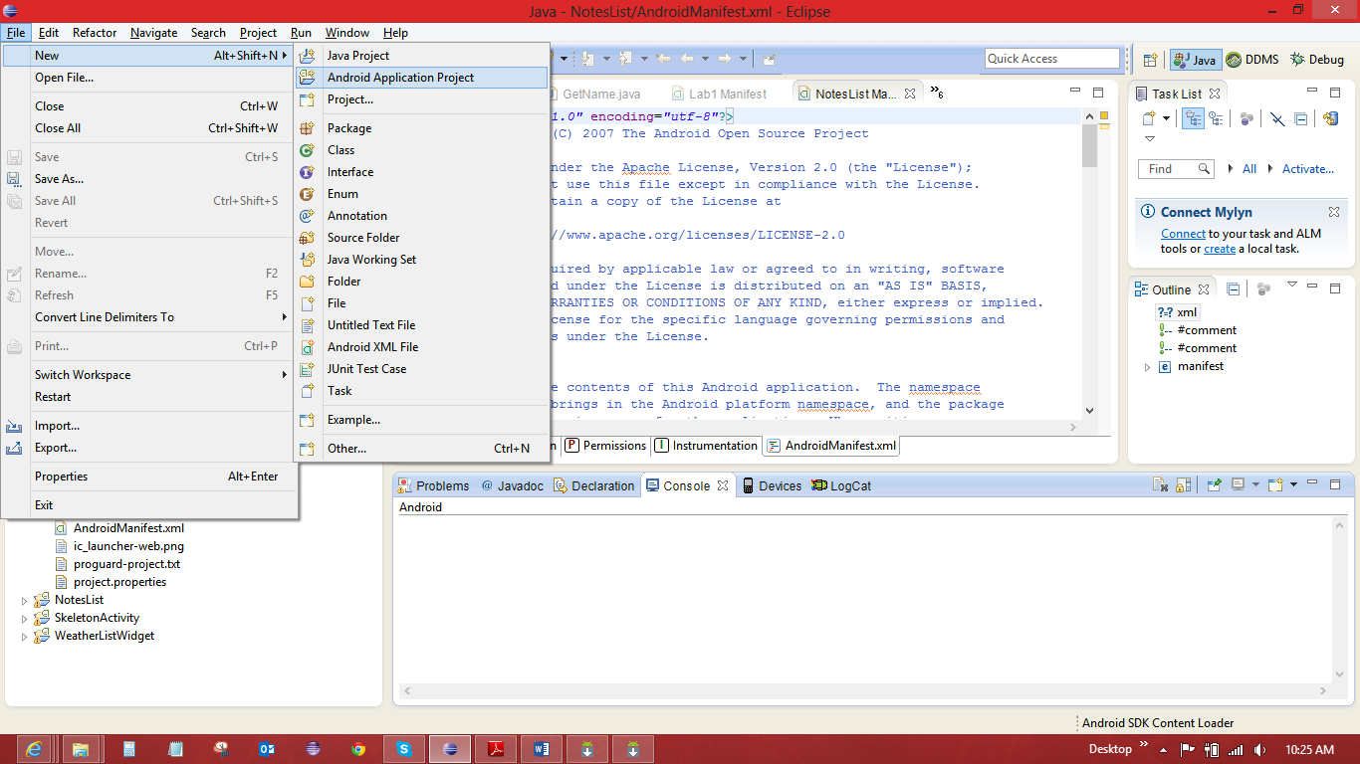
3. Min and Max SDK the app will support and the App name:

