Experiment-2
AIM:
To create and provide a simple cloud-based software application using Zoho Creator to demonstrate the Software as a Service (SaaS) model for Flight Reservation System.
Procedure:
- Open a web browser and visit the Zoho Creator website.
- Create a Zoho account or log in if you already have one.
- Click on 'Create Application' and select 'From Scratch'.
- Choose 'Blank App', name it Flight Reservation System, and click Create.
- Create a form named 'Flight Booking Details' with fields like Passenger Name, Flight Number, Departure Date, etc.
- Mark necessary fields as mandatory (e.g., Passenger Name, Flight Number, Departure Date).
- Save the form and customize the visual themes as needed.
- Configure user access in Settings to allow multiple users (Admin, Editor, Viewer).
- Save the application and generate the URL from the Share Application settings.
- Access the application through the generated URL in any web browser.
Ouput:
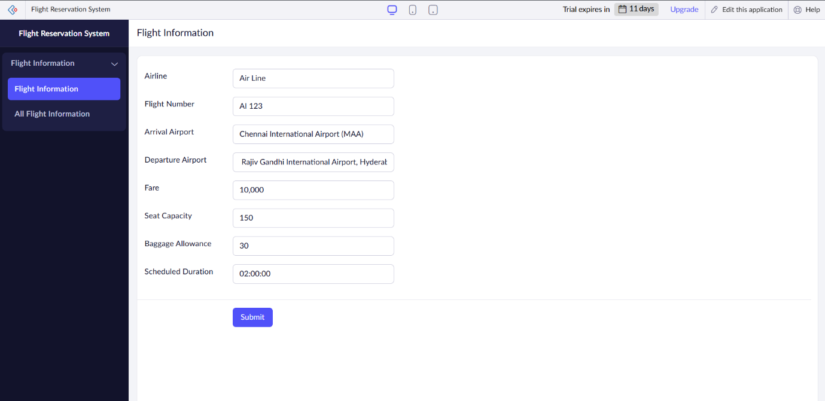

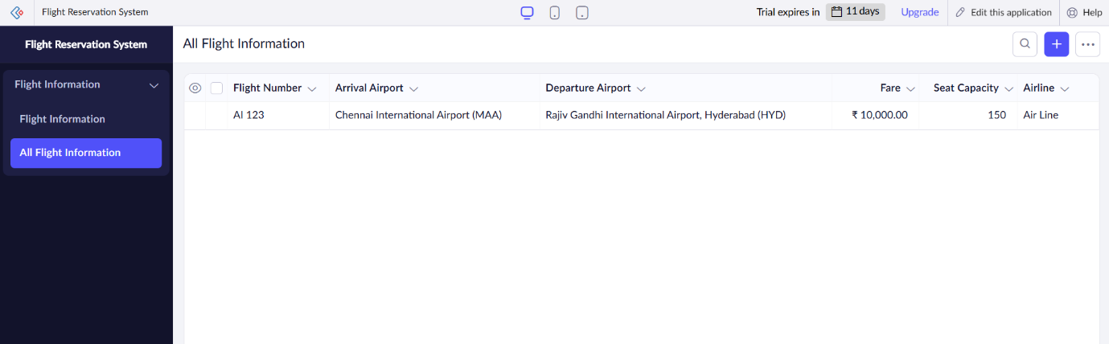
Result:
A cloud-based Flight Reservation System was successfully created and deployed using Zoho Creator. The application is accessible through a web browser without the need for installation, allowing users to book flights, track payment status, and manage flight details effortlessly. Users can input passenger information, select flight options, and monitor reservation statuses in real-time. This demonstrates the Software as a Service (SaaS) model, where the application is hosted in the cloud, ensuring easy access from any device, no installation required, and seamless management of flight reservations and payments.

