EXPERIMENT 8
Title
Creation and Allocation of Virtual Hard Disk in VirtualBox

Aim
To create a virtual hard disk and allocate storage using VirtualBox.

Procedure
- Open VirtualBox and select the VM.
- Go to Settings → Storage.
- Choose Create New Virtual Hard Disk.
- Select disk type (VDI).
- Choose dynamically allocated or fixed size.
- Allocate storage size.
- Attach the disk to the VM.

Output
- Virtual hard disk successfully created and attached.
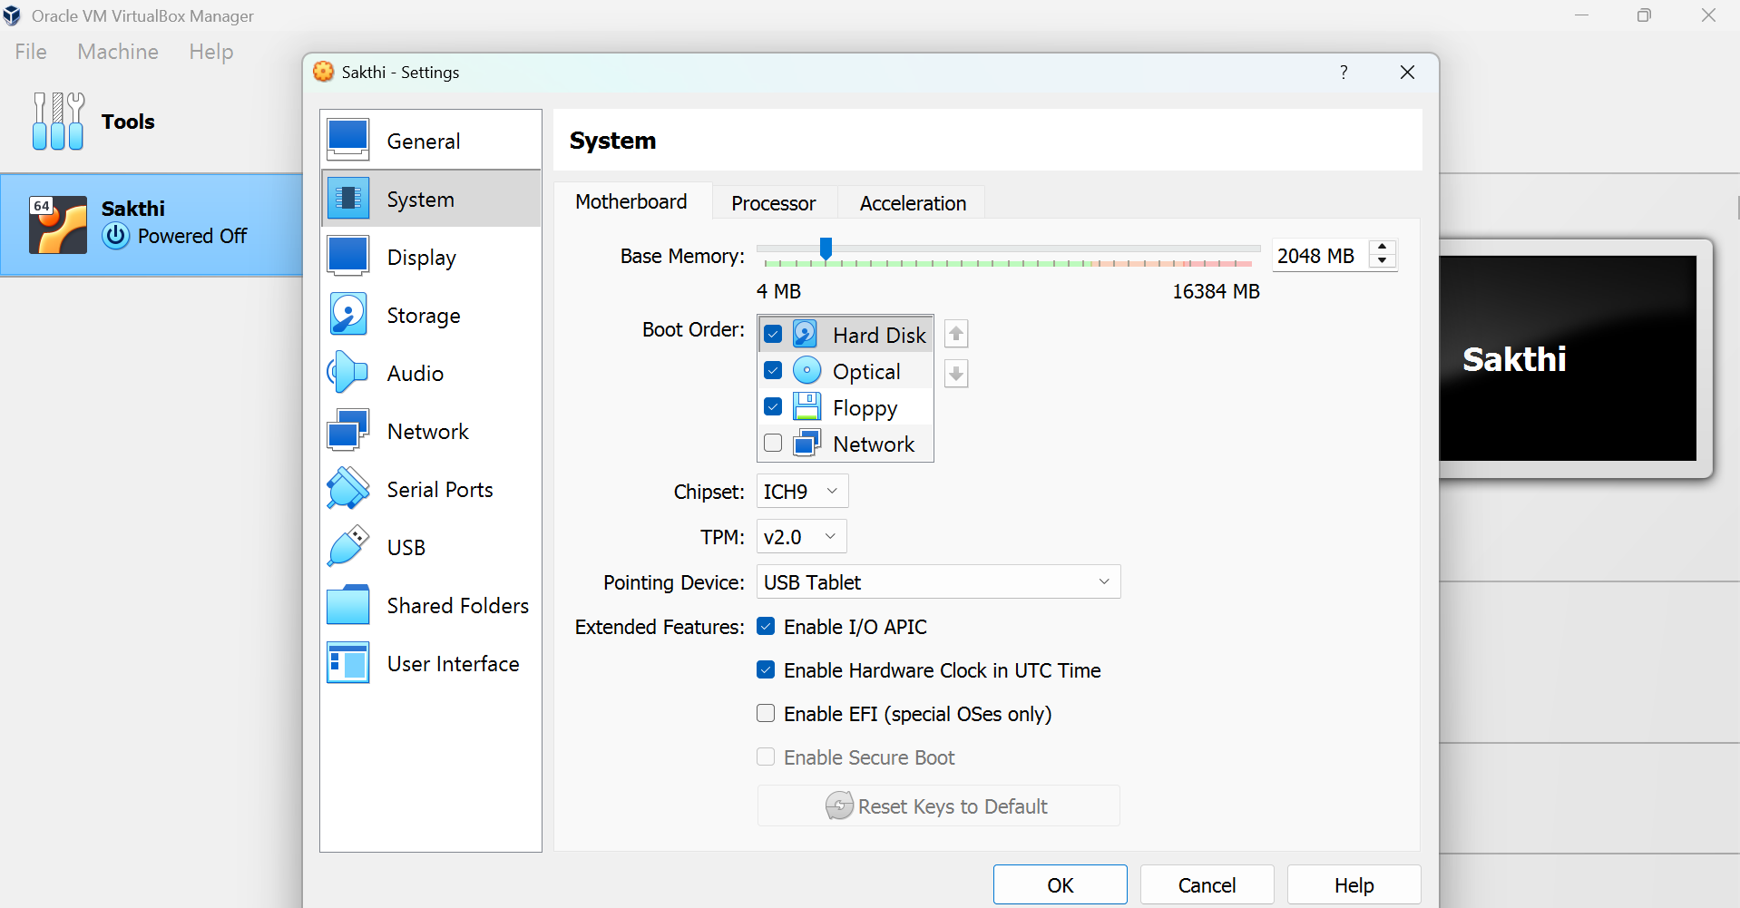

Result
Thus, a virtual hard disk was successfully created and allocated using VirtualBox.

