Experiment-4
AIM:
To create and provide a simple cloud-based Car Booking Reservation System using a Cloud Service Provider (such as Zoho Creator) to demonstrate the SaaS (Software as a Service) model.
Procedure:
- Open a web browser and visit the Zoho Creator website.
- Create a Zoho account or log in if you already have one.
- Click on 'Create Application' and select 'From Scratch'.
- Choose 'Blank App', name it Car Booking Reservation System, and click Create.
- Create a form named 'Car Reservation Details' with fields such as Customer Name, Car Model, Pickup Date, Return Date, Pickup Location, and Payment Status.
- Mark necessary fields as mandatory (e.g., Customer Name, Car Model, Pickup Date, and Return Date).
- Save the form and customize the visual themes to make the app user-friendly.
- Configure user access and sharing settings to allow multiple users (e.g., Admin, Customer, Employee).
- Save the application and generate the URL for sharing the app.
- Access the application through the generated URL in any web browser.
Output:
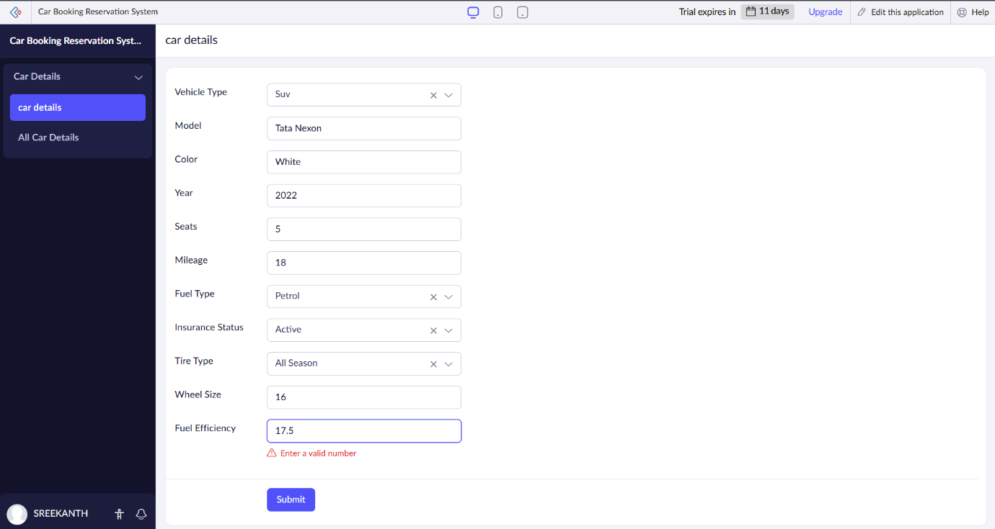
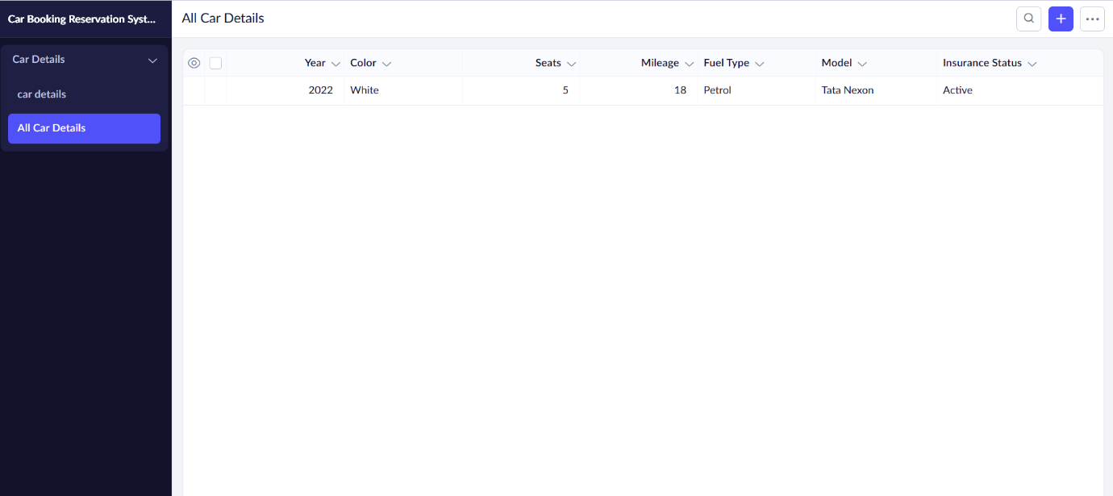
Result:
The cloud-based Car Booking Reservation System will provide a smooth, easy-to-use platform for both renters and car owners. Renters can quickly search for, book, and pay for cars, while car owners can list their vehicles and manage bookings. The system will ensure secure payments and scale automatically to handle more users. Hosted on AWS, it will be reliable, fast, and simple to use, making car rentals hassle-free in Chennai.

