EXPERIMENT 10

Aim
To create and test a clone of an existing virtual machine.

Procedure
- Power off the VM.
- Right-click the VM and select Clone.
- Choose clone type (Full/Linked).
- Name the cloned VM.
- Start the cloned VM.

Output
- Cloned virtual machine runs independently

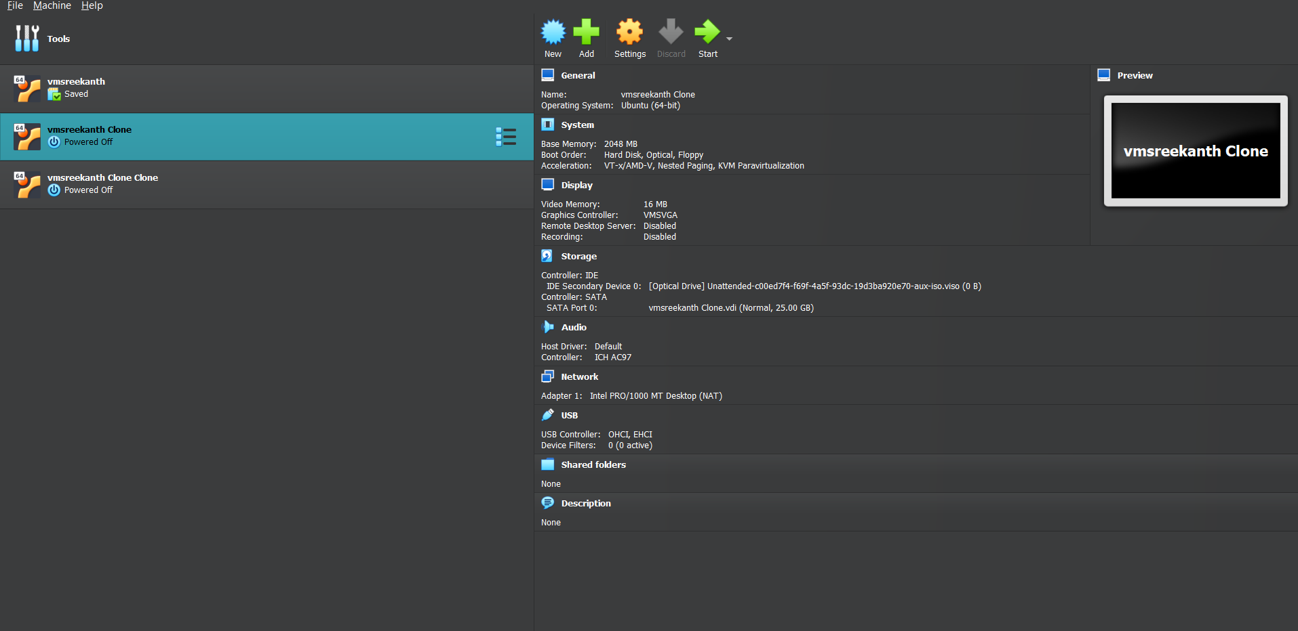

Result
Thus, cloning of a virtual machine was successfully performed and tested.

