EXPERIMENT 7
Title
Creation of a Virtual Machine Using Type-2 Virtualization Software

Aim
To create a virtual machine with 1 CPU, 2GB RAM, and 15GB storage using VirtualBox.

Procedure
- Open VirtualBox and click New.
- Enter VM name and select OS type/version.
- Allocate 1 CPU.
- Allocate 2GB RAM.
- Create a virtual hard disk of 15GB.
- Attach the OS ISO file.
- Start the virtual machine.

Output
- Virtual machine is created and started successfully.
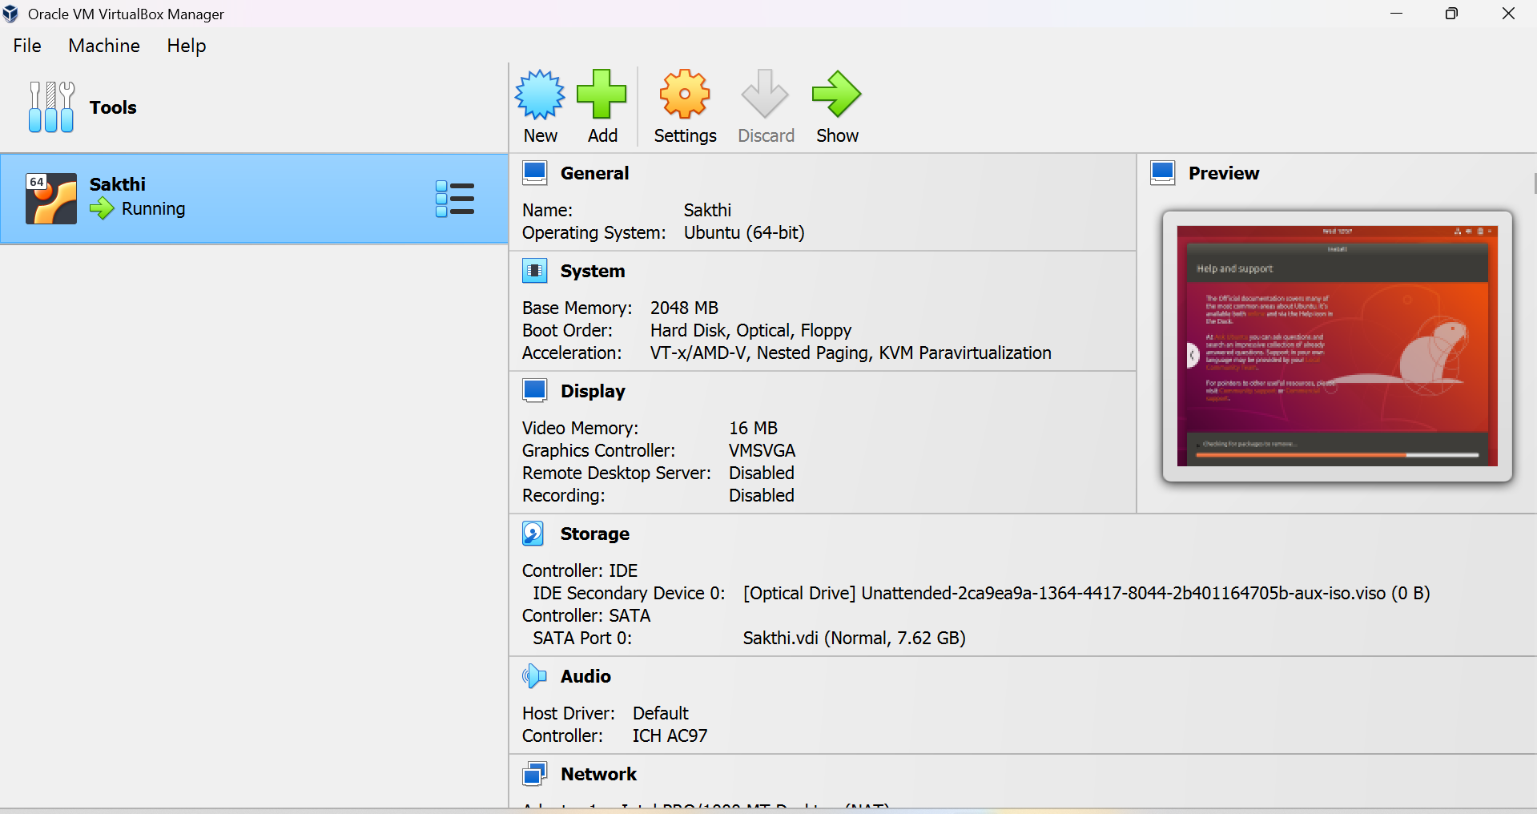

Result
Thus, a virtual machine with specified hardware configuration was successfully created using VirtualBox.

