EXPERIMENT – 3
Create a simple cloud software application for Property Buying &amp; Rental process (In Chennai city) using any Cloud Service Provider to demonstrate SaaS.
Aim: The aim of the application is to provide a seamless platform for property buying and rental processes in Chennai, enabling easy search, listing, and transaction management for users.
Procedure:
- Choose AWS as the cloud service provider for hosting and infrastructure.
- Develop a frontend web application using HTML, CSS, and JavaScript (ReactJS).
- Set up a backend with Node.js or Python to handle APIs, user authentication (AWS Cognito), and data processing.
- Use AWS RDS to store property listings, user data, and transaction history.
- Implement property search functionality with filtering options and integrate Amazon Location Service for maps.
- Add a messaging system using AWS SNS to allow communication between users and property owners.
- Integrate a payment gateway (e.g., Razorpay or Stripe) for rental payments and secure transactions.
Output:
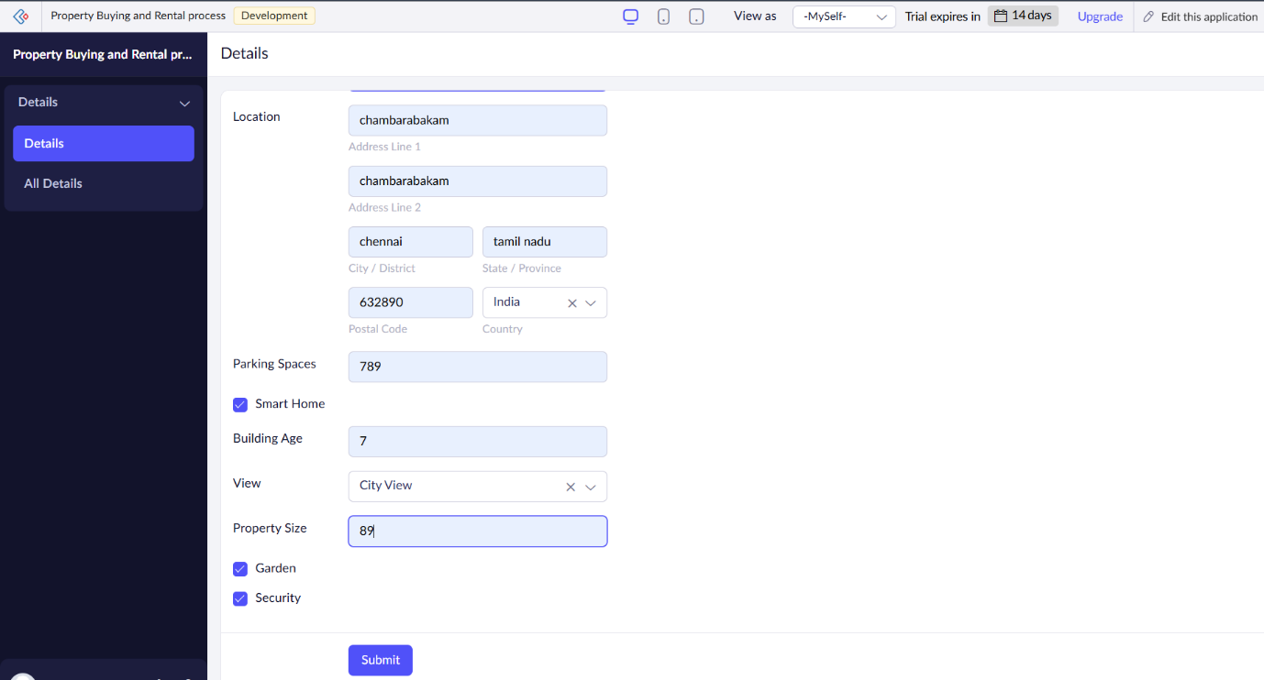
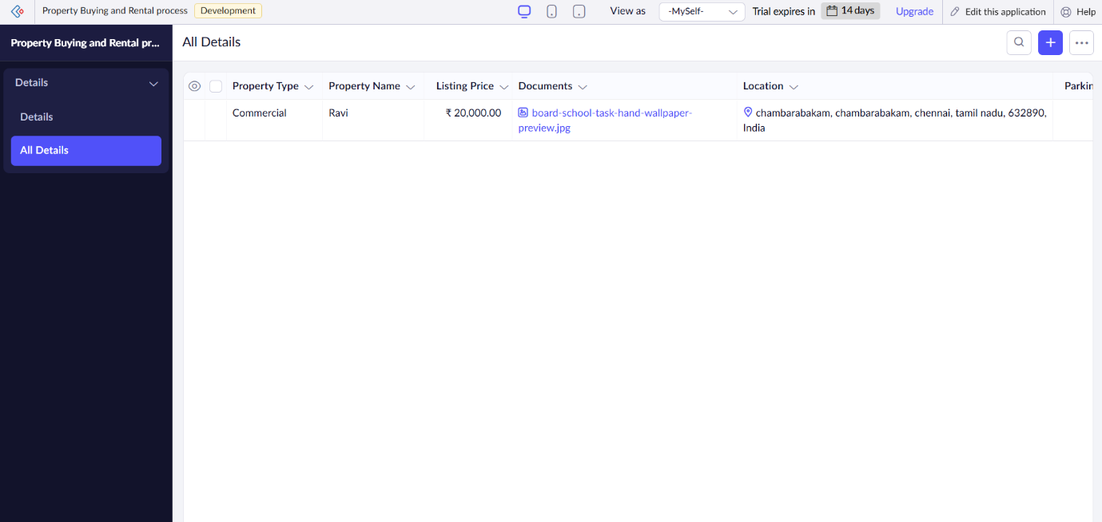
Result: The result will be a scalable, cloud-based platform that enables users to easily search for, list, and communicate about properties in Chennai, with secure payment processing for rental transactions, offering a seamless experience for both property seekers and owners.

