EXPERIMENT 11

Aim
To change the hardware configuration of an already created virtual machine.

Procedure
- Power off the VM.
- Open Settings.
- Modify hardware settings such as CPU, RAM, or storage.
- Alternatively, create a new VM using clone.
- Start the modified VM.

Output
- Virtual machine runs with updated hardware configuration.
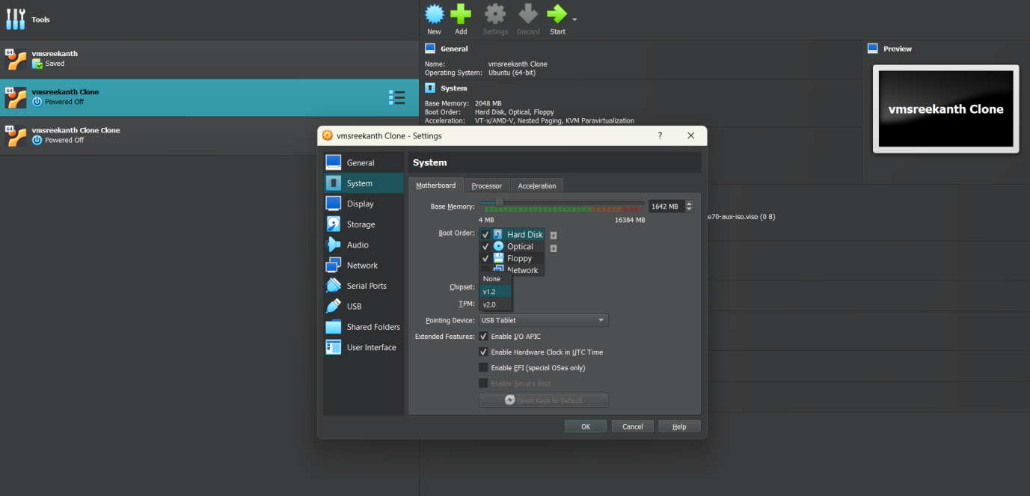

Result
Thus, hardware compatibility of an existing virtual machine was successfully modified using VirtualBox.

