EXPERIMENT – 1
Create a simple cloud software application and provide it as a service using any Cloud
Service Provider to demonstrate Software as a Service (SaaS).
AIM: To create and provide a simple cloud-based software application using Zoho Creator to
demonstrate the Software as a Service (SaaS) model.1. Open a web browser and go to Zoho Creator website.
2. Create a Zoho account and log in.
3. Click on Create Application and select From Scratch.
4. Choose Blank App and provide the application name as Personal Expense Tracker
5. Create a form named Patient Details and add fields such as Name, Category, Date,
Payment Mode,Status.
6. Mark the necessary fields as mandatory.
7. Save the completed form and alter the visual themes.
8. Configure user access and sharing settings to allow multiple users to use the application.
9. Save the application and generate the application URL.
10. Access the application through the URL using any web browser.
Output:
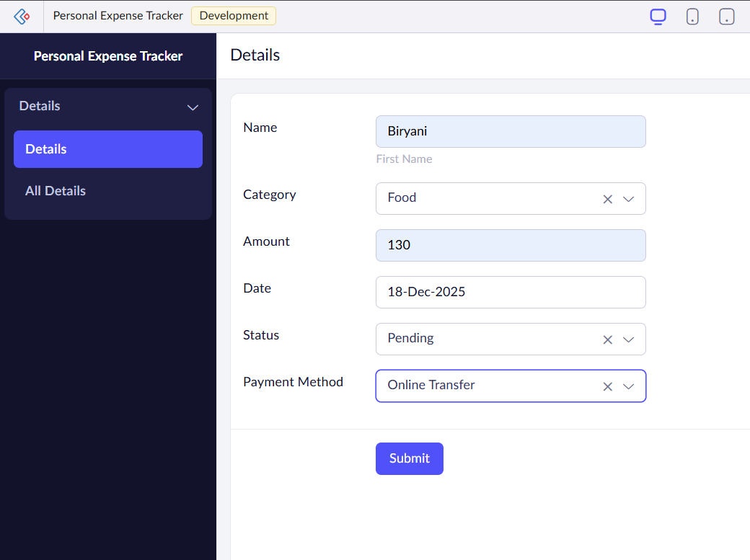
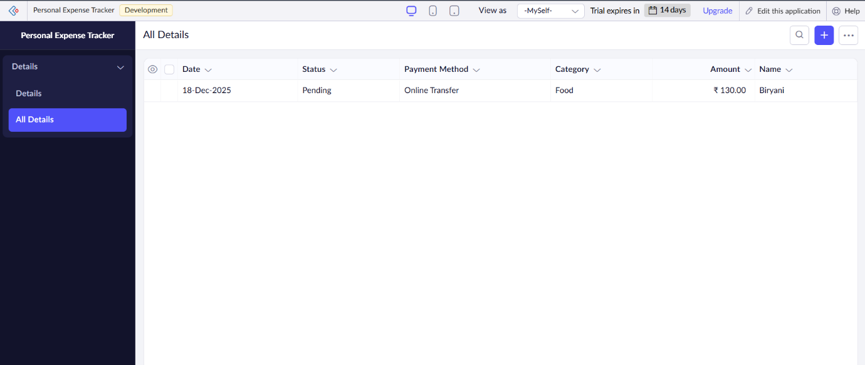
RESULT:
A cloud-based Personal Expense Tracker application was successfully created and deployed using Zoho Creator. The application is accessible through a web browser without the need for installation, allowing users to track and manage their daily expenses effortlessly. Users can categorize expenses, set budgets, and monitor their financial habits in real-time. This demonstrates the Software as a Service (SaaS) model, where the application is hosted in the cloud, ensuring easy access from any device, no installation required, and seamless management of personal finance data.

