Experiment-5

Aim:
To create a cloud-based Library Book Reservation System for SIMATS that allows users to search, reserve, and manage books easily.
Procedure:
- Create an account on Zoho Creator and set up a new app for the Library System.
- Design the database schema with forms for books, users, and reservations.
- Set up the book reservation form to allow users to search and reserve books.
- Create workflows to notify users when a book is successfully reserved or if availability changes.
- Use Zoho Creator's user authentication to manage login for both librarians and users.
- Design reports and dashboards to allow librarians to track reserved books and manage inventory.
- Deploy the app on Zoho Creator's cloud platform and set up automatic scaling for performance.
Output:
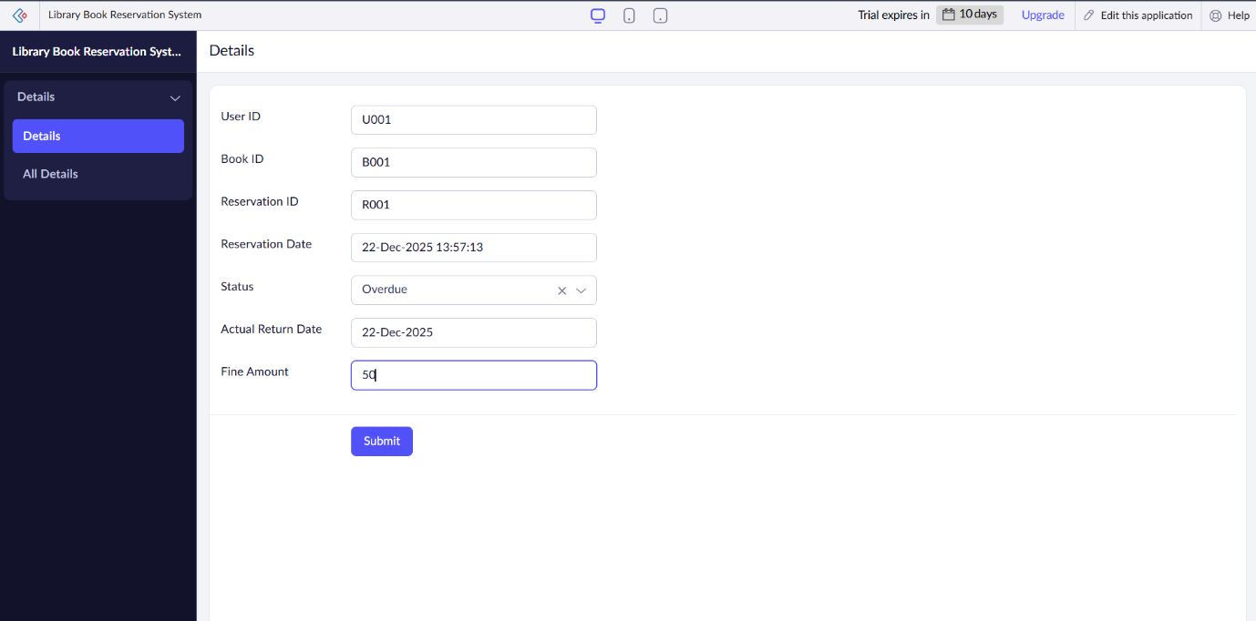
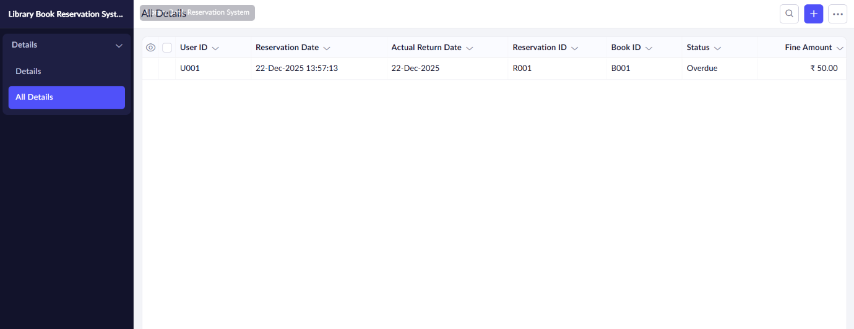
Result:
The Library Book Reservation System in Zoho Creator will provide an easy-to-use platform for both users and librarians. Users can quickly reserve books, view their reservation details, and track fines for late returns. Librarians can manage the status of each reservation, monitor overdue books, and calculate fines automatically based on return dates. The cloud-based system ensures real-time updates and seamless access, improving the overall user experience and streamlining library management.

Result:
The Library Book Reservation System in Zoho Creator will provide a simple, cloud-based platform where users can search for and reserve books, while librarians can manage book availability. The system will ensure easy access for both users and admins, automate notifications, and allow real-time updates. Hosted on Zoho's cloud platform, it will be scalable, efficient, and accessible from any device, making book reservations at SIMATS Library seamless and hassle-free.

