Experiment-6

Aim:
To demonstrate virtualization by installing a Type-2 Hypervisor (Oracle VirtualBox) on the
host system and to create, configure, and run a Virtual Machine (VM) with a host operating
system (Windows/Linux).

Hardware Requirements
• Computer/Laptop with virtualization support (Intel VT-x / AMD-V enabled)
• Minimum 4 GB RAM
• At least 20 GB free disk space

Software Requirements
• Host Operating System: Windows / Linux
• Oracle VirtualBox (Type-2 Hypervisor)
• ISO image of Guest Operating System (Windows/Linux)

Procedure
Step 1: Install Oracle VirtualBox
1. Download Oracle VirtualBox from the official website.
2. Run the installer and follow the installation wizard.
3. Accept default settings and complete the installation.
4. Restart the system if required.

Step 2: Download Guest OS ISO
1. Download the ISO file of the required Guest OS (Windows/Linux).
2. Save the ISO file to a known location on the system.Step 3: Create a New Virtual Machine

1. Open Oracle VirtualBox.
2. Click on New.
3. Enter the VM name.
4. Select the OS type and version (e.g., Linux → Ubuntu / Windows → Windows 10).
5. Click Next.
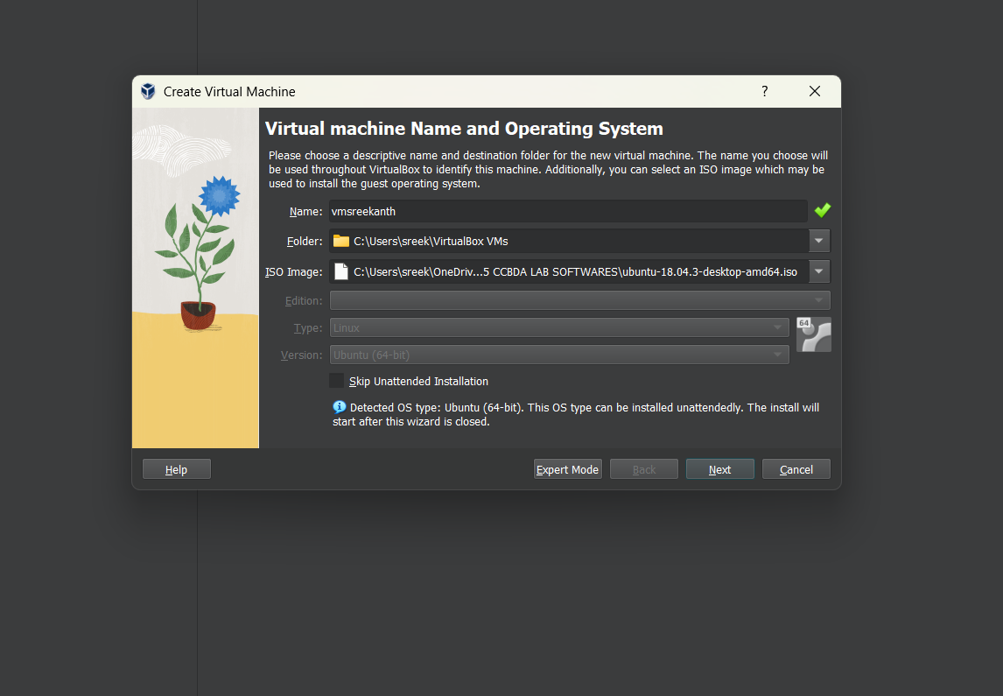
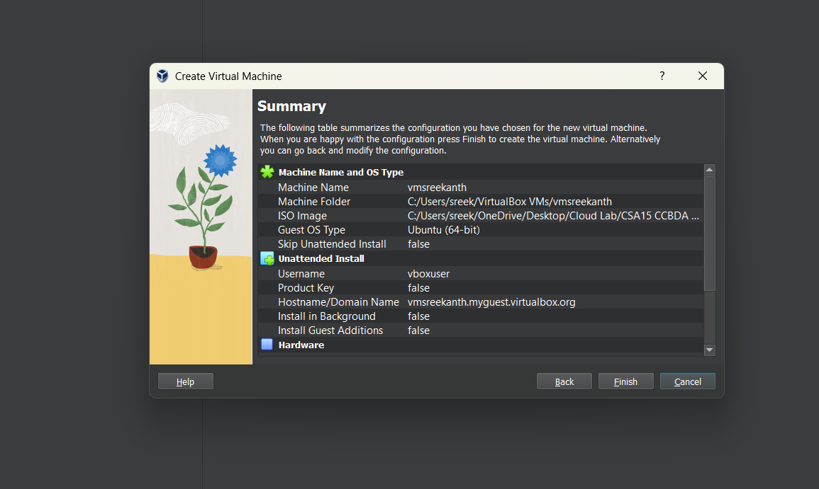
Step 4: Configure VM Hardware
1. Allocate RAM (minimum 2 GB recommended).
2. Create a virtual hard disk.
3. Select VDI (VirtualBox Disk Image).
4. Choose Dynamically Allocated.
5. Allocate disk size (minimum 20 GB).
6. Click Create.

Step 5: Attach Guest OS ISO
1. Select the created VM.
2. Click Settings → Storage.
3. Under Controller IDE, click Empty.
4. Attach the downloaded ISO file.
5. Click OK.

Step 6: Install Guest Operating System
1. Click Start to boot the VM.
2. The system will boot from the ISO file.
3. Follow the OS installation steps (language, region, user account).
4. Complete the installation and reboot the VM.

Step 7: Verify Virtual Machine
1. After reboot, log in to the guest OS.
2. Check system information to confirm successful installation.
3. The VM now runs independently inside the host OS.

Result
Thus, virtualization was successfully demonstrated by installing a Type-2 Hypervisor (Oracle
VirtualBox) and creating, configuring, and running a Virtual Machine with a guest operating
system.
Output: -