**TRANSFER LEARNING-BASED OBJECT DETECTION BY USING CONVOLUTIONAL NEURAL NETWORKS**

**Objective:** The objective of this project is about detecting the objects based upon the model accuracy. The different convolutional neural networks (CNN) are used in this work. Here for the improvement in the result, the majority voting scheme is used. Based on the high accuracy, the objects are detected using the specific model.

**Abstract:** Object detection has become an important task for various purposes in our daily lives. Machine learning techniques have been used for this task from earlier but they are used for the classification of image based species to extract the feature set. This task of deciding the feature set helps to decide the desired object detection. To overcome the object classification problem, this paper proposes a transfer learning-based deep learning method. The different convolutional neural networks (CNN) are used in this work. Here for the improvement in the result, the majority voting scheme is used. Based on the high accuracy, the objects are detected using the specific model. The results obtained have shown incredible improvement in the accuracy of the proposed work when compared to the different CNN models.

**Keywords:** Object detection, Deep Learning, Convolution Neural Network (CNN), Transfer learning.

**Existing System:** This model emphasizes an existing method that which is designed using the RNN algorithm of deep learning. AS, object detection has become an important task for various purposes in our daily lives, that can used in the many applications. Here the dataset is considered and trained by using the RNN algorithm of deep learning and and some of the CNN transfer learning models, after the training process it is tested and the considered objects are detected.

**Disadvantages of Existing System:**

* Less feature compatibility
* Fixed size input and output
* Low accuracy

**Proposed System:**

The proposed model emphasizes a deep network architecture which is used to detect the objects. Object detection has become an important task for various purposes in our daily lives. Machine learning techniques have been used for this task from earlier but they are used for the classification of image based species to extract the feature set. This task of deciding the feature set helps to decide the desired object detection. To overcome the object classification problem, this paper proposes a transfer learning-based deep learning method. The different convolutional neural networks (CNN) are used in this work. Here for the improvement in the result, the majority voting scheme is used. Block diagram of proposed method is shown below.

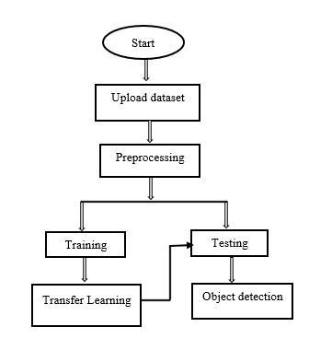

**Fig. Block diagram of proposed method**

**Advantages of proposed method:**

* High feature compatibility
* Time Saving
* Low complexities

**Applications:**

* Image processing
* Picture retrieval
* Security
* Observation
* Computerized vehicle systems
* Machine investigation.

**Software & Hardware Requirements:**

# **H/W Configuration:**

# Processor : I3/Intel Processor

* Hard Disk : 160GB
* RAM : 8Gb

**S/W Configuration:**

* Operating System : Windows 7/8/10 .
* Server side Script : HTML, CSS & JS.
* IDE : Pycharm.
* Libraries Used : Numpy, IO, OS, Flask, keras.
* Technology : Python 3.6+.

**LEARNING OUTCOMES:**

* Practical exposure to
  + - * Hardware and software tools
      * Solution providing for real time problems
      * Working with team/individual
      * Work on creative ideas
* Testing techniques
* Error correction mechanisms
* What type of technology versions is used?
* Working of Tensor Flow
* Implementation of Deep Learning techniques
* Working of CNN algorithm
* Working of GoogleNet algorithm
* Working on ResNet50
* Working on VGG16 and VGG19
* Working on AlexNet
* Working of Transfer Learning
* Building of model creations
* Scope of project
* Applications of the project
* About Python language
* About Deep Learning Frameworks
* Use of Data Science