**Problem Statement 1:**

Is gender independent of education level? A random sample of 395 people were surveyed, and each person was asked to report the highest education level they obtained. The data that resulted from the survey is summarized in the following table:

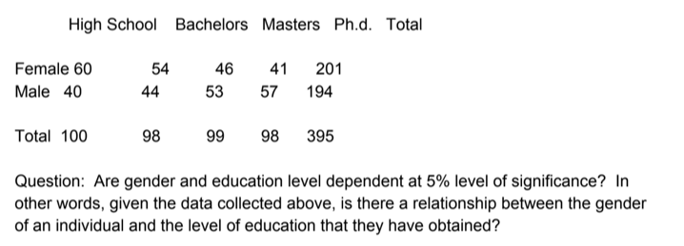

**Chi-Square Test Statistic**

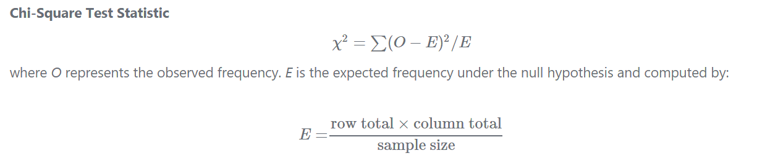

Here's the table of expected counts E:

|  |  |  |  |  |  |
| --- | --- | --- | --- | --- | --- |
|  | High School | Bachelors | Masters | Ph.d. | Total |
| Female | 50.886 | 49.868 | 50.377 | 49.868 | 201 |
| Male | 49.114 | 48.132 | 48.623 | 48.132 | 194 |
| Total | 100 | 98 | 99 | 98 | 395 |

χ2 = (60−50.886)2 /50.886 + ⋯+ (57−48.132)2/48.132=8.006

The critical value of χ2 with 3 degree of freedom is 7.815. Since 8.006 > 7.815, therefore we reject the null hypothesis and conclude that the education level depends on gender at a 5% level of significance.

**Problem Statement 2:**

Using the following data, perform a one-way analysis of variance using α=.05. Write up the results in APA format.

[Group1: 51, 45, 33, 45, 67]

[Group2: 23, 43, 23, 43, 45]

[Group3: 56, 76, 74, 87, 56]

Sample means (*x*¯x¯) for the groups: = 48.2, 35.4, 69.8

**Intermediate steps in calculating the group variances:**

**Group 1**

**value mean deviations sq deviations**

|  |
| --- |
| 1 51 48.2 2.8 7.84 |
| 2 45 48.2 -3.2 10.24 |
| 3 33 48.2 -15.2 231.04 |
| 4 45 48.2 -3.2 10.24 |
| 5 67 48.2 18.8 353.44 |

**Group 2**

**value mean deviations sq deviations**

|  |
| --- |
| 1 23 35.4 -12.4 153.76 |
| 2 43 35.4 7.6 57.76 |
| 3 23 35.4 -12.4 153.76 |
| 4 43 35.4 7.6 57.76 |
| 5 45 35.4 9.6 92.16 |

**Group 3**

**value mean deviations sq deviations**

|  |
| --- |
| 1 56 69.8 -13.8 190.44 |
| 2 76 69.8 6.2 38.44 |
| 3 74 69.8 4.2 17.64 |
| 4 87 69.8 17.2 295.84 |
| 5 56 69.8 -13.8 190.44 |

**Sum of squared deviations from the mean (SS) for the groups:**

612.8 515.2 732.8

Var1=612.8/5−1=153.2

Var2=515.2/5−1=128.8

Var3=732.8/5−1=183.2

MSerror=(153.2+128.8+183.2)/3=155.07

Calculating the remaining *error* (or *within*) terms for the ANOVA table:

*dferror*=15−3=12

*SSerror*=(155.07)(15−3)=1860.8

**Intermediate steps in calculating the variance of the sample means:**

Grand mean (*x*¯*grand*) = 48.2+35.4+69.8/3=51.13

group mean grand mean deviations sq deviations

|  |
| --- |
| 48.2 51.13 -2.93 8.58 |
| 35.4 51.13 -15.73 247.43 |
| 69.8 51.13 18.67 348.57 |

Sum of squares (*SSmeans*)=604.58

*Varmeans*=604.583−1=302.29

*MSbetween*=(302.29)(5)=1511.45

Calculating the remaining *between* (or *group*) terms of the ANOVA table:

*dfgroups*=3−1=2

*SSgroup*=(1511.45)(3−1)=3022.9

**Test statistic and critical value**

*F*=1511.45/155.07=9.75

*Fcritical*(2,12)=3.89

**Decision: reject H0**

**ANOVA table**

| **source** | **SS** | **df** | **MS** | **F** |
| --- | --- | --- | --- | --- |
| group | 3022.9 | 2 | 1511.45 | 9.75 |
| error | 1860.8 | 12 | 155.07 |  |
| total | 4883.7 |  |  |  |

**Effect size**

*η*2=3022.9/4883.7=0.62

**APA writeup**

*F*(2, 12)=9.75, *p* <0.05,

η2=0.62.

**Problem Statement 3:**

**Calculate F Test for given 10,20,30,40,50 and 5,10,15,20,25. For 10, 20,30,40,50:**   
  
**Calculate Variance of first set**   
  
Total Inputs (N) =(10,20,30,40,50)   
Total Inputs (N)=5   
 Mean (xm)= 150/5 = 30

SD=sqrt(1/(N-1)*((x1-xm)2+(x2-xm)2+..+(xn-xm)2))   
 =sqrt(1/(5-1)((10-30)2+(20-30)2+(30-30)2+(40-30)2+(50-30)2))   
 =sqrt(1/4((-20)2+(-10)2+(0)2+(10)2+(20)2))   
 =sqrt(1/4((400)+(100)+(0)+(100)+(400)))   
 =sqrt(250)   
 =15.8114   
Variance=SD2   
Variance=15.81142   
Variance=250   
  
**Calculate Variance of second set**   
For 5, 10,15,20,25:   
Total Inputs(N) =(5,10,15,20,25)   
Total Inputs(N)=5   
 Mean (xm)= 75/5 = 15   
   
SD=sqrt(1/(N-1)*((x1-xm)2+(x2-xm)2+..+(xn-xm)2))   
 =sqrt(1/(5-1)((5-15)2+(10-15)2+(15-15)2+(20-15)2+(25-15)2))   
 =sqrt(1/4((-10)2+(-5)2+(0)2+(5)2+(10)2))   
 =sqrt(1/4((100)+(25)+(0)+(25)+(100)))   
 =sqrt(62.5)   
 =7.9057   
Variance=SD2   
Variance=7.90572   
Variance=62.5   
  
**To calculate F Test**   
F Test = (variance of 10, 20,30,40,50) / (variance of 5, 10, 15, 20, 25)   
= 250/62.5   
= 4.   
  
The F Test value is 4.